

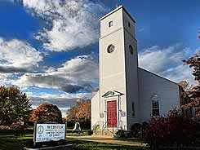

**The Webster Word**

June 2021 Webster Congregational Christian Church Volume 21, Issue 6 5451111101091093932321210101010101096554521211111011091089448978776756Volume 14, Issue 5

***A community of faith in Havre de Grace***

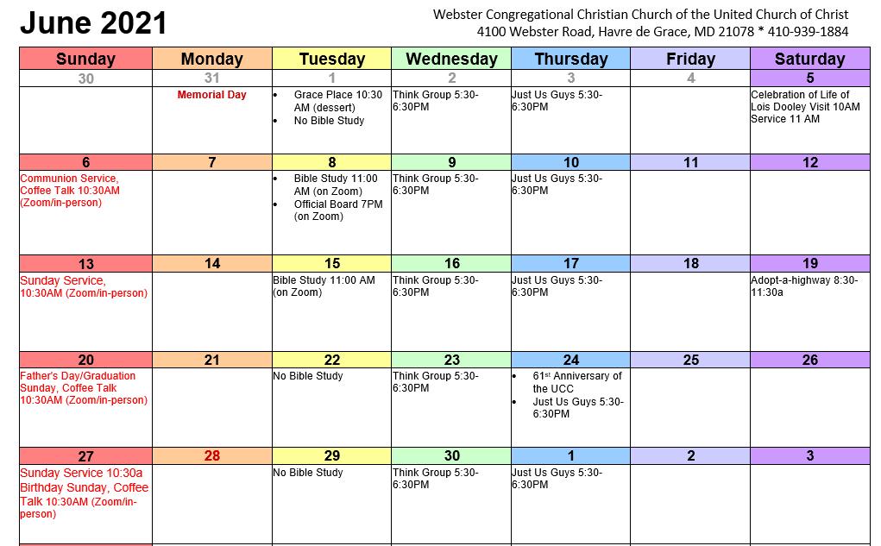

**INDEX**

**Moderator………………………..…2**

**Diaconate…………………………...3**

**SCCW ………………………………….4**

**Clerk’s Report……………..…..4**

**Lectionary Readings ……….5**

**Scripture Readers………..…5**

**Birthdays ………………………...5**

**Reopening Procedures……..6**

**Outreach ……………….………..7**

**Bible Study notice:**

**Bible Study will meet via Zoom at 11 AM on Tuesdays, June 8th and 15th.  There is no Bible Study on June 1st,22nd, or 29th. *Each week in Bible Study, we investigate and study the scripture readings for the upcoming Sunday.  Those who attend have commented that they gain greater insight into the sermon (which always focuses on the scripture reading) each week.* Email or call Pastor Jim if you are interested in joining us so you can get the contact information.**

**MODERATOR**

**By the time you read this edition of the Webster Word, we will have finally returned to in-person worship at Webster Church. We have been absent from in-person worship for fourteen and a half months. In mid-March of 2020, we could not envisage, not physically worshipping together. But we did just that, picked up on Zoom and are now on the other side. During that time, we did lose some dear members to other health issues, but we have so far avoided death by Covid in our congregation. Praise God for bringing us through the pandemic, for all those who have worked to keep us safe, for essential workers who could not stay home, and for the miracle of vaccinations that will help keep us safe in the future.**

**We know the Covid disease is not entirely behind us and that many in our country and around the world will continue to suffer and die. We know we must continue to practice safe actions that keep us and others safe. We are humbled by the sacrifices that so many have made for these many months. WE know God has blessed us and our families and we are grateful. And we know love will triumph!**

**To those who want to worship in person, we joyously welcome you back. And to those who wish to worship on Zoom, we are still connected to you and welcome your faithfulness.**

**Ann Helton – Moderator**

**DIACONATE**

**Recently I received a Dish Garden from a family I watched grow up. Unlike many people, I know I do not have a green thumb and one of the plants died. I quickly came to the realization that I needed to replant each of the remaining plants in separate containers so I could continue to enjoy them. I recruited my granddaughter to help. Unknown to me she was learning about plants and planting in preschool. She talked me through the whole process and corrected my planting skills several times. This was very exciting to me because I remembered she was BACK IN SCHOOL and excited to share with me the experience of planting she had there. It had been more than a year and her joy of sharing school lessons was back. Her JOY and EXCITEMENT about learning had returned to the level it was before Covid entered our lives, a lesson learned from a five-year old.**

**I hope you are feeling the JOY and EXCITEMENT of returning to the sanctuary at WEBSTER and reuniting as a CHURCH FAMILY. , it will be different as we try to return to normal or as we here so often the “new normal”. The Deacons are looking forward to greeting everyone as we return and we are thrilled to continue Zooming our services so we can still greet and worship with our brothers and sisters around the country, to me the best part of this “new normal”!!**

**Our June Sunday Schedule looks like this:**

* **6/6 Communion/Coffee Talk/Webster and Zoom**
* **6/13 Worship and Coffee Talk/Webster and Zoom**
* **6/20 Worship and Coffee Talk/Webster and Zoom**
* **6/27 Worship and Coffee Talk/Webster and Zoom**

**Hope to see you every Sunday at Worship!!**

**Tony Dooley, Deacon**

**Celebration of Life**

**A Celebration of Life service for Lois Dooley will be held a Webster Church on**

**June 5, 2021. The family will receive people from 10:00AM to 11:00AM with the**

**Service beginning at 11:00AM. A luncheon will be served following the Service.**

**We want to thank everyone for their sympathy cards and calls. They lifted our spirits**

**and were very comforting. Through these last years of Lois’ illness we have been so**

**supported by our Webster family as we made this long journey with her.**

**Thanks to all,**

**The Dooley Family**

**SCCW – Society of Congregational Christian Women**

**Even though the SCCW hasn’t met for over a year, we have been sending cards to those who have been ill or lost someone. Some meals have been provided and phone calls have been made to keep in touch with members of the congregation.**

**Usually there aren’t any SCCW meetings over the summer, but as we gain some more normality in our lives, hopefully we will be able to enjoy some form of our usual summer events.**

**For now, the scheduling of meetings has been on hold, but we look forward to the time we can gather again for meetings.**

**Happy Father’s Day.**

**Doris Lyttle**

**Clerk’s Report**

**Things Happening at Webster Church**

* **Sunday services will be in-person and Zoom starting May 30th. Bible Study and meetings will continue on Zoom through the summer.**
* **Check out the updated Webster Church website at www.websterucc.org.**
* **Official Board meeting June 8th at 7 PM on Zoom.**

**Scripture Readers**

**DATE READER**

**June 6 Heidi Pensell Communion**

**June 13 Marge Joseph**

**June 20 Lauren Dooley Father’s Day/Grad.Sunday**

**June 27 Linda Placzankis**

MC900430219[1]

**Those celebrating May birthdays are:**

Judith Haverstick Linda Placzankis

Susan Cohen Benjamin Walker

Gretchen Roeder Carol Greimel

Vilma Duffy

Jocelyn Greimel

**LECTIONARY READINGS FOR June:**

**June 6 –** **Mark 3:20-35**; 1 Samuel 8:4-11, (12-15), 16-20, (11:14-15 and Psalm 138;

Genesis 3:8-15 and Psalm 130;2 Corinthians 4:13-5:1

**June 13 –** Ezekiel 17: 22-24 and Psalm 92:1-4, 12-15; **Mark 4:26-34**;

1 Samuel 15:34-16:13 and Psalm 20; 2 Corinthians 5:6-10, (11-13), 14-17

**June 20** 1 Samuel 17:(1a, 4-11, 19-23) 32-49 and Psalm 9:9-20 or

1 Samuel 17:57-18:5, 18:10-16 and Psalm 133; Job 38:1-11, and Psalm 107:1-3,23-32;

2 Corinthians 6:1-13; Mark 4:35-41

**June 27 –** 2 Samuel 1:1, 17-27 andPsalm 130; *Wisdom of Solomon 1:13-15, 2:23-24*

or Lamentations 3:22-33; Psalm 30; 2 Corinthians 8:7-15; **Mark 5:21-43**

**Reopening Procedures**

**On Sunday, May 30, at 10:30 am, we will reunite with an in-person service at Webster Church. If you are comfortable with that arrangement,**

**we will be so happy to see you and worship with you! Zoom service will also be available and will be beamed from the Sanctuary.**

**For your comfort and safety, there are certain rules we will have in place:**

**1. Masks will be required throughout the building except when you are seated for Coffee Talk**

**2. Please use hand sanitizer upon entering**

**3. Offertory plate will be available in the rear of the Sanctuary for your contribution as you enter, and it will not be passed into the pews**

**4. On Communion Sundays as you enter, you will receive a secured packet of the wine and bread to be used in the pews**

**5. A modified form of Coffee Talk will be held with all food and drink safely prepared and served**

**6. Pews have been designated to allow for social distancing. Please sit only with your family and/or pod members in the pews with the blue tape.**

**7. Heidi will offer some form of Sunday School activity for our young people**

**8. If you are able, please enter the Sanctuary through the front door**

**9. We will not have a choir but there will be glorious music from Angie and selected soloists**

**We hope this works for you and your family. If you need transportation, please call Doris (410-937-9054) or Ann (410-734-7206)**

**Support a Child for a Year**

**The school year is about to end, but we are making plans to supply backpacks on weekends for the 2021 – 2022 school year. This year the Harford County School System supplied meals on weekend due to the pandemic, but in the fall we plan on packing backpacks for 75 students at Havre de Grace Elementary School. To supply these backpacks, we will need to raise approximately $6,000 this summer as our funds are very low. This program is important for these students because it may be the main source of food they have over the weekends. You can help support a child for next school term with a contribution of $115, but we will accept any amount you can give.**

T**o contribute to the Blessings in a Backpack Webster Church fund, send your contribution to**

**Blessings in a Backpack Bank Lockbox**

**P.O. Box 950291**

**Louisville, KY 40295**

**Remember to write Havre de Grace Elementary on the memo line.**

**Amazon Smiles**

**Whenever you order from Amazon, you can help Blessings in a Backpack. When you place an order from Amazon, sign into Amazon Smiles. Select Blessings in a Backpack and then select Louisville, Kentucky branch. Then place your order. Blessing in a backpack will receive 1½ % of your sale. Thank you for helping feed the children on weekends.**



ADDRESS CORRECTION REQUESTED

www.websterucc.org 410-939-1884 websterucc@comcast.net

**Special Notes**



Webster Congregational Christian Church

of the United Church of Christ

4100 Webster Road

Havre de Grace, MD 21078

410-939-1884

H[Uwebsterucc@comcast.netU](mailto:websterucc@comcast.net)

H[Uwww.websterucc.orgU](http://www.websterucc.org)H

*JUNE*



1