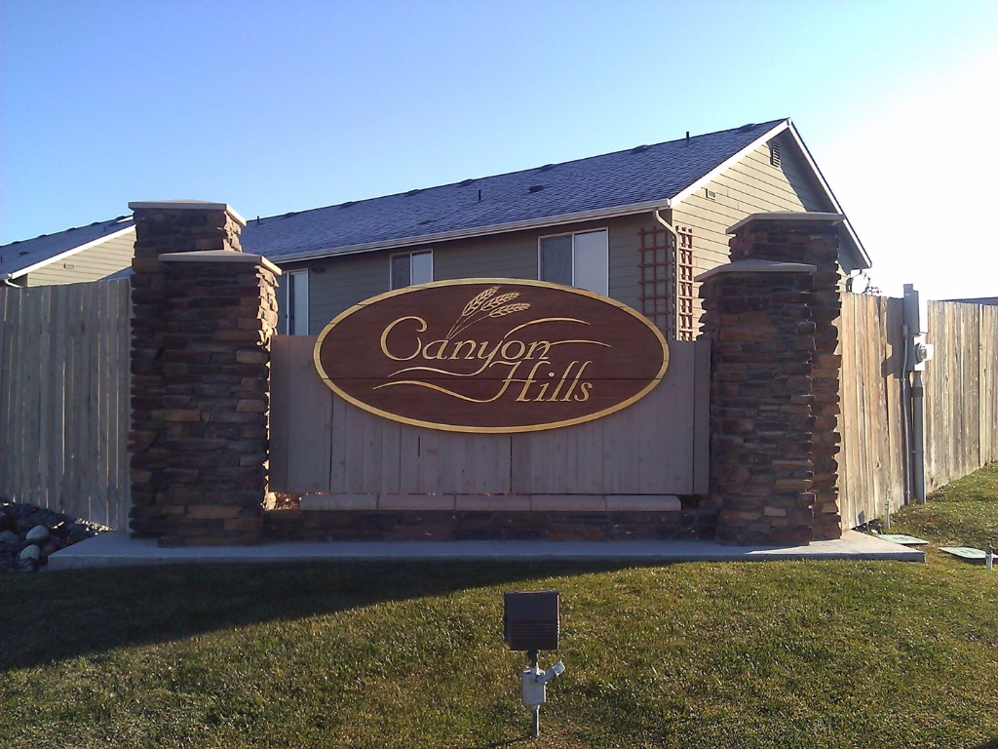

Happy Spring!
School Bus Stops

If you have a child that rides the bus to school, please have a talk with them about safety, appropriate behavior at the bus stop, and about respecting other people’s property.

Children should not be walking across lawns and rocky areas in the yards next to the bus stops. They should not be throwing rocks into the road. They should not be climbing on utility boxes.

They should be stopping and looking for cars before crossing the road and crossing in front of the bus before it departs.

The snow is finally gone and Spring is here! It’s time to trade out the snow shovel and snow blower for the lawnmower and garden tools. Ah the joys of home and yard maintenance.

We’re all neighbors here folks!
Disagreements and issues are bound to come up with our neighbors. Often, having a civil conversation is all that’s needed to resolve the problem.

A Few Friendly Reminders:
- Now’s the perfect time to get started on yard maintenance. Things will go from barely sprouting to overgrown in the blink of an eye. If you’re looking for somewhere to take your trimmings, try the Stemilt Recycling Center and the Chelan County Dryden Transfer Station for reasonable rates.

- Your pets are glad that it’s spring too! They might want to get out and roam. We’ve had a few strays wandering around. Please make sure that they can’t get out of your yard without you. Also, just a friendly reminder to please pick up your dog’s waste. We will be installing pet waste bag dispensers near the mailboxes for your convenience. Please use them!
Please note that the HOA address is NOT a physical address. It is a mailing address only. We hope to get a drop box installed soon for dues and other inquiries.

- Slow down! Please mind the neighborhood speed limit. Speeding through our neighborhood is dangerous. Please relay this information to any teenage drivers in your household as well.

- Park your cars in your garage/driveway. Cars belonging to anyone living in your home should not be parked on the street. In 2013 the board approved a fine schedule for owners of vehicles that are not in compliance. Please see the parking fine letter under the documents tab at Canyonhillshoa.com for more info.

- Store your toys! RVs, Boats and other recreational items should be stored out of view. Per our covenants, they should be screened from view by a 6’ high solid fence.

