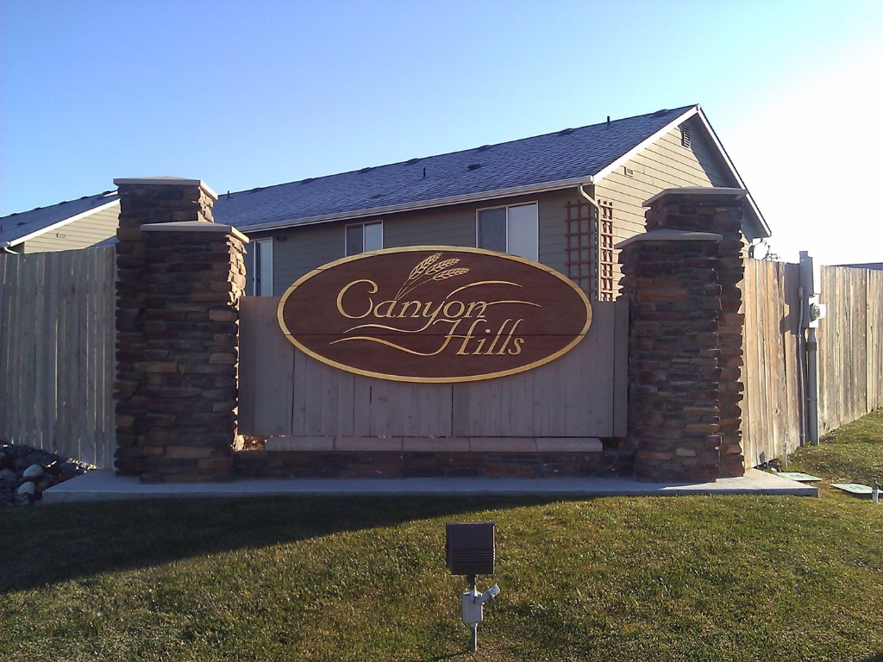
January 2018 Happy New Year!
SNOW, SNOW, SNOW!

The HOA hires someone to clear the mailbox areas, but you are responsible for clearing the sidewalks on your lot each time that it snows.

If you live on a corner lot, you need to clear the sidewalk on the side of your home as well.

Failing to clear the snow leads to icy and dangerous situations.

Compact snow is much more difficult and time consuming to clear. Try to get to it early if you can.

We’re hoping to make 2018 the best year yet in Canyon Hills! Please help us out with this by making sure that you’re doing the following:

- Shovel your sidewalks!


- Slow down!
Please mind the neighborhood speed limit. Speeding through our neighborhood is dangerous. Please relay this information to any teenage drivers in your household as well.

- Park your cars in your garage/driveway.
Cars belonging to anyone living in your home should not be parked on the street.

- Store your toys!
RVs, Boats and other recreational items should be stored out of view. Per our covenants, they should be screened from view by a 6’ high solid fence.

Due to the increased costs of mailing out invoices and newsletters the board would like to offer email correspondence to homeowners. If you would be willing to receive your invoices and newsletters via email rather than post mail and haven’t yet signed up please fill out the information below and check the box authorizing this change and send it in with your 2018 dues or email us your authorization at info@canyonhillshoa.com.

Name: _____________________________ Property Address: __________________

Email address: ___________________________________________________________

I would like to receive all future Canyon Hills HOA invoices, newsletters, and other correspondence via the email address above.

