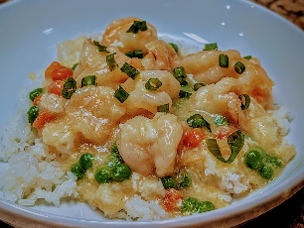SHRIMP IN LOBSTER SAUCE

If you’ve ever browsed Asian-American menus, you’ve likely seen a dish billed as “Shrimp in Lobster Sauce.” Despite the name, the dish rarely contains actual lobster and, in many home kitchens, it isn’t swimming in a traditional lobster reduction at all. The term can be a bit misleading, but it has become a beloved staple in many Asian-American households, celebrated for its savory, garlicky, slightly sweet flavor and silky texture.

In its authentic spirit, the dish is often built around well-seasoned shrimp and a robust sauce that mimics the luxurious notes of lobster without using lobster meat. The result is a quick, comforting dish that pairs beautifully with steamed rice and a sprinkle of green onions. Important note: this version does not use real lobster sauce. If you’re searching for a dish with a lobster flavor profile, you’ll find it in this recipe through its careful balance of aromatics, soy, and a touch of sweetness—not from lobster itself.

**What Makes it Distinctive?**

A quick, high-heat method (stir-fry or quick sauté) highlights the shrimp without overcooking.

The sauce centers on garlic, ginger, soy, and a touch of sweetness, sometimes enriched with a light cornstarch slurry for a glossy finish.

Common garnishes include sliced green onions and a whisper of white pepper, which lift the dish without masking the shrimp’s delicate flavor.

This version intentionally omits any actual lobster sauce or lobster meat, delivering a satisfying “lobster sauce-inspired” experience through technique and seasoning.

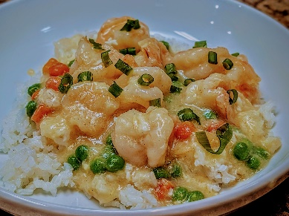

Recipe: Shrimp in Garlic-Ginger Sauce (No Lobster Sauce)

Servings: 4

Total time: about 20 minutes

**Ingredients**

* ▢24 ounces shrimp *(21/25 size)*
* ▢4 ounces [ground pork](https://thewoksoflife.com/2018/01/how-to-grind-meat-without-a-grinder/) *(can substitute ground dark meat chicken or turkey)*
* ▢4 tablespoons neutral oil *(I use olive oil)*
* ▢2 cloves [garlic](https://thewoksoflife.com/chinese-chives-scallions-aromatics-peppers/#garlic) *(minced)*
* ▢2 tablespoons [clear rice wine](https://thewoksoflife.com/rice-wine/) *( I use sake)*
* ▢2 1/2 cups [low sodium chicken stock](https://thewoksoflife.com/homemade-chicken-stock/)
* ▢1 teaspoon [sesame oil](https://thewoksoflife.com/sesame-oil/)
* ▢1/2 teaspoon sugar (for marinating)
* ▢1/2 teaspoon sugar
* ▢1 teaspoon [salt](https://thewoksoflife.com/chinese-spices-condiments/#salt) *(fine sea salt)*
* ▢1/2 teaspoon [MSG](https://thewoksoflife.com/msg-monosodium-glutamate-good-or-bad/) *(optional)*
* ▢1/4 teaspoon [white pepper](https://thewoksoflife.com/what-is-white-pepper/)
* ▢1/2 cup frozen peas
* ▢1/2 cup frozen carrots
* ▢2 tablespoons [cornstarch](https://thewoksoflife.com/rice-grains-and-flours/#cornstarch)
* ▢2 tablespoons water
* ▢2 eggs *(beaten slightly)*
* ▢2 [scallion](https://thewoksoflife.com/chinese-chives-scallions-aromatics-peppers/)s *(chopped)*

Prep the shrimp: Marinate the shrimps in sugar and salt for a tastier flavor while preparing the other ingredients.

1.  Aromatics: Heat the oil in a large skillet or wok over medium-high heat. Add the minced garlic and ginger, and sauté for about 20–30 seconds until fragrant but not burned.

2. Add the shrimp in a single layer. Stir-fry for 1 minute, until they start to turn pink. Flip and cook for another 30–60 seconds until fully pink but not overcooked.

3.  Add the chicken stock, sesame oil, sugar, salt, MSG (if using) and white pepper. Stir in the peas and carrots.

4. Thicken the sauce: Give the cornstarch slurry a quick stir and pour it into the pan. Stir constantly for about 30 seconds until the sauce thickens to a glossy coating.

Adjust seasoning with white pepper and, if desired, a touch more soy.

5.  Spread the slightly beaten egg across the mixture and let simmer for a few seconds. Use your spatula to fold the egg into the sauce with a few strokes.

**Variation**: You may add water chestnut for a crunchy texture.

**Serve:** Transfer to a serving dish, sprinkle with the green onion greens, and serve hot with steamed rice.

**Tips for best results**

Don’t overcook the shrimp; they cook quickly and become rubbery. Remove them as soon as they’re pink.

If you prefer a stronger lobster-sauce-inspired note, add a teaspoon of oyster sauce, but adjust saltiness accordingly.

For a lighter version, skip the cornstarch slurry and simmer a bit longer to reduce the sauce to coat the shrimp more lightly.

If you want more heat, increase the garlic and add a pinch of chili oil.

**Closing note**

This article presents a version of Shrimp in Lobster Sauce that intentionally does not contain lobster or a traditional lobster sauce. It delivers the familiar, satisfying flavor profile through careful seasoning, aromatics, and technique, making it a reliable, weeknight-friendly dish that still feels special. Enjoy with steamed rice or a side of greens for a complete meal.