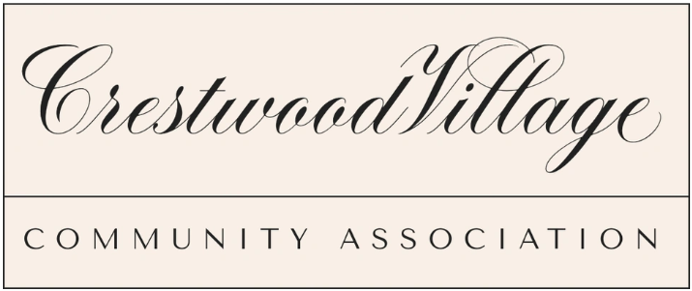

On behalf of the Crestwood Village HOA board, we would like to address any rumors going around regarding the current lawsuit that is ongoing. We have been made aware that there are residents who may be putting out information that is not completely accurate regarding a recent ruling from the judge. If you have any questions or concerns regarding this matter, please reach out to the board so that we can avoid any type of misunderstanding.

Please send any correspondence to CrestwoodVillageBoard@gmail.com and someone on the board will make sure to get back to you.

