I, , verily that I have received payment in the amount of $ 150.00

from Female-Centric Films for the rental of my facilities in the filming of a certain screenplay tentatively entitled "Strap-On Slave 2" filmed on March 10, 2008.

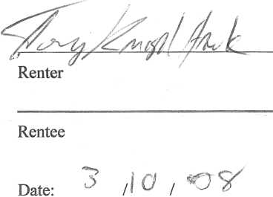

I, , verify that I have received payment in the amount of $ 150.00

from Female-Centric Films for my photography and videography services rendered in the filming of a certain screenplay tentatively entitled "Strap-On Slave 2” filmed on March 10, 2008.

Photographer/V ideographer

I, /^(fa^erifythat I have received payment in the amount of $400.00 from Female-Centric for my acting services rendered in the filming of a certain screenplay tentatively entitled "Strap-On Slave 2" filmed on March 10, 2008.

