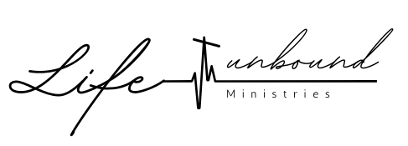

VOLUNTEER JOB DESCRIPTION

MEDIA SUPPORT STAFF

Role:
This position provides vital social media marketing, video, and photography support to help Life Unbound Ministries tell their success stories, visually and creatively communicate their mission, and to advertise, promote, document, and/or livestream events.
Acceptance of this position will be for the period of one year and will include training, team meetings, and at least 1 hour of volunteerism per week (or 4 hours per month).

Requirements:

- Attend all required training and meetings.
- At least 4 volunteer hours per month.
- Experience with Social Media Marketing, Facebook Live, Instagram Stories, photography and video.
- Preferred experience with photo and video editing software.
- Ability to stand on feet for up to 4 hours at a time.
- Ability to lift up to 40 lbs.
- Strong servant-leadership skills and positive attitude.

Responsibilities:

- Attend all mandatory staff meetings for the event.
- Arrive 1 hour prior to the event unless otherwise instructed.
- Responsible for set-up and break-down of all cameras and equipment.
- Primary person responsible for Livestreaming videos of community education or other public events for audiences unable to attend in person.
- Video interviews with participants or donors.
- Take professional pictures of events for marketing and advertising.

Ratified by Board of Directors __________ day of ___________, 2022

__________________________________ __________________________________
Founding Director Board Chair

