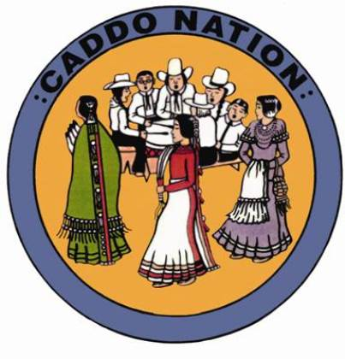
Caddo Nation of Oklahoma
Chairman – Bobby Gonzalez OKC Representative – Jennifer Wilson
Vice Chairman – Kelly Factor Anadarko Representative – Tracey Martine
Secretary – Jennifer Reeder Ft. Cobb Representative – Arlene O’Neal
Treasurer – Verna Castillo Binger Representative – Kara Dougherty
Caddo Nation Membership Meeting
Caddo Nation Cultural Building
January 31, 2026

Call to order: 10:56 a.m.
Quorum established: 3 in person and 18 online
Invocation: Chairman Gonzalez
Motion 01: by Sydney Samaniego, seconded by to approve the October 16, 2025 minutes. Motion Carried: 20-0-1
Updates
- Caddo Nation Election Board update from Sydney Samaniego:
  - The Election Board announced the next General Election will be held on the second Saturday of July 2026, for the following positions:
    - Vice Chairman
    - Secretary
    - Fort Cobb Representative
    - Anadarko Representative
    - Binger Representative
  - The Election Board has been working with the Constitution Committee. Proposed hosting a meeting on February 28 to gather citizen input on changes to the constitution.

- Caddo Nation Constitution Committee update from Shannon Freeman:
  - Three methods of citizen engagement were outlined: Community outreach meetings (seven total, including two virtual sessions); Surveys (two planned; first survey closed on December 1;Small-group meetings, available upon request (virtual or in-person)
  - Outreach meeting on February 1 at the Culture Hub in Oklahoma City.
  - Outreach meeting in March at Texas Native Health in Dallas/Arlington.

- Louise Smith: Is council working on establishing veteran’s services for Caddo Nation? Could the office maintain a list of Caddo veterans for outreach.
  - Chairman met with VA about coordinating services.
  - Vice-Chairman Factor currently working with Bruce Gonzalez/Delaware Nation on veteran group.

- Dr. Kelly Irvine: Offered to assist with telehealth mental health services.

- Sydney Samaniego: What are elders to do about dental now that the denturist is no longer active?

  - Issue will be brought up with the Southern Plains Tribal Health Board, Caddo Nation CHR and Social Services to look for other sources of help.
  - What’s going on with McKee’s?
    - Staff changes have caused the store to be short staffed. HR is in the process of hiring more staff.
  - Tracy Newkumet Burrows: Why were the glasses benefits cut to $150?
    - Referred to Kandace Keahbone and Sharla Moore for input.

Motion 02: by Steven Edmonds, seconded by Sydney Samaniego to adjourn at 12:02 p.m.. Motion failed: 15-0-0
- Meeting ended at 12:02 due to a loss of quorum.

CERTIFICATION
We, the undersigned Chairman and Secretary of the Tribal Council of the Caddo Nation of Oklahoma, hereby certify the above Caddo Nation Membership meeting minutes were approved by a quorum of the membership at a duly called meeting convened and held on this __ day of ___________, 2026 at the Caddo Nation Tribal Complex in Binger, Oklahoma, and that the forgoing minutes were duly adopted by an affirmative vote of ___ For, ___ Against, and ___ Abstentions.
_______________________________ __________________
Bobby Gonzalez, Chairman Date

_______________________________ __________________
Jennifer Reeder, Secretary Date

Online participants for January 31, 2026 membership meeting:
- Misty Heath
- Lauren Haupt
- Kelly Irvine
- James Cussen
- Yonavea Hawkins
- Francey Freeman
- Louise Smith
- Shannon Freeman
- Diana (no last name listed)
- Nicole Habbart
- Elliott Greenlee
- Brandi Brown
- Amy Heath
- Kristine Chandler
- Tracy Newkumet Burrows
- Sue Koskela
- Nicole Molake
- Debbie Turner
- Shayna Sheridan

