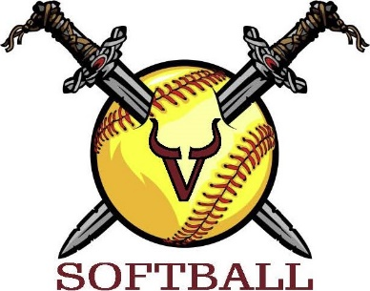
VIKING SOFTBALL TEAM SPONSOR FORM

The Viking Softball Club is a nonprofit girl travel softball organization. Our teams play
competitive tournaments throughout Pennsylvania and neighboring states. Your
generosity helps offset player registration costs and helps take the burden off of the
families. With a contribution of at least $100, your business will receive a Facebook
“shout out” and receipt for a tax write off.

Player Name: _____________________ Team Name: __________________________
Business Name (EXACTLY as it should appear on Facebook)

______________________________________________________________________
Contact Name: ____________________________
Contact Phone No: _________________________
Contact Email: ____________________________
Would you like a receipt? Yes____ No____
Authorization Signature: _____________________

Payment Options (check one):
- ___Cash
- ___Checks payable to “Viking Softball Club” Mailed to PO Box 117 Jonestown, PA 17038
- ___Venmo– vikingsoftballc@gmail.com (when using Venmo please indicate player name)
**Sponsorships are Non-Refundable after 30 days of receipt**

