Stephanie Leigh-ThundHerStruck

DRUM PLOT

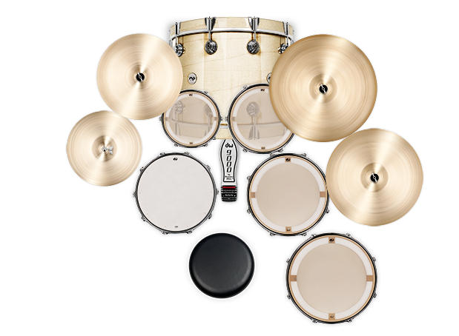

SABIAN 18”

PEARL DRUM KIT:

24” bass drum.

12” and 14” **rack mount toms.**

16” floor tom.

18” floor tom **(add effects/gate for the Cannon on the song “For Those About To Rock”).**

14 x 5 ½” snare drum and stand.

14” hi hats and a heavy duty enduro stand.

TWO 18”, ONE 19” and ONE 20” crash cymbals. 2 straight and 2 boom cymbal stands. (One cymbal and stand shown as orange circle on plot. Located to the left of hi-hat)

1 DW single bass drum pedal.

1 drum throne; seat needs to sit **low.**