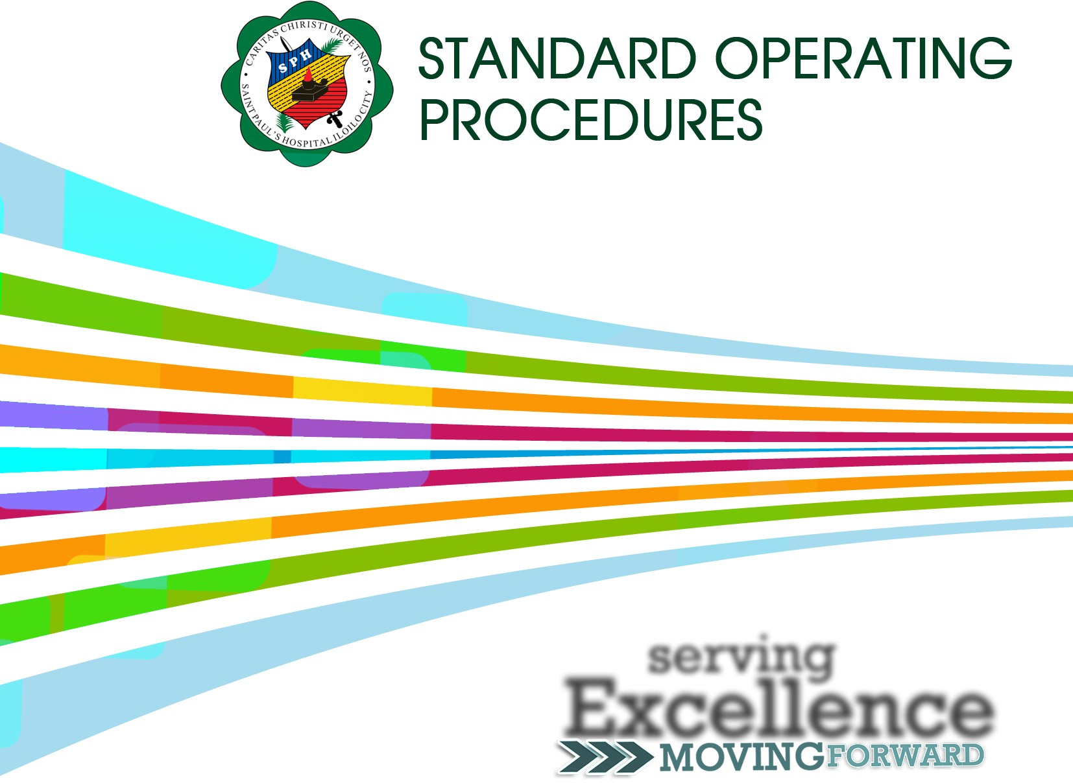

2O20 l 8th Edition
ST. PAUL´S HOSPITAL OF ILOILO, INC.
INSTITUTIONAL REVIEW BOARD

serving
Excelleinnce

(Based on Philippine Health Research Ethics Board Standard Operating Procedures Workbook, 2O15)

