1. E-MAILS ON HF/SSB WITH PACTOR MODE

The operation of sending e-mails on HF/SSB can sometimes be frustrating, and surely takes time and patience. There are some objectives which need to be addressed prior to getting or sending e-mail via SSB.
1. Receiver & transmitter should be a FCC: typed unit. The transceiver should be aligned, and on frequency. Stability [plus & minus 10hz] is necessary
2. A good engineered antenna system for the design of your vessel.
3. Most important, but usually overlooked is a superb grounding system. Highly recommended is grounding plates on the hull of your vessel. The RF grounding system is completely separately from the DC or electrical grounding system.
4. If the electrical run between the computer and the SSB radio is farther than 3-4 feet, it is recommended that RF chokes be installed at both ends of the electrical and communications cables.
This practice minimizes the possibility of RF pickup into the computer and the TNC [Terminal Node Controller]. Remember that there are different kinds of RF iron core chokes, and different ones are used for different applications. Contact CruiseEmail engineering to understand as to which type either a #73 or a #43 Ferrite type or a mix of the two.
5. The RF electrical run from the auto-tuner to the ground either a 6X18 inch ground plate or 2-3 thru holes connected together should not exceed 5-7 feet. It should be kept separate from other electrical and communication lines. A good grounding strap should be a 1/2 inch to 1 inch wide copper strap, not wire.
For installation instructions please click onto Radio Installation for SSB radio's on the home page.
For consulting assistance for new or old installation contact Dr. John Gregory at "w3ate@earthlink.net".
CruiseEmail has engineering services that specialize in SSB installs, for any type of marine vessel.

RF GROUNDING FOR MARINE VESSELS

Addressing the RF grounding problems that are necessary to perform good and clean signal transmission while sending e-mail and or transmitting other data and or receiving clean clear signals.
►PROBLEMS:
The grounding of a vessel either sail or power is basically address the same.
This paper will address the basic sail vessel either mono-hull or cat configuration. Many of the problems appear when transmitting with the single side band high frequency radio.. The indicator lights on the DC panel start to light up, air conditioner shut down, the propane alarm goes off, noise in the SSB radio in intolerable, and good gathering of weather faxing is noisy, and or e-mail get cut off, or extremely difficult to send e-mails.
►CAUSES:
Let first take an understanding as to what is causing these problems into the RF system, of the vessel, and to why these situations happen.
By using the old concept of grounding to everything that is metal, has been the concept since installation of radio and electronics on board private vessels.
For many years grounding to all metal objects has been the standard, and that manufactures of radio and electronic equipment have just accepted, and not reasoned with or challenged the old concept.
What happens is that the ground side of the antenna also carries the RF signal as it's leaving the ATU [automatic antenna tuner] it couples with the DC system of the vessel. The DC system is also connected to the bonding system of the vessel, which means that when ½ half of the sine wave is transmitted, that portion of the transmission is coupled into the electrical DC side of the vessel directly.
Another miss understanding is that many vessel owners believe that the copper strap that goes to the ground shoe is the ground and counterpoise to the ATU. This is the major causes of interference to not only SSB radios, but to autopilots, and noisy GPS'', electronics, laptops, and many other electronics devices.
►GROUNDING:
Let's not mistake RF grounding as radial/counterpoise of the RF radio system.
For proper grounding of a RF radio system ground shoe needs to be mounted on the outside hull of the vessel. This ground shoe should be located within 5-7 feet from the antenna tuner.
This ground shoe is now the grounding rod to earth ground as many visualize, "the stake into the ground" It's also the electrical current return from the antenna via the tuner. As an average mounting place, many ATU's are mounted in the aft lazerret of the vessel.
A copper strap with a width of ½ to 1 inch, anything wider is a waste of time and money, and has no electrical advantage. This copper strap should be no thinner than 5 mils in thickness. The copper foil that is usually available in many marine stores will desolve within month in the salt-water environment. That reason is because it’s actually galvanized material then copper coated.
The ground shoe that is to be mounted in the water, we recommend a silicon/bronze plate with dimensions of 6-8 inches wide and a length of 16-18 inches.” The new smaller ground shoe designed by Rope Antenna, www.ropeantenna.com” exceeds any if not all the commerciual ground shoes on the marine market today.
The theory of the 100 square feet is a myth, and will be address later. This plate should be mounted deep under the waterline, as when the vessel heels, it does not come out of the water. The 2-4 bolts that come through the hull for mounting should be all strapped together giving as much transfer of RF grounding as possible.
Another fallacy from the marine yards when mounting the plate is that the yards will take 5200 sealant and press the grounding shoe up against the hull and then bolt it to the hull. This is a poor solution for a few reasons.
By placing ¼ to 3/8 spacers on the outside of the hull. The ground shoe now receives water from both sides, thus doubling the capacity to water and lowering the resistance to 4-12 ohms to water, which is ideal for grounding.
Some vessel owners feel that raising the ground plate will slow their vessel by a few hundredth of a knot.
A deep conversation with a few renowned marine architects state there is more drag from the growth on the hull of the vessel then from the extended ground shoe. Once the shoe is mounted then from the inside the placing of 2-4 copper straps to each terminal of the ground shoe, and with both sides of the ground plate exposed, will be more than sufficient RF grounding for your electrical needs.
►RF CONNECTIONS:
The RF connections, to and from the ATU, to the main radio are also of extreme importance.
The coax connection from the radio to the tuner can be either RG-8 or mini-8 coax 52-ohm coax. It should be marine grade, which means that the copper shield is silver tinned, and not the typical copper color.
This type coax will not rot after 6 months of use. This rotting is identified by an off color green around the connector.
The PL-259 connect should be stainless steel or which I prefer the new silver-tin PL-259 which makes the soldering much easier. Proper solder of this connection is covered in another paper.
The coax is now connected to the RF output of the radio to the tuner.
There is another control line, which will send DC and a key/start command to the ATU to pre-sense the ATU processor for setting up the frequencies in the ATU.
The radio is also grounded to the ground shoe via a 1/2-1 inch ground strap with the same quality as previously mentioned. A DC block is also installed as to prevent any DC back to the radio causing electrolysis.
At the ATU a ground strap is then also attached to the same ground shoe to the ground wing nut on the tuner. Again this copper strap to the ground shoe, from the ATU should not exceed 5-7 feet. Again a special DC block, passing RF only to the ground shoe is necessary. That prevents any DC components back to the antenna tuner, casuing problems. This type of DC block canbe viewed on the RopeAntenna.com web site. www.ropeantenna.com.
With the ATU installed, along with the radio, the counterpoise/radials need to be installed.
►COUNTERPOISE / RADIALS:
These counterpoise or radials will attach to the same grounding lug on the ATU as the copper strap going to the ground shoe.
The twin lead ladder lines with be laid in the hull on both sides of the vessel.
Each counterpoise will have certain lengths, with the opposite side being shorter than the other. This is to maintain the different frequencies of the marine bands, and or ham bands. The line should be approximately 3-4 feet apart understanding that many vessels starting from the rear lazerette, that these counterpoise, line will run together either via the engine compartment or prior under the berths. This is acceptable as long as you do not run them on top of each other for distances greater than 10 feet.
This will now conclude the installation of a good RF grounding and counterpoise system for your vessel.
Just to add some additional information as to counterpoise. The counterpoise is as important as the antenna them selves. These counterpoise lines are the recipical lines to the antenna itself. These lines are resident to the operational frequencies, but represented in wavelengths. From ¼ wave length to 5/8 wave length, and other factors as wire volicity is also incorporated. Matching the counterpoise lines is not as siple as it looks. It takes very expensive test equipment, such as signal generators, grid dip meters and constant balancing and adjustments between the two twin lines to give the antenna a close match to allow maxium output from the antenna tuner and also the radio transmitter. Some companies, try to improvise what they claim are counterpoise line with lengths of coiled wire inside a hose, calling that counterpoise. This cannot be accomplished because coiled wire at a shory or any length and tightly wound interrracts with the wrapped wire and does NOT impedeance wise match any antenna tuner.
►ADDITIONAL FILTERING:
Additional filtering is deemed necessary to isolate your DC ground and RF system.
RF inline filters placed both at the input of your radio and another inline filter placed at the input of the ATU. These filter minimizes the RF feedback that cause intermod, and interference to your radio system, and prevents RF feedback to your TNC modem and radio. Sometime this is sensed with RF biting while you’re talking into your microphone.
These devices are also called RF chokes, and are made up of RF clamshell iron filters. These RF core chokes are also installed in the computer cables from the laptop to the TNC/modem. Each located at the ends of each cable. Another set of claim shell filter chokes are installed at the beginning and end on the cable connecting.It’s also a good practice to install RF core chokes on the power lead to your radio.
These are also called RF beads.Up until lately these beads were made up of # 73 material.. These number 73 were good from frequencies starting around .1 through to about 20 Mhz.
To cover frequencies up to 300 Mhz you need material #43. Then you can use them in conbinations using both types of materials and cover a large spectrum or with a new material #31 ferrite core. My recommendation is to use the #31.There are two basic sizes .25 inch and .5. best results is to size your coax, control cable, to the core size.
►DC BLOCKING:
The final set is resolving the interference problems is stopping the DC loop that accurse when connecting all these straps and cables to a common ground source.
The copper ground strap that connects from the radio to the ground shoe carries a DC component which is also referred to as a ground loop. This DC loop also causes interference and can be eliminated by placing a DC block in line with the strap.
This stops the DC from passing from the antenna tuner back to the radio. The DC block contains a special capacitor that stops the DC, but allows the RF to pass to the ground shoe. Some vendors, or dock side engineers, as they believe to be, say upi only need a diode/capacitor. First that there is no diode, and it’s a capacitor that needs to be resident to the operational frequency.This is actually a tuned circuit. Again review www.Ropeantenna.com and view a designed DC block.

2. WHAT FREQUENCY DO YOU MEAN?

The frequency listed or displayed for a radio station can differ, depending upon the radio receiver, the type of modulation used and how you are demodulating (or modulating) the signal, and the person listing the frequency. This is especially true for high frequency (HF) radios. To help avoid confusion, three terms are used to describe these radio frequencies: assigned, carrier, and window.

►Assigned Frequency
The assigned frequency is defined by the International Telecommunications Union Radio Regulations as "the centre of a frequency band assigned to a station". In fact, it is the actual radio frequency of the signal being transmitted and received. This is the most commonly used frequency designation.

►Carrier Frequency
The carrier frequency is the frequency of the carrier, or the suppressed carrier of a signal. For many, perhaps most radio signals, the carrier frequency and the assigned frequency are identical. They are identical for AM (dual sideband) signals. They are different for single sideband radios. For maritime HF single sideband transmissions, which are always upper sideband, the assigned frequency is always 1.4 kHz greater than the carrier frequency.
The carrier frequency designation, not the assigned frequency designation, is normally used in referring to single sideband transmissions. History partially explains the reason for this.
Marine radiotelephony was originally AM (dual sideband), and the carrier and assigned frequencies were the same. Certain frequencies, such as the distress and calling frequency 2182 kHz, were internationally recognized and known by any mariner using a marine radiotelephone. When marine spectrum became scarce, the International Telecommunications Union moved all marine radiotelephony transmissions from dual sideband to the more efficient single sideband. At first, the carrier signal was left untouched, so old AM radios could still receive the new single sideband transmissions. In time however, the old carrier signal was eliminated. The old marine frequencies such as 2182 kHz, commonly known and used, were retained and still displayed by marine radios. Although no signal was actually transmitted on these carrier frequencies any longer, receivers still had to be tuned to those frequencies so that the voice signal could be properly demodulated and understood.
Maritime digital signals, such as narrow band direct printing (NBDP or sitor) or digital selective calling (DSC), are transmitted on an assigned frequency 1.7 kHz above the (suppressed) carrier frequency. Marine weatherfax signals are transmitted on an assigned frequency 1.9 kHz above the carrier frequency. NBDP, DSC and weatherfax radios normally display the assigned frequency. However, if a single sideband radio with a separate decoder unit is used to receive a Sitor, DSC or weatherfax signal, it's likely that receiver would have to be tuned to the carrier frequency for the decoder to work properly.
The ITU assigned channel numbers to many single sideband and NBDP frequencies to help avoid this confusion. However, DSC frequencies, and most simplex single sideband, NBDP and weatherfax frequencies do not have channel numbers.

►Window Frequency
The window frequency is simply the frequency displayed (on the front panel numeric display "window") by a particular radio receiver or transmitter. Depending on the equipment, the window frequency could be either the carrier or the assigned frequency. Since the window frequency is dependent upon the equipment used, the term is not generally used by the USCG.

►Is the frequency listed assigned or carrier? What frequency do I tune my radio to?
The USCG tries to use standard convention in its listing of radio frequencies: Single sideband frequencies are generally carrier frequencies; all others are generally assigned frequencies. When the carrier and assigned frequencies differ, we generally list both.
Read your radio's instruction manual, or talk to your marine electronics dealer, to learn whether your radio should be tuned to the assigned or the carrier frequency.

3. When is Grounding Your Yacht Ever Good ?
( Written by Capt. Rob McClain, edited for technical content by Dr. John Gregory, CTO CruiseEmail )
January 7, 2009
Well it’s not when you have lost your way in the fog and end up on the rocks, that’s for sure.
Where it does come into its own is when it is providing the best earth possible to your electronics and in particular, you’re Single Sideband Radio.
If you are planning to venture further than the usual trip across the English Channel or indeed 30Nm or more offshore, and want to remain in contact, then you will probably be looking at installing a long range High Frequency (HF) radio, more commonly known as a Single Sideband (SSB) Radio for your communications.
You could be looking at other more modern (and expensive!) options such as Inmarsat, Satellite Telephone or indeed Mini-M after maybe having had a poor experience with SSB radios in the past, but look out, you will be paying through the nose for any pictures and weather forecasts you receive. SSB radios are not an antiquated form of communication by any stretch of the imagination!
It may be that you already have an existing SSB radio fitted, but the installation fundamentals have just been overlooked and because of your resultant lack of reception or poor quality signal, you may have given up and are looking at alternatives.
Well …… not so fast
A good SSB installation will give you very good weather forecasts, reports, faxes, routing, worldwide communication and radio contact with various yachting safety networks all for free; and with the easy addition of a special “PACTOR” modem, you can even get Internet downloads and email at a very affordable level!
Very soon, CruiseEmail will have available a new non modem system, which means that the expensive modems will no longer be needed. This new system uses the sound card from you labtop or an inexpensive external sound card.
You might be installing a long range radio system from scratch, maybe with a view to break free from your regular life and sail your dream across the Atlantic to the Caribbean. Good examples of this are the 200 or so yachts that annually compete in the A.R.C. (Atlantic Rally for Cruisers). A race across the Atlantic, from Gran Canaries to St Lucia.
These yachts have a daily reporting schedule whilst in transit, where they check-in with their positions (and quite often amusing anecdotes) whilst crossing the ocean in company and relative safety. They utilize their SSB’s to receive weather information to enable them to choose the best route and avoid any nasty surprises. Then once they are safely ensconced in the Caribbean they may check in daily to weather and safety radio nets so they can safely cruise the Caribbean Island chain and keep in touch at the same time.
- So where do you start?
Well, you would have chosen a high quality transmitter / receiver unit such as the ICOM IC-M710 with an ICOM AT-130 automatic tuner unit. You will have chosen an aerial option (whip, backstay or halyard), a separate dedicated radio battery and charger, and a way of getting the whole system earthed into the ocean such as a grounding plate like the one from Rope Antenna. This is now the new Ground Shoe, which is much smaller in size, 2 1/2 times the surface capacity and only 2 through rods ,with only 3/8 holes. This New grounding shoe is truly a new design and works even better then old previous models.
- So you’ve bought the components, now you have to plan your installation.
Let’s start under the water. For a good earth (assuming you are not steel hulled) you will have to haul the boat to install a grounding plate. It should be installed as deep as possible and as close to the centerline as possible to ensure it’s always covered with water, and when you install it, it should “hang off” of the boat so that the plate has water on all of its faces to maximize its earthling area. Do not bond it to the hull using 5200 between the plate and the hull or you will regret it!
If you short cut the grounding process by earthing to the engine block or a keel bolt, you may as well throw the whole lot overboard as the “noise” and interference you will get, will make the radio annoying and maybe unusable.
On our boat (a 61ft Oyster sailing yacht called “Talisman”), we chose the Mark VII Wonderbar (21” long x 7” wide x ½” thick) as a grounding plate. The new Ground Shoe by RopeAntenna was not available at this time. This comes with 5 holes, 5 countersunk screws and 5 seals called “WonderSeals” which keep the water out of the boat if installed properly! But now, you need to review and consider the smaller but more efficient Ground Shoe, with only two holes.
We basically threw the screws that it came with away, [money wasted] and invested in a 6ft long length of Bronze Silicon threaded stud (the same diameter as the holes in the plate) and cut it into 5 equal 14” lengths using a band saw, cleaning the threads afterwards.
Bronze Silicon stud is the best metal for conduction of “earth” and although it’s expensive, it’s not much in the grand scheme of things.

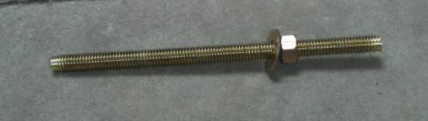

The Bronze Silicon Stud, nut and washer. Expensive but worth it!
We also bought an additional 5 “WonderSeals” to complete the install of the plate so that we have a seal on the inside and the outside of the hull. A bit over the top maybe but it’s a good, easy and cheap way to make sure it doesn’t leak.
We have just sailed over 5000Nm in 4 months with this install and it hasn’t leaked a drop and the quality of our signal both sending and receiving is fantastic.
The longer studs and suspended grounding plate basically enables us to dive on the boat at any stage and remove the plate to clean it. That way we don’t have to haul and we keep our radio performance in peak condition. The plate does tend to clean itself when you transmit on the radio but if you don’t use it for any length of time, it soon clogs up.
It is quite common for people to dive on their yachts in the tropics to attempt to keep their hull clean, unless they have a very good antifouling (such as Micron 44 or 66) suitable for that type of water and usage.
The antifouling you choose to paint your yacht with is another important point to bear in mind before you attempt to sail to warmer climet. Unless (of course) you want to haul and re-paint when you get there. Mind you, scrubbing your hull by hand underwater is a good way to combine a swim with a keep fit class!
- Back to the fitting.
Next, we have to carefully and accurately drill the holes in the hull to fix and connect the plate to the “inside world” of your yacht. On the waterside of the hull around the holes, it is important to remove any antifouling equal or greater in area to the footprints of the “WonderSeals” so that they can adhere to the hull in a strong and watertight way.
You can antifouling the area again after the install but the seals must have a good solid surface to stick to. A Dremmel tool is good for this. The area should obviously be sanded flat before fixing to.

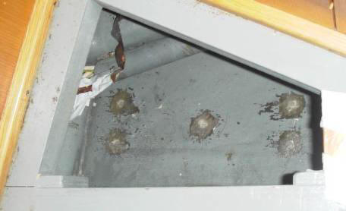

Carefully drill Holes to suit the grounding plate. Remove the bilge paint and antifouling from both inside and outside to ensure a good bond to sound surfaces. It’s normally easiest to drill from the outside. Have a vacuum cleaner sucking from inside the boat to catch the mess and stop debris clogging up your limber holes in your bilge.
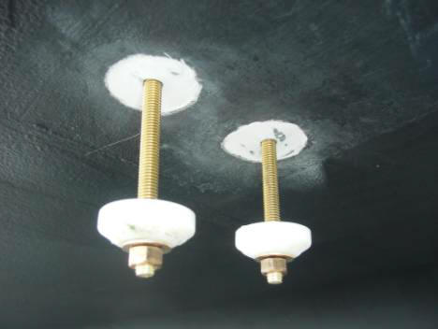

Notice that the antifouling has been stripped back ready to receive the seals and adhesive. The seals have a donut recess in them to take the sealant. Placed like this, it allows you to add the sealant with minimal mess, then just push them up against the hull and tighten the nuts on both sides. Don’t forget to run some 5200 up the holes in the hull and around the threads of the studs.
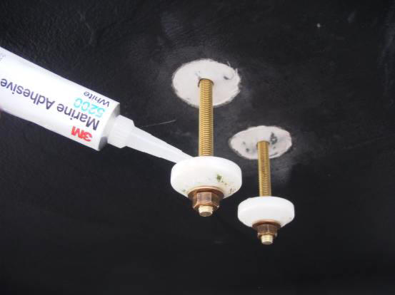

Add the marine sealant (Use 3M 5200 – permanent bond for best results) to the seals both inside and outside and tighten the nuts up on both sides allowing 24hrs to “go off” before fitting the plate and copper foil strip inside the boat.
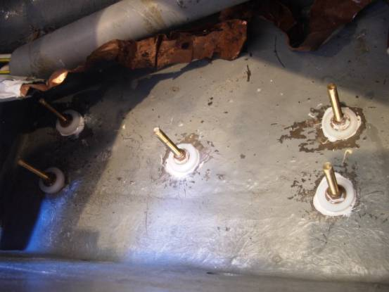
The 5 studs and seals are now in place ready to take the plate outside and copper earthing foil inside after the sealant has had time to go off.
Mineral Spirits can be used effectively to remove excess sealant and to clean the threads, and your tools. Don’t go too mad though. It doesn’t matter that you can see some sealant around your seals and studs. Just a light wipe is all I would suggest. I always worry that it will affect the “setting” of the sealant if you use too much.
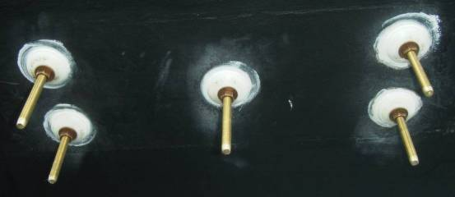
Outside, the finished seals are ready to take a couple of coats of antifouling. Do not paint the studs.
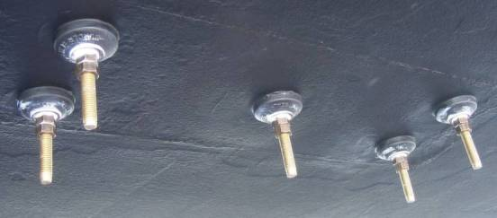
And the finished thing, ready to take the Grounding shoe. Note the double nuts to lock the studs in place.
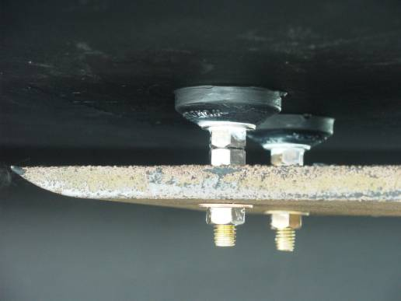
The finished product. The manufacturer’s countersunk screws are replaced with 14” long Bronze Silicon studs (length depends on the thickness of your hull) so that the plate can be removed with ease for cleaning. Also the plate is suspended from the hull to maximize the surface area for grounding purposes.
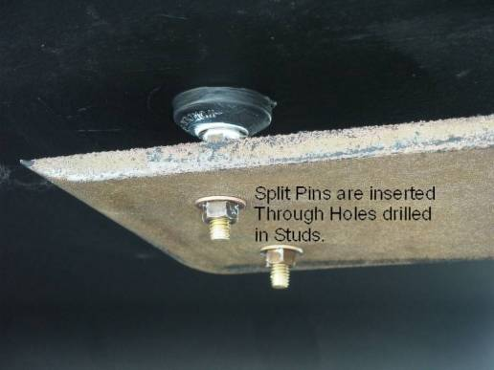
This plate is not new and has been re-used over the past 2 years and still going strong. Muriatic acid (The old name for hydrochloric acid (HCl)) is great for cleaning it up like new but wear goggles and gloves, as it’s very corrosive. The plate does tend to clean itself when you transmit on the radio.
The ends of each stud were drilled through and split pins inserted to stop the final bolts from dropping off.
Sectional Diagram Illustrating the Installation of the Grounding Plate, seals and studs:
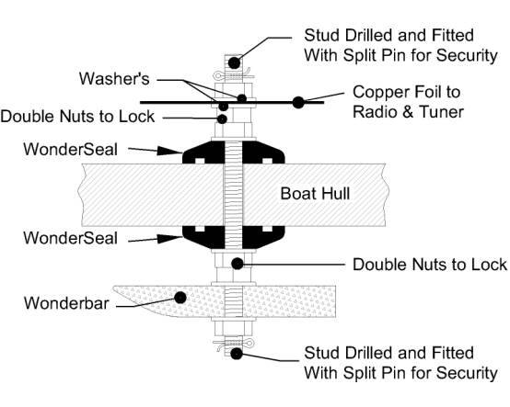

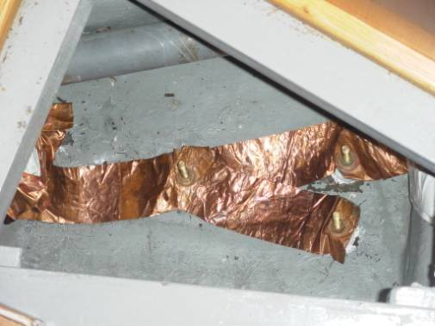

Copper foil is run to every stud to maximize the use and area of the grounding plate. This plate is purely for the SSB radio. There is a second smaller grounding plate for the electronics, which massively reduces radio interference and noise.
Why foil?
Round wires create inductive reactance at radio frequencies, and are not effective as a good grounding conveyance. Use 1 or 2 inch wide, 5 mil copper foil (available at most marine stores or plumbing supply houses) to achieve a good seawater ground. Technically should you measure the "RF" resistance it should be between 4 to 12 ohms to salt water.
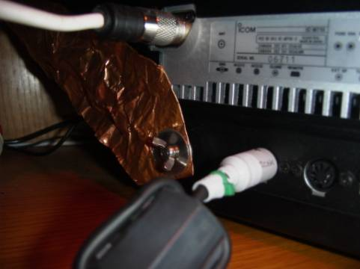
One end of the copper foil is connected directly to the back of the radio unit itself. Fold the foil 2-3 times being careful not to cut yourself (it’s very sharp) and drill it through so you have a good connection. Do not be tempted to earth anything else to this foil.
It is VERY important that you do not attempt to connect the radio or tuner or any part of your radio system to earth using a wire no matter how thick it is. Copper foil is all you should use throughout; as wire develops a resistance to earth and will severely affect your whole system.
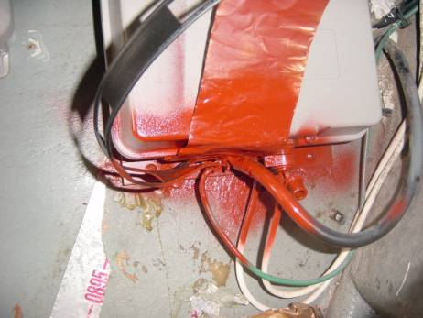
The other end of the copper foil is connected directly to the automatic tuner (mounted in the lazarette in this case) and all of the electrical connections are covered with a Urethane Seal Coat aerosol paint to reduce corrosion as much as possible.
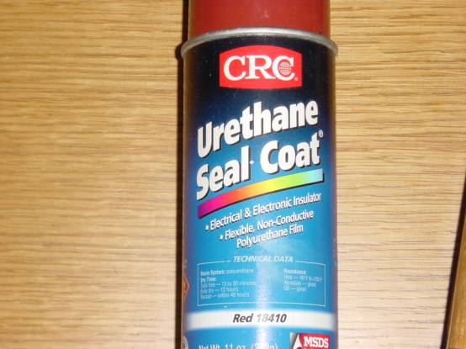
Polyurethane Non Conductive Seal Coat to protect connections from the elements.

In between the radio and the grounding plate we installed a DC Block, which is simply a couple of one-way diodes to stop any DC voltage looping around in the system. This dramatically reduces noise in your radio system.
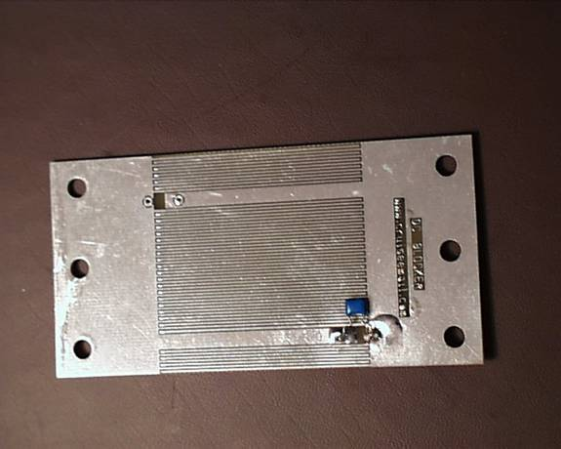
This DC Block is specifically designed for marine frequencies and is available from CruiseEmail.
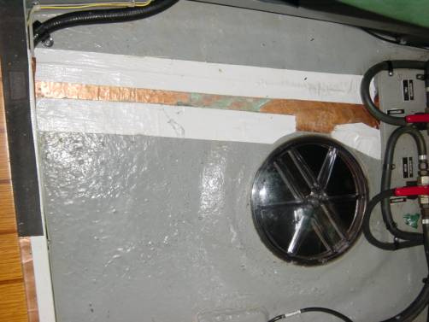
The foil can be folded neatly to run through the boat but you should avoid scrunching the foil. Staples are useful to hold it in place. Run duck tape over the edges of the foil so that it doesn’t get damaged and also you won’t cut yourself next time you have to work around the foil. Cover the rest of the copper with a thin coat of paint or epoxy to keep it clean and un-tarnished. Do not cut the foil unless you absolutely have to. There is always somewhere else to run the foil. Don’t rush this part. Take your time and you will reap the benefits.
- The next stage is to look at the link from the tuner to the aerial.
The best and only wire to use is special brade ¼ inch to have minimal resistance to the antenna from the antenna tuner. Not GTO-15 cable. This wire was never intended to be used as a RF signal cable. it’s wire diamenter size about the size of number #20 wire and RF signal voltage is a surface voltage and ¼ brade carries less RF resistance.

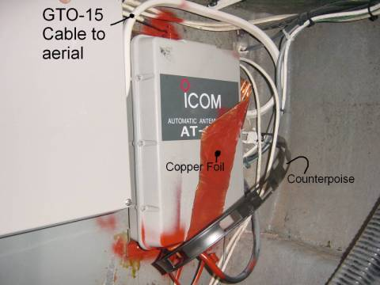
You will see the connection of the GTO-15 cable on the top of the tuner. Note the heat shrink and the application of the Polyurethane Sealer paint.
The other important thing to notice is the Counterpoise wire. This is the black flat plastic strip of wire with holes cut out of it. This runs from the tuner in the lazarette all the way to the bow locker (about 75ft in total) and the radio waves use this as a “Springboard” when you transmit giving you extra range and a much clearer signal.
The whole installation is finished by strapping all the cables and wires down using cable ties and wire hold-downs (not shown here).
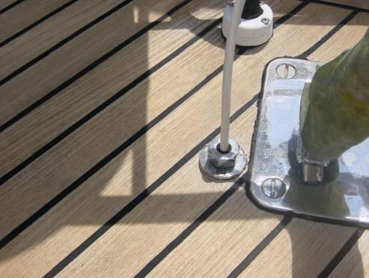
The GTO-15 cable comes through the deck via a waterproof deck flange fitting and runs up to the aerial of your choice.
There are 3 types of aerials you can have installed on your yacht.
- Backstay aerial - The typical installation is a backstay aerial that utilizes the wire backstay(s) as the aerial itself with the installation of isolators to avoid the risk of giving members of crew RF burns when you transmit. The length of the aerial within the backstay i.e. the distance between the isolators is critical and you will hear this referred to as a measured backstay. You should get advice on this or contact crew4sail for help. This is a satisfactory aerial solution but the metal(s) in the backstay unfortunately do not lend themselves as great transmitters or receivers like the halyard aerial does.
- Whip aerial – These are reminiscent of old CB radio aerials you would see on the back of cars many years ago. They come in different lengths and sizes and are quite simple to fit although I personally find them quite ugly. They again are quite satisfactory as aerials but still nowhere near as effective as the halyard Rope Antenna’s designed, built and sold by Rope Antenna. [ Rope Antenna.com ]]
- Rope Antenna Halyard aerials –(www.ropeantenna.com ) or www.cruiseEmail.com

- These aerials are quite new technology and can be difficult to find, but by far the very best in aerials and if you go for this option you will not be disappointed. They also have the added benefit that if your rig should ever drop (god forbid), you can run the aerial along the deck or guardrails and still transmit and receive in a satisfactory manner without a mast. They are basically an epoxy coated silver / nickel and copper wire floating inside the outer braiding of a length of braid on braid rope with an eye splice at either end. The outer braiding can take up to 3000lbs of tension without straining the wire inside. They look just like a halyard and as such, blend in beautifully with your yacht. These should also be made to an exact length and advice should be taken on this so you can have one tailor made for the height of your mast. The only drawback is that it is not so easy to install isolators at the bottom of the halyard to avoid RF burns. What I do to get around this is just shouting out of the hatch for anybody on deck not to go near the aerial until I tell them otherwise. We have had 12 people aboard while transmitting (including teenagers) and never has anybody had any problems or burns with this. The quality of this aerial however is fantastic. You are transmitting and receiving through a medium that is perfect for the job and the lack of noise and quality of what you send and more importantly (in the case of weather faxes) what you receive as good as any picture you could download over the Internet. I have downloaded color sea surface temperature charts of the Gulf Stream using this aerial and downloaded the same image from the Internet and I couldn’t tell the difference.
What we use on Talisman is both the halyard aerial which is a new addition, plus the old measured backstay aerial as a backup.
The GTO-15 cable comes from the tuner, through the deck flange and up the starboard backstay to a connector where we can choose which aerial to use.
Recently Dr. John, the RF designer of the Rope Antenna has develope even better way to feed the Rope Antenna or any other type of antenna. GTO-15 is originally design to power neon lights as in dinners, and decorations on windows. GTP-15 has and not ever designed for RF feed line applications. There is no shielding or any other properties that make GTO-15 a good choice to be used for RF applications. The Rope Antenna and CruiseEmail engineering team now uses ¼ inch silver/nickel tinned brad. The brad is then inserted into high voltage plastic loom that is used in automotive applications. RF energy is a surface voltage and the brad give very low RF resistance form the antenna tuner to the actual antenna. When viewing GTO-15 the size of the internal wire is less then the size of a straight pin. This RF antenna feed line can also be purchased from RopeAntenna.com.
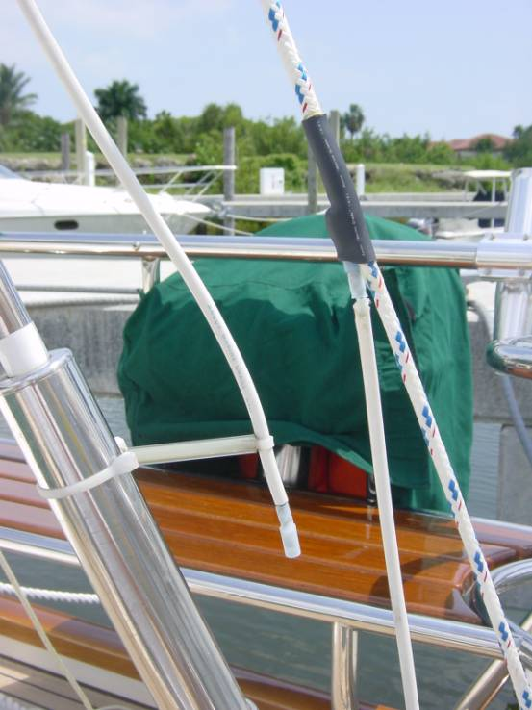
You will see that we are currently using the halyard aerial. The connections are tin soldered and heat shrunk after being covered with dialectic paste to prevent corrosion. There is enough slack in the wires to trim off and re-connect if necessary. We now replace the GTO-15 with the new brad loom feed line from RopeAntenna.com.
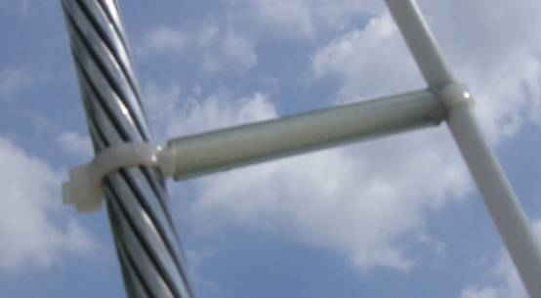
A good tip to avoid earthling your hard earned signal out to the un-insulated backstay is to hold the wire off of the backstay using plastic tubing and cable ties spaced every 2ft or so.
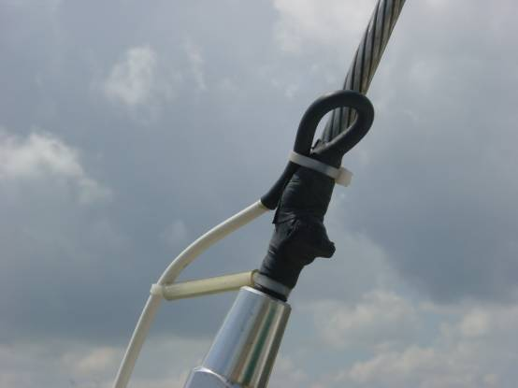
If you decide to use the backstay aerial option, run the GTO-15 cable up the backstay to immediately above the lower isolator (using the spacers every 2ft), again soldering, coating in dialectic solution and heat shrinking the connections. The wire can then simply be clamped to the backstay itself using a hose clamp or jubilee clip. If you introduce a loop in the wire as shown above, then any dampness will not be encouraged down to the connection itself but away reducing corrosion even more.
To finish off, wrap the whole kit and caboodle in self-amalgamating tape. Remember that corrosion will quickly reduce the quality of any system installed on a yacht so you should always endeavor to make any connections as good as possible even if it does take extra time. You’ll be glad you did when you come to service or replace parts.
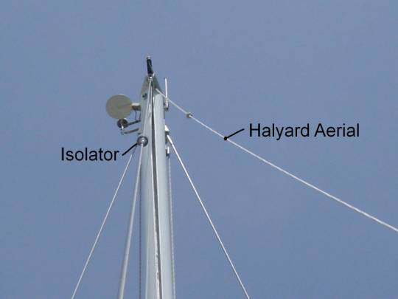
This photo taken from the stern looking up to the masthead, shows the halyard aerial (on the right) attached to a topping lift.
It can be quickly and simply dropped and coiled when you don’t need it. I always drop and coil it away if there is a risk of a lightening strike and disconnect the backstay aerial. You will notice the isolator at the top of the backstay in a position to maximize the range of the radio.
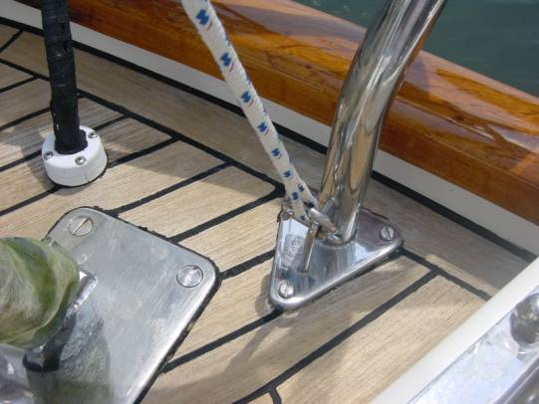
The bottom of the halyard aerial is simply shackled to the pushpit through the eye splice.
- Counterpoise
We haven’t talked about the installation of additional counterpoise wires in your installation as yet, so here goes. Your system will work without them but if you can be bothered to put in the work, you will certainly reap the benefits.
What is a counterpoise?
Basically a counterpoise is a springboard for your radio transmission to “bounce off” of into the atmosphere.
Good grounding or counterpoise techniques are absolutely necessary for maximum single sideband range.
Half of your antenna is your radio frequency (RF) ground. The radiating portion of your antenna needs to see a mirror image of itself before it will send out your SSB signal.
This mirror image (called a counterpoise) is created by using a metal surface and seawater as your radio frequency ground plane.
Your marine single sideband system will not perform satisfactorily if you don't have a good counterpoise system. Poor counterpoise (ground) equals poor range. This is especially true on lower frequencies where large RF grounds (counterpoise) are required for good range.
Of course, for those of you with aluminum hull vessels, your RF ground plane (counterpoise) is your hull, and you'll probably have the loudest signal anywhere in the world. No further RF grounding is necessary for you lucky people.
As an extra counterpoise (RF ground) to our ground plate and copper foil, we decided to install additional wires, which connect to the same point as the copper foil on your tuner. This then runs the entire length of the yacht right up to the bow if possible.
A capacitive ground system such as this, made up of copper foil run around the hull below the water line, and individual copper strip wires at one-quarter wavelength sections, is one way to achieve a very good ground.
The wire we used was basically 2 wires separated by plastic (available at most electrical shops). This allowed us to run two runs of cable at the same time. We then removed a 1.5ft length from one side of one of the wires at 37ft down the run from the tuner. These lengths correspond with the ¼ wave radial lengths required to match the most commonly used frequencies in the marine industry.
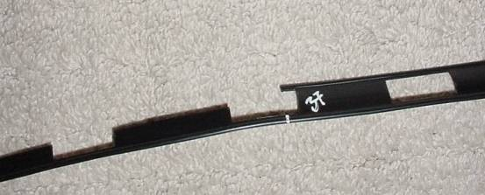
After all of this work, which took about a week to install completely, we popped Talisman back in the water and started to see how she worked.
Here is image downloaded using “ICS Weather Fax” software on a laptop computer connected to the audio out socket of the SSB radio.
As you will see, the quality is excellent. And you can leave the software on permanently to grab the broadcasts when they are made or set up a schedule to download at the right times of day.
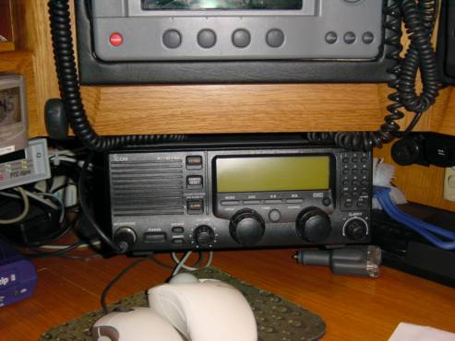
This is the finished installed radio set hung from the shelf above. It’s easy to use front end with large LCD display and positive feel knobs makes using it a pleasure.
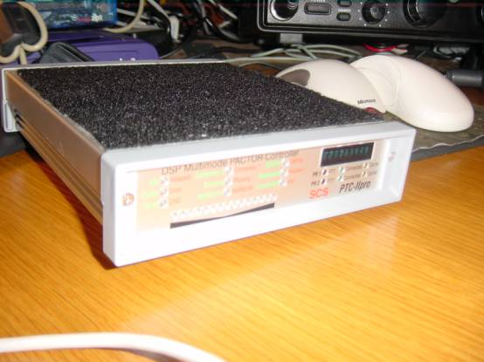
The Pactor PTC-II Pro is an excellent addition to the radio set for email and Internet access.
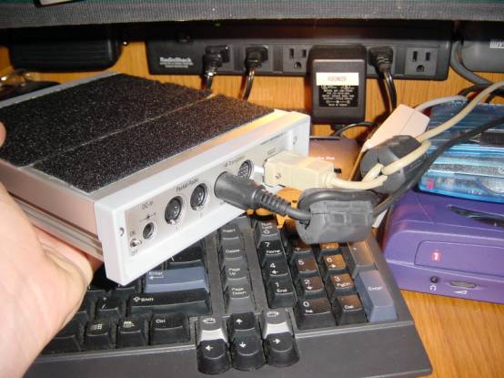
The connections are simple and it’s powered by the SSB radio itself. Note the graphite insulators that the wires are run through. These reduce noise and interference even more.
I hope that this helps you install or re-install your SSB system so that you start to see the same results that I did.
I am a fully qualified MCA Class 4 Master of yachts and have been running yachts professionally for 6 years, having started playing in boats at the age of 6.
I have a lot to offer and if I can help you further, maybe with sourcing and sizing a halyard or backstay aerial, or your counterpoise, just drop me a line. You will find me through my web site at www.crew4sail.com. Follow the “Contact Us” link.
Here are some additional areas you can look at if needed, to reinforce your knowledge and resources:
http://www.RopeAntenna.com. (Link for Grounding Shoe grounding plates.)
http://www.marinco2.com (Link for the Dynaplate grounding plates)
http://www.sailnet.com/collections/articles/index.cfm?articleid=suelar0175. (A good article on Single Sideband Radios)
http://icomamerica.com/ (ICOM’s web site.)
http://www.atomvoyages.com/AerialTricks.htm
www.cruiseEmail.com (email services)
www.ropeantenna.com (SSB halyard antenna)

