OnBase New Enhancement
Starting December 1, 2021, all applicants that pay for their own fuel will be required to submit and upload the fuel document under the Document Tab on the VS1.
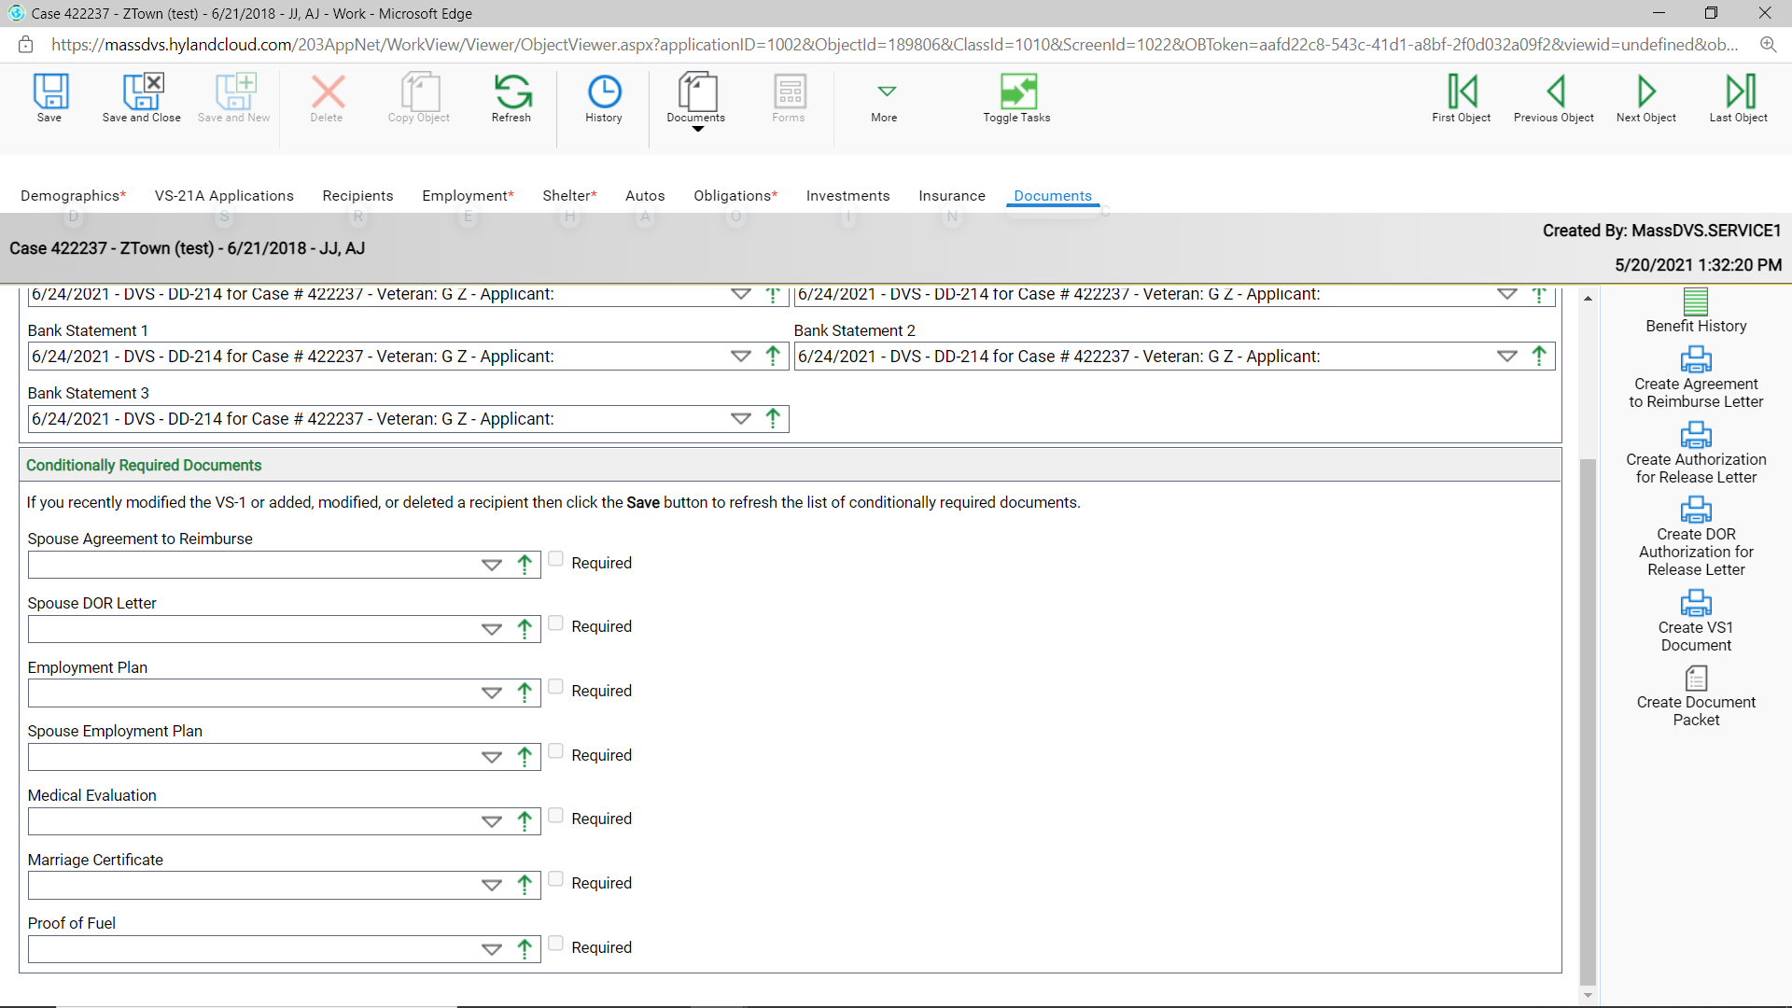
- This requirement is reading off the VS1 under the Shelter tab.
