Instructions for Recertification
- Do a new VS21A an enter the applicants’ benefits.
  - All six months for fixed incomes.
  - Three months for applicants on an employment plan.
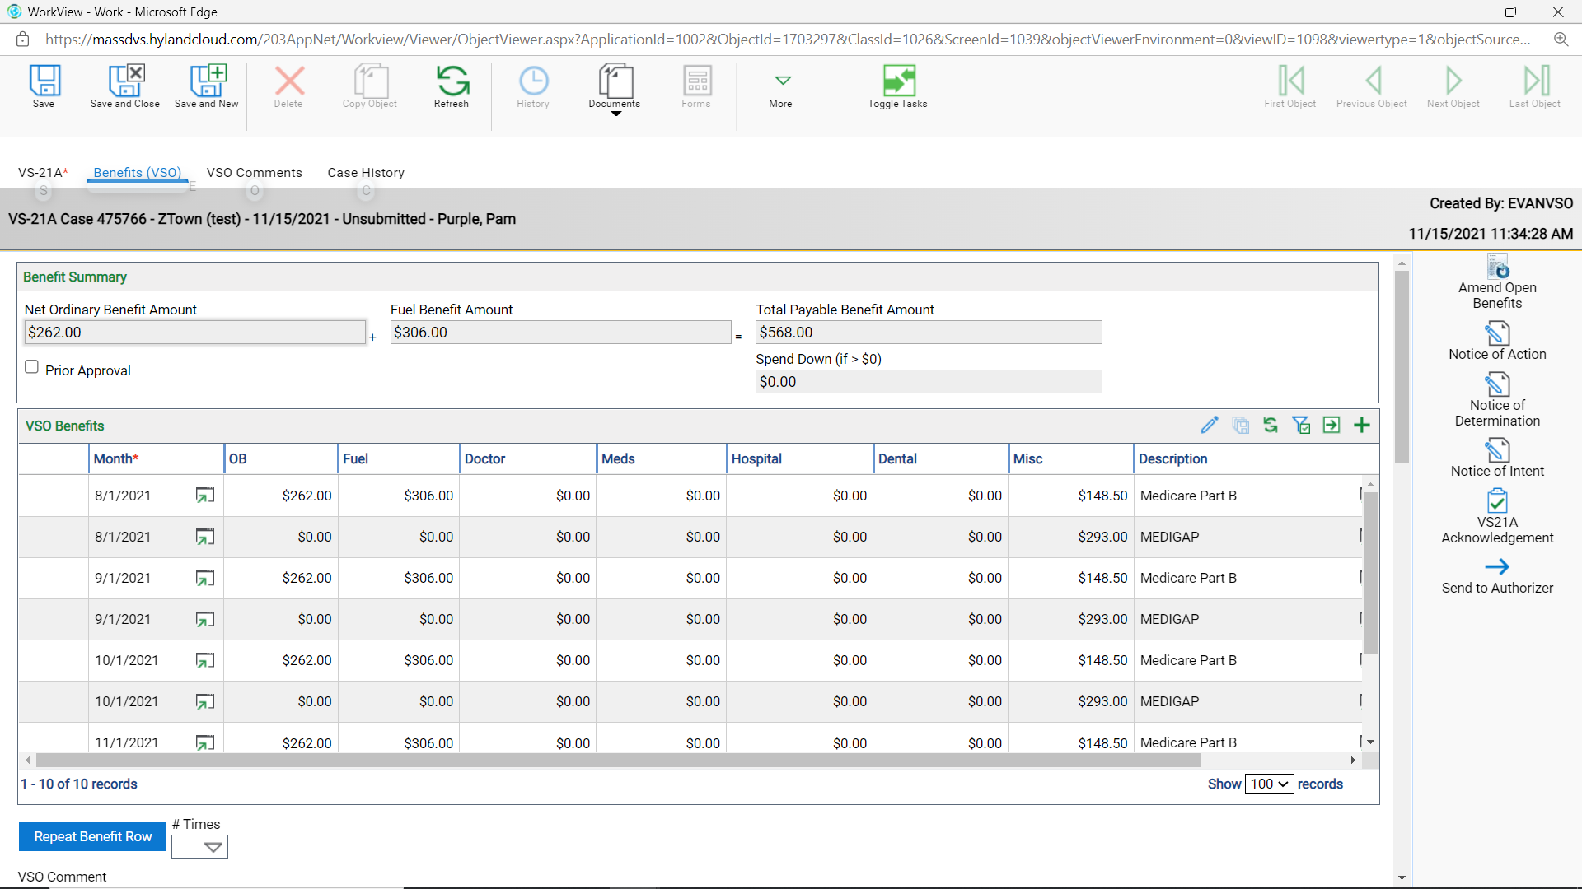
- Click on the VSO Comments tab to enter a note to the Authorizer and to add a private one for the case.
  - This is where you want to enter what you received for docs and notes about the case.
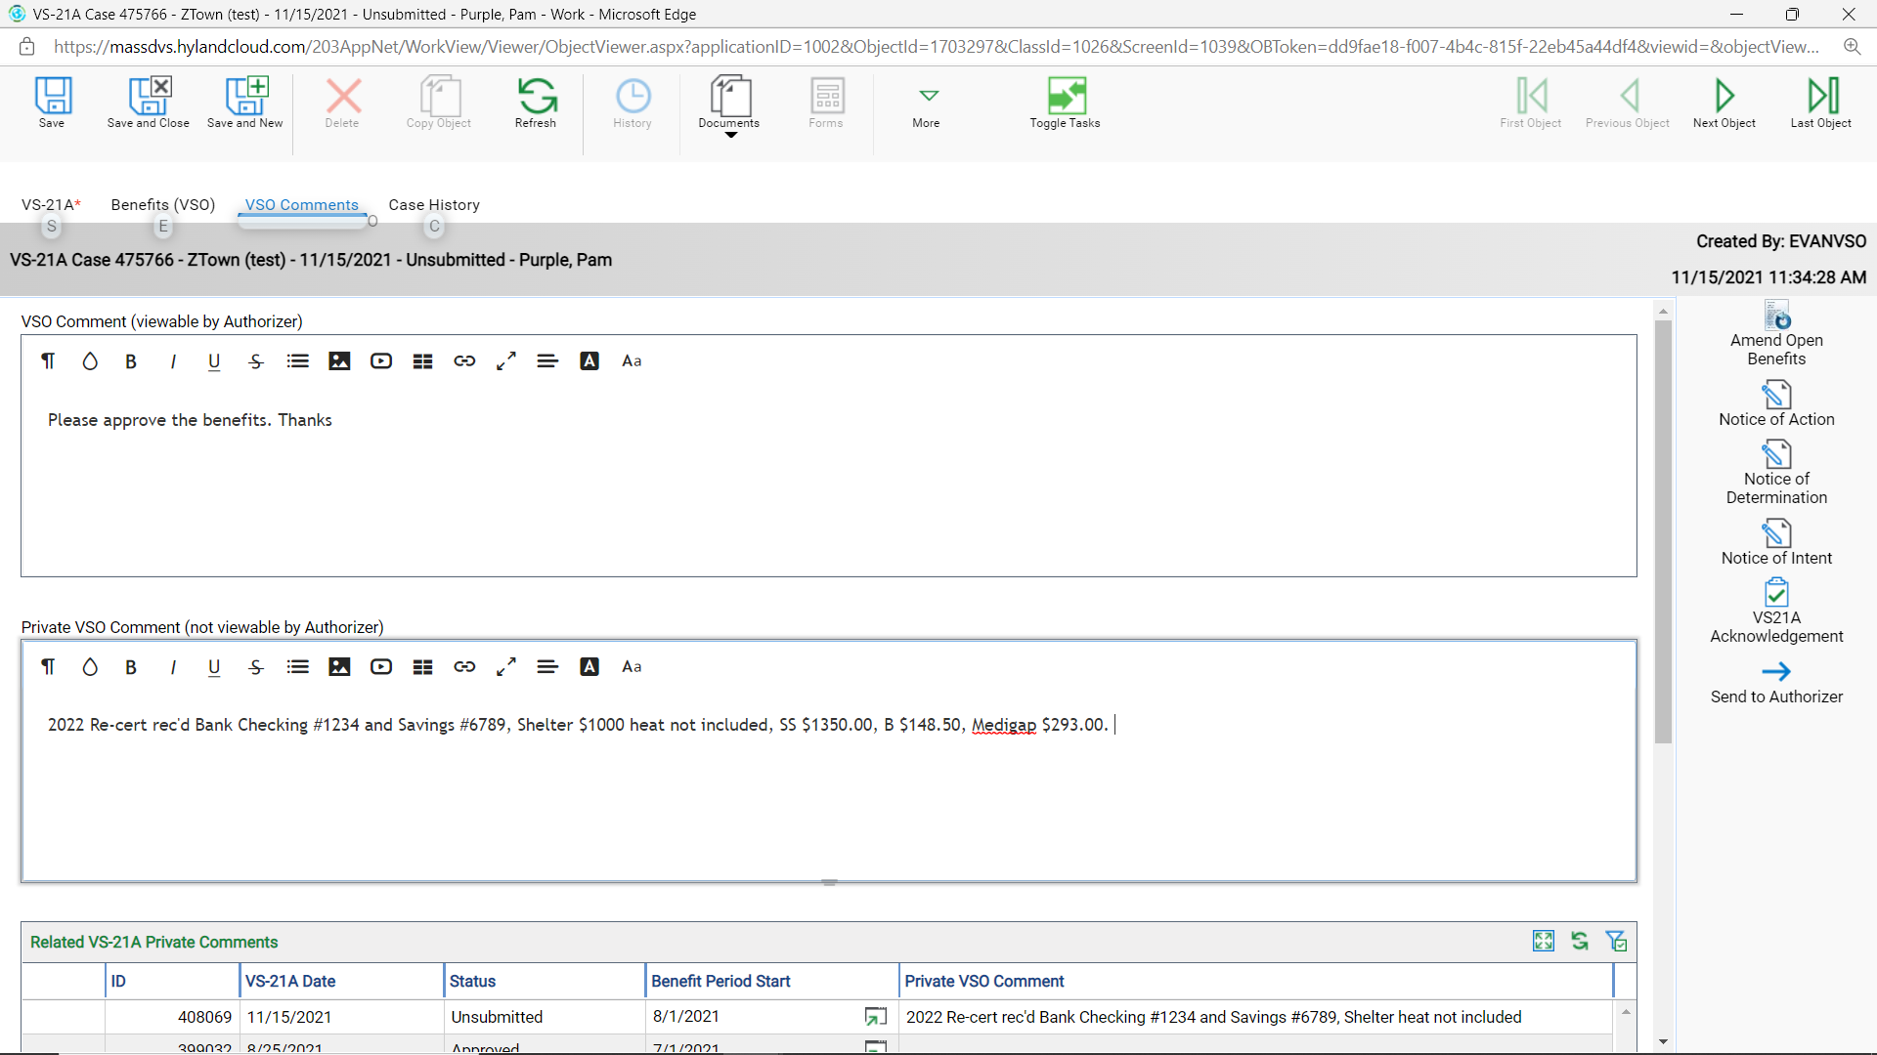
- Once all benefits and notes are added, upload the documents in one file. You want to have the VS21A open and be either on the VS-21A tab, OR the Benefits (VSO) tab, OR the VSO Comments tab.
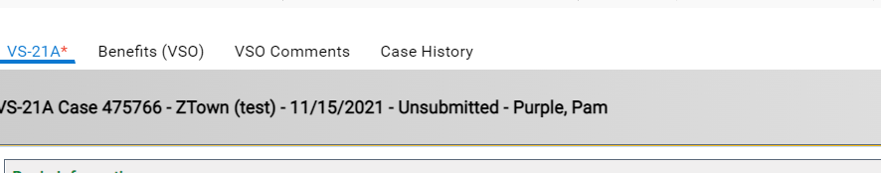
- Click on the Documents tab then click on the Upload.
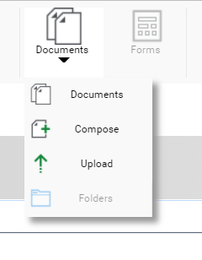
- There are three important steps.
  - Choose File (blue arrow)
  - Select the correct Document Type Groups (yellow arrow) Choose ALL or DVS - MIS
  - Select the correct Document Type (red arrow) Choose Re-cert Packet
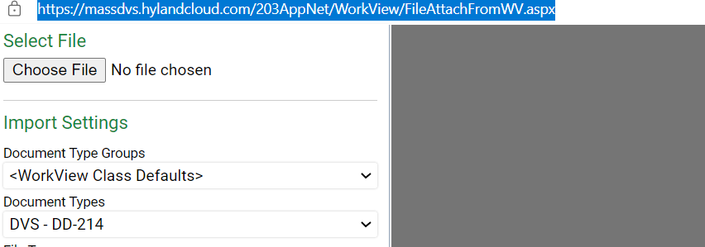

Example: See Document Types, VERY INPORTMANT CHOOSE RE-CERT PACKET (red box)
This will help YOU and the AUTHORIZER to find the documents easy.
