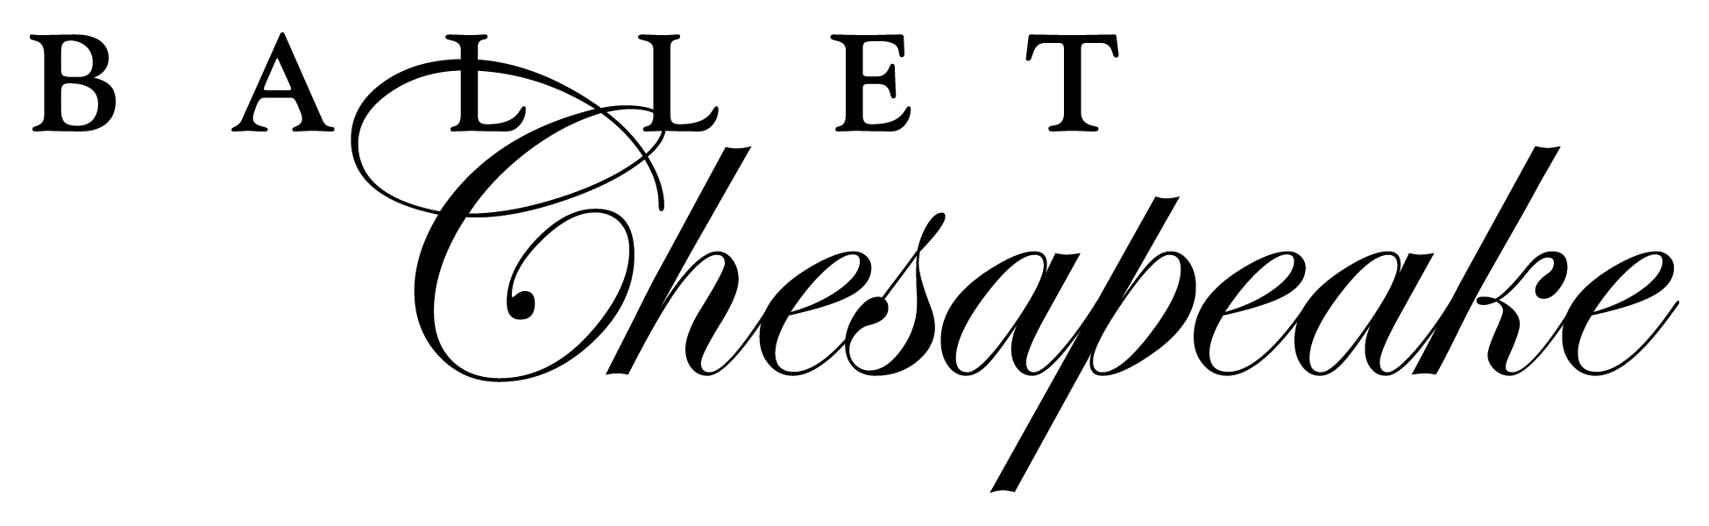

Nutcracker Tea Party Outreach
Friday, December 15, 2017
Bel Air Armory, 37 North Main Street, Bel Air, MD

Ticket Order Form
Name of School:

Contact Name: Phone:

Address:

Email (required):

Please fill out the information below and return this paper (make a copy for your records) to the following address: Ballet Chesapeake, 701 Whitaker Mill Rd., Joppa, MD 21085

Number of Children attending:

x $8.00 =

Number of Parents/ Teachers attending:
May NOT be more than 20 per school for those arriving by car (no more than 10 cars per school)
May be up to 30 for schools arriving by bus
x $8.00 =

Total $:

MUST CIRCLE ARRIVAL VEHICLE: Cars (no more than 10 cars per school) Bus Van

Please choose a time: 9:15- 10:15 10:45- 11:45

Please return this form with a check for 25% of the total to reserve your space. Space is filled on a first come first served basis. Full payment will be due NO LATER than Nov. 18.

If Ballet Chesapeake has not received full payment by this time the school will be dropped to the bottom of the waiting list and the deposit will not be refunded.

Should the number of children or adults attending change, please call Ballet Chesapeake (410-877-0777) as soon as possible to update our records and ensure correct spaces reserved and amounts charged. Parties are limited to 100 children and 70 adults and fill quickly. Any additional children or parents without a prior reserved space at the performance will be turned away. Transportation will be the responsibility of the students’ school. No refunds or exchanges.

The above information is true to my knowledge and I have read and agree to follow the parking and ticket policies issued by Ballet Chesapeake.

Signature of School Contact Date

