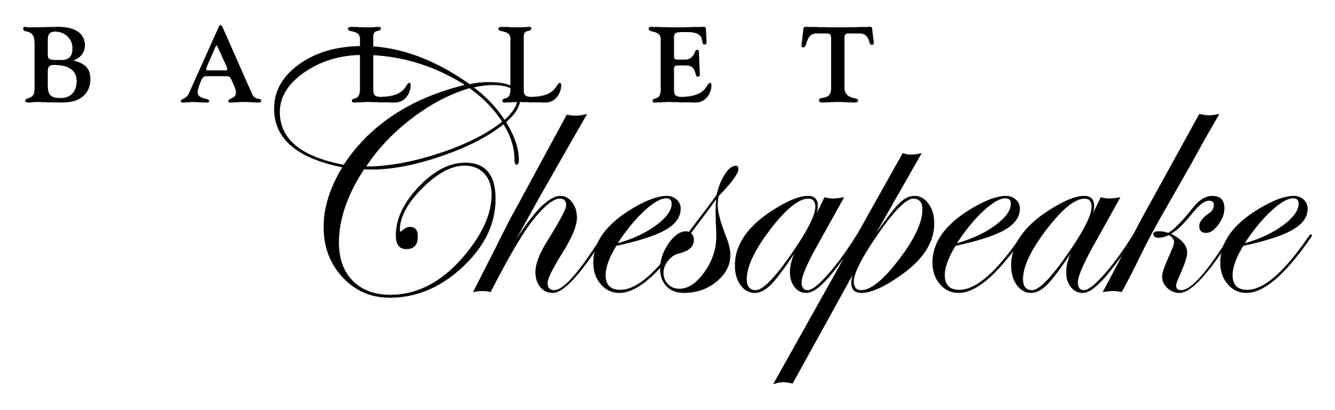
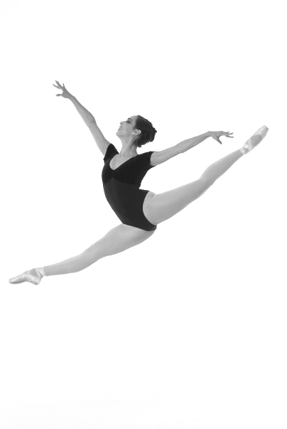

ADVERTISING OPPORTUNITIES

PRICES FOR PROGRAM ADVERTISMENTS

___ CENTERFOLD: $400 ONLY 1 CENTERFOLD AVAILABLE
(7 ½” W x 10”) Advertiser will receive 2 complimentary tickets

___ INSIDE BACK COVER: $350 ONLY 1 INSIDE BACK COVER AVAILABLE
(4 ½ “ W x 7 ½ “ H)

___ FULL PAGE: $300 DEADLINE FOR SUBMITTING ADS: 11/10/17
(4 ½ “ W x 7 ½ “H)

___HALF PAGE: $150 Circulation: 2,000 Programs Printed
(4 ½ “ W x 3 ¾ H“)

___ QUARTER PAGE: $75
(4 ½ “ W x 1 ⁷/₈ “ H)

Ad Contact:

Address:

Phone: Fax: Email:

Special Instructions:

Amount Enclosed: $

Please mail your check (payable to Ballet Chesapeake) to:
Ballet Chesapeake, 701 Whitaker Mill Road, Joppa, MD 21085
Ballet Chesapeake can also accept Visa or MasterCard payments by phone
Digital ads may be emailed to: info@balletchesapeake.org
If you have any questions, please call Ballet Chesapeake at (410) 877-0777

For Office Use Only:
Date: Rec. By: Payment Info:

