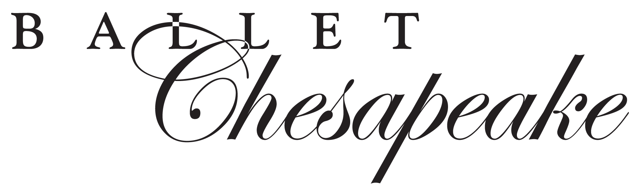

Corporate Sponsorship Opportunities
Sponsorship with Ballet Chesapeake affiliates your company with an organization known for quality and excellence. Supporting Ballet Chesapeake gives you the opportunity to reach over 2000 ballet patrons, members and families.

Tickets to the ballet are a great way to entertain clients and reward employees. Ballet Chesapeake also offers your company branding opportunities in Ballet Chesapeake print and other advertising, at performances and throughout the year. Supporting Ballet Chesapeake can be a great way to market your products and services.

SPONSORSHIP FORMAT STRUCTURE
SPONSORSHIP  OPPORTUNITIES | APPRENTICE | CORPS | SOLOIST | PRINCIPAL
Credits in video production
Half page program ad (2,300 attendees)
Presence on all marketing materials*
Attend in-studio rehearsal
Corporate display in lobby**
Backstage dancer meet & greet
Nutcracker premium seating |  |  | 4 | 8
Spring Production premium seating |  |  | 4 | 8
Website presence* (3,300 unique visitors)
Production announcement (2,300 attendees)
Letterhead presence*
COST OF SPONSORSHIP | $500 | $1,000 | $1,500 | $2,500
*Sponsors must provide digital print media. **Sponsors must provide their own signage for performances.

Contact: ___________________________________________________________

Address: ______________________________________________________________

Phone: __________________ Fax: ________________ Email: __________________

Special Instructions: ____________________________________________________
______________________________________________________________________

Please remit your check (payable to Ballet Chesapeake.) to:
701 Whitaker Mill Road, Joppa, MD 21085
BC accepts Visa or MasterCard payments by phone: 410-877-0777
Digital ads may be emailed to: info@balletchesapeake.org

