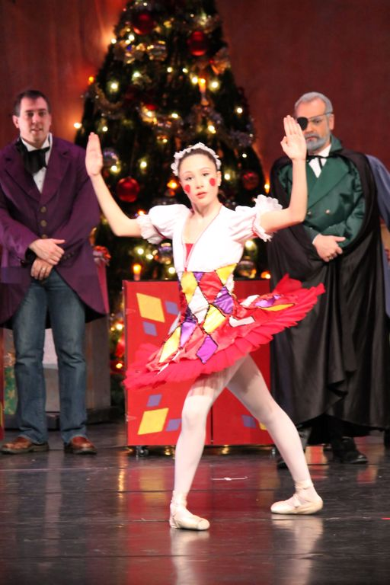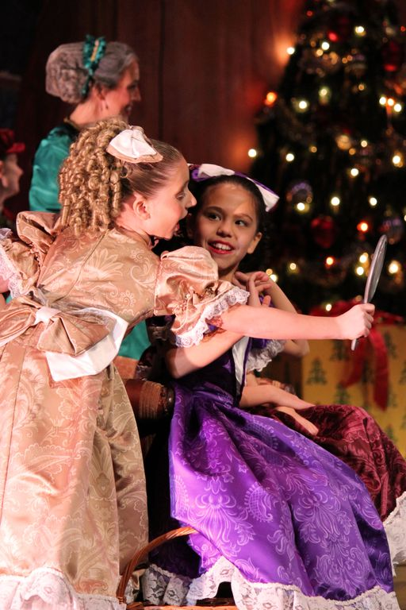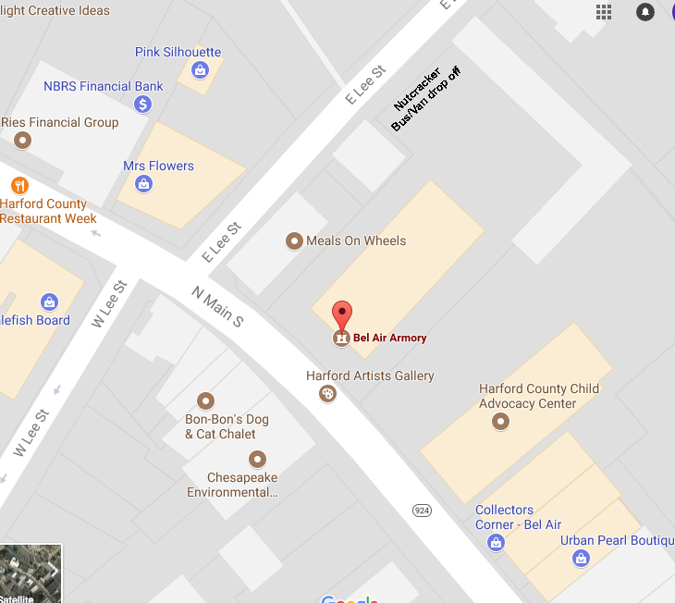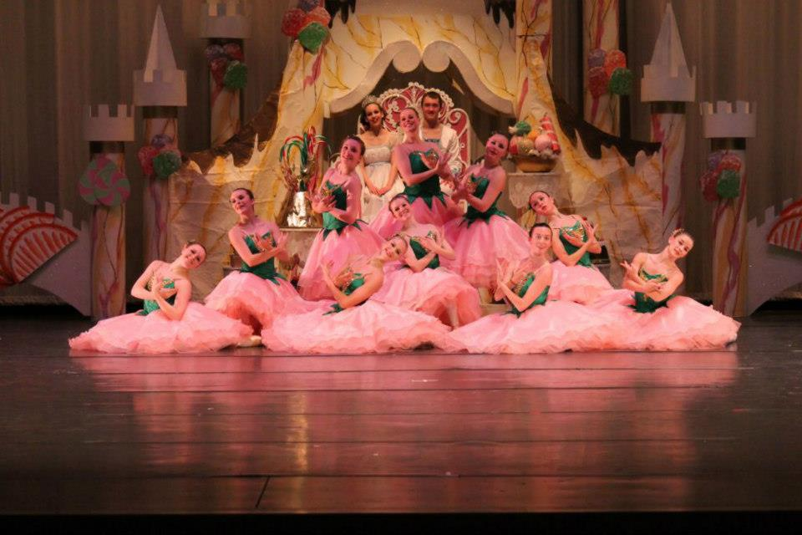

Cost: $8 per person, child or adult.

Space is limited and fills quickly! Please complete the enclosed registration form and return it to Ballet Chesapeake with a 25% deposit to reserve your spot!

At Bel Air Armory

Outreach Performances for Preschool to 1st Grade

The Nutcracker

701 Whitaker Mill Road, Joppa, MD 21085

410-877-0777

info@balletchesapeake.org

Ballet Chesapeake

Ballet Chesapeake (formerly Harford Ballet Company) developed its Nutcracker Outreach in 2001 to provide children in our community with a rare glimpse into the world of professional art.

This special program serves to expose the very young to the wonder and enchantment of a ballet performance while teaching basic theater etiquette and table manners.

The performances have been specially designed for preschool, kindergarten and 1st grade audiences. Children will delight in the magic onstage as the narrated ballet comes to life before their eyes!

## Ballet Chesapeake’s Outreach History

### Friday,

### December 14, 2018

### 9:15-10:15

### 11:00-12:00

### 12:45-1:45

## Ticket Information

Celebrate the season with Ballet Chesapeake!

**Ballet Presentation**

Ballet Chesapeake will perform an abridged version of their complete professional staging of The Nutcracker ballet with intricate costumes and sets along with Tchaikovsky’s timeless score.

This version is child-friendly and includes live narration of the Nutcracker story to accompany dancers.

This special program serves to expose the very young to the wonder and enchantment of a ballet performance while teaching basic theater etiquette and table manners.

**Tea Party**

Following the performance, the children are led to a decorated tea party area for a formal tea of punch and snacks.

The dancers – still in costume – serve the tea while the Nutcracker interacts with the children.

Each child will have the chance for a photo with their favorite character and will leave with memories to last a lifetime!

The event will be held at   
Bel Air Armory,   
37 N. Main Street,   
Bel Air, MD

Please DO NOT contact Bel Air Armory for information regarding this event.

Limited parking is available and bus/van transportation is strongly recommended. Each attending school is limited to no more than 10 cars.

Please see below diagram for parking location.

Schools are asked to arrive 15 minutes before performance time.

# Location