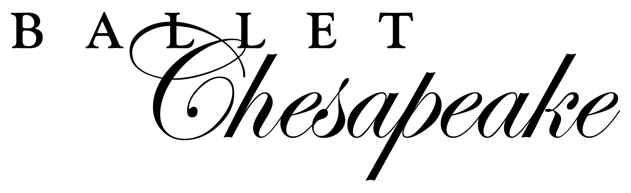
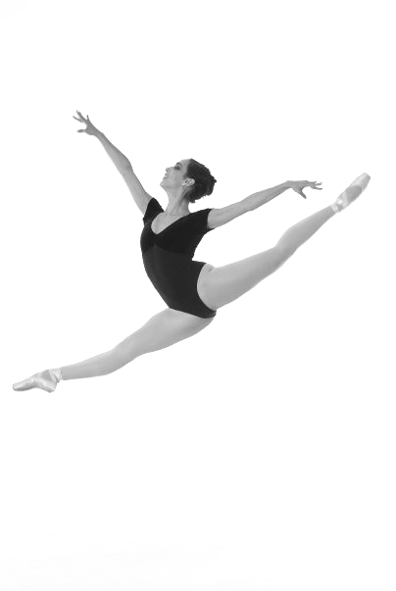

ADVERTISING OPPORTUNITIES

PRICES FOR PROGRAM ADVERTISMENTS

___ CENTERFOLD: $420 ONLY 1 CENTERFOLD AVAILABLE
(7 ½” W x 10”) Advertiser will receive 2 complimentary tickets

___ INSIDE BACK COVER: $370 ONLY 1 INSIDE BACK COVER AVAILABLE
(4 ½ “ W x 7 ½ “ H)

___ FULL PAGE: $320
(4 ½ “ W x 7 ½ “H)

___HALF PAGE: $160 Circulation: 3,000 Programs Printed
(4 ½ “ W x 3 ¾ H“)

___ QUARTER PAGE: $80
(4 ½ “ W x 1 ⁷/₈ “ H)

Ad Contact:

Email: ___

Payment Methods (please circle one): CHECK CASH CREDIT
CREDIT CARD PAYMENT
Circle: Visa MC AmEx NAME ON CARD:__________________________________________________
ACCOUNT #:________________________________ EXP:__________
SIGNATURE:_______________________

Please mail your check (payable to Ballet Chesapeake) to:
Ballet Chesapeake, 3473 Merchants Blvd, Suite A, Abingdon, MD 21009
Ballet Chesapeake can also accept Visa or MasterCard payments by phone
Digital ads may be emailed to: info@balletchesapeake.org
If you have any questions, please call Ballet Chesapeake at (410) 877-0777

For Office Use Only:
Date: Rec. By: Payment Info:

