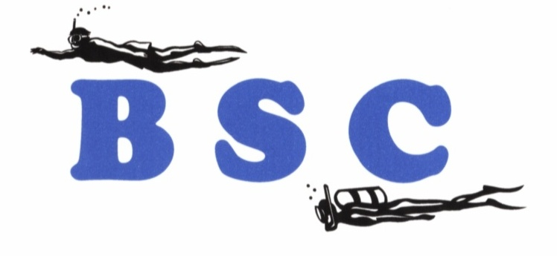

Battlefords Scuba Community

Fall 2025

_____________________________________________________________________________________

The Prez Sez
Dennis McCullough
It’s been a while since we put together a newsletter, but this is the major means of communication between the club as a whole and its members as individuals. We encourage members to submit items for the newsletter so that it is a collective effort rather than one individual’s diatribe.
The focus of this issue is dive travel, although there is a bit of an item dealing with the downside of things – statistics on liveaboard accidents and some thoughts on those concerns. We also included an article about diving fatalities and the contributing factors. However, we did put a positive spin on that by suggesting there are ways that we can improve our odds of not becoming part of that unfortunate parade.
We hope that you enjoy it, or at least parts of it. Maybe some of the materials will even be useful at some time.
One of the matters that concerns the executive is dwindling numbers – fewer members, lower numbers at the Sunday swim sessions and other club activities and events, difficulties in getting members to allow their names to stand for nomination as directors, etc. Part of this is a societal trend – people are not joining clubs and groups unless they must get something they specifically want. But we do have a concern that part of it may be of our own making, that we are missing the target with our offerings. This is your club, and the executives look to the membership for a general direction. If there is something that we should be doing, please let us know; if there is something you would like to see us undertake, please let us know. If there is no support for events and activities, we have to ask the question “What is the point in doing this?”
A former member said it well – it’s about bums in seats.

___________________________________________________________________________

BSC News

Meet Your Executive

Adele Perrett
A non-diver, Adele, has been a member of the executive and the executive since the club’s formation. She has developed and maintained the website and edited the newsletter. Adele is an enthusiastic photographer and pickle ball player. Adele will be the Secretary and jack-of-all-trades for the club again this year.

Tatiana Tanina
Tatiana discovered diving when snorkeling in the Red Sea and got her Open Water certification during the summer of 2024. She is pursuing further certifications. Tatiana has been the driving force behind the club’s involvement with the Fall Festivals in both Battleford and North Battleford for the past two years. Tatiana will fill the shoes of the Vice-President this year.

Richard Reed
Richard is a long-time diver, earning his first certification with the ACUC in the mid-1980’s and earning his PADI Divemaster certification in 2022. He is an enthusiastic skier and instructor, pickle ball player and coach, and loves his time at the cabin during the summer. Richard has been a mainstay in the Discover Scuba for High Schools program. Richard take over the role of Treasurer for the coming year.

Dennis McCullough
Dennis is one of the original members of the club and the executive since its formation. He discovered diving in 1967 and obtained his ACUC Instructor certification in 1972. He then crossed over to become a PADI Instructor in 2010. Dennis has been active in many pursuits over the years but always seems to come back to the water. He will Serve as President for the 2025 – 26 season.

There are three vacancies on the board at the present time. If you would like to do a little work to support and promote safe scuba diving in the community and the province, please let us know. We are looking for thoughts, ideas and maybe a little bit of elbow grease on occasion.

Good Bye For Now And Many Thanks

This fall, the club lost a number of members of the executive, members who have give a great deal of time and effort to make the club what it is today.
Darren Erbach filled the role as club Treasurer for the past eleven years, a thankless role if there ever was one. He brought his family into scuba diving and lent quiet support to the club’s activities. Darren has accepted a new position in Regina and has moved on. We will miss his quiet sense of humour and his work on the books. Good luck in a new endeavour Darren!
Noreen Barclay is another of the original members of the Battlefords Scuba Community and the executive. Noreen severed a term as President and then spent many years in the role of Past President of the club. Noreen managed to bring most of her family into the diving community and was an avid diver, along with husband Mark, for many years. She was always there when the club needed bodies for an event and brought ideas to the meetings. She was always happy to promote diving and the BSC, bringing guests to the pool and talking to anyone who would listen. Unfortunately, health problems made diving problematic, and Noreen and Mark decided to hang up their fins and turn to the stars for inspiration for future endeavours. We are sad to see you go Noreen and we will miss our little “fire plug”. Many thanks for everything Noreen.
Joanne Turpin came to diving to keep up with her husband Robert and very quickly became a member of the executive. Joanne served several terms as the Vice-President and worked on many committees during that time, always there to get involved. I think everyone who has been to a club event has experienced Joanne’s love of cooking, and her readiness to feed the masses. Joanne started out with a little concern about her well-being in the water but overcame that to become a very competent diver who loves to travel with Robert to exotic locations for dive holidays. With Robert’s love of aircraft and flying, it is difficult to keep track of Joanne now that they have retired from farming. Joanne was always ready to speak her mind and to work toward the ends she believed in. We will miss her ideas and her work ethic but will enjoy visiting with her at the pool sessions. We appreciate all the effort and time Joanne. Enjoy your travels!
Rob Florence originally qualified as an Open Water Scuba Diver while he was a student at the University of Saskatchewan but came back with his wife Wendy and daughter Trisha on one of the Club’s first courses. Rob and Wendy travelled with family and friends to many tropical dive locations over the years. Combined with their love of skiing, they lead a very active lifestyle. Rob served three terms on the board helping with many projects along the way. We will miss his thoughtful input and dry sense of humour. Their plan is to do more travelling, and we wish them smooth roads and fair winds!

Thinking About Trying A Liveaboard?

One of the most intense diving experiences that a diver can enjoy is life on a liveaboard – a vessel where a group of divers spends several days together away from the usual resorts doing little but diving, eating, sleeping and talking diving with likeminded people who may have had different experiences they are happy to share. These liveaboards are becoming more popular and are located around the world and provide a distinct experience compared to the usual dive resort. The boats can be compared to the all-inclusive resorts in that everything is looked after and the diver can dedicate time and effort to enjoying the diving experience, which is most often at locations that cannot be reached by boats operating from shore.
The divers on these vessels are often subject to more stringent rules than in other diving situations. During the dive briefings depths and times for the dive are clearly laid out and the diver who violates those limits may find that their diving for the day is done. The divers are further from medical assistance should an instance of DCS arise and we all know that prompt treatment is paramount. If the boat has to head to port to deal with an injured diver, many more divers are inconvenienced, and the operators do not want to deal with this circumstance. Many of the boats insist that divers use their dive computers so that they are sure that they are working and what the settings are, but feel free to use your own in addition. More emphasis is placed on briefing the divers before each dive and before the trip begins for reasons of safety – everyone is a long way from help if things go sideways.
The daily schedule often looks like dive, breakfast, dive, lunch, dive, dinner, dive and then some social time before sleep to repeat the next day. Usually, a maximum of two dives are done at a site before moving on to another. The time between dives is a chance to get to know the other divers on the boat, to exchange ideas, experiences and stories and a place to strike up friendships that last far beyond that trip.
This has been a great way to get in a lot of diving in a short time, and it continues to be so, but in the last decade there has been a dark side to the liveaboard business – sinkings, fires and capsizings. The reports seem to appear regularly and that maybe a result of the need for material to fill the ever-increasing appetite of the various media for any sort of news – best if it is bad news. However, between 2012 and 2024 there were twenty-three disasters involving liveaboards and this figure raises some alarm bells.
A few details will help paint the picture for us. In terms of where these incidents occurred:
- Egypt – 9
- Indonesia - 5
- Thailand - 2
- Mexico – 1
- United States - 1

Causes were attributed as follows:
- Fire – 12
- Ran Aground – 6
- Capsize - 3
- Bad weather – 3
- Damage to the hull from unknown object - 1

Sixty-five lives were lost.
The timing of the disasters is as follows:
- 2001 – 1
- 2012 – 2
- 2015 – 2
- 2017 – 1
- 2018 – 2
- 2019 – 2
- 2022 – 3
- 2023 – 7
- 2024 - 3
It can be noted that the majority of the sinkings occurred in Third World countries where the regulations governing the operation of boats may be different and enforcement of the regulations may not be as stringent as we in the more developed countries have come to expect. The economic climate in those countries may contribute to poor levels of maintenance. Almost half the events occurred after the pandemic – the operations had taken severe economic hits and crews had found other employment resulting in corners being cut and staff being somewhat inexperienced.
Some of the comments made by passengers, crew members and operators were of note:
- Passengers were not made aware of safety procedures and escape routes.
- Evidence of smoke detectors was not apparent.
- Fire prevention and fighting equipment was inadequate (i.e. water fire extinguishers in the galley and the engine room).
- Boats had been converted from other uses with resulting changes to the electrical systems and the size of the superstructures.
- There was not always a crew member o n watch at night so that if something went wrong at night there was no one to detect it and take appropriate action or raise an alarm.
- Guests were often left to deal with government officials and bureaucracy in foreign countries with no documents and personal possessions and this process took considerable time.

This is not to say that a great many divers have wonderful experiences on liveaboards, but it is intended to raise some caution flags. Do some research before booking a trip:
- Using social media, explore what previous users have to say, look at photos of the vessel in question, and others in the fleet if possible.
- Talk with other divers or dive shop operators to see what their experience has been.
- Talk about it with your travel agent and have them use the resources to check as well.

When you do book a trip:
- Look carefully at the boat and the crew.
- Look for and ask about escape routes.
- Ask about life jackets and lifeboats. Ask about emergency drills.
- Ask about emergency procedures and equipment.
- Keep an emergency dry bag with you with your passport, your personal documents, credit cards, cell phone and a change of clothes and any medications you require. Some early preparation may save a whole lot of grief if an accident does occur.
- Heed the rules as laid out by the crew – they do not want to have to deal with an emergency any more than you do. The rules and practices are there for a reason.
A liveaboard experience can be unlike anything you will ever experience outside that environment but one has to consider where it is taking place and what the local conditions and practices are. And outward appearances can be deceiving. It is BUYER BEWARE in this case as in so many others.
With a little preparation, a liveaboard holiday can be the experience of a lifetime!

____________________________________________________________________________

Long Reach

Battlefords Scuba Community is a small dive club located in the middle of the Canadian Prairies. Surrounding the club’s home there are a myriad of lakes, some large and some small, but all feature cold and murky water (both of those relative terms as we well know). But members of the club have reached out to test the waters elsewhere – around the world in fact. Who would have thought a small club would have such a reach?
Members have come to us for training for a variety of reasons. There were many who wanted to learn to dive so they could explore what was under the local lakes. Others came because they had peeked beneath the surface of the ocean while on a hot holiday and wanted to get certified so they could continue that exploration. There were some who sought training as an excuse to take the hot holiday and travel more. And there were some who looked for training because they were curious – what was it like to breathe underwater and what was there to see?
But no matter the reason those divers became certified, members of the club have become explorers and reached across the globe to satisfy a yearning to try something different, to see something different, to experience something new. We have informally tracked where club members have dived for interest’s sake. For a small prairie city we seem to have a large number of divers whose curiosity has led them far afield. Beyond the local lakes and the lakes with Canada, BSC divers have visited Caribbean in great numbers – Mexico, Cuba, Jamaica, Turks and Caicos, Aruba, Curacao, Bonaire, Cayman, Barbados, Dominican Republic and Costa Rico. But the venture quest has drawn some further from home and those destinations include Iceland, Sirocco, Galapagos, Maldives, Indonesian, Philippines, Antarctica, Australia, Red Sea and the Black Sea. A number have tried life on a liveaboard where diving is central to the entire effort. Just talking to these people rekindles their excitement and their willingness to share their adventures.
No matter where one has dived, I am sure that person has come away having learned something and having their life enriched and by the same token have left a little something with their fellow divers and/or the local residents. And every diver has had their life changed to a greater or lesser degree by trying the sport – kind of like the ripples they create getting into the water. Are we not the lucky ones to have seized the opportunity to get wet, really wet?

__________________________________________________________

Dive Travel Opportunities

For anyone looking to travel abroad to dive with a new group of friends, Alberta Adventure Divers has a number of expeditions slated for the coming seasons. They are a group of friendly divers who welcome new faces to their dive community.
In February of 2026 (21 to 28 to be exact) they are off to St. Lucia in the Caribbean for a week of diving. The package includes twelve boat dives and two night dives. The diving is in the heart of marine reserves which are touted to be among the most spectacular in the Caribbean. I have more information, or for more information or to register, please contact Connie Faas or Kevin Brown at diver@albertadivers.ca (phone 780-842-2882).
They also have a trip to Fiji planned for March 7 to 14. This one includes five days of two tank boat diving and free shore dives. To book for this trip, or for more information please contact Jenny Collister at jenny@reefrainforest.com or phone 1-800-794-9767 extension 302.
Never one to sit idle, Connie has a third trip planned for the spring – this one is headed for Tasmania from April 5 through 15. This is home to beautiful weedy sea dragons and the Tasmanian Devils. Six full days of diving with 2 to 3 dives a day have been arranged and two dedicated boats reserved. There are land tours available for non-divers or for those on off days. Please contact Connie Faas or Kevin Brown at diver@albertadivers.ca (phone 780-842-2882) for details.
And if these selections are not enough, there is a trip to Indonesia slated for March 3 to 11 of 2029. This one features nine days and eight nights on a boutique liveaboard. The dives are centered in an area that is the epicentre for biodiversity and biomass. Rare critters and likely whale sharks are among the attractions. Apparently, the meals are mouth-watering (this is a return trip for the Faas clan). Please contact Connie Faas or Kevin Brown at diver@albertadivers.ca (phone 780-842-2882) for details.
These expeditions will be first class and offer great opportunities to broaden your diving experiences.

____________________________________________________________________________

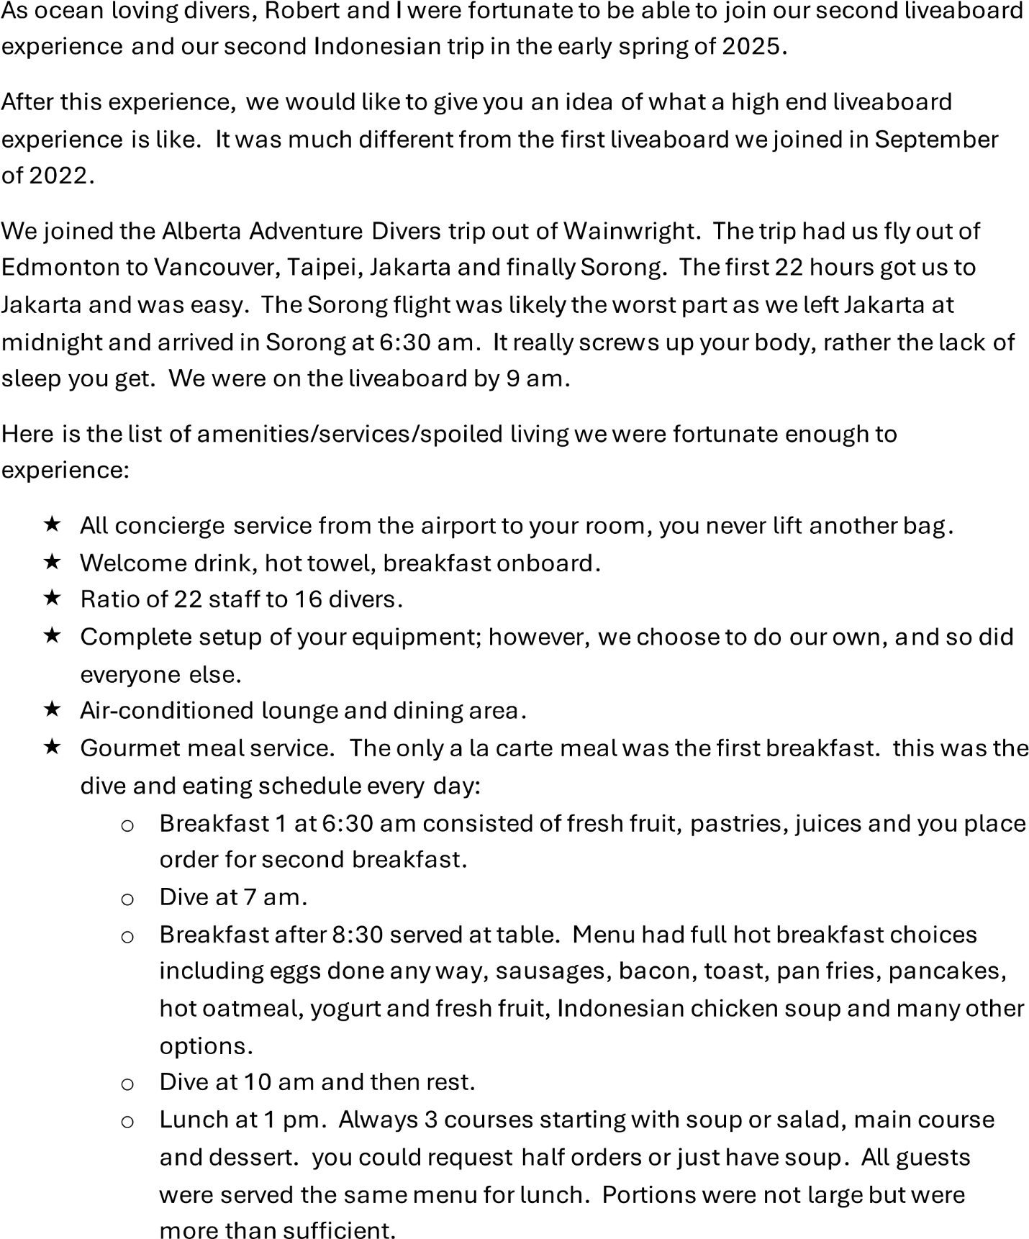
Indonesia Liveaboard – February, March 2025
By: Joanne & Robert Turpin
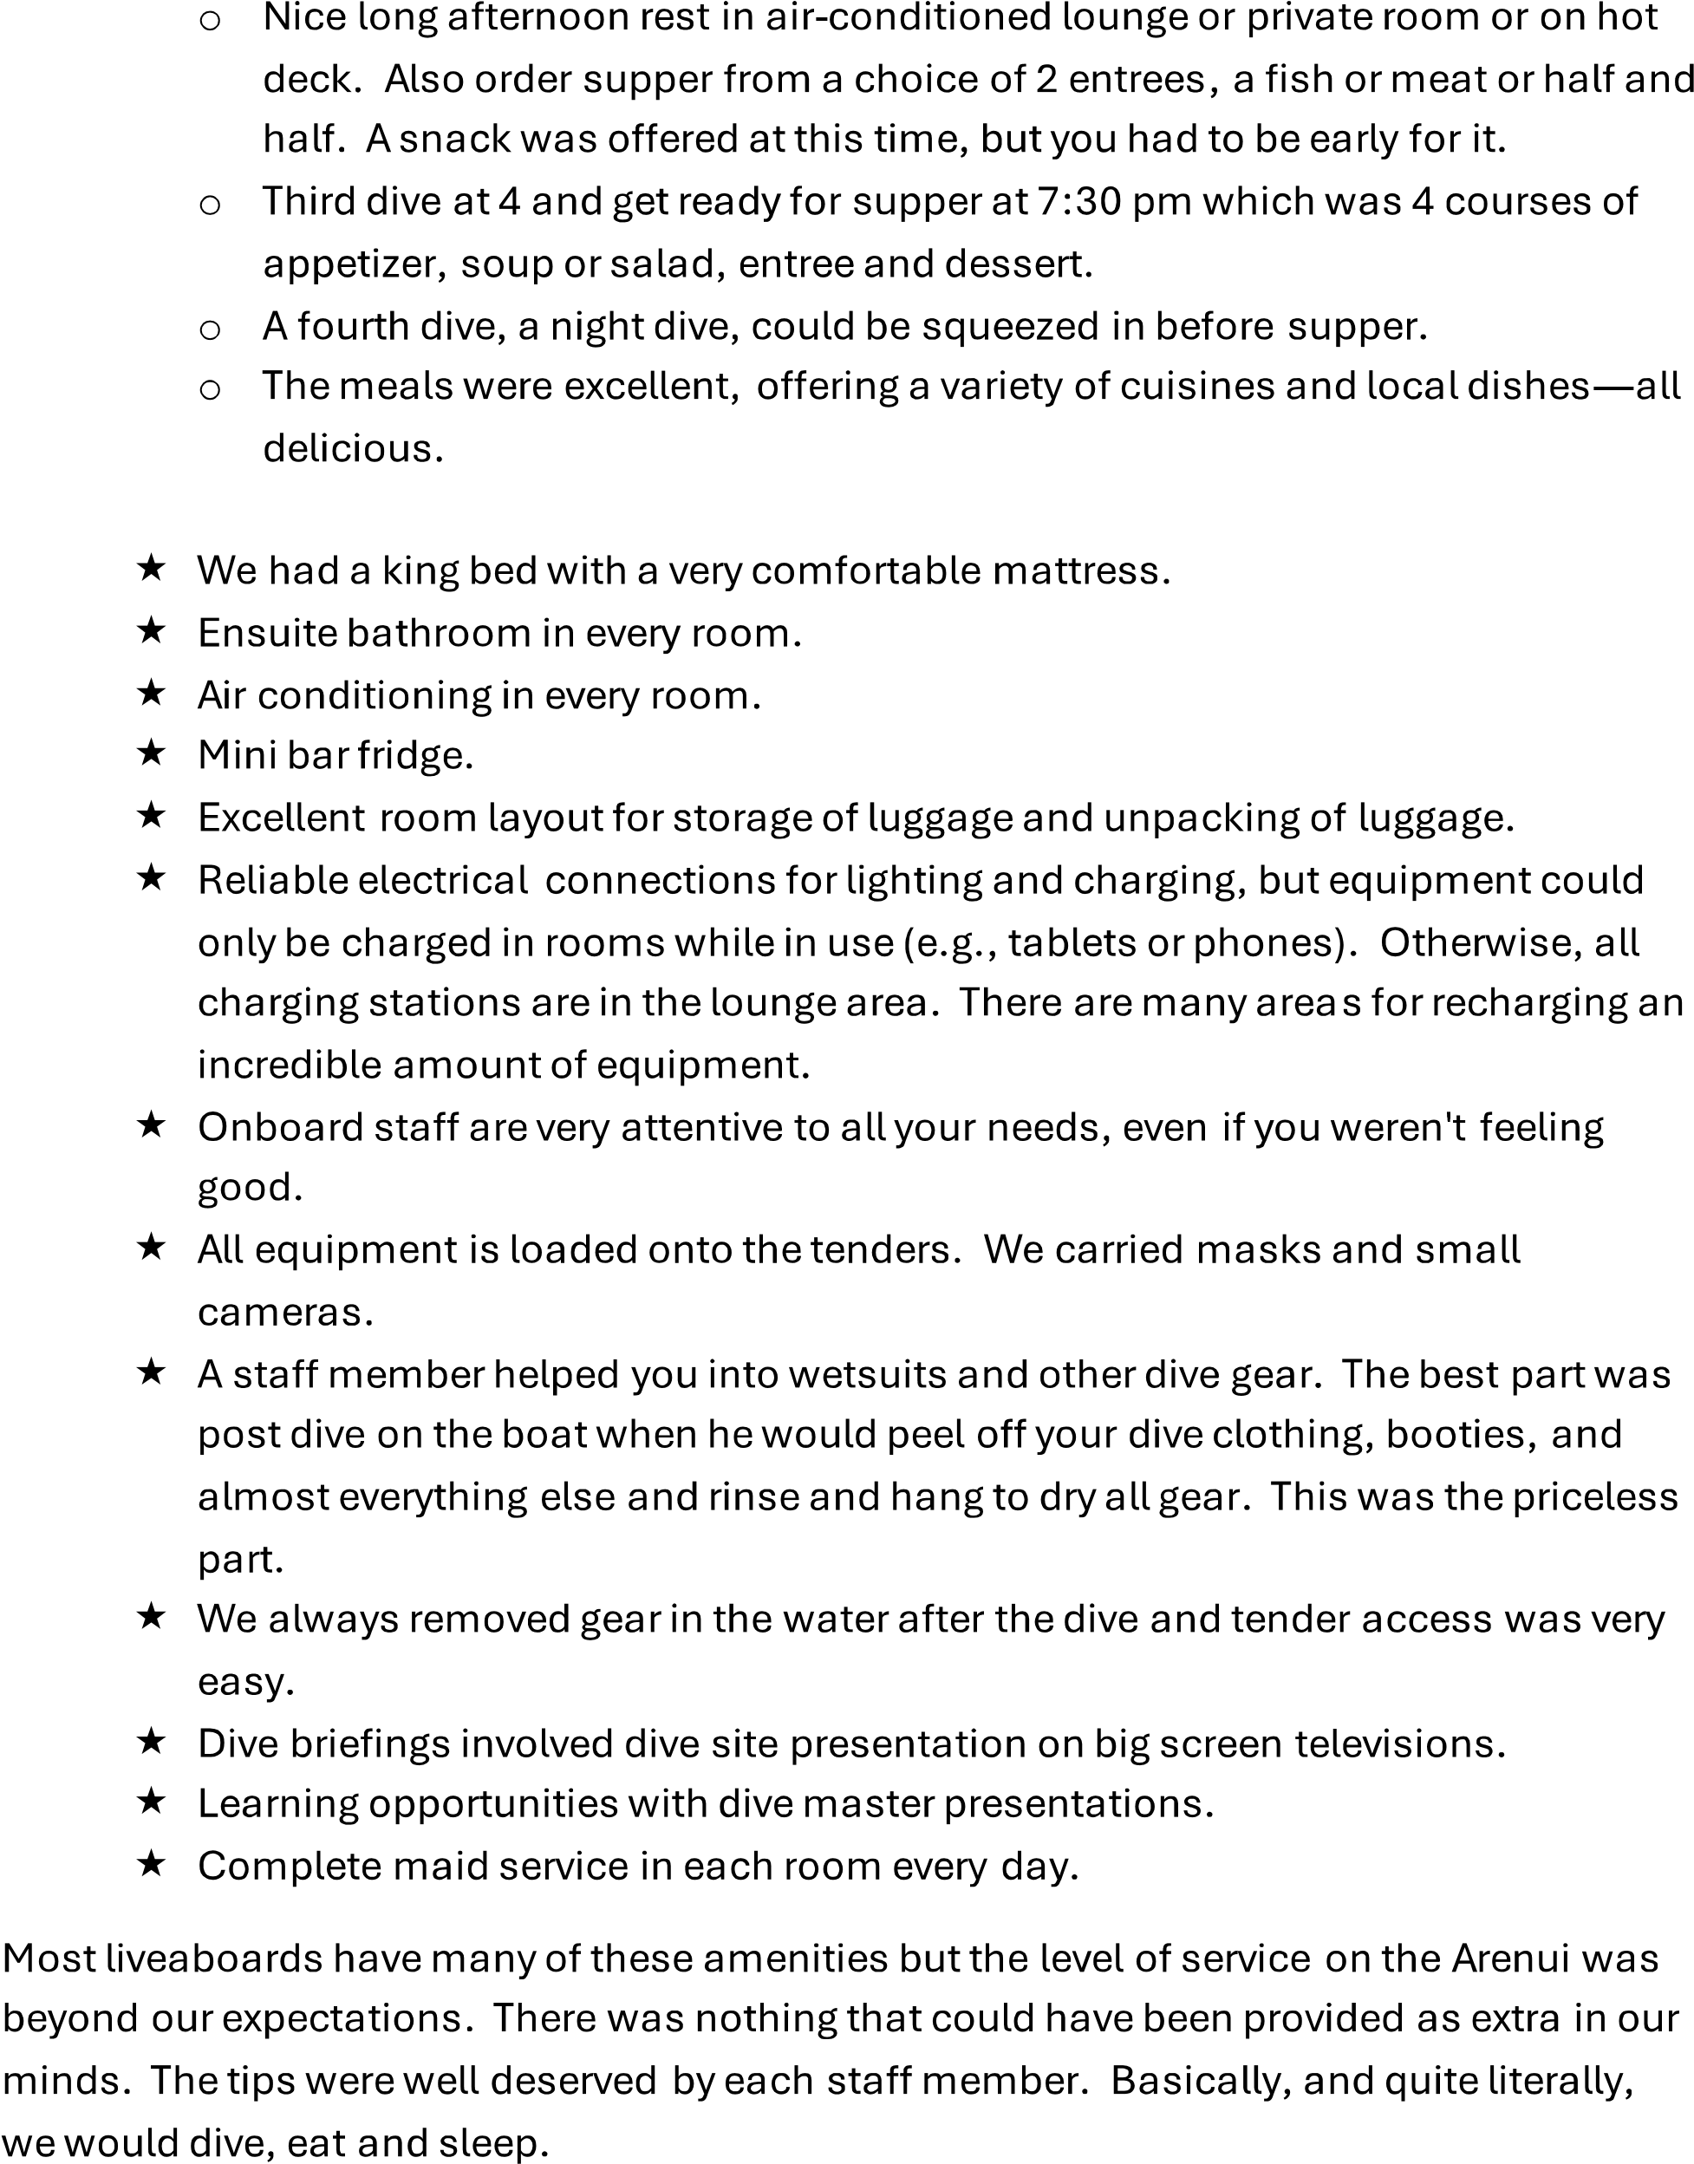

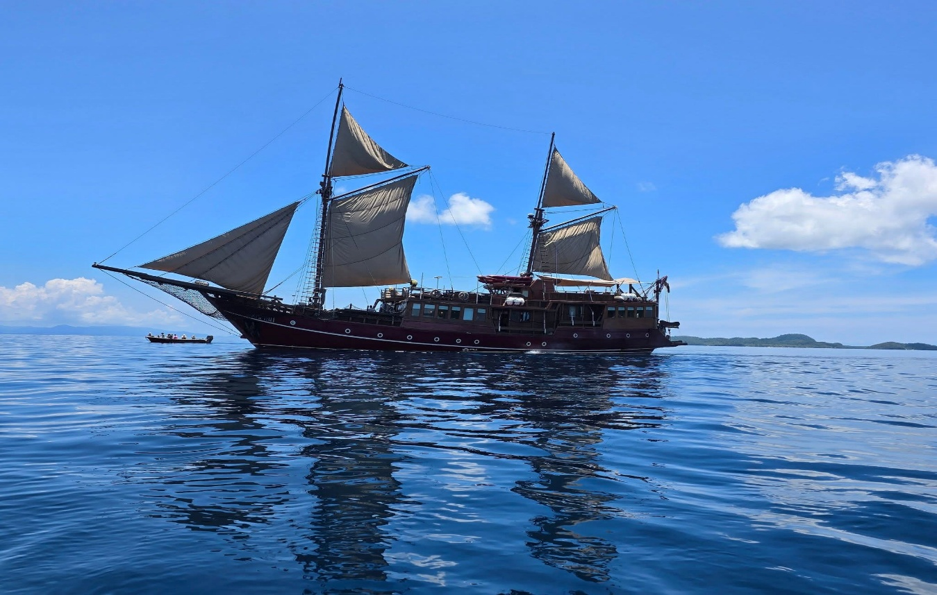

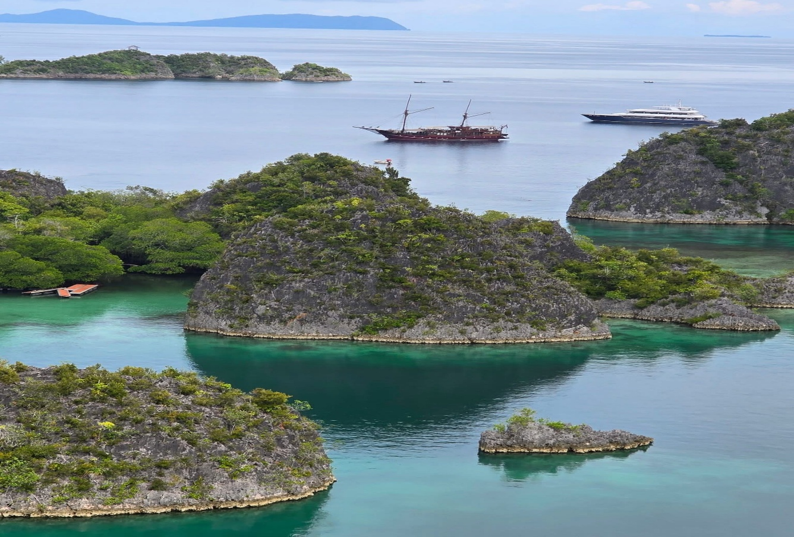

Curaçao - December 2024
By: David & Suzanne Odishaw
My wife Suzanne and I spent two wonderful weeks on the Dutch island of Curaçao in December. We managed to do 2 days of diving with Dive Center Pietermaai. It was interesting because all 4 dives were shore dives which we had never done before! Getting all geared up beside the bus then trudging 100-200m to the water was a new experience for us. The diving was very nice there as the water was always 82F surface and at depth. The reefs were in great shape with lots of very colorful coral, abundant sealife. We saw turtles, eels, octopus, lobster, hundreds of smaller tropical fish, peacock flounder, flying grunards, southern rays, barracuda, and even a couple of seahorses!
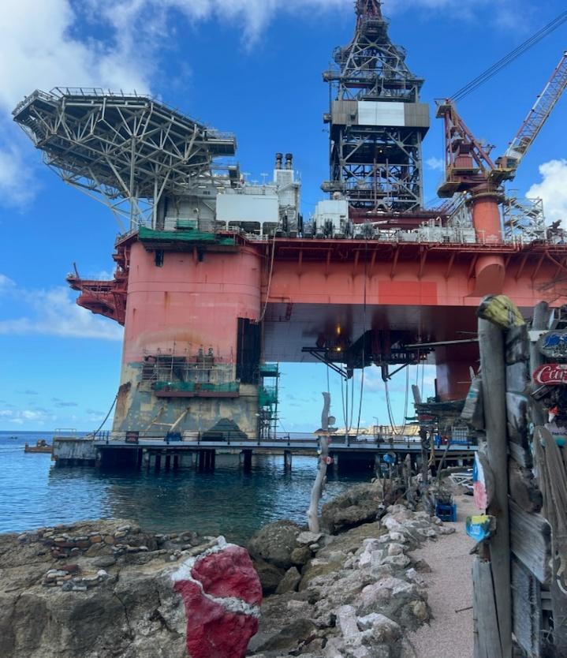
We did two dives at the northern end of the island - Playa Kalki and Playa Piskado, then the next day was south at Director’s Bay and Tugboat Beach. Tugboat was cool because we entered under an oil maintenance rig which we had never seen before in real life! I highly recommend Curaçao as a great dive destination.
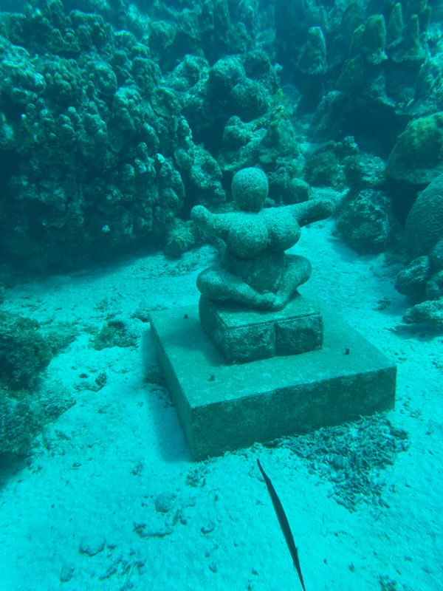

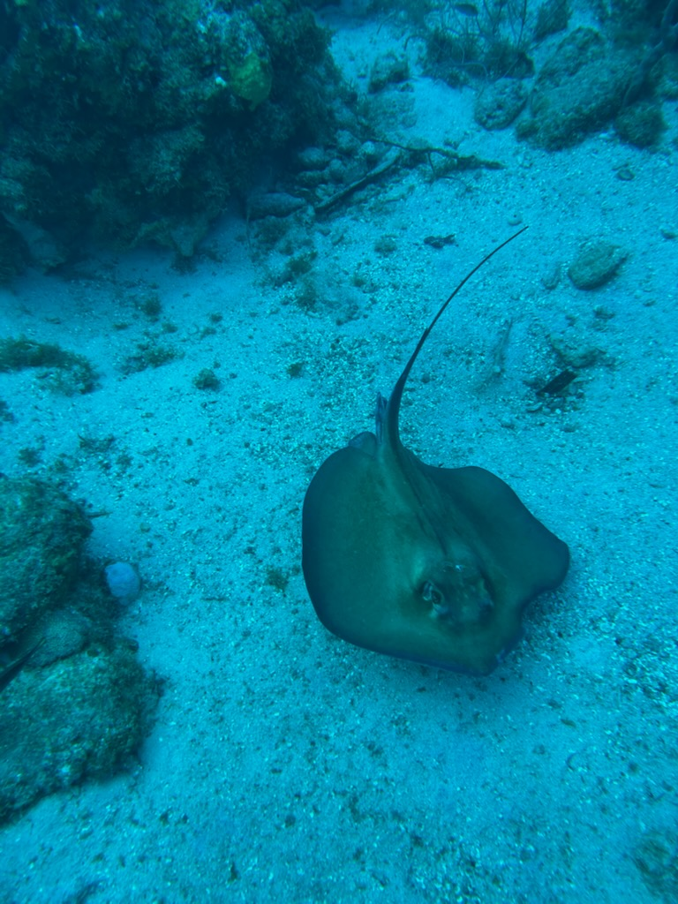

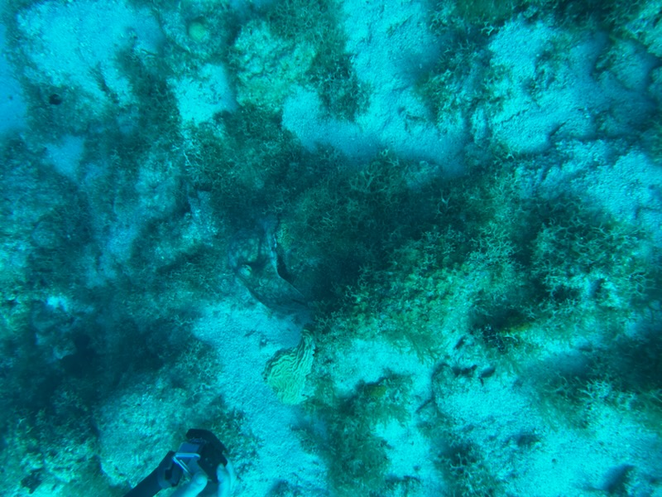

Discovering the Underwater Wonders of Sharm El Sheikh: A Diver’s Paradise in Egypt

By: Tatiana Tanina

During my recent diving trip to Egypt, I had the chance to experience some of the most stunning dive sites in the world, particularly in Sharm El Sheikh. Located on the Sinai Peninsula along the Red Sea, Sharm El Sheikh is renowned for its crystal-clear waters, vibrant coral reefs, and rich marine life.
I kicked off my diving adventure with a boat dive through the Crazy Shark Dive Club. The boat trip was a fantastic introduction to the region’s beauty, but I also wanted to experience the freedom of shore diving. I rented equipment at one of the local dive shops and spent a few days exploring the underwater world from the beach.
It was July, so the air temperature was quite hot, around 35°C, while the water temperature was a comfortable 27°C. With the perfect conditions, I managed to complete six dives in total—two boat dives and four shore dives, including a thrilling night dive from El Fanar Beach with my dive master, Hady Kotb.

The Sharm El Sheikh Reefs: An Underwater Wonderland

Sharm El Sheikh is home to some of the most famous and breathtaking coral reefs in the world. The region offers a variety of dive sites, each more spectacular than the last. Here’s a closer look at the coral reefs and key dive locations in the area.
Ras Mohammed National Park
Ras Mohammed is one of Egypt’s most famous dive sites and a must-see for any diver visiting the region. This protected national park, located at the southern tip of the Sinai Peninsula, features dramatic underwater landscapes, including coral walls, drop-offs, and pinnacles. The area is teeming with marine life, from schools of colorful fish to larger creatures like barracudas, reef sharks, and groupers.
Among the standout dive sites in Ras Mohammed are Shark Reef and Yolanda Reef. Yolanda Reef is especially notable for its wreck, the Yolanda, which sank in the 1980s. Divers can explore the wreck and marvel at the surrounding coral gardens, which are home to a vibrant array of marine species.
The Thistlegorm Wreck
One of the world’s most famous wreck dives, the Thistlegorm shipwreck, is located in the northern part of the Red Sea, near Sharm El Sheikh. The British cargo ship sank during WWII after being bombed by German aircraft. Today, the wreck is covered in corals and teems with
marine life, including moray eels, giant groupers, and schools of jackfish. The site is a favorite for divers who enjoy exploring history beneath the sea.

Ras Um Sid
Ras Um Sid is another fantastic dive site near Sharm El Sheikh, offering a blend of sloping coral gardens and steep drop-offs. The vibrant reef here is home to many species of fish, including cleaner wrasses and butterfly fish, as well as larger creatures like eagle rays and tuna. The site is suitable for both beginners and advanced divers, thanks to its varying depths and calm waters.
White Sands
During my trip, I had the chance to dive in an area known as White Sands. This site is famous for its beautiful sandy bottoms and its gentle transition from shallow coral gardens to the deep blue sea. The clarity of the water is incredible, with visibility often exceeding 30 meters. The calm conditions make it an ideal spot for divers of all levels. The underwater landscape was peaceful and stunning, and I had the opportunity to observe a range of marine life, from smaller fish to rays and turtles gliding by.
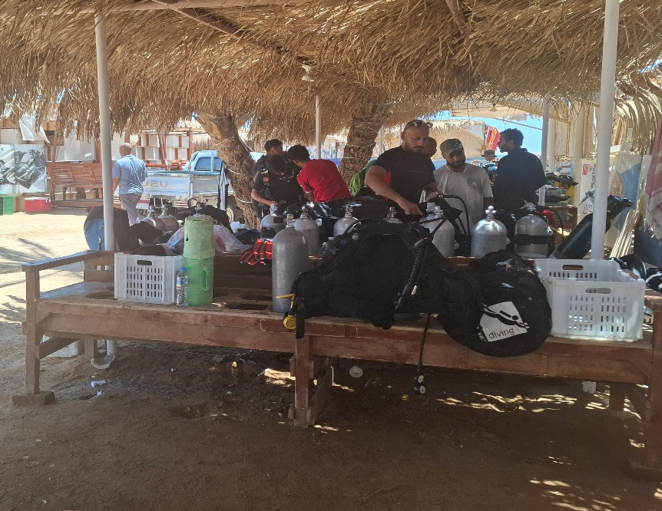

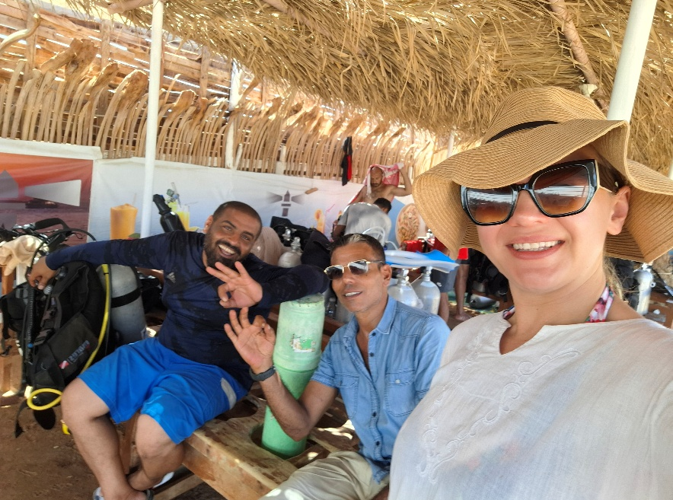

Snorkeling and Shore Diving in Sharm El Sheikh

After the boat trip, I decided to spend a day snorkeling from the shore and relaxing on the beach. In Sharm El Sheikh, you don’t have to go far to see the wonders of the coral reefs—the reefs start almost right at the shoreline. As soon as you put on your mask and fins and swim a few meters out, you’re surrounded by vibrant colors and an incredible variety of marine life.
On the beach, I met several divers and visited a few dive clubs. It’s very easy to find a place to rent equipment or join a guided dive in Sharm. The diving community is friendly and welcoming, and I met some wonderful new people from around the world who share the same passion for the sea.
I went snorkeling and diving at different times of the day, and it was fascinating to see how the reef changes. During the day, the reefs are busy with both divers and fish activity. Schools of parrotfish, angelfish, butterflyfish, surgeonfish, clownfish, and lionfish move gracefully among the corals. If you look closely, you can also spot moray eels hiding in crevices and blue-spotted stingrays resting on the sandy bottom. Turtles occasionally swim by, unbothered by the curious divers.
In the early morning, when the water is still calm and there are fewer people around, the reef feels almost magical. It was during one of these quiet morning dives that I had an unforgettable moment—I saw a reef shark chasing a school of smaller fish. It was thrilling to watch this scene of pure nature unfold right before my eyes.

At night, the underwater world transforms completely. The nocturnal creatures emerge, revealing a side of the reef that most people never see. The beams of dive lights reveal octupuses changing colors, crabs and lobsters crawling out of their hiding places, and Spanish dancers – beautiful red nudibranchs that move gracefully through the water. You can also spot feather stars, sea urchins, and even basket stars spreading their arms to feed. The reef becomes a mysterious, glowing world full of life that only comes out after dark.

Other Notable Dive Sites in Egypt

While Sharm El Sheikh is one of Egypt’s premier diving destinations, the country offers many other incredible dive sites for underwater enthusiasts.
Hurghada
Located to the north of Sharm El Sheikh, Hurghada is a bustling resort town with numerous dive sites. Giftun Island, Elphinstone Reef, and Sha'ab Abu Nuhas (famous for its shipwrecks) are just a few of the many incredible places to dive in the area. Hurghada is a great destination for divers of all experience levels.
Marsa Alam
For a more tranquil and remote diving experience, Marsa Alam in southern Egypt is an excellent choice. The area is known for its pristine coral reefs and diverse marine life. Notable sites include Elphinstone Reef (home to hammerhead sharks), Abu Dabbab (known for its sea turtles and dugongs), and the Hamata Islands, which are protected marine areas with undisturbed coral gardens.
Dahab
Located on the eastern side of the Sinai Peninsula, Dahab is famous for its deep, vertical dive sites. The Blue Hole is one of the most iconic dive sites in the world, offering divers a chance to experience an underwater tunnel and unique topography. Other popular sites in Dahab include The Canyon and Lighthouse Reef.
The Northern Red Sea: Aqua Blue & Coral Gardens
For divers seeking more remote experiences, the northern Red Sea offers pristine dive sites like Aqua Blue. This area is known for its untouched coral gardens, peaceful dives, and abundant marine life, with fewer tourists than the more popular destinations further south.
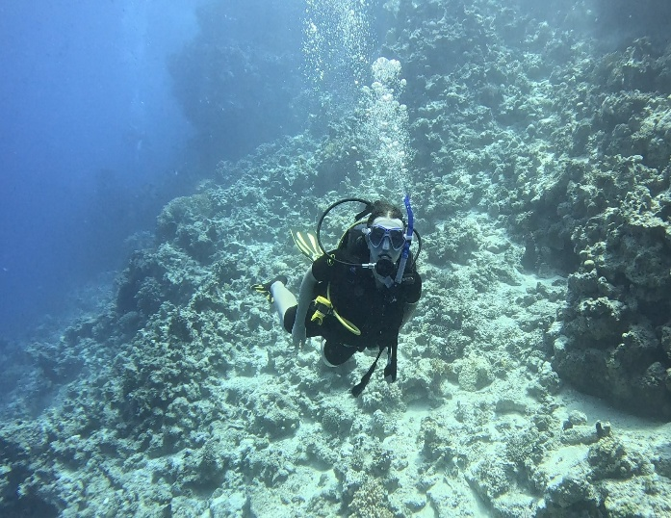
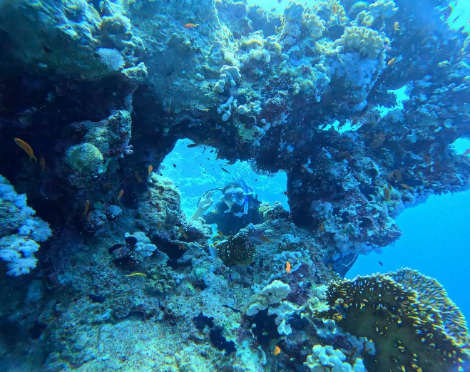
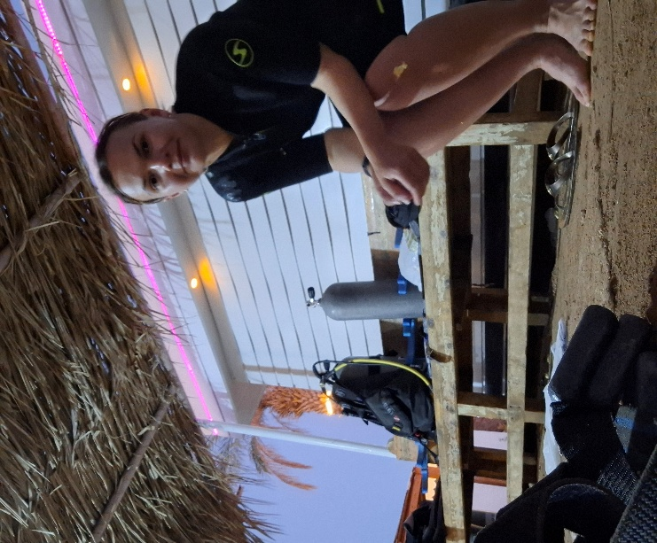
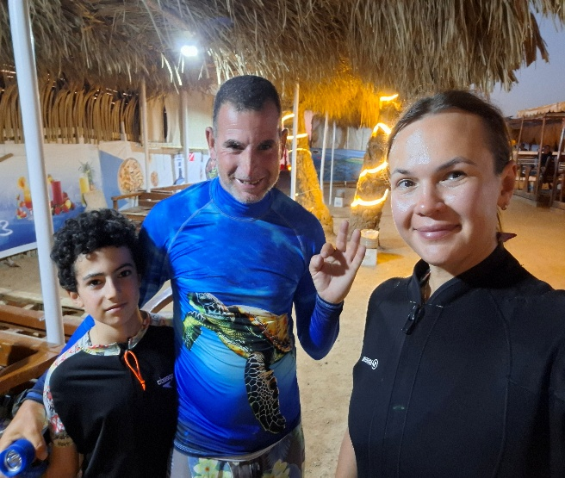

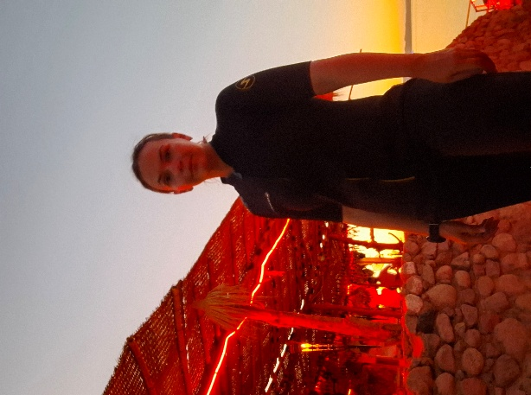

The Marine Life of Egypt’s Reefs
Egypt’s Red Sea is one of the world’s most biodiverse marine environments. Divers encounter an impressive variety of fish, from small wrasse to large groupers and jacks. Sharks—including reef sharks and occasional hammerheads—are a common sight at deeper sites. Turtles, rays, and dugongs also inhabit the region. The reefs’ abundance of both hard and soft corals creates stunning, colourful underwater ecosystems.

Conclusion
Egypt offers a dream diving experience for anyone passionate about underwater exploration. From the celebrated Ras Mohammed National Park and historic WWII wrecks like the Thistlegorm, to relaxing snorkels right off the beach at Sharm El Sheikh, the Red Sea delivers countless unforgettable moments.
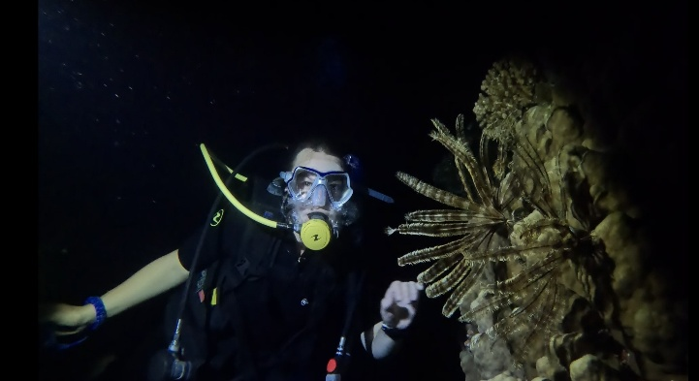
With opportunities for every level of diver—from early morning shark sightings to the mysterious allure of night dives—Sharm El Sheikh truly deserves its reputation as one of the world’s premier diving destinations. Every dive reveals a new story beneath the surface.
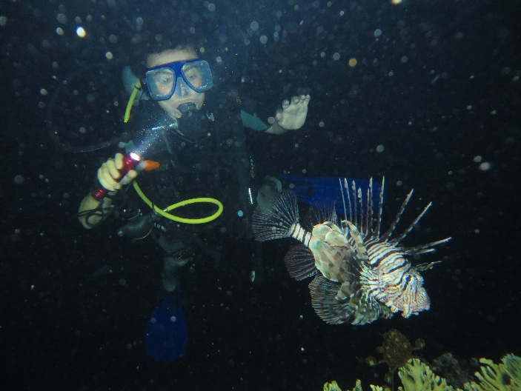

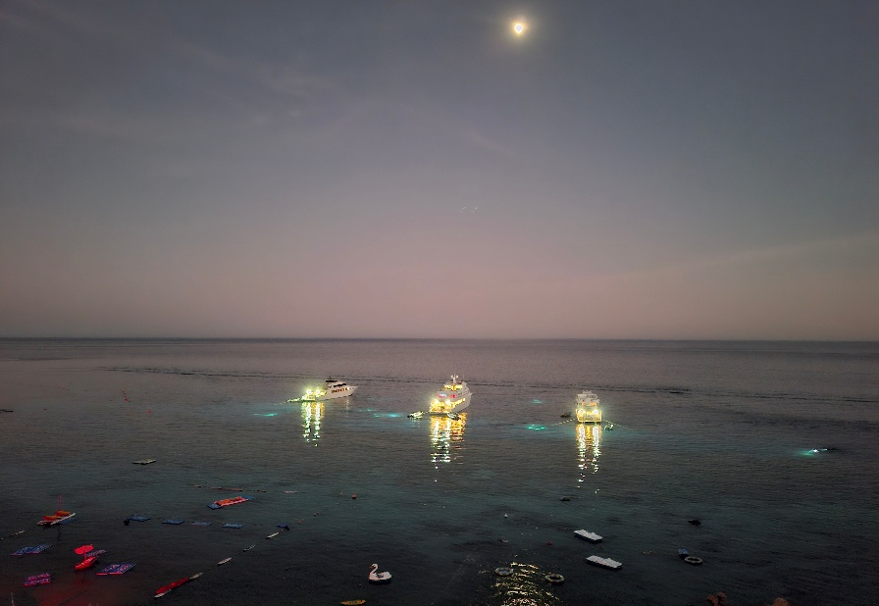

LLMT Trophy Winner

The Len Freniere Memorial Trophy is presented annually to the member making outstanding contributions to the Battlefords Scuba Community. The points that determine the winner are calculated in the categories of education, leadership, community involvement and diving.
This year’s winner is Joanne Turpin whose work to support club activities when she was not diving took her to the top on the list. Joanne is shown receiving the trophy from last year’s winner, Tatiana Tanina.
Congratulations Joanne and thanks for all your efforts!

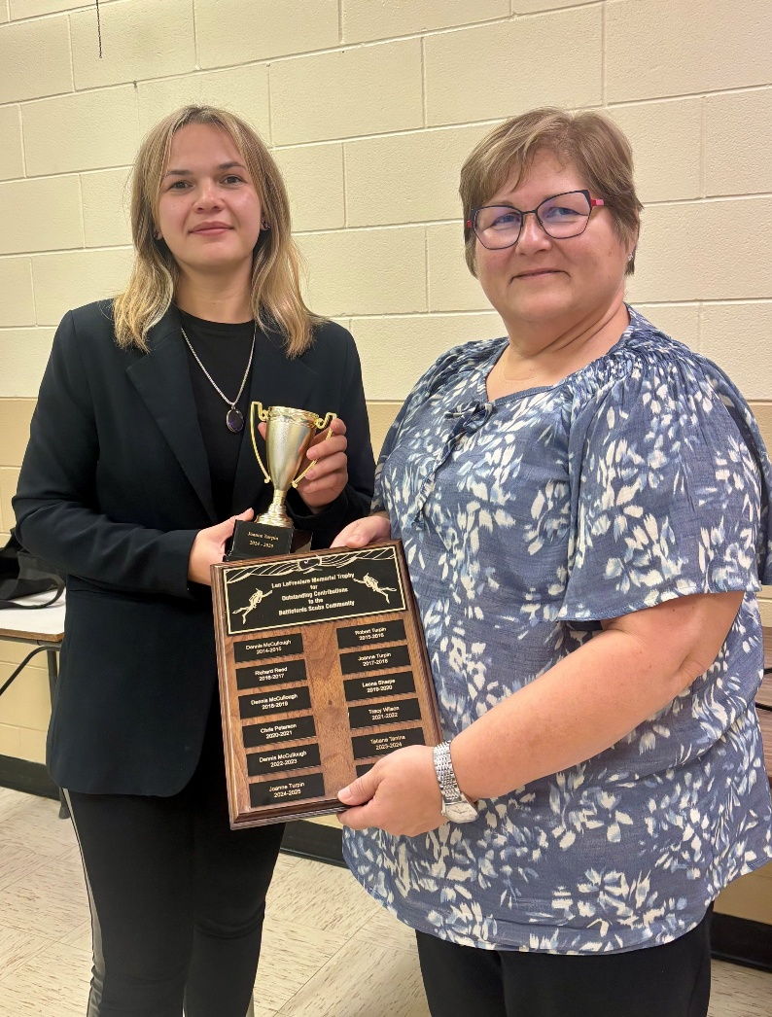

Battlefords Scuba Community
Coming Events

Sunday, December 7 Swim with Santa
Sunday, January 18 Re-Activate (refresher) session
Sunday, January 25 Discover Scuba
January 30, 31 & February 1 Open Water Scuba Diver course
Sunday, February 8 Underwater Gymkhana
March 7 & 8 DAN First Aid for Divers course
March 21 & 22 Ice Diver course
Saturday, April 11 Viz Party (cylinder inspection)
Sunday, April 19 Discover Scuba course
April 24, 25 & 26 Open Water Scuba Diver course
Saturday, May 30 Shake Down Dive
June 20 & 21 Definitely Diving Days
Saturday, July 19 Women’s Dive Day & Beach Clean-up
Sunday, August 2 Drive ‘n’ Dive
If there is anything you would like to see added to this list, please let us know and we would be happy to add it.

Merry
Christmas

