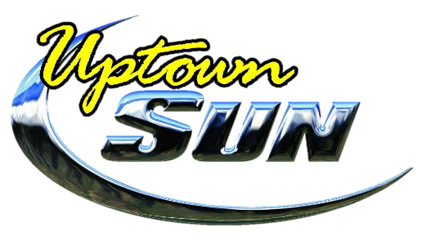

Norvell Spray Tan Prices
Full Body Premium Custom Sunless Tan $35
Half Body Premium Custom Sunless Tan $20
Upgrades
Norvell Xlatan pH Balancing Prep Spray Included
One-Hour Rapid Dry add $10
Venetian Plus add $10
Venetian One-Hour Rapid Dry add $10
Organic Cosmo add $10
Norvell Post Sunless Hydrofirm Moisturizing Spray add $5
Spray Tan Parties
3-5 people $28/person (20% off)
6-9 people $26/person (over 25% off)
10+ people $24/person (over 30% off)
Bride Special
Purchase 1 visit and receive a complimentary visit 30 days before the big day to see what your magnificent Norvell custom sunless tan will look like!
