Dream Resources
Sunshower Rose
Sedona, Arizona
https://collaborativeartworks.com

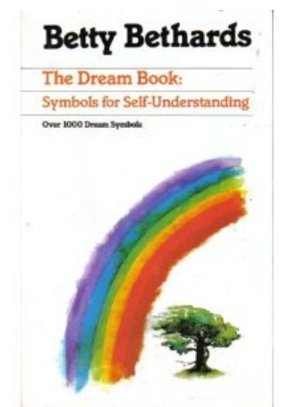
Amazon: $4.29

Barnes and Noble

https://www.goodreads.com/book/show/88681.The_Dream_Book

Carl Jung established the field of analytical psychology, and thus became known as, the "Father of Modern Analytical Psychology"
https://www.carl-jung.net/dreams.html

SEDONA , a magical place for INTUITION with 4 major vortices

What is a vortex?
Google: A Vortex is a place in nature where the earth is exceptionally alive with energy. The term Vortex in Sedona refers to a place where the earth energy swirls and draws to it s center everything that surrounds it like a tornado.

Psychics:
https://visitsedona.com/spiritual-wellness/readings-psychics/

Spiritual Medium:
https://www.freewebs.com/messagesofhope/

Why do we forget our dreams?

https://www.scientificamerican.com/article/why-do-memories-of-vivid-dreams/

Do we dream every night?

The average person has three to five dreams per night, and some may have up to seven. However, most dreams are immediately or quickly forgotten. Dreams tend to last longer as the night progresses. During a full eight-hour night sleep, most dreams occur in the typical two hours of REM.

Dream Movement: Senoi aboriginal tribe, Malaysia

https://dreams.ucsc.edu/Library/senoi.html

DRAWING:

“Drawing on the Right Side of The Brain” - by Betty Edwards

https://www.goodreads.com/book/show/627206.The_New_Drawing_on_the_Right_Side_of_the_Brain

Exercise from this book:
https://www.youtube.com/watch?v=AaLt5rTwn84

