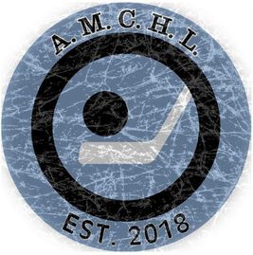
Date: Aug 18th, 2021
AMCHL Board Meeting Minutes

Meeting is held over Zoom

Present:
Board Members: Matt Schouten, Rob Beukema, James Stiksma, Jason DeVries,
Non Board Member: Tim Stiksma

- Voting of Executives results is as follow:
Chairman – Rob Beukema
Vice Chair – Matt Schouten
Secretary - James Stiksma
Treasurer – Jason DeVries
- Administrator Position – Tim Stiksma
- Board Member to replace James Stiksma – James has requested to step down effective after the 2021/22 season. Board will replace a board member before season end

- Statician Position – Levi Minderhoud will stay on as statician
- Player ratings – All players are discussed to the best of our knowledge. Lots of 2nd year players who could be better than previous year. Teams seem even, but we move forward with caution and expectation is trades will be needed

- Roster Review – Teams are pre-constructed by the Admin. They are reviewed and players are moved around according to parity, friend requests. Board keeps all core groups together as submitted.

- Spares -Spare system remains same as last year. Teams can call a spare of same rating of player missing. Overall cap is not affected.
- Jerseys – admin has ordered 2 sets to replace the Bomber set which was wrecked and had discoloration from previous team using them. Panthers Jersey set is also replaced. Knights will be Dallas Green, Panthers will be Tampa Bay White

- Schedule Notes:
- Games will be on Wednesday and Saturdays

- Team Leaders for the year are picked, board members will no longer act as team leaders.
  - Capitals – Derek Bulthuis
  - Jets – Eric Super
  - Knights – Braden Schouten
  - Huskies – Justin Bontkes
  - Panthers – Levi Minderhoud
  - Red Wings – Kevin Hendricks
  - Flames – Levi Coates

- Matt Schouten closes the meeting in prayer
- Next Meeting: TBA

