Below are instructions to copy a slide master (and all its associated layouts) from one presentation into another. The file that you are converting must end in .pptx.

Copy the slide master from the first presentation
- Open both presentations: the one you want to copy a slide master from, and the one you want to paste the slide master into.
- In the presentation that has the slide master you want to copy, on the View tab, select Slide Master.
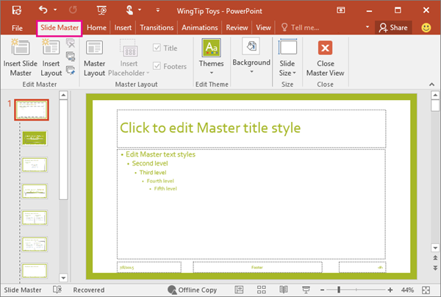
- In the slide thumbnail pane, right-click the slide master, and then select Copy.
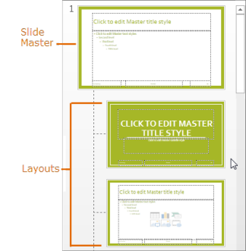
Notes:
- In the thumbnail pane, the slide master represents the larger slide image, and the related layouts are smaller, positioned beneath it (shown above).
- Many presentations contain more than one slide master, so you may have to scroll to find the one that you want.
- Delete slide master(s) that will not be used for the power point.

Paste the slide master into the new presentation
- On the View tab, select Switch Windows, and then select the presentation that you want to paste the slide master to.
- On the View tab, select Slide Master.
- In the thumbnail pane, right-click the slide master, and then do one of the following;
  - To maintain the theme colors, fonts, and effects of the presentation that you are copying from, click Keep Source Formatting .
- When you're finished, select Close Master View.

