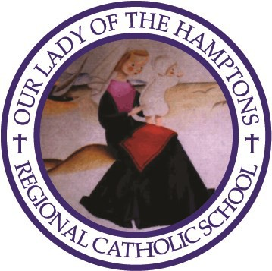**OUR LADY OF THE HAMPTONS REGIONAL CATHOLIC SCHOOL**

**FAMILY RE-REGISTRATION FORM 2020**

Each family is asked to fill out and return this form to the school office on or before February 14. This will assist in our planning for the new year, including setting of budget and tuition decisions.

FAMILY NAME

MAILING ADDRESS

**TOWN** **ZIP**

As of this date*, it is our intention to re-register our child(ren) for the school term at OLH beginning in September 2020.

Name grade in September_

Name grade in September_

Name grade in September_

This student, currently in Prep8, will attend for high school

As of this date, it is our intention to transfer our child(ren) to

­­­­­­­­­­­­­­­­­­­­­­­­­­­__________________________________________For September 2020

Signature of parent__________________________Date____________

* While there is no re-registration fee due at this time to hold your child’s place, be advised that transfers after March 15 notification will require a $150 withdrawal fee.