ANEMIA

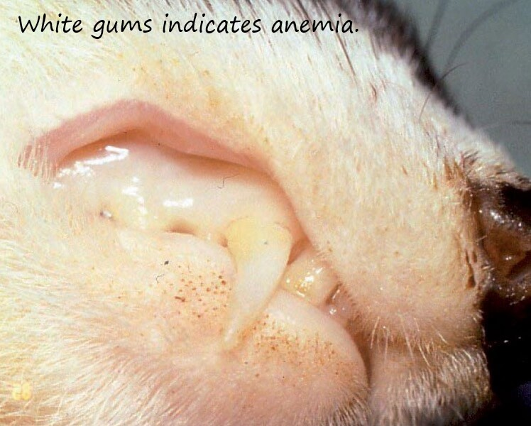

Anemia is when there is a low red blood cell count. This comes from too much blood loss. Blood loss occurs from fleas (even just a few can cause anemia), ulcers, lymphoma, and other causes. A ferret with anemia will generally not have much energy. The gums, lips, ears, paw pads, and nose will all appear white or light pink than normal. This requires a vet visit for a blood test to see how bad the anemia is and help determine a cause. Treatment is usually a high iron supplement, like Hi-Vite, and organ meat (liver, kidney, gizzard, heart), along with treating the root cause of the anemia (flea or ulcer treatment).

I frequently stress the importance of having your ferret accustomed to eating soup. If a ferret gets sick, it will usually stop eating kibble. If it's used to eating soup, it will often continue to eat the soup, which keeps it from getting sicker. Also, if the ferret is used to eating soup and you need to give it medicine, sometimes the medicine (or organ meat in the case of anemia) can be added to the soup without a fight from the ferret. (This is not the case with bad-tasting medicine. In that case, it will keep the ferret from eating the soup.)