CHORDOMA

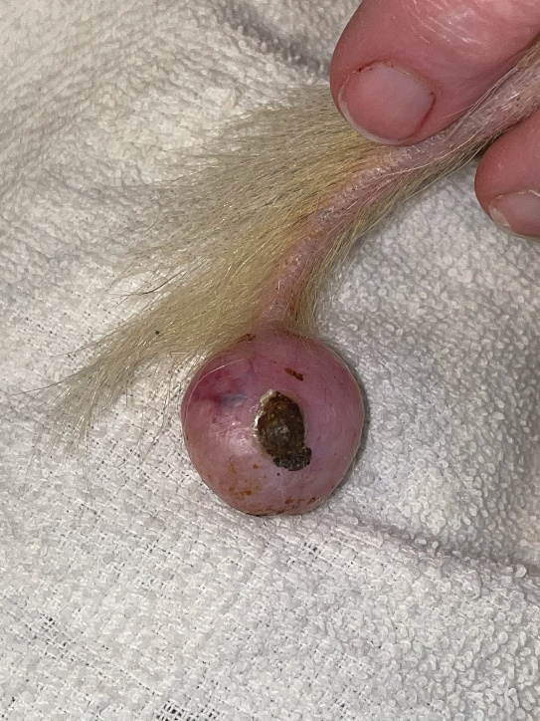
A chordoma is a tumor that grows on the spine of the ferret, usually at the base of the tail. It puts pressure on the spine, which can cause pain, discomfort, loss of mobility, and bleeding from it hitting things. It can even cause incontinence because of pressure on the spinal nerves.
The first picture is of a large chordoma. At this size, it is painful for the ferret to pull around on its tail, as it's putting a lot of pressure on the spine. It's also painful as the chordoma hits things and splits open. That is a scab on the chordoma from where it has split open after being hit.
Treatment is surgery to have the tail amputated from a couple of vertebrae before the chordoma.
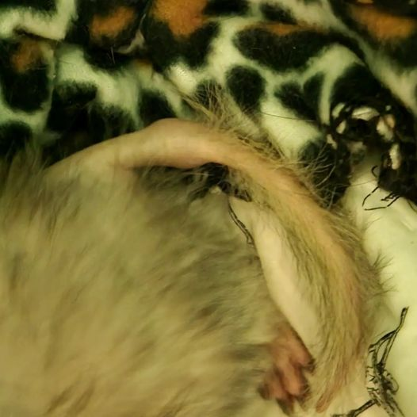

The second picture is of a chordoma near the base of the tail. This means the entire tail will have to be amputated to remove the chordoma. This is a more complex and expensive surgery. The ferret should be fine after the surgery but will have a little trouble with balance without a tail.

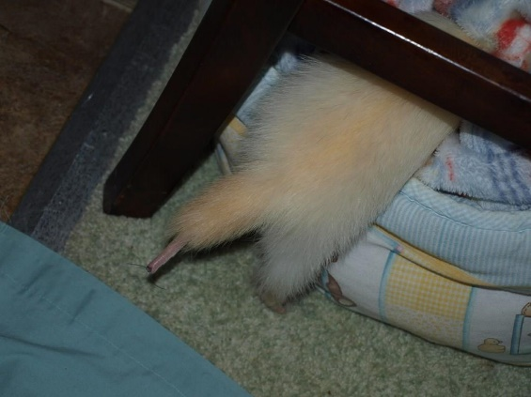
This third picture is after the chordoma removal surgery. This ferret seemed to be acting fine before the surgery. However, after the surgery, she was a lot more active and clearly feeling better. This just shows the chordoma was causing her discomfort, even though it was at the end of the tail. Her tail is shorter because part of it had to be amputated to remove the chordoma. Sometimes the fur grows back fully. Sometimes it doesn't.

Below is a link to an excellent article on chordomas!
https://www.themodernferret.com/ferret-chordoma-tumor-tail/

