EAR MITES
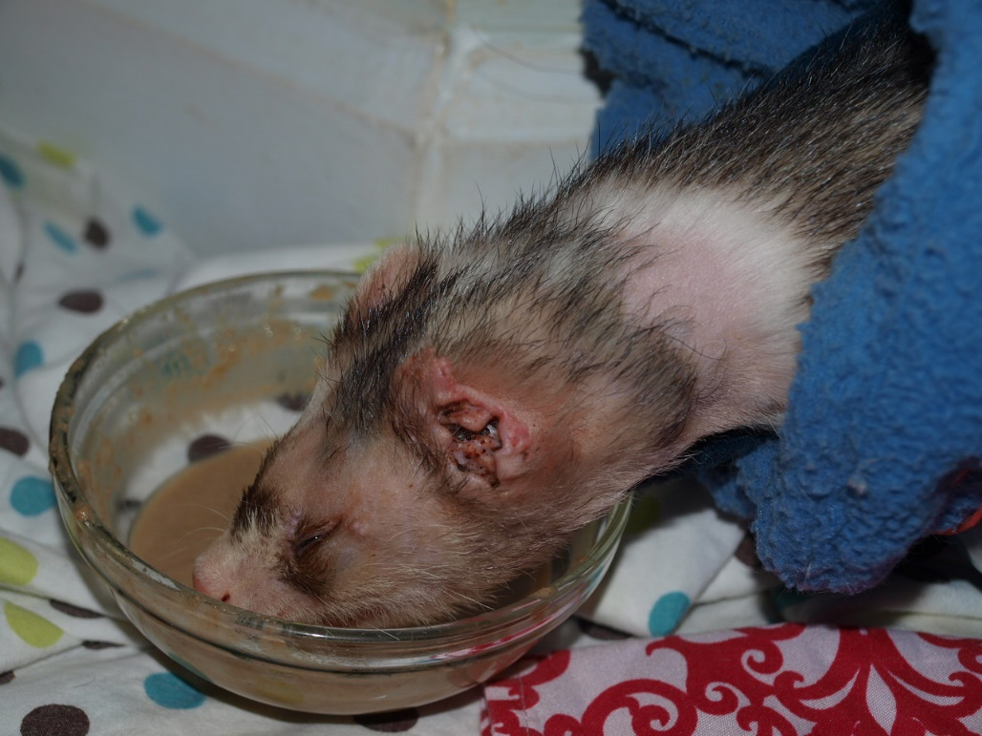
This is a pic of a ferret with ear mites. Ear mites are microscopic and nearly impossible to see with the naked eye. They feed inside the ear, causing dried blood and a waxy build-up. The animal will scratch its ears a lot because the mites are irritating. Ear mites should be treated quickly. They can result in a serious ear infection, hearing loss, and worse if the infection deepens. If there is redness, there is usually an infection that will also need to be treated. If one pet in your home has ear mites, there's a good chance all the pets do. So, all pets should be treated at the same time.

Revolution or Selapro topical treatment kills ear mites, as well as fleas and intestinal parasites, and prevents heartworms. You can use Revolution or Selapro for dogs or cats. It's the same product, just different packaging. The rescue uses Selapro for very large dogs to save money. Use 1 ½ drops per pound of body weight. So, two to three drops for most females and three to four drops for most males. If you give one extra drop, it's okay. If more than that, quickly wipe off some of the treatment as it can cause a toxic reaction. You can purchase Revolution or Selapro at most vet offices, get a prescription from the vet and order it online or order online from https://www.pets-megastore.com.au/ without a prescription. This is the cheapest place I've found to order Revolution or Selapro.

