HAIRBALLS and BLOCKAGES
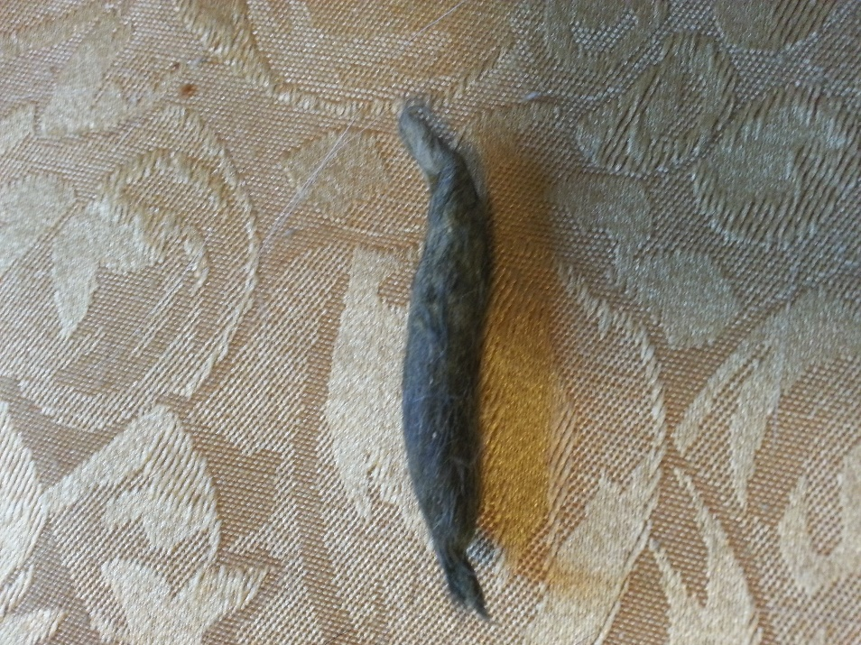
Ferrets get hairballs. Ferrets cannot throw up like cats, so the hairballs must pass through the system. They must be given something to help the hairballs move through the system or they can get a blockage. Below is a pic of a large hairball removed from a ferret.

To prevent hairballs, give a hairball remedy at least once a week. There are over-the-counter hairball remedies, like what is used for cats. I do know of one person whose ferret got a hairball and required surgery, even though she was given over-the-counter hairball remedies once a week.
During the spring shedding season, you should give hairball remedies two to three times a week. If the ferret has 'blown' its coat (shed all of the long guard hairs and only has the soft undercoat), give hairball remedy three to four times a week. If you have more than one ferret and only one of the ferrets is shedding, they should all get the hairball remedy twice a week because they groom each other.
Many people make their own with 1/2 teaspoon of petroleum jelly mixed with salmon oil, coconut oil, FerretVite, or something else the ferret likes. (That small amount of petroleum jelly, coconut oil, Ferretvite, etc. once a week will not hurt the ferret.) If you feed a soup mixture, you can add a 1/2 teaspoon of canned pumpkin to a 1/4 cup of soup. This will help move hairballs through as well. (Too much pumpkin can cause a firmer stool, which can worsen a hairball.)
Some people use eggs for hairball prevention. I have talked with numerous vets about this, and we do not believe there is enough to the egg to move fur through the system or break it down. If you're using egg, please take care and use something else with it.
Other ways to prevent hairballs are to frequently brush the ferret, wash the ferret bedding weekly and vacuum your house a lot. This gets rid of loose hairs that can stick to and then be ingested by your ferret. I shake the ferret bedding outside really well before washing to get as much hair off of as possible. (This also helps the bedding wash better and keeps fur from accumulating in washer piping.)
Example of a ferret Hairball
Ferrets will also eat ANYTHING off the floor and can get a blockage from it. They can also get a blockage from hairballs. This can cause life-threatening blockages in the stomach or intestines. (Pic is of a hairball that had created a blockage.)

Signs of a blockage:

- Lethargy
- Thin, stringy stool
- Coughing/hacking
- Loss of appetite and weight
- Lack of interest in food
- Vomiting or dry heaves
- Pawing at the mouth
- Rubbing face on the carpet (not like cleaning the face after eating)
- Dehydration (can pick up the skin on the back of the neck and it goes down slowly)
- Bloating
- Swollen belly

Signs of pain:
- Squinting eyes
- Watering eyes
- Pulling at fur
- Biting at belly
- Whimpering
- Gnashing teeth

If your ferret shows any of these symptoms, take him to a vet the same day or, if at night, the next morning. Even if the symptoms come and go, the ferret should be seen by a vet. There could be a partial blockage or a floating blockage that, if not taken care of quickly, could kill the ferret. (Better to be seen in the morning in case surgery is needed.)

While waiting to get the ferret to the vet, give it as much unflavored Pedialyte (or generic) as you can get the ferret to take. This will keep the ferret from getting as dehydrated, which can help prevent more serious complications or death. It also gives the ferret electrolytes and sugars to keep the blood glucose level from getting too low.

When you see the vet, insist on an x-ray. Some vets recommend waiting to see if the blockage passes on its own. That day or two days can be the difference in life or death. An x-ray will show how large the blockage is or if there is a backup in the intestinal tract of food that has been unable to pass the blockage. It is important NOT to give the ferret anything that will make the blockage move. If the blockage moves, it could tear the stomach lining or intestinal walls or cause the intestines to twist (torsion). Either of these can kill the ferret within a couple of hours and it's an agonizing death. This makes it more important to get the ferret to the vet fast because it must have food in the system every few hours due to their high metabolism.

