MAST CELL TUMORS
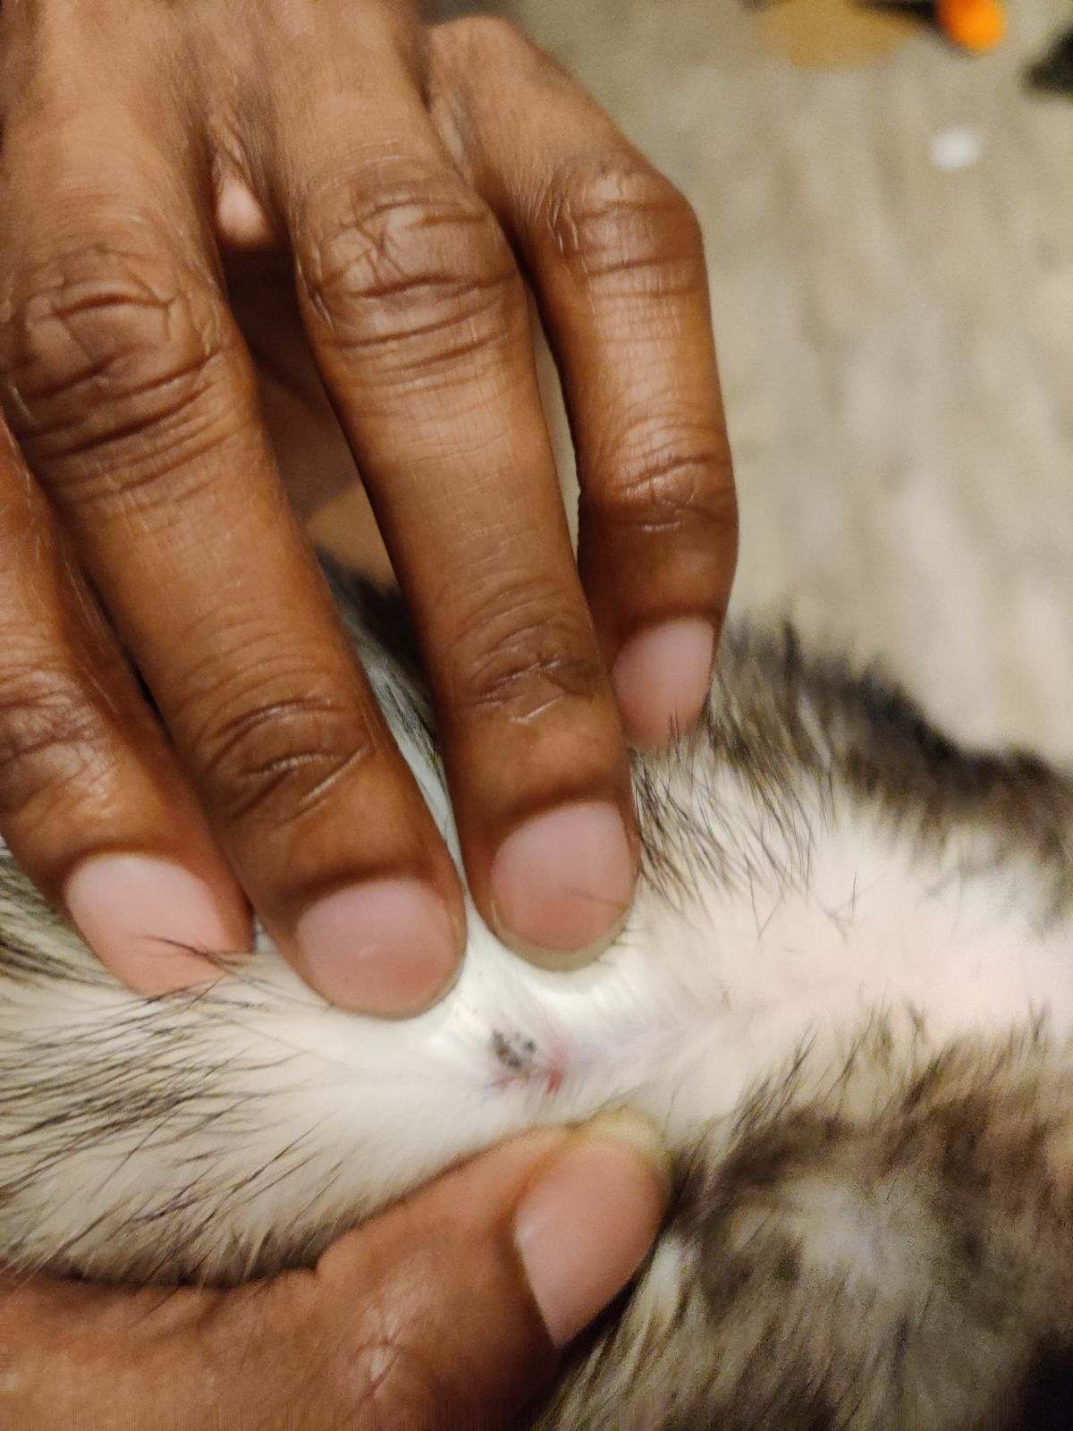
Figure 1: Example of a Mast Cell Tumor.
Mast cell tumors are very common in ferrets. Mast cells are a group of cells in the skin that are associated with blood cells. They cause allergic reactions with redness and itching like from hives. Mast cell tumors are usually benign in the ferret.
Mast cell tumors often start as a flat balding spot on the ferret's body. They don't usually attach to anything under the skin. Ferrets will sometimes chew or scratch at the spots because the tumors itch a lot. The tumor may go away and come back, stay the same size, or get larger. If done when the tumor is still very small, sometimes the vet can inject it with a chemical over two or three visits to freeze it off. Otherwise, surgery is needed to remove them when they get larger or when they cause too much itching.
You can try applying some antihistamine cream (like Benadryl) to the spot to see if that helps.

Levocetirizine (brand name XYAal) is an antihistamine that does seem to influence itchiness for some ferrets. Liquid (concentration of 2.5 mg per 5 ml) - Give six to seven drops daily. The ferret isn’t going to like the taste, so it’s sometimes easier to give the tablet. 5 mg tablet – Crush and mix with 1.7 ml of Ferretone, salmon oil or whatever liquid the ferret likes. Rub one drop on the tongue or gums. If the ferret gets two drops instead of one, it is okay. Treat once a day for two days. If no change or not enough change, treat twice a day for two or three days. If no change or not enough change, double the dosage in the morning and give the normal amount 12 hours later. If the doubled dosage helps during the day, then double it at night too.

There are many people who believe treating a ferret with a mast cell tumor with an Essiac tonic can help slow down the progress or, at the very least, help with inflammation and general discomfort. https://www.herbsetc.com/essiac-tonic-2-oz-alcohol-free/ Always refrigerate after opening.

Typically, for mast cell tumors, ear tumors, etc. - Mix eight drops of Essiac with one cup of warm water. Soak the affected area for ten minutes twice a day. If you can't soak the area, apply the mixture with a gauze pad and keep it applied for ten minutes twice a day.

