PROLAPSED RECTUM

A prolapsed rectum occurs when the animal is straining too hard to defecate and the rectum is pushed out. It will be bright red and may have blood. The attached pic is of a bad prolapse.
Treatment: Clean up the area with a warm soft cloth, then treat the difficulty of defecating. Provide soup or softened food. It’s easier to digest and pass as a stool. Remove hard kibble until the ferret's better. For softening food, cover with water, let stand 20 seconds, then pour off all water. This softens without making it mush.
Give ¼ teaspoon of salmon oil, Vaseline, or other types of oil 2-3 x a day. The oil or Vaseline makes it easier for food to pass which means less straining to defecate. (A ¼ teaspoon of oils or Vaseline for a short time will not harm the ferret.)
Apply warm compresses 3 x a day or more. This comforts and relaxes the colon and anus, making it easier to defecate.

Use hemorrhoid cream on the anus. This makes it easier to defecate, shrinks the anal tissue, and eases discomfort. If the ferret licks it off, get a bad-tasting cream to add to it. (Vet offices sell Yuck cream and it works very well!)

Don’t give anything with pumpkin. Pumpkin can firm the stool making the ferret strain to pass it.

Kits get a prolapsed rectum from being fed hard kibble. Their organs can’t process the hard food as easily as a mature ferret. They also tend to not drink enough water, which only worsens things. A kit should be offered soft food for 2-3 weeks. Hard kibble can then be offered with the soft. Once the kit is eating only hard kibble, remove the soft kibble.

(Example of a prolapsed rectum below)

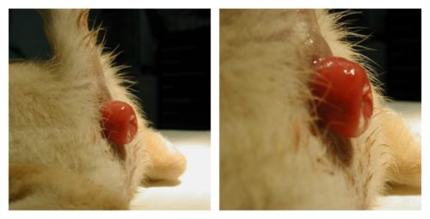
If the prolapse is really bad or these measures don’t help enough, the ferret has to see a vet. It likely means there's a bacterial infection. Continue to use the measures above while treating with antibiotics. If really bad, the rectum may have to be stitched in place. If so, it’s important to follow the above notes, or the ferret will strain again and pop the stitches. (When giving medication, first give the ferret something it likes [soup, salmon oil, Ferretvite, etc.] to coat the mouth, then the antibiotic, then more of what it likes to help get the bad taste out of the mouth.)

