RAT TAIL
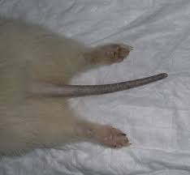
Example of a ferret with "Rat Tail"
When the pores of a ferret's tail get blocked with oils or dirt, the tail loses fur and looks like a rat's tail. Hence the name rat tail. It happens more often with white ferrets because they tend to give off more oils. This isn't a medical condition or disease, just something that needs to be taken care of. You can use mild shampoo to wash and dry the tail daily to clean out the pores. I've had excellent luck with using a human facial cleanser, like Noxzema. If you wash the tail daily for about ten days and the fur doesn't start growing back or if there is fur loss elsewhere besides the tail, then it is likely adrenal disease causing the fur loss.

