SWOLLEN PROSTATE
A swollen prostate gland is an adrenal disease symptom for male ferrets. This usually occurs with more advanced cases of adrenal disease but can occur early on. The symptoms are the same as urinary tract infections, kidney stones, bladder stones, urinary tract crystals, and more.
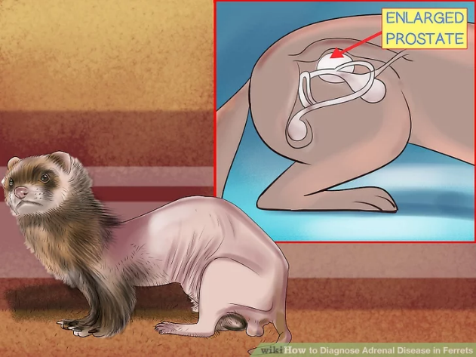
Symptoms can include:
* Blood in the urine (dark brown or obvious red)
* Straining or being unable to urinate
* Showing signs of pain when urinating (whimpering, grimacing, eyes watering, teeth gnashing)
* Dribbles urine when walking away after urinating (still urine in the bladder that's not being expelled due to pain or blockage)
* Urine is brown or really concentrated yellow (urine being held due to pain or blockage, or not enough fluid intake)
* Not urinating every few hours like normal (urine being held due to pain or blockage)
* Urinating large amount at a time (urine being held due to pain or blockage)
* Frequent pooping and/or diarrhea (can indicate colon is aggravated from bladder or prostate swelling or from pain)
* Lethargy
* Increased thirst
* Lack of appetite
* Weight loss
* Weakness
* Vomiting or dry heaving (from nausea)
* Fever (increased color and/or heat in ears, feet, nose, mouth, or skin)
Immediate treatment is necessary to keep the prostate from swelling and prevent urination. The fastest treatment is to use the human medication Flutamide. Your vet must write a prescription and you get it filled at a human pharmacy.
This is how the rescue vet has me prepare it. This is for a reference for your vet. Flutamide 125 mg. - Empty the contents of the capsule into a small bowl with a lid. Add 12.5 milliliters (12 1/2 full small syringes) of salmon oil or other liquid the ferret may like. Mix them together well. Give 1 ml. (one full small syringe) once a day. Stir well each time you give the medicine. If symptoms are bad, give twice a day (about 12 hours apart). Once the symptoms are better, reduce them to once a day. Mix well every time before giving. Do not refrigerate. Treat for a minimum of two weeks or treat for one week after the last of symptoms. Try not to use this for too long at any one time as it's hard on the liver. To help prevent prostate issues or help once it's there, you can use Saw Palmetto liquid. Ask your vet about this and the amount for your ferret. For prevention or when there are no obvious prostate problems: give 1/8 - 1/4 dropper full of soup once a day for six days, then skip a day. When there are prostate problems: give 1/4 - ½ dropper full up to twice a day (about 12 hours apart) for six days, then skip a day. As the ferret gets better, take to once a day, then reduce the amounts. Don't refrigerate.

