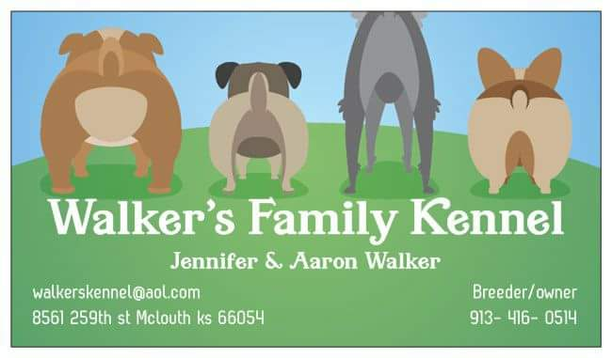
WALKER’S FAMILY KENNEL
8561 259TH ST
MCLOUTH KS 66054
913-416-0514
walkerskennel@aol.com

*This document is a binding agreement between seller: (walker’s family kennel) and buyer.*

All puppies must be taken to your vet within 3 business days of receiving your puppy, proof must be provided within 10 days by mail or email. If this is not done, the health guarantee becomes invalid and buyer assumes all responsibility for the health of the puppy. Health guarantee is valid for 1 year. All puppies leaving my facility are current on their vaccinations, wormings, microchipped and vet checked. Any veterinarian not accepting my protocol will void your health guarantee. You must take your health record I gave you to your vet appointment to ensure your vet doesn’t try to revaccinate. Over vaccinating is a health threading issue. To ensure the welfare of the puppy’s immune system and longevity we will not honor our health guarantee if your vet revaccinates what I have already given. Puppies should be wormed every two weeks from 2 weeks of age until 12 weeks of age, and then every month until the puppy is 6 months of age then they can be treated as adults (wormed every 3 months). We do not cover parasites as they are easily contracted in puppies and every effort was made to prevent the spread/infestation. They will need a series of vaccinations during their lifetime and health guarantee will be void if not kept up to date on vaccinations, worming, exams, ect. Your puppy should be picked up by 8wks old unless previously arranged as space is limited and the rest of the litter has usually gone home. When your puppy is left with us beyond the 8wk mark they then sleep in bed with us and it becomes harder for us and the puppy to leave. You will be charged a boarding fee of $30 per day after the pickup date.

It should be noted that diarrhea is common among puppies that have been moved into a new environment. This is normal and is not covered under our health guarantee. Also not eating or drinking within the first 24 hours is common as they are extremely nervous. This will normally subside as the puppy adjusts to their new environment. Your health guarantee only covers life threading genetic flaws. If you find your puppy has this I will need a statement and health record to send to my vet. Our vet will decide if this constitutes a life threatening defect/flaw. Walker’s family kennel will then make the final decision. Walker’s family kennel will cover up to the price you paid for the puppy. At that point you will be given the opportunity to return the puppy and be put on the waiting list for another puppy or just refunded your total balance you paid us for the pup. It is you’re responsibly to contact us within 24hrs of your findings. If you decide to opt out of treatment or notify us we are not responsible for any bills or expenses accrued or the death of the puppy. Proof of all veterinarian records must be provided if claim is made.

The majority of our puppies are sold as pet homes only and sold at a pet price. This means you agree to get your puppy spay/neutered and we will take legal action if our dogs are bred purposely or by negligence. Registration papers will be withheld until proof of procedure has been mailed or emailed to me. It is the responsibility of the purchaser, not the vet to ensure I have received verification of the altering of puppy. If puppy is not altered by 6months of age this will be considered a breach of contract and the puppy must be returned to me within 2weeks and no refund will be given. All travel costs if any will be your responsibilities not mine. Our deposit and any payments made are nonrefundable unless something happens on our end. If you would like registration papers I need to know at time of deposit so I can get them ordered. Most could care less about the papers so im not going to waste my money getting them unless you want them.

Good breeders don’t sell puppies with the expectation of getting them back. A forever home is supposed to be just that. But life happens to the best of us and a whole host of issues such as illness, allergies, divorce, relocation, and financial problems. This can make it impossible for an owner to continue keeping a dog despite the best of intentions. No matter what the reason for the rehoming, we must be notified. Even if your now adult dog is going to live with another loving family or close friend I will still want to know about any change of ownership. While this might seem controlling, look at it from my perspective, in order to be responsible for every puppy I bring into the world, we need to make sure they are in loving responsible hands. We will also want the new owners to know we are available to provide the same guidance and advice that we gave you. We NEVER want our dogs in a shelter! We are here for the lifetime of your dog. If you cannot find an appropriate home they will always have a home with us or we will find them one.

****By signing below you agree you have read and understand our contract and that all information regarding your puppy has been disclosed.

Seller: Walker’s Family Kennel Date: ____________________

Buyer: _________________________________________Print:_________________________________________

Chip number: ________________________________ Breed: _______________________________________

