Michael Lee Valentine
March 21, 1956 – September 12, 2020

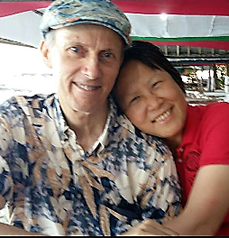
Mike and wife Yan
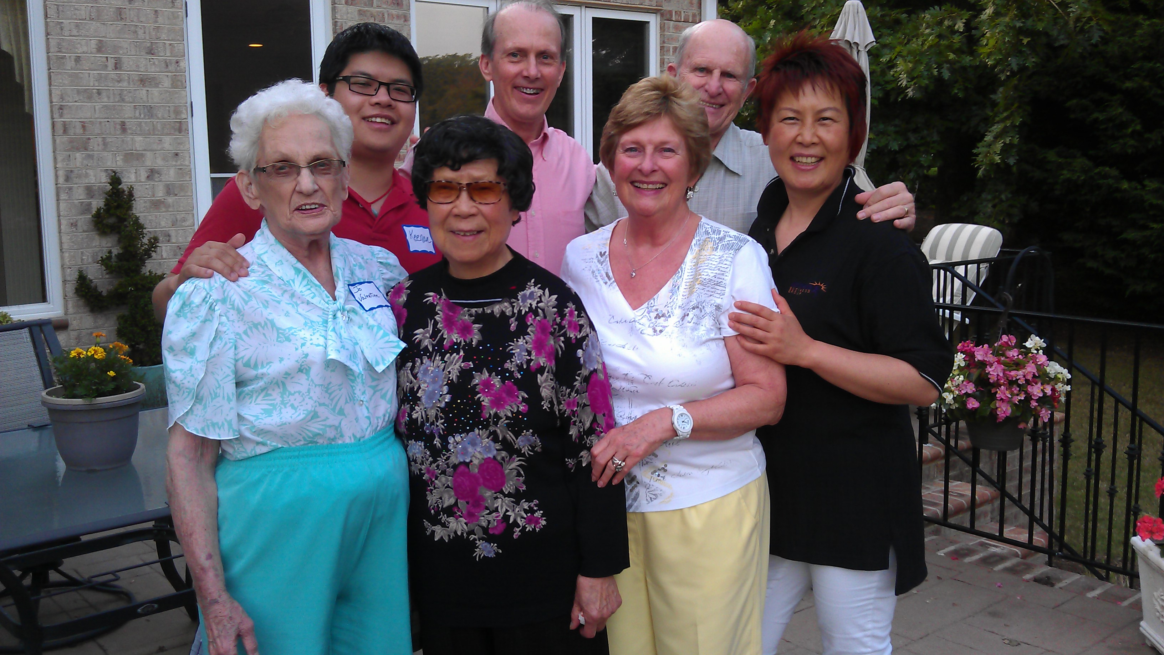
Mike’s mom Jo, Son Keenan, Yan’s mom Zhao, Mike, Pat, John, & Yan
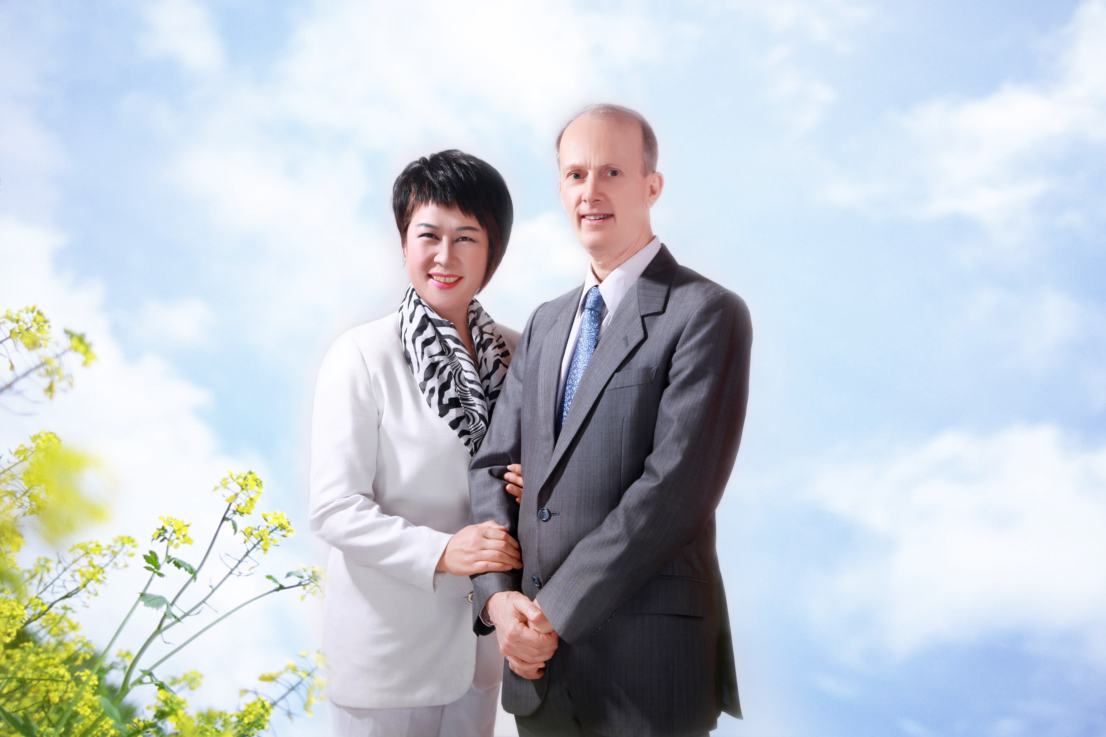
Yan and Mike Diamonds China
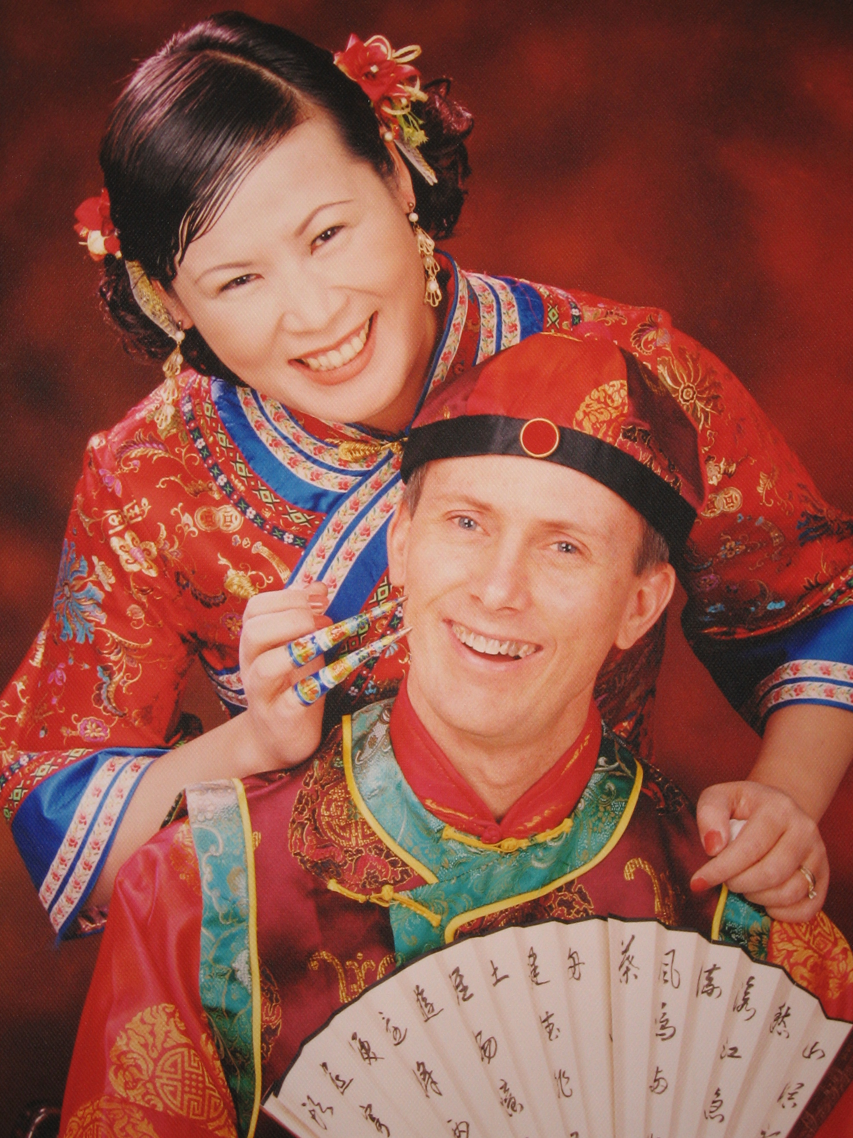
Shanghai and throughout China
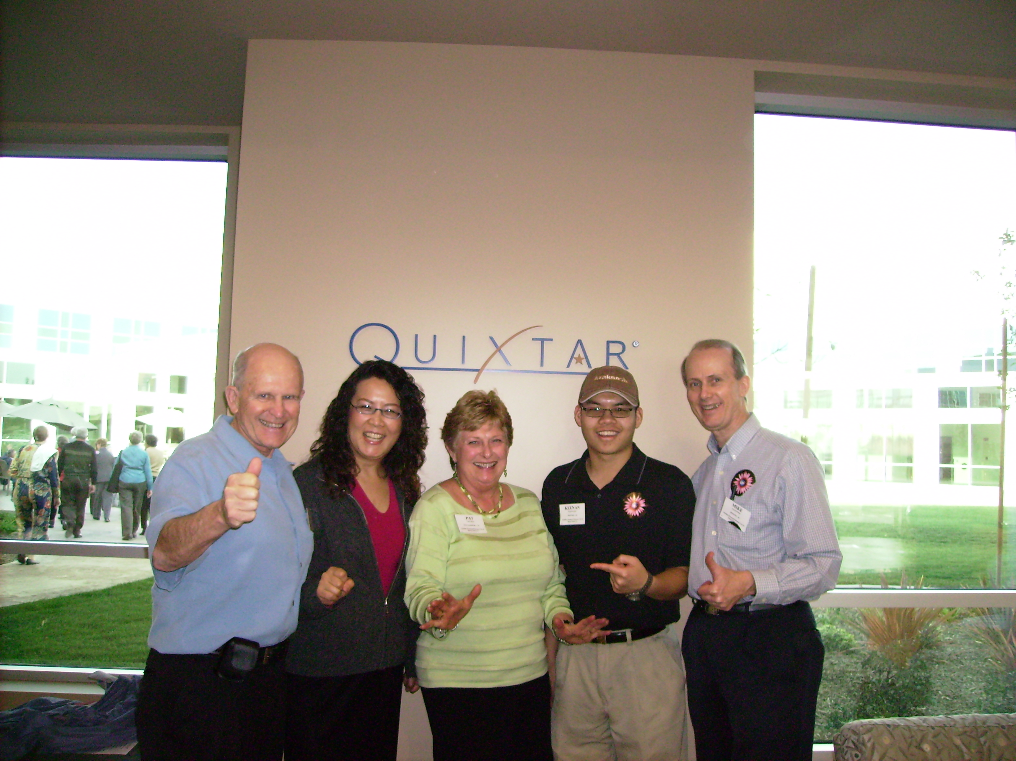
Touring Nutrilite at Buena Park, CA
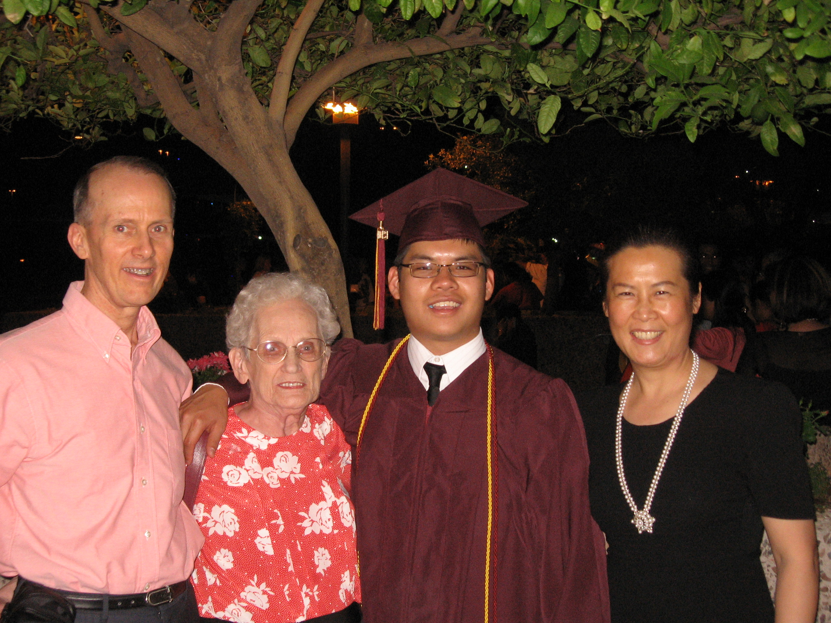
Valentines celebrate son Keenan’s PhD from Cornell
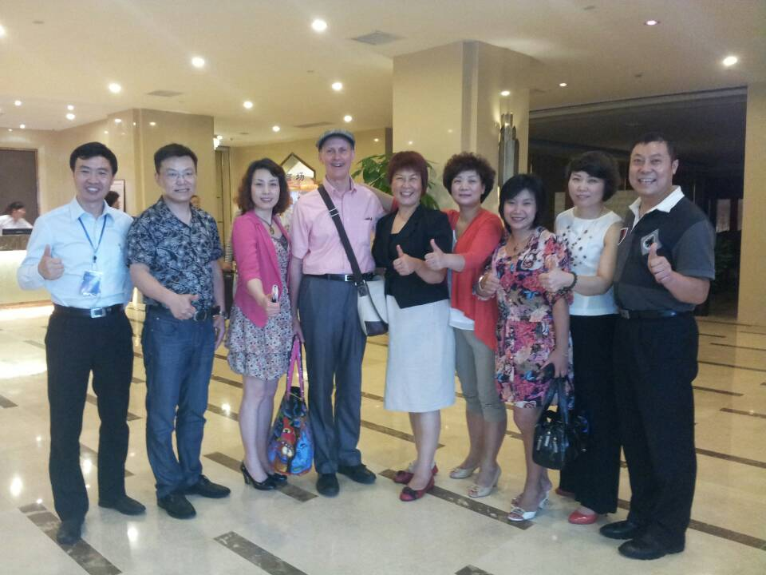
Valentines with 7 of their many leaders in China
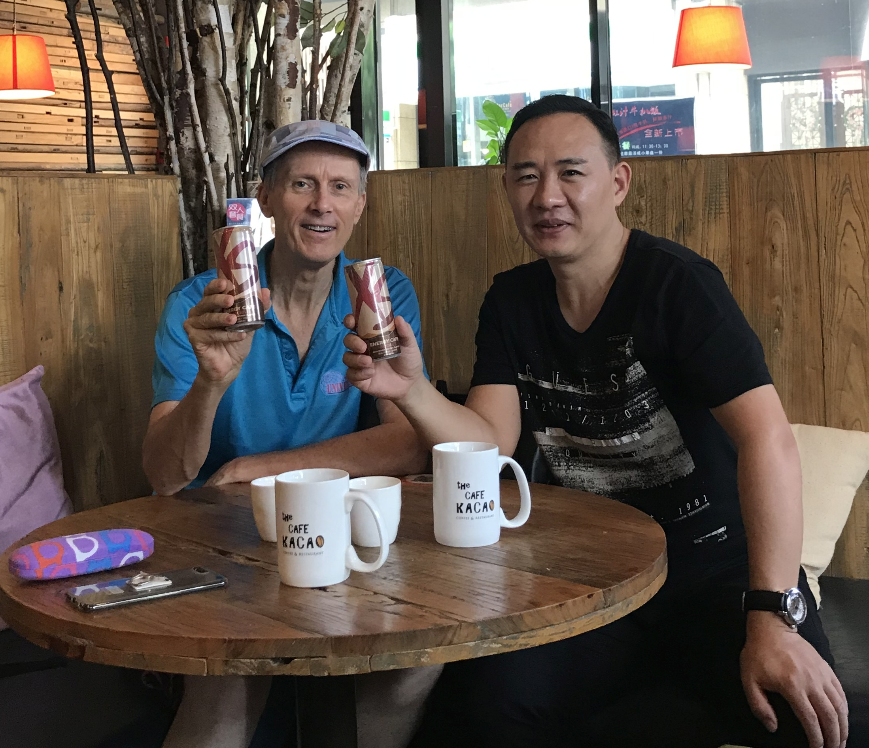
Mike and his good Shanghai friend Jimmy Hao
The Mike Valentine Story
As related by John Vaughan on September 13, 2020
The memories of my good friend Mike will live forever in my mind. He was raised in Phoenix, Arizona and died there yesterday. A major part of his life was in Shanghai with his wife Yan.
He loved being a drummer and travelling with Up with People. He kept some of those friendships his entire life. Yanny bought him a drum set when he was in home hospice and he played.
Mike lived for years with his mom in a rather unique elliptical street of about 30 homes in the middle of Phoenix. Rentals were not allowed so with just one entrance to the compound it was a nice community. With the hot sun and walls, there was plenty of privacy. We had many business meetings there with ample parking. Mike’s mom was an outgoing real estate lady with many friends from her church. She was Mike’s sponsor, downline in Cosgrove group.
Mike worked with the telephone company handling customer complaints, an unusual job for someone who had bipolar disorder. He negotiated about 3 hours a day off in the middle of his shift to come home and decompress, then to return for another 4 hours. He was a student of The Business for over a decade. He was positive, set goals, and told me that he desired to make Platinum and tell his story of how you can do it on Lithium. He never told that story after he made Platinum and Diamond in China, but he successfully managed his bipolar disorder with an intense regime of daily affirmations, positive thinking books, and the Bible. He was one of the greatest Warriors of the Mind, and with humility.
After about a decade at 100 PV and all the knowledge one needed to build the business, Mike told me he wanted an adventure. He was good at languages and loved his time in Mexico with Up with People so he was thinking of moving there. Instead for some reason he decided to learn to speak Chinese. At one of his Phoenix classes he met Yanny who came by to visit the instructor. She had left China for good she thought, and was in Japan learning to speak Japanese. She was also singing some songs in English and her operas in Italian.
At a Behnke weekend seminar in Colorado Mike finally sponsored Yan into the business and even was selling the idea of going to China to live and build the business. During their entire time in China, Yan always told Mike that anytime he wanted to leave she would agree and they would return to Phoenix, or at times after Diamond they even talked about Italy.
Mike secured a job as an English as a second language instructor. His first assignment was by himself in a rather remote place outside of Guangzhou. It was difficult. Yet he sponsored some people, including a line that is now led by a Crown. He was so excited when Yan came to live with him in China, but when she arrived they found Yan could not understand the local language any better than Mike, it was not the usual Mandarin Chinese as spoken in Shanghai, Beijing, and all the major cities.
Eventually Mike was able to find a job in Yanny’s hometown of Shanghai as an English as a second language instructor in a more upscale environment. He later worked at the best place possible, Shanghai’s best medical university with some of the brightest minds in medicine. From there he sponsored some outstanding doctors, some of which are now Emeralds and Diamonds and are leading speakers on the subject of nutrition and Nutrilite. Mike met other people by just being at a coffee shop and the few adults who were curious and also spoke English would start a conversation with him.
When Pat and I went to China to visit the Valentines and admire Mike and Yan’s work, they had built a business of over 10,000 distributors. Yan showed us her brilliant combination of left brain and right brain as she handled all our expenses perfectly and planned a mind-blowing show of culture, history, people, and business. We stayed and had meetings at the most exclusive setting in Shanghai, near the old airport, far from the new international airport, at a secluded place where all the visiting presidents of the US and other countries stayed. She had a distributor who worked there and made all the housing and meeting space arrangements. It was so peaceful with gardens and lakes and no sights or sounds from the surrounding millions of people.
She took us on a tour of some of their best groups in Beijing, where we held meetings by the Great Wall, and then Chengdu, and then Baoji. No tourists go to Baoji. There is nothing there but drab industrial buildings and colorless high rise apartments. The hospitality and interest of their distributors was superb. Baoji is a bus ride west of the ancient imperial capital and walled city of Xian, where we stayed and then visited the Terracotta Warriors. Valentines had their wonderful and most comical Emerald leader from the beautiful city of Kunming come up to our meetings. We had some people follow us to the next city to attend the next meeting. Yan, Pat, and I flew and they rode all night on a train.
Building free enterprise in China is not easy. The rules are rigid and no one jokes or complains about them. Pat was speaking to a large group in Chengdu, yet I was told no meetings allowed over 50 people without a government official there. I asked my translator sitting next to me about the rule. He assured me it was true and that Pat was only talking to 50 people and her translator was talking to another 50 people and that all the other people were there waiting for the next meeting.
For over 1 year Yanny took care of her dying mother. Her mom was a rare early woman college graduate who suffered greatly back during Mao’s Cultural Revolution, losing her well-educated husband immediately. Mike and Yan were used to sacrifices and did a remarkable job during these last few years in Shanghai with many hardships taking care of mom until she passed. Then they thought of possibly moving to Italy to support Yan’s opera singing.
Then COVID hit in early 2020. Mike frequently called in from China to our International Connection Sunday conference calls in the US. He told me one day that they didn’t believe what was being said in China about the virus. They were thinking of coming back to the US. He did not realize Yanny was out right then buying the airline tickets for Shanghai to Phoenix. They left immediately with 3 suitcases, leaving everything behind. They are American citizens with American passports, but were some of the last to be able to leave China and enter the USA.
All seemed fine in Arizona. They were healthy and had dreams for their business future here. They travelled and lived for a few weeks in the mountains and other areas north of Phoenix before settling in Sun City, renting a home found thru Arla, a retired Corporation distributor relations friend. The home was one of 5 rental homes in Phoenix owned by one of the first Diamonds, Mary DeJean. More on that later. Two months before Mike passed; he and Yan were hiking in the mountains with no cares and no apparent illnesses.
Mike’s diagnosis was stage 4 pancreatic cancer. It sneaks up on people and usually is not discovered until it is too late. They went to Mayo Scottsdale for help, but settled with an outstanding oncologist who completed residency and Hematology-Oncology Fellowship Training at Cleveland Clinic Foundation. Her parents were Chinese; she was born and raised in the Philippines before coming to the US. They chose her because she was brilliant and spoke Mandarin. Yanny can speak some English but can’t read it well and wanted to understand everything. I got on the Hipaa form with son Keenan and I also discussed things with the oncologist. It didn’t matter. Chemo treatments in the hospital for 2 weeks with no one allowed to visit Mike was not what he wanted. He told me he wanted quality of life not quantity. He wanted to be in home hospice with Yanny there all the time and no more chemo. Simply morphine.
They got a call from Arla. Mary DeJean had passed after a long life. The family was selling all her Phoenix rental homes. Her daughters knew Mike and Yan Valentine were Diamonds and Mike’s situation. They talked among themselves and decided they would not sell that house immediately; and that Mike could stay there rent free until the end of 2020.
Mike told me to thank everyone for the emails, cards, notes, and letters he received from The Friendship Network. He was overwhelmed by the love and caring.
I talked to Mike and Yan usually every day. We started with brainstorming different treatments, but the blood and biopsy tests were proving things not possible. Conversation progressed to memories and then strawberry ice cream to gain weight. Finally Mike just wanted me to tell a story of my last golf game, and he would listen. Then our total conversation just became “I love you”.
Yan called today. Her son Keenan was driving her to Sedona, playing classical music, to hike in the mountains. There will be a service next week. Yan said she saw Mike before they took him away – his face was relaxed and smiling. He looked so handsome. He is in the right place.

