**Vaughans Celebrate Life** A story starting March 8, 2018

**Thank you to my wonderful husband, John.   He has been by my side every step of the way with pen and notebook in hand.  He has a half of notebook filled with every name and piece of information we have been told.  He has a very old notebook that he found in a drawer.  I have a purple notebook that is almost empty except the title which is “I want to live!”  
The next line says “My goal is to be at Emily’s graduation May 12.”   I wrote those lines 2 weeks ago.  The rest has been a blur for me.  John says my eyes have been leaking a lot (good for dry eye).   I almost lost it when I looked out at my wonderful friends and business associates in Grand Rapids.  They were so filled with excitement and hope.    
   
Thank all of you who have been praying for me and our family.  I asked many of you to pray for discernment so we would make the best decision for the best outcome.   When one asks in prayer, one should listen in prayer.  We believe God has given us the answer which is stick with Dr. Kruger, our neighbor who moved in a month ago.  He is one of the top oncologists in Virginia & specializes in Lymphoma and blood cancers.  He told us from the beginning he thought I had one of the most treatable lymphomas which was now just confirmed by all the tests.  We always thought we would go to one of research centers if something icky happened.  John had already done the research & talked to professionals.  Last night when Dr. Kruger called and gave us the “good news=treatable,” (prayers answered) John said “you have saved my wife’s life and I’m sticking with you.”  (2nd prayer answered).   
   
We are on our way from OBX for our first appointment (just got called). Found out my first treatment of 6 a month program starts next week.   It is a bit overwhelming.  We will keep in touch and let everyone know what color “wick” I select.   (I may not need one!)  Keep us in your prayers.  We know God is in charge and we are in His will.  Thank you.  Happy Easter!   That’s what it’s all about.**

**Love, Pat 23Mar2018**

**Subject:** **the unusual celebration 21Mar2018**  
**As our daughter Julie said when we just called her, you are the only 2 people I can imagine who are cheering, celebrating, and having a glass of wine over the fact that you will be getting a port, take chemo for 4 to 6 months, likely lose your hair and need a wig, and have a few other side effects!**  
  
**The reason for our weird joy was after 3 cat scans showed lymph nodes enlarged throughout Pat’s body, now constant cough, now constant stomach ache, and indications that doctors took to be a high grade, aggressive cancer; Pat was told tonight that her diagnosis by 3 pathologists at Norfolk General is she has good news in that her non-Hodgkin lymphoma (NHL), is Follicular lymphoma (FL), meaning B cells (not T cells), and is low grade 1-2, meaning slow growing (first time Pat didn’t get a high grade in something). She is stage 3A FL.**  
  
**She will get a port next week and “chemo teaching” and then start on 4 to 6 treatments of Rituximab plus Bendamustine. This R-B to treat FL is usually R on day 1 and B on days 1 and 2 – repeat every 28 days for 4 to 6 cycles. Oncologist says this is best diagnosis we could have received after what they saw going in, nodes will shrink after 1 or 2 treatments with this predictable prognosis ( treatment) and she will be fine. See how quickly one can learn a new vocabulary in just 14 days from the big surprise call from Pat’s primary care doctor that she wanted Pat to see an oncologist! Oncologist said today that going to Emily’s college graduation is possible.**  
  
**Pat’s natural interest in helping others led to her making soup to welcome the new neighbor who moved in 4 houses down from us. Since her husband worked long hours, we then took her with us to meet the other neighbors at the monthly happy hour. Pat then learned her husband was an oncologist who worked with the doctor who bought our previous home in Poquoson. No more thoughts until our March 8th call from Pat’s doctor after seeing the radiology report on her cat scan to figure out her sometime stomach pain.**  
  
**As we sat in a Grand Rapids Michigan hotel that Friday morning March 9th in shock and confusion, Pat thought - why don’t we call our new neighbor? I called a cell and he answered from the hospital, asked for Pat’s SSN to see her online scan and then called us back in 10 minutes. He suggested we cancel our one month drive seeing IBOs and relatives, playing golf with grandson Graham in Florida, etc. and come home. He felt we could see everyone later and would go crazy in fear of what was really happening. We agreed and started our drive straight home on Sunday, right after running our annual weekend business seminar.**  
  
**When our neighbor asked where Pat wanted to take the treatments, I told him how much I appreciated all he has done so far and we didn’t want to leave his side – could we take the treatments in his garage?!**  
   
**Pat so appreciates all the prayers from many solid prayer warrior friends, including 3 that are a few months ahead of Pat and are fighting incredible battles with C. Even my kid sister has been entering churches for the first time in decades and lighting candles as she travels throughout Europe.**  
  
**Lastly, Pat is amused as she receives text messages back from some friends and cousins as I type this – they are primarily focused on the wig – what color, where getting it, Pat’s Flemish grandma called it her “wick”, etc.**  
  
**Love to all, and deep gratitude,**   **John**  Smile, it sends a message to your brain.

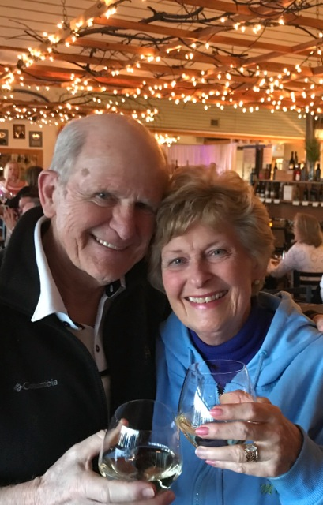

**John & Pat celebrate life at the OBX!  March 23, 2018**

 And we celebrate ***you*** **two**!!  God works in miraculous ways and is always at least two light years ahead of each of us while watching every minute of our lives.  Wonders and blessings.  Scott is a brilliant, caring, wholly dedicated and devoted physician as well as an involved, sensitive person.  We are blessed to have him on this planet and, right now, your neighborhood (you have to give him back when you get well!). Your aqua buddies

 Pat and John, you are in good hands: through our great God, your physicians and your friends and neighbors.  We stand by you and will be honored to do whatever we can do; we will be at your side. Thank you for this beautiful email and for sharing your struggles.  We join you in the fight. Love and blessings, Gail and Roger

**Know that I will be back often!   NEVER GIVE UP!  PV  
Aqua Buddies   I know rumors have been circulating around the neighborhood so this is the real scoop.  We really appreciate all your love and support.  No one has a neighborhood as great as ours.   Our special thanks to Drs. Scott Kruger, Fred Robinson, Theresa Emory & Dr. Palani, primary, for their advice and expertise.   Also to Dr. Janae Johnson who lives in Spencer’s Grant and did my biopsy. I see her house out my window & know her kids!**

Hi Pat, What a beautiful picture of you and John!  You two look just great.  And we pray this is just a little bump in the road of life. Growing old is a challenge.  Luckily you have a great faith in God, a loving husband, and very supportive family and friends. You have great determination, and I trust you will come through your treatments with grace and grit. And you will be in my daily prayers.   
Much love, Annette La Palm

Strange dual reaction:  Terrible news!  Great news!  Could have been soooo much worse, apparently.  Happy to do anything we can do to help. Rick Spatz

Sorry to hear of your upcoming adventures, Pat. Prayers all around. Exactly 25 years ago (March 5 or so, 1993. I remember June 29, his last day of chemo, much better) Charles got a similar call. Non-Hodgkin’s Lymphoma, out of the blue. His cell type was different and his disease very aggressive, but look at the guy 25 years later! Healthy!! Please don't hesitate to call if you want to talk.  I know the overwhelming crush of well-meaning friends wanting to tell you all about Aunt Sue or their sister-in-law's neighbor's cousin in Boise... so I won't do that to you! But we are in your corner and ready to step in. Lots of changes in a quarter of a century, but yes, you do have a great doctor, and I know that it is a beatable disease.  You are an optimist, a saving grace in this process. Steel yourself to just not letting the treatment get you. It will end (yes, it will) and you will look back and see some shockingly beautiful moments in the torment. I will stop my droning on... Prayers. Peace. Love, Ginny C

What a wonderful photo of you both and an inspiration for all! As I sit in the Atlanta airport waiting for my flight to Seoul, I feel uplifted by your spirit! Heartfelt positive wishes are sent your way. We will stand by you through this journey. Theresa Emory

Shedding tears of joy and saying prayers of gratitude. Safe travels! Love, Sherry Cowley

I appreciate this message from you and John.  I'm pretty much lost for words; however,  I'm thinking.  This could most likely be the reason I was moved to call Walter Wenk and tell him about the Kruger couple who needed a place to stay for a couple years.  AND…why Walt was moved to call the Krugers!  God Bless Us, everyone!!! Please keep in touch, by dear friend! ME Maryellen Smith

Sorry it took me a day to reply.. We are headed out of town for spring break. I think it never hurts to get a second opinion if it makes you more comfortable.. but I also think Dr K would be honest with you if he thought this was something that needed a big cancer center .. heme onc drs are able to treat these “ more common cancers and blood disorders “ very well and frequently ... if this were a rare subtype or something with very little research on outcomes or one that required an extensive / difficult surgery , i would advise going to a bigger center .. this to say , i would be very comfortable with him treating my family without a second opinion in this case but always do what feels right for you !!  Janae J.

Oh my!  You guys are amazing in your strength. Sending our thoughts and prayers for Pat and all your family.  Thanking you both for letting us know.  Gail Thompson

Thank you Pat and John.  What a wonderful letter.  Now we know more about non-Hodgkin’s lymphoma than we did before.  What impresses me more are the "thin threads of miracles" (to borrow John's words).  You have a new neighbor who happens to be an oncologist.  Your oncologist friend has the best bedside manner.  Your new neighbor could have been anybody but God sent you an oncologist.  You found that you can trust and confide in your friend.  How comforting it is to be able to rely on somebody.  Think of the people who are suffering who do not have a friend to lean on.  I had a friend who had breast cancer.  At the time we met, she was already 15 years into remission.  I saw pictures of her before chemo.  She had auburn hair.  After chemo, hair grew back twice more than she had before and was shiny platinum blond.  You'll look good in platinum blond I think, ala Marilyn Monroe.  Hope you don't mind the kidding.

Pat, you are unbelievable.  You never let on that you were having pains.  I think of that day when we were in Williamsburg for Jim's continuing education seminar (which he never attends).  You and John found time to spend with us to encourage Jim.  In spite of everything, you put others before yourself.  How lucky we are to have you, I've said that before and I will say it over and over again.  For my own selfish reason, I pray for your strength, health and happiness.  We need you.  And John Vaughan, you are the greatest!   Great husband, great caretaker, great human being. Priscilla Gaines

Yes, the Vaughans do indeed! Usually doctors are conservative.  So when they say it's good, then it's good. Love, Keenan Valentine

Hi Pat, Got news that you became ill, challenging, but good news is coming in from your doctor and hospital! You are in our prayers for complete recovery!   Love, Takao and Masako

Dear John and Pat, You are the most positive, inspiring, prayerful and appreciative people we know who rejoice in life and live it out to the fullest absolutely touching all those in your path and leaving your joy in them.  Luis and I have absolutely no doubt that you will beat the cancer, Pat, and help so many others with lymphoma as you go through your treatment.  It must be a time of high emotions and shock like you are living in a dream, but your determination, love, hope and faith will win! We are thinking and praying for you and your family and we know you WILL go to Emily's graduation on May 12th and be cancer free! With deep appreciation and love, Nia and Luis M

Pat and John, Thanks for sharing such beautiful thoughts about life and more specifically about your lives and your faith. We love you both and will continue to keep you in our prayers. Love, Dave Quick

Pat & John, We are praying for you. God still has plans for you. Emily's university graduation, you will be there. As for possible wick color, in China streaks of greens and purples seem to be popular with young people. Also they are doing partial shaves. Love Ya, Mike Valentine

Looking for the right words and have not yet found them but the message below was sent this am and will add to the list of 'messages' that Pat (and you) receive.  Worthy enough to send along.  Know that Myrna and I push and pull with you both (no-one can say they walk with you) in the expectation of bathing sun light. From an older guy as you just noted.  Love J and M Borling.

**To our Business Associates and Friends,   Some of you are new to the business and just beginning to understand what we mean when we say we are building the "Largest Friendship Network  
in the World.”  Like us, you probably joined the business for money.  You can make a little bit (I only wanted $30/month) or you can make a lot.   We certainly have.  However, in the end you will stay in the business because of the people.  Once again this has come to us in spades.  Two weeks ago our life dramatically changed.  In that two weeks we have learned what networking is really about.  
  #! Because we built the business we can choose where and how we live.  Because of where we live we have access to the best medical professionals to help us, and the best neighbors and friends to support us.  
  #2 Because we built the business we have friends and business associates all over the world to pray with us and for us.  
 #3 We have the best Nutritional Supplements to help us fight the battle.  
  Since you don’t know what your journey will be, build the business now so you too will have the tools, resources, and health to make your journey a successful one.  
God Bless.   Pat & John, praying for “another baby miracle."**

**Mary Vaughan (John’s baby sister) is the first of the family to go to Poland.  Their mother’s family is Polish. She has been lighting candles all over Europe.     
Mary, you have touched my heart with your devotion.  You have gone beyond the call of duty. Thank you a million times over. Your mom is smiling over you.**She wrote:  
Today we visited the Jasna Góra Monastery at Czestochowa, Poland’s holiest shrine and home to the black Madonna.  I lit a candle, had the priest bless the rosary I bought and said a prayer to the Madonna, who legend says, performs miracles for your successful treatment.    
LOVE YOU❤️❤️❤️❤️❤️❤️❤️❤️❤️❤️  
  
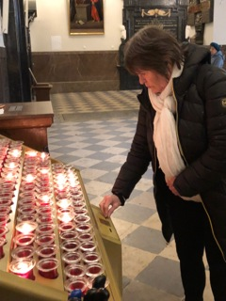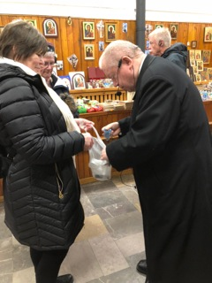  
  
  **Our journey begins tomorrow March 27th at 5 am when we go to get the port installed at 7:30 am at hospital.  Wednesday the chemo treatment begins at 9:30 am for 6 1/2 hours.  Thursday another treatment for 1 1/2 hrs. I will be mostly resting and taking meds for the next few days. We will see how it goes.   Our son Richard is coming Friday & Saturday.   His job is golfing with Dad.  My neighbor will keep an eye on me while they are out chasing that little white ball and whacking the heck out of it!  
  This has all happened in two weeks so we are a bit anxious and just doing what we are told.  I even have to take off my brand new nail polish for surgery!   Bummer!    
We are grateful for the prayer responses from around the world.  Today we got emails from China wishing us well and sending their prayers. It is wonderful hearing from longtime friends and new ones too.   Thanks for the funny and touching cards, flowers, and chocolates!  We don’t need any food yet.  There is very little I can eat and John has lots.  We are blessed.   So many people are on our prayer team John says God is probably saying, “I know, I know!  I got it!  Heal Pat Vaughan!  Enough already!”  Never enough!  
 Our son, John Clark, is home from Saudi Arabia.  The Williamsburg family came over for one last hug as they are leaving for Spring Break in Florida.  Johnny (11) gave me a beautiful picture of the Blessed Mother to watch over me.  He made it in Art class.**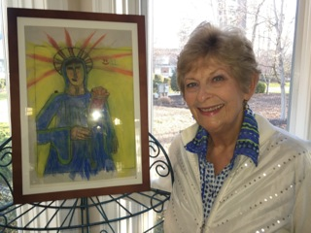  
  
**The bad news is I’ll miss my water aerobics buddies for a couple of weeks.  Just pretend I am on some exotic trip around the world!   “Mrs. Gotrocks gets a do over.”  
 The good news two of our sons and daughter are coming to visit in the next three weeks.   Gotta hug Mom (and Dad).   
Thank you again for all your prayers and support.   We are overwhelmed with your kindness and caring.   We have a BIG GOD and we are in HIS hands, HAPPY EASTER! Love   Pat & John**

Pat, Thanks for letting us know about your lymphoma.  I am adding you to my prayer list to lift you up daily to the Heavenly Father.  There is, of course, tremendous power in prayer.  I believe it is one of the primary means by which God’s will for His children is worked out in this world.

I agree that there is no better place to be, no state of being that is stronger than that of recognizing that you are in God’s hands.  He has a good purpose for every tribulation and trouble that we face.  We may not know what that purpose is or how he will work it out, but we do know that He is faithful to His promises.  So, when the believer can say with a confident heart that “My affairs and my life are in God’s hands, why should I fear?  The circumstances that he brings into my life are intended for my benefit.  Why would I question that He is not directing my path for my good?” . . . then that person is standing on solid ground and can count on our Good and Great Lord for comfort and peace.”

And I believe as well that calling on Him for healing is fully in accordance with His will and pleasing to Him.

So, that will be the nature of my prayer for you, that the Master of all things heals you in His time and His way, that you look to Him at all times for comfort and peace, and that He will reveal His purpose to your understanding when it is best for you.

Scott McMichael

**Thanks to all of you who are praying for me and our family.  Thank you to all who have sent cards, messages, and flowers.  Thank you to all the medical professionals who are helping me heal.  
Thank you God for sacrificing Your Son for all of us.   
 I have had my first “wellness treatment.”   Four or five to go.  Thankfully I am just a little wobbly and have a sore stomach, but not much else.  
No complaints only-- gratitude. I am overwhelmed by your caring and kindness.  The link I have included is a song sent to me by my dear friend, Pam Deaton.  We all need healing in some way or another.  Let it wash over you and share with others..  Pam calls it her ‘Go to” song.    Love, Pat & John**<https://youtu.be/YNqo4Un2uZI>     
  
  


Wishing you and John the very best. Earl Rogers

A VERY HAPPY EASTER to Pat & Jack! Thoughts and prayers for you and family. Good time to remember ALL and hope that all goes well for Pat…. Our church service this AM made us think and pray for all ‘rellies / friends’ in these tough times. It all comes / A G E …. Sounds like you have great medical folks like we do right here in TC… Just a great feeling…. Love to ALL…. Ken & Stewie

Amen again! It is good to be loved... Easter is our time for new beginnings! Pat Ward

Aunt Pat, Hope the first treatments have gone well and the chemo is targeting the cancer cells and kicking butt. We are thinking of you today (and every day) and continue to sends prayers for your health and quick recovery and treatment. Please let us know if there is anything we can do to help. Love and prayers, Joette and Tommy

We are praying for both of you in this time of anxiety and unknown. Have faith and turn it over to Him. We love you guys!......... John and Pam Walker

Dear Pat and John, You have our prayers, so that everything goes well and Pat, go ahead. Fortunately nutrients Nutrilite, help us maintain cellular health, despite chemo, God with you. I have waited a long time to write a well-written letter in English and tell you that we are very grateful for what John did for our family by teaching us the business. That we feel his affection and good will and that he is reciprocated. I am confident that Pat will win, because of the love that has united you and because you are together. I toast with you for life. We love you, Hortensia and family

Dear John, I am Jiang Hongjie your Diamond in China. Thank you very much for sharing the Amway business with us so that we can all lead a happy life today. I heard that your wife, Pat, is sick. We are all very worried. We are all here to pray for her and hope that she will recover soon. I love you. Jiang Hongjie

Dear brother, we just got your Easter card, so loving. My tears started: knowing that your journey has started, knowing that it is treatable and knowing that you are the best support Pat can have (& your note taking is epic!), Knowing that your children will be there for both of you. This is the beginning, we pray for you both to have strength. You are a beautiful team. Thinking about you & Pat all day, love you both 💕 Ginny L

Hi Pat, Thanks for sharing in order that we can and will be praying for you. I don't know how people make it through trials without that relationship with God. My prayer will not only be for restoration of health but also a stronger relationship with God, which He allows and seeks through trials. I have added some verses that are very close to me and strengthen my faith. Through this time surrender completely to Him that He may heal both physically and spiritually. Be that light to your family and friends that God may be glorified through these times. You are in our prayers, Bob and Millie

**Subject:** **WONDERFUL!** Now is the time to start blasting the Hallelujah Chorus on every handy device ... my personal favorite this time of the year especially. Could not have received happier news ... and wonderful that you both have loving  family and staunch friends near and far to make this journey with you. Our thoughts and prayers are with you all the way...  Nick and Linda K

And I’m in the chariot behind you!!! Please God! We’ve been good! 🙏😍🌺😇 Pat Ward

Pat, I am so sorry to hear of your troubles.. There really are no words of consolation that will alleviate your fears.  Having been a caregiver, I know your journey in this dark place is not a joyful one, but at the end, once your body begins its recovery, you will embrace all the small moments in life with family and friends.  Those everyday moments in life that held no special significance, we savor again and again.  This "bump in the road" is no small one, but I know your strength and courage will persevere.  Dreena          "The human spirit is stronger than anything that can happen to it".  C.C. Scott

Pat, I just finished early Mass and gave thanks for your healing. I started to ask for healing and thought “no, no, instead give thanks". Sending you lots of love. JoAnn  L

Pat, This Easter will truly be a blessed one for you and your family.  I will be thinking of you all and continue to send prayers and positive energy your way.  I hope your treatments go well and you don’t suffer too many side effects. With love and hugs, Kerry Lannin

Good Morning Sweet Friend, Just making sure God's had received one more prayer for your 1st chemo treatment.  Just picture the meds flowing into your body are actually little "Pac men" gobbling up the bad cells!  They are shouting to each other as they race along... "I GOT THIS ONE".  "I GOT THIS ONE! ☺ Prayer is the place where burdens change shoulders!  Hugs & Prayers, Donna & Lloyd

We surely did miss you and send you tons of love! Wine and Dine

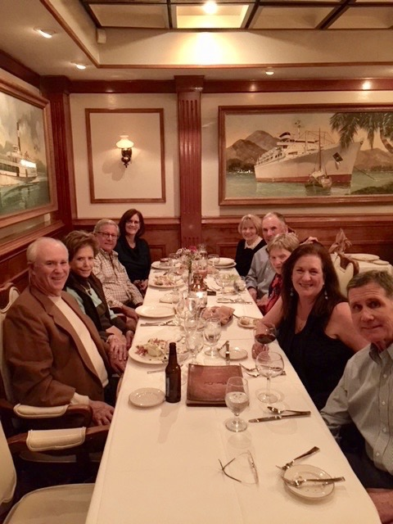

Morning Pat.  Thanks for sharing your journey with us and all of your Friendship Network.  Rest, read, and rest some more.  I know you’ll picture Mother Mary telling cancer, “Not on my watch!”  She could use her wonderful crown to do battle.  Next picture the chemo handing onto Mother Mary’s dress hem doing battle right along with her. God’s got this – and right now she’s one angry super Mom!  J Leland

Dear Pat, Thank you for keeping me in the loop, and it sounds like good news about bad news! I didn’t realize you did not know Dr. Kruger all that well, but it sounds like Divine Provision that he just moved in to your neighborhood! In terms of sleep, I recommend that you start with the sleep solution, but use the prescription medication if you feel like you need it. Is it something like Ativan? This type if medication has a down side in terms of cognition, but there is more of a deleterious effect from not getting sleep, especially when going through chemotherapy. Keep eating your bulletproof diet with lots of veggies and keep exercising as much as you can. And the best thing of all in your favor is all the love and support and prayers you are receiving from friends and family. You will get through this just fine! Blessings, Jennifer

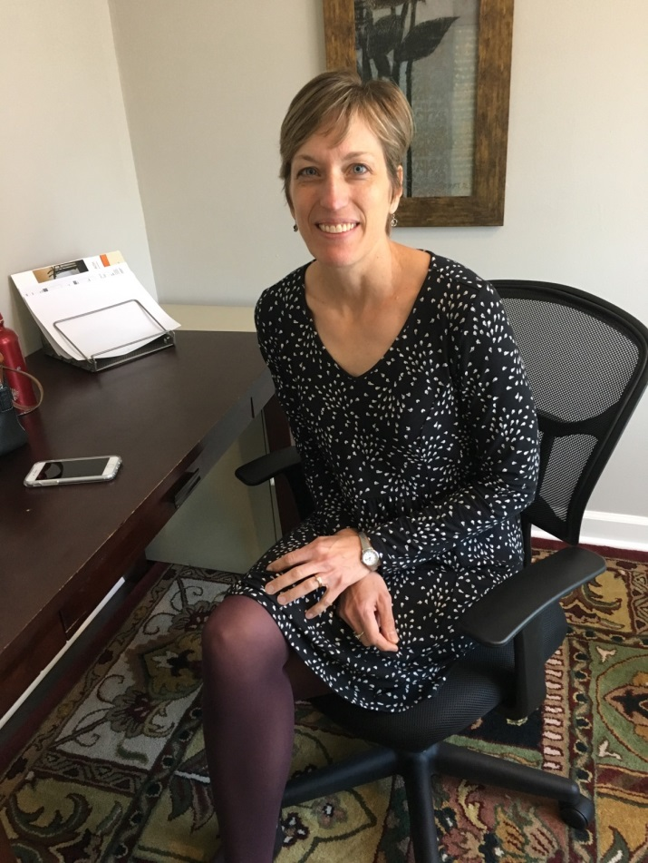

Most of the meds you listed are for use as needed. I am not sure why the Zyprexa. That is used for psychosis and sometimes for agitation. Avoid using if possible. The Ativan can help with sleep and anxiety. Reserve for when you really need it. The Zyloprim is for use with some chemo. Other meds are for nausea—only if you have that as a side effect from the chemo. But you may not have any problems except for fatigue. The nurse will know what are the common side effects with the chemo you are getting, but remember, this doesn’t mean you will have them! Jennifer M

Good morning Pat and John.  Thinking of you on this Palm Sunday.  Jon has prepared these Lenten Reflections for each week of the Lenten Season for our Choir members.  I thought you might appreciate these reflections too! God bless, Dottie Holstine

Pat, This is an amazing journey you and John have been on.  This is truly how one knows there is a God!  Sounds like you have the wick thing figured out.  However, in case you’re not aware, The Sentara Wmsbg Auxiliary operates the Unique  Boutique for cancer patients; by appointment at Sentara hospital, run by cancer survivors So they’ve walked a mile in your shoes. If you’d like a contact #, let me know. Love the picture at the end. Prayers from Colorado. 💖❤️🙏 Neva L

Good Morning Pat and John, Just wanted you to know I’m putting Pat on the prayer list for my Bible Study group. It is a wonderful group of women, and it’s always a good idea to have a long chain of prayers. While I know it takes time to manage the immediate future, I hope you know how much you both are loved, and that RE is ready to jump in and help out. Please, please let me know if there is anything I can do to make life easier for you. With blessings and love, Mary and Wayne Williamson

Dear Pat & John, We were very saddened to hear about the news of Pat’s illness and you are in our thoughts and prayers. Last November I too was hospitalized for over a month, in rehab etc and am on dialysis for now, but it’s with prayers and good thoughts of family and friends that I am slowly recovering. Our faith in the almighty helps us through and will surely see you through this ordeal as well. You both will be in our thoughts and prayers. My husband Sharookh was at my side all along and our partners go through as much stress as we do, so John take care of yourself as well and keep us posted and let us know if we can be of any help. Warm regards, Sharookh & Zenobia L

Hi Pat and John, thanks for the update and so sorry about C… aarrghh.  You have an amazing attitude and outlook, and have thoroughly consulted experts!!  Sounds like you’re in “good hands.”   Having been down the chemo and C path, I’d be happy to talk with you about anything you may wish.  I’m also available to go with your to treatments, if needed.  Although, I know how important it is to have a partner/scribe/advocate. A couple quick notes… a port is wonderful!  I couldn’t have gone through everything without it.  (I semi-teasingly ask doctors if I could keep the port since it’s so convenient.)  As for a “wick,” ;-)  You might contact the Unique Boutique at Sentara Williamsburg.  They provide free wigs, hats, scarves. We continue to hold you close in prayer. May the peace, hope and joy of Easter fill your hearts, Terri and Stan Goodwin

Wow what a pathway! We thought you were going to visit us in March after Grand Rapids. Guess it sort of got pushed to the back of our thoughts because Ken just finished his 25 days of radiation and is recovering to a regular plumbing behavior.  He is doing great except for an interrupted nighttime schedule of urinary urgency. We are grateful for our new and well stocked (with oncology Drs) Cowell Cancer Center. It has drawn new Drs to add to the already exceptional group we had. Now we are on to another C problem and it is me. I will have a MOHS surgery in a few days. It is a skin cancer on my face that my regular dermatologist took a sample of last week. A lot of thankfulness for the nudge to get my usual skin "look over” scheduled.  When I saw my Dr at church, I told her that we had missed our appointments because of Ken’s prostate program and her office said they were scheduling in September! So she gave me a secret number to get in NOW and it worked. Just saying, God does hang out at church. It helps that her parents are good friends, that she went to school/Connie and Goudy and that we went to her wedding. My Mother, and that is a capitol M because she was a capitol MOTHER, had many bouts of cancer and seemed to breeze through much of it because she believed that God was leading her to the best treatments and telling her that she should relax, be helpful to others, (I can’t imagine God having to tell her that) and enjoy life. I used to go to chemo with her, and the first thing she would do was head for the refrigerator, pull out a cold cap and clamp it on her head.  She never lost her hair or her smile! Boy do I miss her!! Many thoughts and prayers go out to you and your successful treatments. Relax and let God hold you in his hands. Love Stewie and Ken

Dear Pat, We have heard from Bea B that you are not well. Please know you are in our prayers and we hold a vision of you healthy and vibrant and mischievous as always. Our love to you and John and your family, DeeDee/Diane Levine and Richard Reitman "Out beyond our ideas of wrong and right, there is a field. I'll meet you there." - Rumi

Discernment will be the top of the list! Hugs, L & D Claypool

Pat, I just learned of your diagnosis. I am so sorry to hear of it, but as you say it is treatable. I will commit to praying for you and John. Please call us if we can be of assistance.

I would like to recommend watching Jeanne Robertson on YouTube. She is quite funny. They say laughter is good medicine. Below is one site.

<https://www.youtube.com/user/JeanneRobertson> Blessings, Sue Lind

I bet it is overwhelming.  Going to be a journey.  But we will get through it.  One step and breath at a time. Any way I can help?  I talked to Glenda today; she knows Dr. Kruger and says he is awesome.  So great choice there!  ☺ Julie

Hi Pat, Thinking of you and hope you are feeling well. Glad to know your results are favorable and know we are keeping you in our thoughts and prayers. Keep us posted and if we can do anything please let us know. Love, Donna & Bob Pusateri

Pat - So relieved to hear you are treatable. And I’m sure your “wick” will be dashing! You are wonderful friends - will keep sending those prayers up for you & yours! Arla Harvey

The curable lane is good!  Knowing Susie, she will want to straddle the curable with the fast lane.  May the joy of the Lord continue to be your strength! XOXO Becky Valentine

Hi Pat, Well that is surprising news!  Here's hoping and praying for everything to go well with your treatments, and that the treatments don't treat you badly.  You're such a positive person - so like your mother - and you are really meeting this face on.  Wishing you the best outcomes! Corrine Sailus

Hi, Pat & John,

Bea just forwarded your message to me. I am so sorry to hear this news but so happy for your faith in God, your attitudes, positive thinking and desire and goal setting to see EMILY graduate!

I will be praying for all of you! I have so many fond memories of you both and love you very much!

Love you, Darlene Woodall Allen

Pat we are just in ahw that you are going thru this how times if our lives change in a heartbeat....but most of all that things are under control by our wonderful medical people.....you will be just fine we promote our prayers your way ....hugs from us both. Many hugs to your wellness trip know all will be good again have faith it really will be good....we never gave up on our quest to get Don help and finally all come together... Love to you both for your friendship thru the years in the business even as small as ours is and just think where we might be W/O Nutrilite!!!!! Thru the years...you both inspire us both always......hugs Verda and Don

Dear Pat and John, Wow. I am just learning of your new mountain, NO, mole hill, to conquer from the attached email. As you have served us (IBOs) in so many ways, you were serving God. I know Jesus died for your healing and I am decreeing and declaring your healing. So thankful that you and John were listening out for the steps God had already ordered. I have inserted myself into your prayer warrior team. Love, you both, Yvonne Brooks-Little

Pat and John, Thanks so much for your very inspiring email. You are truly models for all of us. Know these are Difficult times; as you know; you have many friends because you are friends first. We are all so thankful for good doctors and modern-day medicine. It is so nice to have such talented and well-known doctors right here in our neighborhood of Kingsmill. Pat, you will look wonderful in your new wig. Better than the rest of us with thinning hair. Thoughts and prayers are with you both. Barbara V and John T

Pat and John, I read your email several times to grasp what you were sharing. Certainly I knew something was up with the prior emails from Neva and others. I am sorry that you have this cancer but I am thrilled that it is treatable and that you are aggressively getting started. Both of you are terrific people, smart and know how to get things done. Pat, you have been masterful at telling all of us how we can help our fellow neighbors. Thus you must continue to tell us how we can help you. If I were there, I would hang a chicken on your door as you did for us.

John’s research skills will be very valuable and I am confident with VA Oncology and John, you will be in knowledgeable and skilled hands. The two of you are some of my heroes. Please know that I care and that I look forward to helping as you travel this new journey. Stay strong, hug often and continue knowing that God cares and has his hands around you and your family. Love, Betty Ann Davis

**Thanks John, All good wishes and hopes for all of you. Oncologist says he will heal her… The doctor is right. JIM and HANNA**

Happy Easter! We are joyfully saying prayers of thanksgiving. Life is a precious gift and we are so grateful for the lavish gift of John and Pat. Love you!  Karen & Keith B

Pat, you are in our prayers.  You are in God’s hands.  He will light the way for you.  We love you and John very much so he is in our prayers also.  Love Jon & Dee

Hi Pat! I'm so happy to hear from you and that you are doing well. Cale sent us your email about your diagnosis. I can’t believe you were dealing with that during the conference!!! What a testimony to your love for your team and your belief in the business.

I am so very sorry about the health challenges- I'm sure it's a whole new world for you guys to learn. But what a blessing about your neighbor, and that you are feeling well.

I want you to know that I am praying for you, and our church is praying too. I believe you will be victorious in this fight! I haven't known you very long, but I can see that you are a heroic and determined warrior and that your heart and mind are STRONG.

I am so glad you had a blessed Easter with your family. Melody

Pat I just want you to know I am praying for you and I know you are gonna make a full recovery because god has the power to do anything. Love you guys and you all are in my prayers. Cody

**As Greek Orthodox we will have Easter on this coming Sunday and so you will have another Easter's worth of wishes for "The Velvet Hammer". Jim and Hanna**

Pat, thank you so much for sharing that fantastic version of It Is Well. I have never had so much touch me before from that song as I had with that version. It's a beautiful song to start with and with the passion with which that was sung really moves a person..... John Walker

Hope you are having a good day.  Been using meditation to rest.  Very healing. God is good.  💕👍🙏👩‍🏫 Team mate! Pat Ward

It is well with my soul and very well with ***your*** soul.  One of my favorite songs in this world.  You are in our nightly blessings and prayers and in our thoughts during the day.  You are strong; you are blessed; you are loved. Standing beside you (and waiting for anything we can do for you; you have but to ask!). Love, Gail and Roger

Thinking of you today as the message is hope for the future... Hugs, Cheryl C

Pat, the music is beautiful - thank you, and so glad to hear you are getting the treatments you need to heal!   God is good and answers our prayers..... Mary & Bob Buenting

Praying for you as you continue the process of healing. Knowing that you are in His hands and good hands as He has directed you! Blessings to you and John and your family! Cathe Myers

You are a brave and spiritual friend! My prayer is for healing for you! Your pathway is before you. God bless you and John. Blessed Easter wishes from us to you and your family. Love to you, Joe & Mimi

I am devastated to hear this news.  My dear SORORITY LITTLE SISTER means so very much to me.  I have been through some tough times and know John Pat and family will prevail.   Please pray for the entire family.  Hugs dear friend, Dawn H

Looking forward to your good health returning soon. Prayers on their way. Richard Reitman and Diane Levine

Hi Pat. Love your positive attitude. You and your family continue in my prayers. Love the song. My church choir is singing "Bow the Knee" next Sunday. Look that up on YouTube and then refer to Jeremiah 29:11 and that's where you are right now. Ken McMillen

Good morning, Pat. Some days will be a monumental struggle, but I hope this is a good day for you... Dreena B

Good Morning Pat: Thank you for the beautiful religious songs.  We all do need a little healing in one way or another. Glad to hear your treatment went well and you are healing and feeling ok.  Will keep you in our prayers. Love, Donna & Bob Pusateri

John & Pat, Prayers for you again this morning🙏🏻 Hope you had a blessed Easter. So good to know your faith is strong and trusting God is in control. Family here at the condo this week celebrating Easter, John's 70th and his retirement 👏🏻 Of course we want to be on your update list. Blessings, Hugs, and daily prayers for you, Norma Teerman

Happy Easter to you too Pat. Just want you to know that we've been thinking and praying for you. God Bless you and your family. Charlene & Carl Zdunczyk

Pat, Thinking of you and sending continuous love and support . . . Love, Pat & Betty K

**So many good things are happening as a result, I have no regrets. Every day I am in awe. Today I found out the pharmacist that handles my meds went to school with son John C in Poquoson. We even met the dr that bought our house & got to tell him what a great job he did.  He works with my dr. I have heard from people for the first time or ever. Friends called from France & we talked for 30 min   I loved your card.   We are praising God for where ever this leads us.💕💪🙏 Pat V 4April2018**

Just to let you know you are loved from Kandetsteg! Sue Goodale

Please keep Pat Vaughan in your prayers. She is battling the big C.  cid:2691B4C4-812E-4144-8737-7E6527F3CD1C🙏🏻cid:2691B4C4-812E-4144-8737-7E6527F3CD1C🙏🏻   
She’s quite the trooper, having strong faith in our Lord. We all love her dearly, she’s a beautiful soul. And pray for John and the family to keep them strong and understanding as they go through this journey with her. It is treatable, so send all your positive energy to her. Thank you. Dee M

[**Laurie Boehmer**](https://www.facebook.com/laurie.boehmer.7?fref=gc&dti=1427031227562609) Plenty of prayers going up with Pat’s name attached!   
God bless her in this journey and the healing needed! Love her lots!

cid:11A32F39-FD1A-4006-8C72-A424FD5611CC

[**William Ellison**](https://www.facebook.com/william.ellison.794?fref=gc&dti=1427031227562609) We love John and Pat, too. Will certainly lift them up to the One who can cure and comfort all. ( One side note on the "light" side: two fond memories I have of old times with John and Pat are (1) at Seaside one year [ I think it was 1999 ], they held up a can of a Goya product and introduced a handy acronym-- "Get Off Your Ass ! " and naturally I think about this every time I pass that shelf in the Winn Dixie,....and (2) helping give a tour of their former house near Virginia Beach ( John arranged to have a camera man in a helicopter to take a group shot of a couple hundred of us waving from their backyard....a treasured picture in my collection.)

Pat, I am sending you good thoughts and wishes that you feel better soon from your first treatment.

Tom retired April 1st and will also be around as he settles into his new lifestyle…so since he too is well acquainted around the kitchen, we will connect with you in providing you a dinner soon.

In the meantime, I will keep you in my prayers. Gloria Johnston

Pat. These are the words I think I want to offer knowing that you will be inundated by well-intentioned words. Many of them will be valuable and the prayers meaningful.  Dear John will be more than steadfast but in the reaching deep process, there can come a great personal and abiding wonder and release.

It is the seeking out and finding of 'wonder' and the letting go that so enables the spirit when pain and death come knocking.

So a few words follow I know to be worthy, mindful of everything else that will consume you--and everything will.  Time will speed and energies will flag given endless Doctors and meds and faith and friends and family and lists and business and more.

So be selfishly sharing as the fun (and necessary) part is in the 'how to' do the seek and find.  It is a singular journey of feeling--thoughtful, even intellectual at times, but mostly, just feeling it.  You can share with those stern enough of spine to pursue an almost childlike joy--but mostly it's just yours and so are the benefits including the cure.

The wonderful part is that you have all the ingredients right there at River's Edge.  Your yard, the trees and grass and OH the water--- the moving river, make them yours in a special and intimate way where you let the earth take from you the cursed cancer and give to you the the abiding goodness of God's great physical nature.  It is a personal pantheism that allows for CREATION (and it's time for journals or videos and the like) but more--- that expression of the soul in whatever form you choose.

I favor making piles of stones and sticks and whatever--little or big monuments.  Go to the woods (mind the copperheads this time of year I would imagine so use a walking stick) and find/build your fort.  Spend time there hopefully with river view.  Walk the river’s edge going as near the edge as you can and then purposefully dipping in.  Find a rock and spend splendid solitude with the waters and the infinite current of life.  Later throw rocks just for the hell of it.

Now the modestly daring part, and so important, like making, but being an angel in the snow.  Regularly, lie nude in the grass in your yard in the warming sun and let the healing earth bask you in that reciprocal process of letting go and taking in.  No schedule--do it when and as often as you feel like it.  Go take your clothes off and lie down, with movement or no, and let the gentle meditation of nothing but oneness with the earth do its magic.  This is your very special rejuvenation time.

As you become experienced, you will become teacher.

It's all waiting for you--go get it.  Courage.   John B

Hi Friends, Not soon after it was delivered, Pat texted that her quilt makes her so very happy.  
Today’s sunshine sure has been delightful! A good day to have a good day; don’t you agree? Here’s hoping she gets many more good days. We all know from experience that loving support goes a long way to help when someone is sick. When Pat can feel wrapped, literally, in our love and support, we can be assured that we are doing something, aside from our unending prayers. Including all of you in this quilt was my intention from the very first stitch. We’re in this together, after all. And thank you for all your kind emails. Love, Sherry C

Dear Pat and John: Dearest Friends:

Thank you for sending your letter. I am sorry to hear your sad news, but I too am very positive--that with your excellent medical staff and family all is very positive.

May God wrap his loving arms around you with his healing powers. I too lift you up in prayers and love for all of Gods blessings. You are the most loving, strongest and giving family that I know.

May you find much rest and calm and peace in the days ahead to be ready for "Emily-- May 12".

All will be well. Love and Prayers with Blessings, Always, Jean B

Prayers have been lifted for both of you and your family. I pray for complete return to health. I miss you guys but love you just the same as always. Hugs, Nancy Z

Hi Pat, It's truly a privilege to be just one of your warriors!!  Such praise you have the treatable type!!  I just love how God puts people together.....your new neighbor!  ☺ Special prayers on Wed.!

 We have a direct in our business, Carolyn Blank, who had the same cancer a few years ago. I called her about an hour ago to make sure and it was the same type.  If you would like her email, I'm sure she would love to share her recovery!! :} Hugs Attached, Donna Claypool

Hi Pat, You are too kind!  Enjoy yourself at the beach and we wish you the best during your upcoming treatment.  You've been so welcoming and generous to us! We are in town until 3/30 and will return on 4/7.  Have a wonderful Easter, if we don't see you before. Janet K

Dear Pat Vaughan: I'm your downline in Shanghai, China. Very appreciate that you bring this opportunity to us.  Lots of people have better lives because of Amway. I wish you more health. God bless you. Gregory Huang

Dear John teacher and wife! Greetings! Thanks to the care of the teachers, thanks to the teacher's choice many years ago, our brothers and sisters have spread all over the world today. The team in the Chinese market has also been deeply rooted in the enlightenment. Our business career continues to progress under the guidance of Fu Yan and Mike. Flourish. I wish my dear teacher a quick recovery! Family happiness! all the best! Gratitude...Partner from Henan, China - Tan Longwen

Pat and John, We are praying for you during this challenging time. May you and your family find peace in knowing that God is in control and He will see you through this. Keep that positive attitude!! Tom & Joyce Heigert

Thank you Pat! I am so thrilled that you found your mother’s rosary! And so happy that you are praying the rosary. I have seen major miracles and prayers answered for me personally, my family and friends through the rosary.. The Blessed mother always hears you. Take nice long walks on the beach and also is a good place to pray the rosary. Miss you and I will see you for wine and dine.❤️❤️❤️ Suzy K

You will do well with all your support. Attitude and Night. Keep on trucking Girl. Ardeth Watson

Hello John and Pat! I'm so sorry to learn of Pat's health concerns; however I lift my voice, my prayers 🙏🏾 and my heart ❤️ to our God, through Jesus Christ our Lord and Savior on your behalf!! He is Lord of all, and in charge of all. So He has Pat's health and you John - her soulmate in His control. I will surely continue to call your names daily in my prayers!!!

I pray now: Dear Father God, we Praise and Glorify your Name now, and give You all Honor!! We thank You for the lives of John and Pat Vaughan, and pray in Jesus' Name for Pat's complete recovery from her illness!! Oh Lord, please be in charge of her health team, and give them Your wisdom as they provide medical decisions and courses of treatment!! Lord, we love You, and we know you are healing right now!! In the Name of Jesus, we thank You for hearing and answering our prayers and petitions!! Amen, and Amen 🙏🏾  With Love ❤️ in my Heart Always, Yvonne Bryant

All of your neighbors are praying for you and keeping you in our thoughts for all the best! Mary Ellen Beale

We put you on our prayer list. I thought you might enjoy seeing the prayer. I see you surrounded by healing white light. Love and blessings, Dee

Please hold Pat Vaughan, a friend of Dee Babel, in prayers of healing, joining both Pat Vaughan and Dee in claiming and affirming Pat's divinity and wholeness. We affirm that God's healing energy is now flowing through every cell and tissue of Pat's body, transmuting any blood cells that do not function in accordance with or in alignment with the divine nature of her body. We see Pat functioning with renewed energy, able to breathe easily and fully receptive to any medical treatment that is divinely determined by her medical support staff, all in accordance with Divine Order. Namaste, Steve

Dear Pat, I miss you and hope you’ll be back to water aerobics before too long. It’s just not the same without your big smile. I wish you the easiest possible journey back to your healthy, vibrant self! Bobbi

Norb and I are thinking about you and hope the gardenia blooms will begin opening and spread their sweet fragrance (in your home or on your terrace). Missed you and John last night. Hugs, MaryEllen

Hi Pat, Thank you so very much for the nice card and warm words.  We hope the start of your treatment is going well and that you are feeling okay.  We are wishing you a full and complete recovery and few, if any, side effects. Scott is available round the clock to help with any issues that arise. Wishing you a blessed Easter and time with your family……. Janet, Scott and Daniel

Hi TeamP!

Hope you are ok. Rough week for me, I thought I had an easy week, but found out m Potassium was dangerously low, so spend 6 hours hooked to an IV.

My next bout is Chemo on Wednesday; I go to Riverside on Kings Way. I really love my nurse and the small room I get to be lazy in.  I pray your sweet little body can handle all of this poison, I certainly don't understand any of it.

As I was leaving the oncologist I ran into Lloyd and his wife Mary. They go to DR. Miller as well.

Please remember if John or you need anything, we are here~~~always.

I ate a decent meal for the first time last night, Hope I can keep it up. Hugs to you all!

Pat W

Pat,

Just wanted to take a moment to tell you that we are all thinking of you and hoping that your quality of life does not suffer during your treatment.

You have always been the leader of the Aqua Ladies and your absence is obvious and sorely missed.

Do you know when you will be allowed back in the pool? Will you have to abstain until your treatment is finished?

I realize you must be getting a lot of cards and notes, so you don’t need to respond to me. I just wanted you to know that I cared and am thinking of you every time I jump in the pool. (And at other times, as is obvious since I am writing this note from my kitchen table. :-))

We all know that no one is immune to health issues. We are just all thankful that what you have is treatable. Let us know about your progress. We continue to miss you. Joann

Hi Pat and John, Thank you for the update on your treatment.  I wish you the best and will keep both of you in my thoughts and prayers. Happy Easter! Love, Lucille Szoke

Pat, you are so good with email responses. Thanks for keeping us up to date. Happy Easter and the best of everything to you and your family. Carol and Bob Palencar

Dear Pat and John, You are in my thoughts and prayers.

From your earlier message, it sounds like the journey won't be a vacation at the beach, but the outcome *will* be good. I can only imagine that all these years of Nutrilite *must* have had a positive (as in good) effect!!

For what it's worth, a dear friend's son fought the same illness in his mid-20's and 20+ years later is still fine. Ditto, for an acquaintance's husband (he was much older---still doing fine).

Pat, I know you can do it! Sounds like you have the best doc going, too! I am cheering for the Vaughan team!! Love, Candi

John, Thank you for sharing this information with us. Barbara and I are sincerely saddened by your note. But we are delighted that the cancer has been diagnosed as treatable; that is good news.

I know Pat will come through this with flying colors; no doubt in my mind. Pat is a very strong lady with great character AND she has you. Don’t underestimate your strength. You have seen adversity before and you know how to handle it; you will guide Pat through this and together you will be successful.

Pat and you will be in our prayers and thoughts. While you have a very supportive family, if there is ever anything Barbara or I can do, please let me know and it will be done. Give Pat a big hug for us. Scott and Barbara

Light those candles at Gornergrat, Switzerland Even at 11,548 feet elevation!!! Bill Goodale

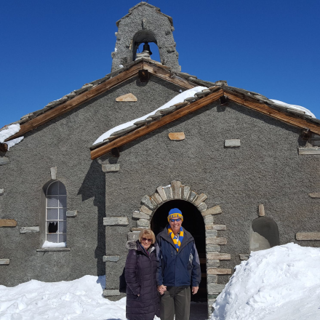

Dearest Pat, Thank you, Thank you for including us on your “list”. It brings us pain to realize that you must take this journey but we will be on it with you: Praying you joy, peace, gratitude, grace and healing. You and John, among all our friends from everywhere, are among those we hold closest to our hearts. We treasure every memory of you. You have been so supportive of us in many ways. Especially now, as we hold you up to the Light, we recall specific times. Jackie remembers the spot she was standing in our family room in Decatur when Pat called as she faced that diagnosis and surgery in 2000. Both of us remember sitting on the side of our bed in Hamilton Mill when John called to talk with Jay as he began his journey with that aggressive leukemia. As we think of you, it is with the same joy and gratitude that we weave into every day.  We love you and will carry you around in our hearts on this journey. Jay and Jackie

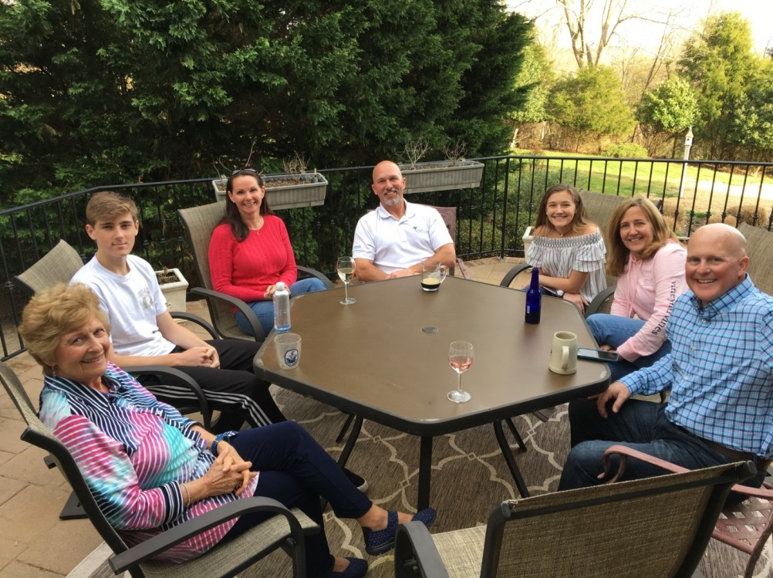

**Picture 1 above: Son Mike from Iowa (on right) and his Seaford friends visit Pat 6April2018**

**Picture 2 below: Pat and Dr Scott Kruger 9April2018 (First visit with Dr was on 13March2018).**

**Picture 3 below: Pat and PA Lynn Kelly at “Chemo Training” 23March2018.**

**Picture 4 below: Pat enjoys two get well cards from Nick Kobylk.**

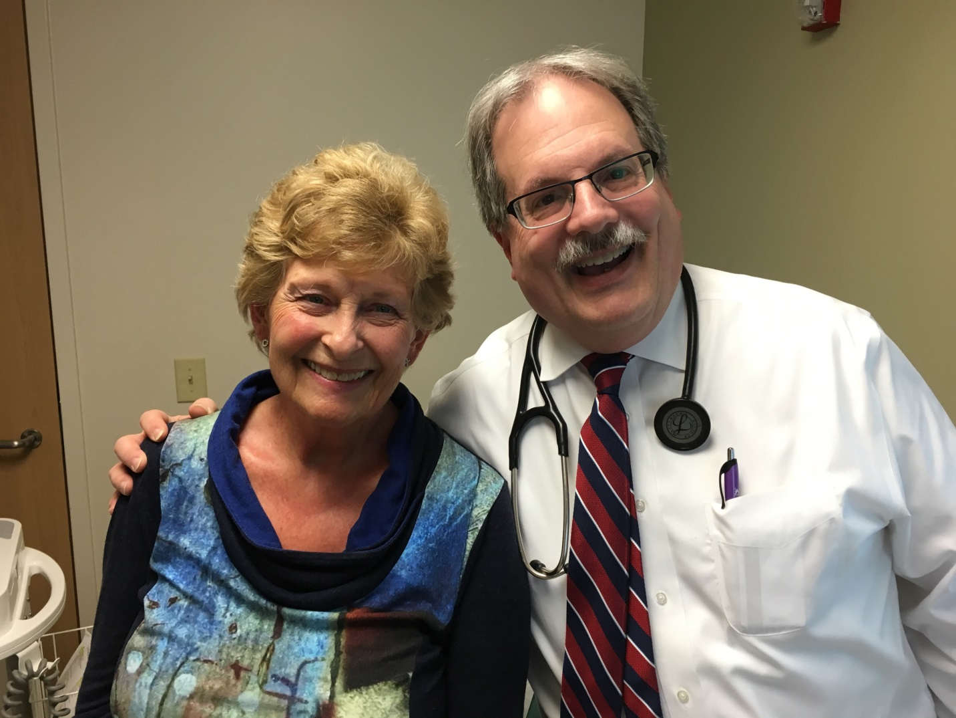

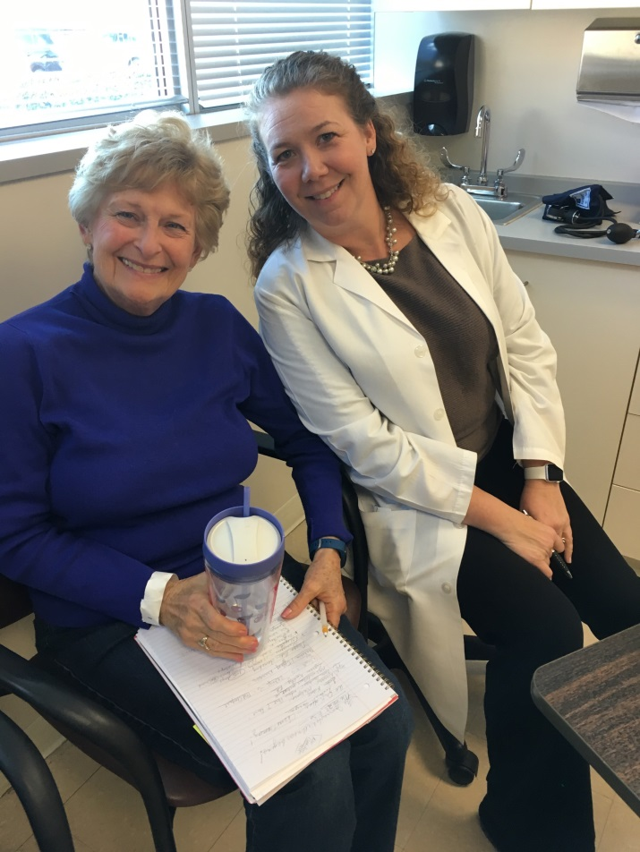

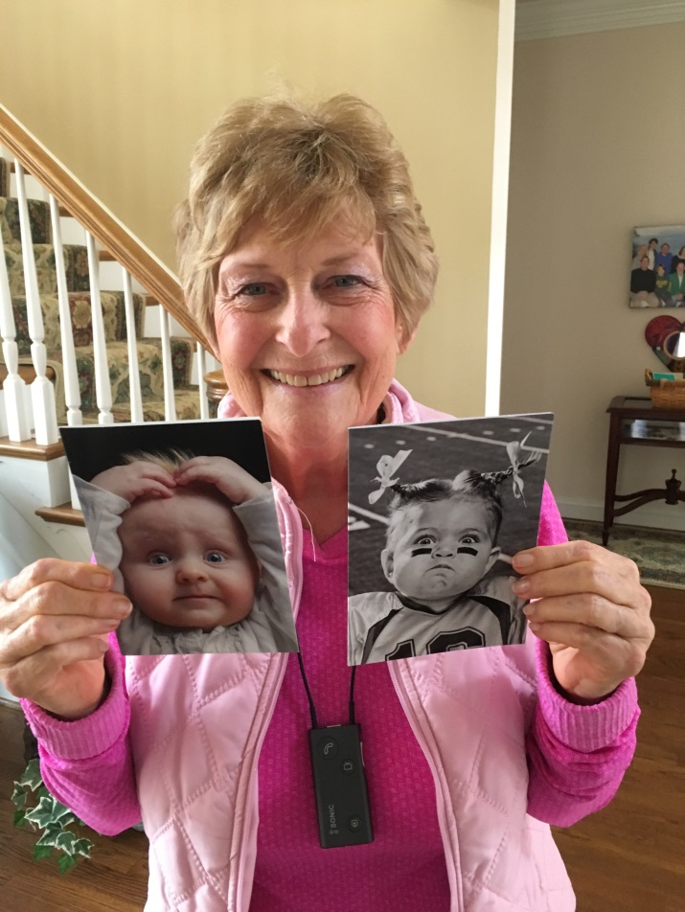

**Great news!   I got an A+ from Dr. Kruger today!   All my blood levels were great.   He said I looked great and he would see me April 25 at 9 am for my second wellness treatment (my description).  Came home, ate a delicious meatloaf dinner by Chef Tanya and had a 2 chocolate cookie celebration!  John asked him what would have happened if I hadn’t pressed my primary to investigate the stomach incidences.  He said the stomach pain would have increased (gone now) and it could have spread to the spleen, liver, and bone marrow.  I thank Pat Ward for scaring me with her diagnosis.   Her only symptoms were indigestion and a sore stomach.  Please pray that her treatments are effective and her pain goes away.  
  
We will be heading for OBX our daughter from CA on Friday.  (2 sons visited last 2 weeks)  
It was great spending time with them.  We’ll stay at beach sucking up +ions for the rest of the week..  “Nurse Bob” needs a break!    I won’t be back to water aerobics for a while.   Dr would rather I walk for exercise than get in the pool.  Thankfully the weather is warming up and the trees are starting to look wonderful. PV 9April2018**

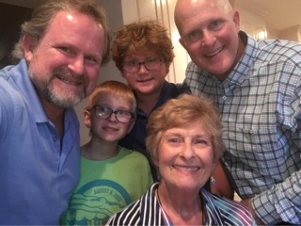

Good morning, Pat, Ron and I are thrilled to know that you have had such good news from your doctor and that you are on your way to the Outer Banks too!  Hallelujah!  I hope the weather will be nice and that you can get some good walking in there with your daughter.  Things are always fun when ones daughter is in the picture! Take care, we will keep you and Pat Ward in our prayers and do have a good time at the beach. Lovingly, Eleanore J

Congratulations to you, Dr. Kruger (you have to give him back, you know😊 when you are finished with him) and your family. Please know you still have a lot of prayer warriors out here routing and praying for you. Every day. I hope your OBX week is filled with laughter, soft spring weather and loving family. And an occasional bird or two floating by. Deep breaths and lazy, healing days.

God is good. Love, Gail and Roger Saunders

Pat: This is music to our ears!!  Keep up the forward progress!  😉 Mike and Linda Whittaker

You are wonderful people and you have the most important medicine....faith.  You have the true Physician.  The peace of knowing that you are in His hands should strengthen you both.  Theresa

Pat, Thinking of you guys today sending Prayers, good thoughts and hugs. Hope all is going better than expected😃 Blessings, John & Norma

Good show, tough lady. Just keep on rolling. And what a great support team you have. Ron Zacks

Hi Pat, What wonderful news!  Continue on your journey to wellness, and our prayers will be with you. Love, Annette

Fabulous news! Enjoy the beach. Salt water and waves are good for the soul! Joette L

Looking great Pat!! Keep those A+’s coming!! All the best, Dick D

WONDERFUL! WONDERFUL! WONDERFUL! Thank you Jesus! It's already done. Kevin

Thank you, thank you, Pat! Have been thinking about you and praying for you and feel blessed by your messages. Don & I held a Leadership training for my Louisville group recently and I read your first message about the friendships we gain by building this business and it was well received. It was an awesome message! Love you! Darlene A

Dear Pat- DeeDee and I are sending our prayers for you to heal well and have good news to report each time. You are such an inspiration to so many. Looking forward to hearing the good news from you and John. Be well and G-d bless you. Richard ❤

Pat, that is wonderful news on your recent results!  Enjoy the beach this weekend…will be warm weather for you to enjoy sandy strolls along the water.  The ladies will surely miss your presence at the Luncheon but am sure they so understand that the Beach is calling you. Gloria J.

Congratulations and thanks because of your example. Blessings, Hortensia and family

I am so glad to hear you are receiving excellent help and especially from John.  What a loving husband.  Take care. You are in many prayers. JoAnne Grady.

Hi Pat, So happy to have received this email and that you are making progress with your treatment.  Enjoy your stay with family and all their support which means so much during this road to recovery. Carol Carter

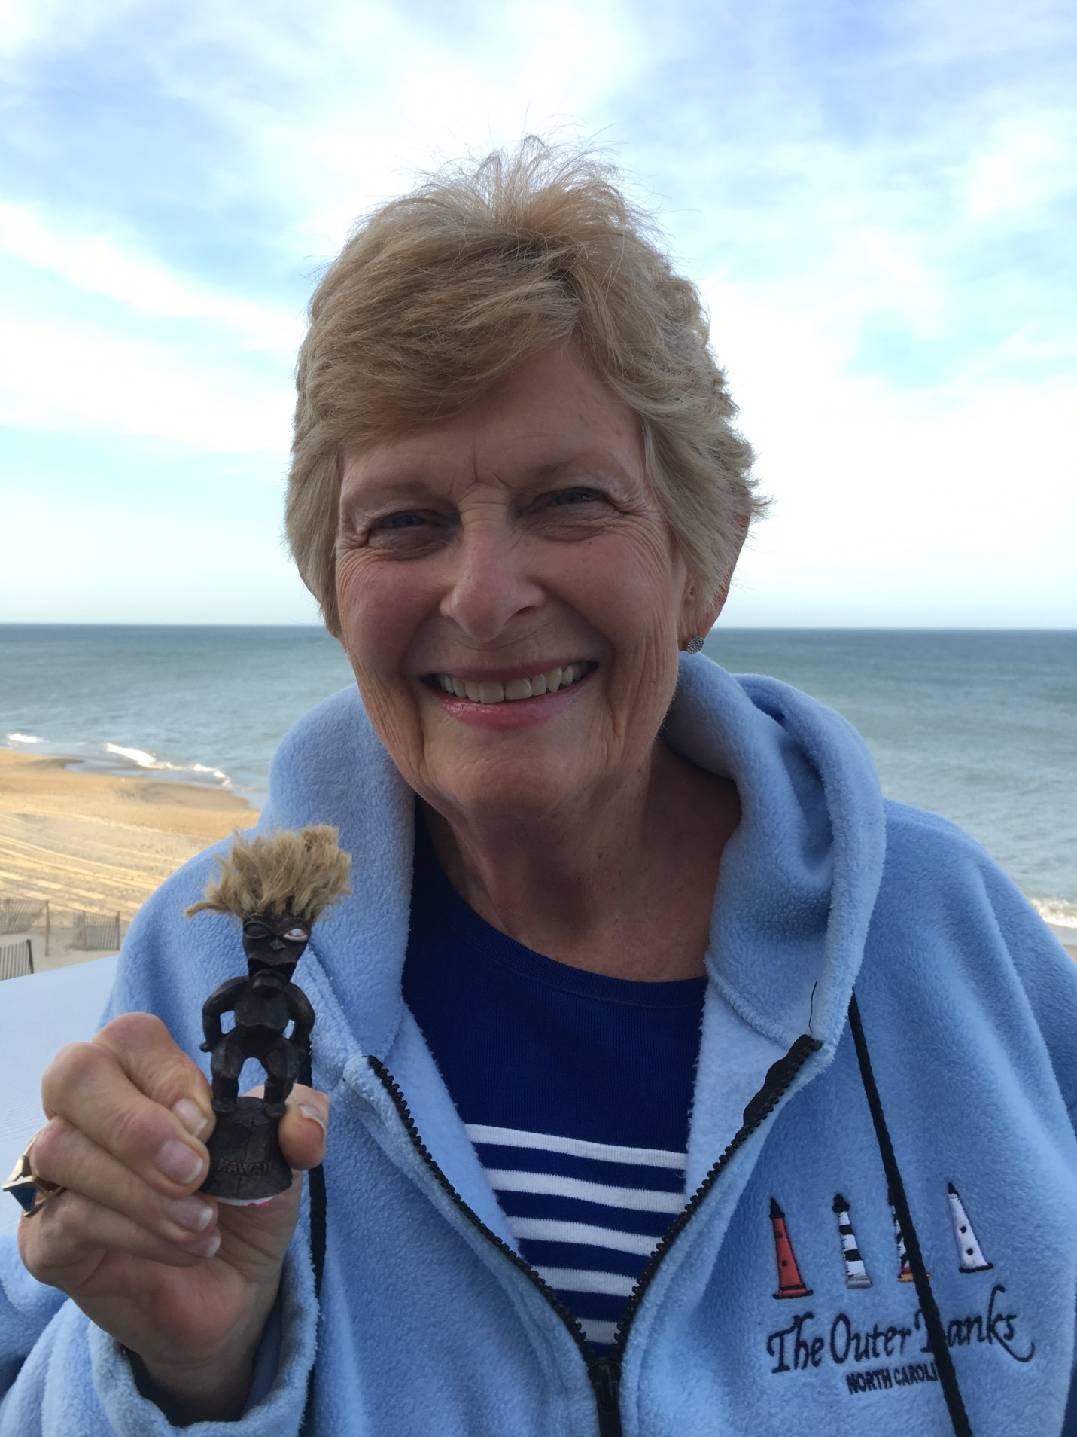

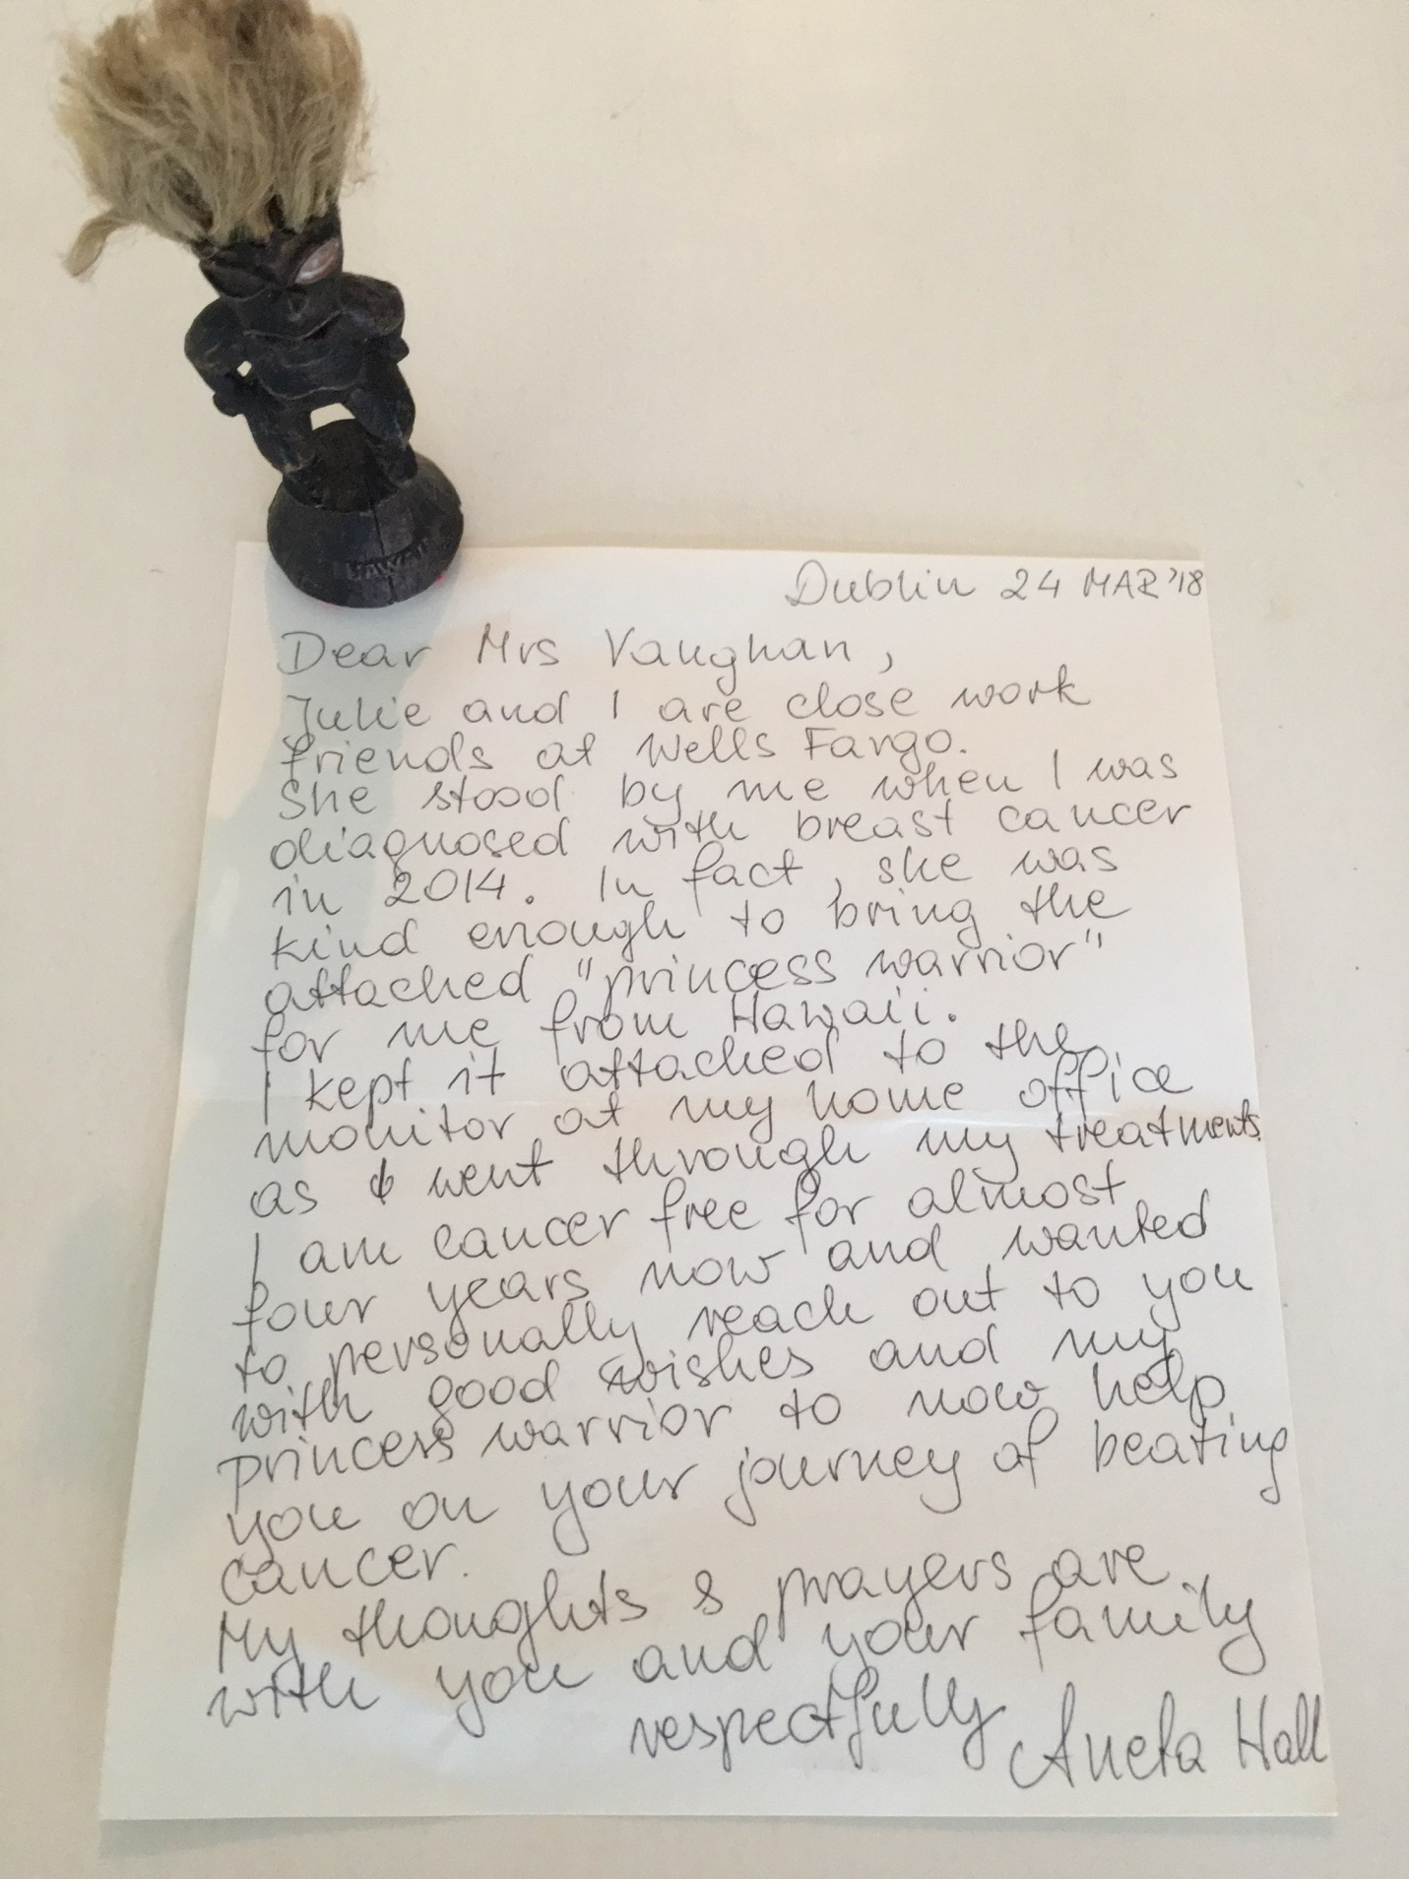

You are in my daily prayers, my friend. Mimi F OFS Spiritual Director, Associate Director Pastoral Care

Pat & John, Praying all is going well with treatments and positive results to come. Tom & Joyce Heigert

That is such a relief! What fantastic news! I knew you wouldn’t miss Emily’s graduation! 😉 Alexander and I don’t know whether you are getting our words of encouragement but if you get this, please know that you are in every one of our thoughts and prayers! We hope to come to Va in early May and will get in touch and maybe we can catch up for a quick hello! Tons and tons of love. Susan and Alexander ♥️♥️♥️♥️♥️

Looking great Pat!! Keep those A+’s coming!! All the best, 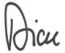

Pat, thank you for the email.  Bless your heart and soul for being so positive with this new diagnosis. Your Faith and your family will surely get you through this.  Congrats on the "A+”!! You will do fine.  Prayers going up for you. You Got this Girlfriend!  😉😘 Love the pic of your family supporters!!  😊 😍 Love & hugs, Julie & Carl

Pat & John, I am in Taiwan and I was thrilled to wake up and see your note!  Lots of prayers coming your way from your friends in Ada and they will continue! Be well!!!! Best, John

Dear Pat,

We had not heard about your lymphoma until this email.  We will be praying for you and keeping you close at heart and soul and mind.  Hope you enjoy your wonderful week at the OBX.  Glad you have had treatments and things are going well thus far. Much love, hugs, and prayers, Pam and Dave

Josey and I are praying for you. Love you and John.

Pat, Thank you for including us in your prayer chain request. This is the first I have heard of your diagnosis. We will keep you in our prayers as these tests and procedures continue. God loves you and so do we. Karen & Jerry

Glad to hear it! Thanks for sharing your journey! Love to you and your family from sunny California.

Jen D “Let’s get up early now / dive clear into the day / let’s get out of the car with open arms / not wait to be embraced”

Hi Pat, what great news. Please keep us posted. You are in our thoughts and prayers. God is with you.  Love Dee & Jon ❤️

SO glad to hear your news.  I'll keep in touch.  Love, Tillie

Hope you are doing well with your treatments. We'll keep you on my church choir prayer list as long as needed. Ken Mcmillen

Hi Pat, Just back from a trip to Brazil with a group of Malaysian leaders and got your memo about the challenges you’ve been facing, which I did not know anything about.  Looks like you have a lot of support and a fabulous attitude.  I’m confident that everything is going to work out positively for you.  In my opinion, the most important thing in good health is a good attitude, and you certainly have that!  Francesca and I send our love.  Holler if you need any input from me and please do stay in touch. Cheers, Sam and Francesca

**We are rested and ready for Round 2 on Wed & Thursday. Will be home Sunday. Thanks for your prayers and support! Greatly appreciated. Pat 21April2018**

**The picture was taken on the Sound up in Duck (north).  They have a beautiful wooden walkway that is behind all the shops.  It is a very healing place.  I am praying the Polish rosary that John’s sister brought me from Poland.  There are 5 of on our healing team.   No one else is allowed to join.   Very exclusive!**

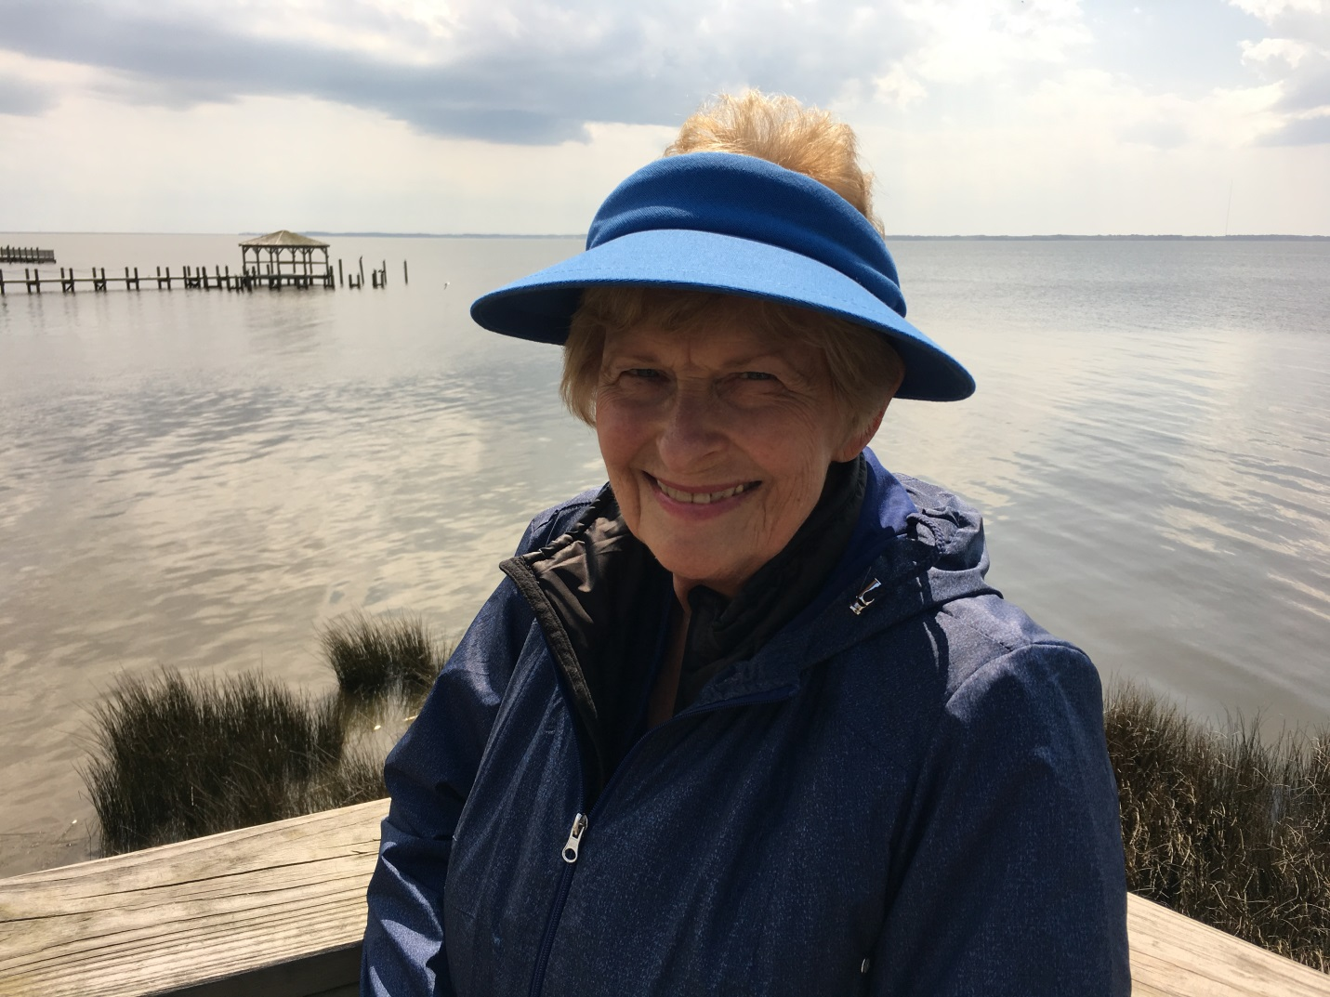

Deseamos que sigas mejor y mejor. We want you to continue better and better. Hortensia

Hi…just wanted to let you know we are thinking about you and sending healing prayers and hugs your way… Hope to see you soon…have missed you both! Love and tights hugs, Sue and Bill

Where was this photo taken? Very lovely. Glad you're ready! Think of you every day. Love you! Jane

And you're looking great too.  My prayers are with you. Bettie

Pat you look lovely!  Prayers for successful treatments.  ❤️🙏 Pam F Good for you and God bless!

We’re with you 💯‼️❤️ Susan A

Lookin good Mama!! OXB does you good!! We are on our way to Asheville and then on to Nashville on Tuesday. Hope to see you when I get back! Suzy

You will remain in our prayers; it is amazing what prayers can do. Lee K

You look GREAT! Lynn C

You are so cute! Thank you for your update. Yes, praying and thinking of you daily. Darlene ❤️

Good Luck and an easy time my dear friend.  I will be thinking of you Wednesday and Thursday.  Many Hugs Dawn

Aunt Pat. We are thinking and praying every day. Love you!!!! Andrea By the way... cute pic of you!!!

Hey girl!  Love you so go get the Rx and know your team is with you.  We are in Houston and have a great experience to share. You and John will love it.  Go team Pat!!!!!!!!!!!!!!!!!!!!! Betty Ann

Hi Pat, Hope you had a relaxing and wonderful week at the beach. Here’s the recipe for the Chicken Pot Pie. Enjoy! Mary W

Pat, glad you are relaxed and ready for the next round! Just wanted you to know that today I spent a good part of the day with CA survivors, mostly breast but some other... Some recovering, some fighting again. Your email and photo from earlier today came during the scrapbooking fundraiser I was attending. I shared your picture and email with the lady who was teaching the workshop I was in at the time. My survivor teacher/friend immediately stopped the class and they prayed for your continued positive response. I was very moved and teary. They asked I keep them updated on your story. I will. So prayers being sent from Michigan for you. The scrapbook day was a fundraiser for their Susan Komen 60 mile walk. To date this group has raised over $100,000 since 2005 for breast cancer. They are an amazing group and I attend every spring to support. Suzanne K.

John - I just wanted to let you know that you and Pat are in my prayers every day and have been for many years. Thanks for the difference you have both made in our lives. We are blessed for that.

I’m praying daily that Pat’s treatment is exceptionally successful and that trusting in our Lord eases the stress that I know you must be experiencing. I know that Janice was super stressed when I was diagnosed with prostate cancer. While she was supporting me, I was appreciative of everyone keeping her in their thoughts and prayers. Know that you’re in mine. Best – Gil

Hi Pat - You’re welcome. I’ve been praying daily that God show you his Mercy and bless you with complete remission. Glad your treatment is progressing well. We are blessed to have great spouses/life partners. And a firm belief and conviction that “out of every adversity, there’s a seed of equal or greater benefit”. Drawing closer to Our Lord and Savior is the most beneficial. Love – Gil

**Just in case you miss me, I want you to know thanks to Ann Horton I am just laying around eating chocolate covered Macadamia nuts pretending I am really in Hawaii!**

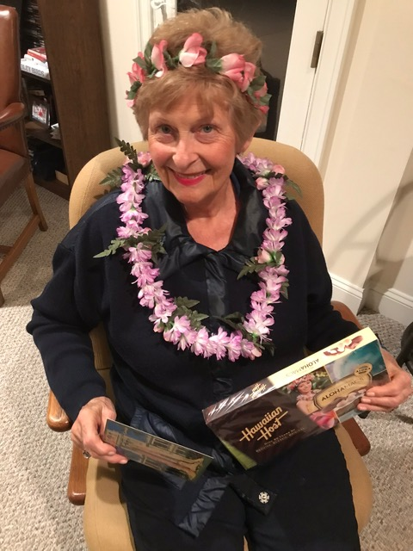

What a great picture!  You look like you belong on Waikiki!

Cathy has asked me how you are doing.  I hope I had it right when I said you had come back from the beach for your second round of treatments and so far you were doing well.  She is keeping you in her prayers.

Ron and I are leaving for Hawaii on May 2 going via SLC where we will stop to visit with my sister and brother-in-law.  I can tell you, I won't look as Hawaiian as you do even if I have all the traditional flowers on!

Take care, we will keep praying and expecting all good news when we get home the end of May! Lovingly, Eleanore

Cute picture. We do miss you. I'll be in the water this Friday and Saturday...will you? Lloyd

You're looking good. You'll have to eat these chocolates and wear a lei all the time. Glad all is going well. Keep up the good work. AND OF COURSR WE MISS YOU. There's very little gossip so we need you back otherwise we'll have to start making a lot up!!!! Dorothea N

Hi Pat, Thanks for your note and Ken and Patt's picture.  As usual, both look like they are having a great time!  Love his yearly greetings. Keep up the good fight.  You are in my prayers. Love, Annette

Well you look like a queen and extremely royal. LOOKING GOOD. BA Betty Ann D

You look beautiful!!! Lots of love, Martha S

Yes, of course, we miss you. As we walked into the Sports Club today, Roger overheard someone say ‘Pat’ and he quickly passed along the good news that YOU Pat were in the pool today. SO, yes, you are missed. And loved and wished every good thing; especially healing.

Thank you for letting us be a part of your story. And, for letting us be a part of your healing.

Gentle rains tomorrow, restorative for all. You are loved, Gail and Roger

God with you. *Dr. Charles F. Bruno PhD.*

Hi Pat, Thinking of you!!! Can we help with anything??? Didn’t your family visit recently? Take care, Terri and Stan G

Love you! Maria V

Hey there young lady, Looking good... May God continue to be with you on your journey of health!!! Keeping you in my prayers always, Love Jay B **God is Good Always**

Great photo!!! Looking so good. Sherry C

Thanks for sharing! We continue to pray for you. John W

❤️ Prayers for good treatment, rest & comfort, God’s touch🙏 Karen & Jerry

You definitely have it from both of us.  You and John have always been supportive to us as well.  That is what friends do for one another.  God bless you both.  Hope to see you all in late May if our trip works out. We hope to make our trip but as you know, it is a day by day vigil when you have an elderly parent and a fragile spouse. Love you, Pam and Dave

Best of luck this week with your healing treatments. We continue to keep you and your doctors in our prayers. Thank you for the updates! Lots of love beige sent your way. Joette and crew.

Great pic! Susan N

Thanks for the update! You look fantastic! Hope the next treatment goes well. I’ve been keeping you in my prayers. I look forward to seeing you back at water aerobics in the not too distant future! Martha B

So lovely! See you soon...the beach is truly a healing place... I can really relate. Love you!! ME S

Aloha “Sweet Leilani “Pat, Glad you are enjoying a touch of Hawaii! We arrived Monday and it is so nice to be with family, sunny skies, aqua-blue water and fairly gusty trade winds...you know what I’m talkin’ about. I got your picture as I sat by the pool. It was just like you were, too! Loved it!!

Sending healing thoughts of love and aloha......the Hawaiians call this “mana” the spirit of all that is good to bring deep healing, physical and emotional. 🌸🌺🌸🌺aloha🌸🌺🌸🌺 Ann H

Looking great! We love you, and we're standing with you. Kevin Porter

  
  
God bless you my friend😘❤️ Levia

Hey Pat! Just wanted to let you know that we’ve been following your progress and sending you lots and lots of good jujus and prayers! We love you! Kaia and Brian 💜🙏🏽👊🏼

So happy you have good news! Eat balanced meals stay strong! Like meditation therapy! Keep thinking about Hawaii and being in the salty air. Glad you are doing well! Tanya

Hi Pat, Francesca and I are just back from a trip up north and received your cheerful/positive memo on your recovery process.  What an example you set for the rest of us.  What a joy it is to know you!  Thank you for your inspiration and for all the love you send our way.  We are sending as much as we can too in your direction and look forward to seeing you in the near future. Cheers, Sam and Francesca

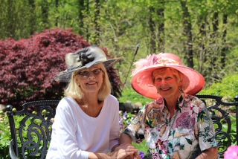  
**My fellow warrior Pat Ward with me in her beautiful garden.  God is good.**  
**I am doing well.  Doctor in fact said I was doing marvelous.  I’ll take that.  My goal is to be strong for Emily’s graduation from U of Iowa on the 12th.  I’m boarding the plane with my fancy mask from son Mike!  Emily will know me—-I still have my hair!  Thank you again for all your prayers, support, food, cards, and ❤️.  We all will be better people because of this.   Please continue your prayers for my fellow warriors, Pat W., Bettie B., Susie K, & Mary H.   We are a team!   💕💕💕😊😊😊🙏🙏🙏👩‍🏫**  
**John has been saving the e-mails and texts that come to us from all over the world.  He has put them into an ongoing journal.  Later he will put the cards in.  As we entered the second month of our journey, he added his own thoughts.**  
**7 weeks into this – from the March 8 phone call from Pat’s doctor, until today – just finishing the 2nd round of chemo. I have learned some life lessons.**  
**Clearing my calendar and becoming “nurse Bob” was easy. Then, being a research engineer I started writing all the new vocabulary words down. Then emails started coming in to Pat. She asked me to save these “love notes”. It is now a 36 page word document, not counting the notes written on the basket of beautiful cards. Amazing that every card is different. I have read these love notes several times.**  
**First lesson learned: it feels as though I have been transformed for the first time in my life into a big bubble of love and prayer. It is a powerful feeling that I have never felt before. Man, can people’s words reach your heart! The volume of them has its effect. They say such beautiful things, such prayerful words. Of course we love the funny cards, they make us laugh and break the sliding feelings. But the love and prayer, that’s an all new and special world. I am grateful and being taught.**  
**Second: so many of the people communicating to us have so many bigger battles they are fighting, and some have had a loved one lose the fight, and yet here they take the time and energy to pray and communicate with Pat. One example, a wonderful lady that I don’t know very well brings us some food. She tells me her daughter had lymphoma, so I innocently ask – “how is your daughter doing now?” She replies “she died, when she was 4 years old.” Me, the master of verbal communication, reply by looking down and saying “well, thank you for the chicken pot pie”. What a guy…**  
**My entire life I have charged forward with positive psychology, having fun, living life, and encouraging others – and being blessed with good health. BUT, when all those friends and relatives I cared so much for got very sick; I was not the communicator. I never felt I knew what to say, so I usually said nothing. They knew I cared and prayed for them… I assumed they knew. And maybe they did, but I am at a new place now. It’s like being brought into a special club, and you have been shown how to act.**  
**I have learned that I must reach out with my sincere love and prayer. Maybe it won’t be the most articulate written message they receive, but trust me, the thought counts. Maybe someone will never write the wonderful inspiring words that the recipient will read over and over, but let me assure you, a simple “Love” can have an important positive effect. Thank you. Love, John    26April2018**

Wow!  What a moving message from John!  I'd say he's a very good communicator.😘 So glad you're doing well, Pat.  You look beautiful and joyful in the photo. 👒 (you look ready for the Kentucky Derby) The weather finally feels like Spring.  And, weather can be so uplifting.  Especially to us "in the club." 🌞🌸🏖😘 Peace and Blessing, Terri and Stan🙏🏼

So glad you enjoyed the dinner.  I try to cook healthy, but you know how that goes, sometimes better than others. Rest, save your energy for your courageous fight!  I’m delighted you are doing so well. Kerry  
  
Wonderful! Thank you so much for the information! I was so happy to see Pat looking SO well! You are obviously a fabulous nurse! Looking forward to seeing you at Mile Course tomorrow! Tons of love

Susan xo (cheerful😊)

Wonderful words from both of you my dear friends.  I am so happy that you have a team Pat.  You have always had a huge team in your life.  John , you really hit how much it means to have people not only care but also tell you how much they care.  Every one of these cards, notes and e-mails means so much when you read them. I learned that too.  Hugs and love and a great trip to Emily’s graduation.   Dawn

My dear Pat and John, This is yet the most heartwarming message I have ever read.  Pat, I love that hat.  Pink always looked good on you.  Thank God for the Pat Ward of the world. What is that line, "misery loves company"?  Well Ladies, you don't look one bit miserable.  How blessed you are Pat to be surrounded by God's people. John, feeling lost for words should not be a capital offense.  Now-a-days even a fist bump can speak volumes.  Looking a person in the eye, a warm smile, a warm thank you, yes, they convey the message.  Imagine me, a foreigner whose first language is not English.  Can you imagine us foreigners struggling for the right way to express our feelings?  In my country, expressions we would use without a moment of hesitation would be like "ay naku (oh my), JesusMariaJoseph, (self-explanatory) Dios Mio (self-explanatory), ka awa awa naman (what a pity) etc. etc.  So at times when I may seem unappreciative, I am not.  Just feeling lost for the proper American English expression to convey.  I have problems with prepositions, infinitives, adverbs, oh, well, the language itself. I read a story, I think from INSIGHT (comes in my email inbox everyday) about a lady who had to be caregiver to her terminally ill husband.  She described it as an entirely different education and the best time she has spent with her husband during their married life.  She came to know more about her husband and how wonderful he truly was.  So we can look for a silver lining at illness.  When we conquer the challenge and have learned life's great lessons, then it is not a set back at all, just a little bump on the road. John, you always make something good out of every situation.  I look forward to reading your journal. Love you both, Priscilla

You two are my heroes!! You both are very inspirational! What a powerful letter. When my father was dying and going in between both worlds from the living and heaven he would come back and say it is all about “Love” and he would repeat this over and over again as he was slowly leaving us. Thank you for reminding me of this as you both are the embodiment of Love! ❤️ As always praying for you.😘🙏 Suzy

Love and hugs to you very special friends… Hope to see you soon…. With love every day, Sue and Bill

What a beautiful update, Pat and John.  I love the picture of you and Pat in her garden.  You both look so pretty and I love your hats!  You continue to be in our thoughts and prayers and please know so many are praying for you and keeping you close at heart. Continue this new journey with grace, faith, and love and you will go far with it for sure.  Sending love, prayers, hugs, and more to the sweetest gal I know! Love, Pam F

Wow and Amen!  We love you both.  Praying for all including the wellness team.  P.S. Love the hats.  Xxx ooo Bruce and Jackie

Thank you for the update and the lovely photo of you and Pat. Praying for you both every day. Sending hugs and love. Gail

Makes me cry!!  So beautiful!!! Now I have to go put on some more eye makeup!  :>) Thrilled to see Pat Ward looking so lovely... Thank you both for everything. God Bless! ME

Pat, I'll go beyond "marvelous" and head right into "Fabulous"! I'm so glad you're doing well and hope that you're well-rested for the graduation. May you and your fellow warriors conquer all obstacles! Are they all named 'Pat'? Love, Ken and Patt

You two look like you’re on your way to the Kentucky Derby - or maybe a visit with the Queen in London…  Lookin’ good!!!!    As a matter of fact - lookin’ GREAT!!!!! Hugs – Bea

Pat, My thoughts are prayers are with you.  I'm so glad you have so much wonderful support to help you through this. John, I feel concern when I read your description of how you haven't responded with the depth of communication you would have liked in various situations. I'm aware the person care-taking and supporting the person who is ill doesn't get as much support, and they need it, too!!! I'm writing to suggest you take some of the pressure off yourself by stop judging yourself for what you feel may be shortcomings. My experience of you is that I see your heart.  I especially see it in what you're writing in this email.  Many people go away from situations where they may have to step in and provide support.  You're in the thick of it and standing strong. John and Pat, I think you're both doing very well. My love to both of you. Sincerely, Marilyn M

I love that you are a big bubble of love and prayer, Dad. We should all strive to live and become that bubble... That freely and generously and thankfully gives AND receives love... What a beautiful place to be... Thanks for sharing your journey and lessons. I am beyond proud to be your daughter and am amazed at your strength, humility, and resilience. I love you both more than words can ever express. :) Julie

John, when I look back in time I feel blessed in so many ways.  I am fortunate to not have many regrets but one would be not getting to know you and Pat better when we all lived in Poquoson.  But, we were all so busy with careers and raising kids and traveling for work it left little time. We think about you guys daily and many prayers are sent your way. Love you guys. Ron W

Pat, Hope you're doing well; I think I can hear the Hawaiian music in the background! Ken

Thanks for the Grammy Pic and update! God is Good all the time!! May your healing and recovery continue to be blessed!!! Love and Prayers, Jay B

Dearest Pat, Thank you, Thank you for including us on your “list”. It brings us pain to realize that you must take this journey but we will be on it with you: Praying you joy, peace, gratitude, grace and healing. You and John, among all our friends from everywhere, are among those we hold closest to our hearts. We treasure every memory of you. You have been so supportive of us in many ways. Especially now, as we hold you up to the Light, we recall specific times. Jackie remembers the spot she was standing in our family room in Decatur when Pat called as she faced that diagnosis and surgery in 2000. Both of us remember sitting on the side of our bed in Hamilton Mill when John called to talk with Jay as he began his journey with that aggressive leukemia. As we think of you, it is with the same joy and gratitude that we weave into every day.  We love you and will carry you around in our hearts on this journey. Jay and Jackie

**It is in times like this that I really miss my mom.   She was so special.  What a dame!  She passed thirteen years on April 27, 2005.  It seems like yesterday. I am doing well after “Wellness Treatment 2.  Doctor says I am doing Marvelous!  That’s better than an A+. Four more to go. On May 10 we leave for Emily’s graduation on the 11th & 12th (2 majors Film & English/Creative Writing). Richard and Sophia will be joining us. Emily is going to Julie & Phil’s in SF with Aunt Mary later in the month. Thanks again for all your prayers, cards, texts, emails & love. John & I are overwhelmed by your caring.   Love to all, Pat**

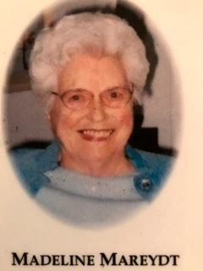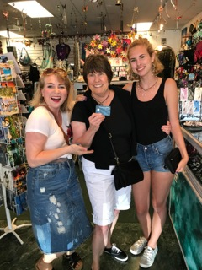

Hi Pat and John, Great tribute to your mom and I am happy to hear your treatment is going so well. I am keeping you in my prayers. Love, Lucille S

Keep up good work. So good to hear. Know what you mean about missing your mom. Xox Jane L

You my dear Pat are always marvelous. ♥️♥️♥️♥️♥️♥️♥️ Butch

Pat! Welcome home we Offered you up at our meal prayers. Love you! Leigh and Lee

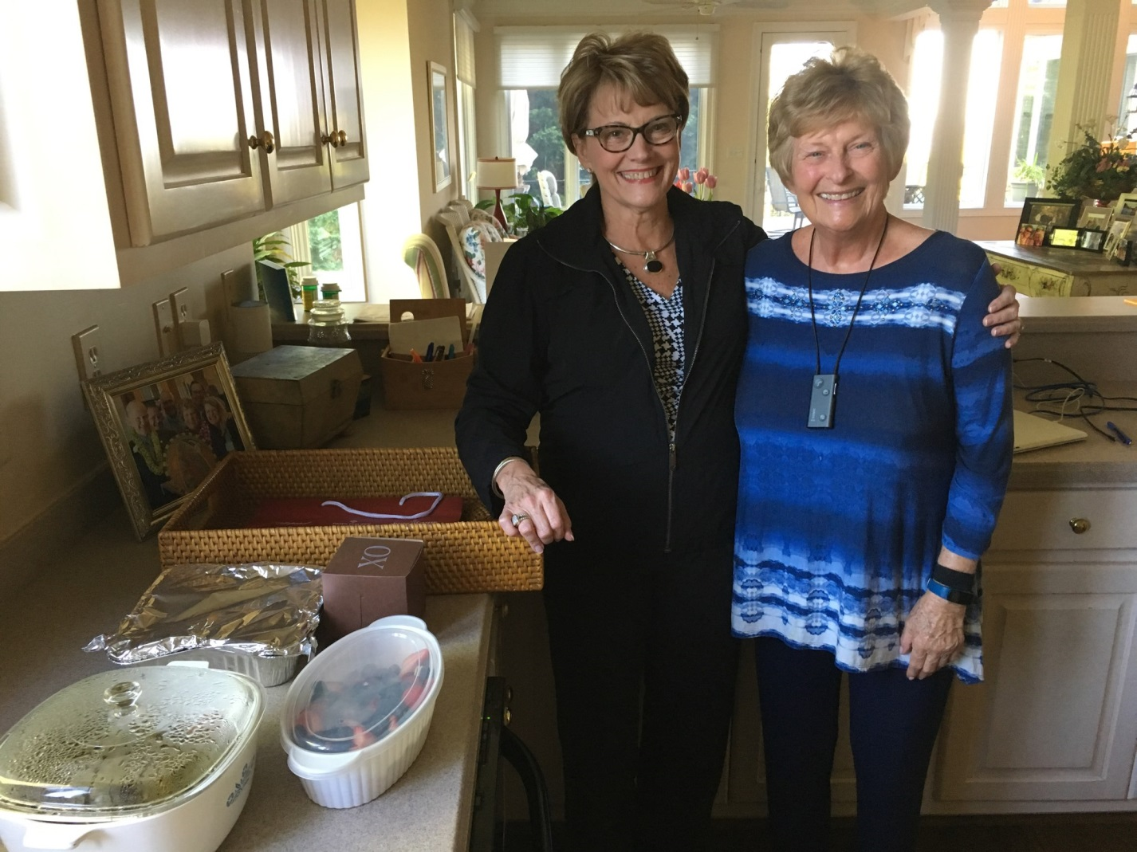

Lana brings nourishment!

Pat, thank you for sending the picture. I am glad that you enjoyed and that you had it for more than one meal.  Prayers of course that you continue to tolerate the treatment well and that is doing what it is supposed to do!! Lana

Hello Pat. We love you and are praying for you. My mom and my mother in law both beat cancer. Praying for Tandy’s chemo to be effective and tolerable. Praying for a healthy future. Steve and Yvonne

Beautiful ladies! It’s great to see you and hear from you!! ❤️❤️Mary Beach

Hi Pat, The picture of the two of you reminds me of two Southern Belles.  Those hats are beautiful.    I am so happy that you are in good spirits and we do miss you at our Aqua Classes!  Your husband writes well and expresses his thoughts with deep reflection on what has occurred in the past months.  The support system you have developed is so important and beneficial with those that you mentioned and yourself! God Bless all of you! Carol C

Thanks to John for sharing his thoughts. You are loved and always have been and will be. Jane

Great Picture!!! Praise God glad you’re all enjoying the journey! Love Jay Bruno

Awhhhhhhhhhhhhhhhhhhhhhhhhhhhhhhhhhhh Brought a tear to my eye!!  John's powerful, meaningful and heartfelt words and such an amazing picture of the both of you!!!! LOVE IT!! Have a great day! Rhondahttp://us.i1.yimg.com/us.yimg.com/i/mesg/tsmileys/m.gif

Good morning and thank you John and Pat for this wonderful and inspiring message from both of you. I love the picture of you two ladies in your hats, “in the garden” and with happiness and faith exuding from you in spite of your challenges. You are so inspiring! Love you! Darlene A

Dear John and Pat. So excited to see the goodness of the Lord on your behalf! What a joy it is to see the joy on your face Pat (and still have your beautiful hair!). Continuing to pray for you both. Much love, Russ and Cathe

Thanks for sharing.  You're both beautiful people - inside and out.  
Our loving thoughts are with you.  Love, Mary Elizabeth & John

Aunt Pat, Kick it !!! You can do it!!!💖 Love  Jay

Pat and John, You are such a strong, dynamic couple and I haven't even met you. Pat, I clearly know in my heart, you got this! I have been remiss in responding to your health messages, not knowing what to say. I lost 2 step fathers and a grandfather to cancers, also 3 classmates. 1 classmate’s husband is failing in last stages now, in a yearlong battle. This past fall, my bff from middle school lost her husband to a 6 month battle. Cancer is awful! It takes everything in us and from those around us, to fight this battle. Pat, YOU are an amazing woman. Your message came today and reminded me how real life can be. I had a bad day with my puppy; vet had to give him a stronger anesthetic to redo his leg cast, which caused seizures. A young man very dear to me (was engaged to my daughter 13 years ago) had heart surgery today, they almost lost him, he's just 38. He's on a respirator and drug induced coma. I have to tell you, YOUR message lightened my heart and reminded me how good and gracious our Lord is, even though I pray daily, study my scriptures and go to church...sometimes, someone else's words just hit your heart, as yours did mine tonight. Thank you. I can't wait to meet you in person. You take care and thank you. Anne W

Hello Pat and John. Just read this latest note. Wonderfully encouraging. Thanks for the regular updates. Although I've been praying for Pat and Susie K since the Ada meeting in March, updates help to be able to pray more specifically. And now I can add Pat Ward and a Bettie person, who I don't know, to my "cancer people" daily prayers. They join my high school classmate, Till, who has (bone marrow cancer) multiple myeloma, and my nephew's daughter, Trina, who has inoperable brain tumor. I appreciated John's comments, especially about never knowing what to say and so saying nothing. That's me, too. However, I decided maybe just knowing you are in another's daily thoughts and prayers is enough to say. God is good! Always! Love, Chris (& Bob) S

Beautiful garden. Great hats! Ken M

Thanks for the wonderfully inspiring letter.  You are a real trooper and demonstrating what positiveness can do to assist one in a difficult time.  Hang in there and keep us posted while we continue our prayers for you! Mary Ellen B

**Kelly brings Pat plants to brighten her day!**

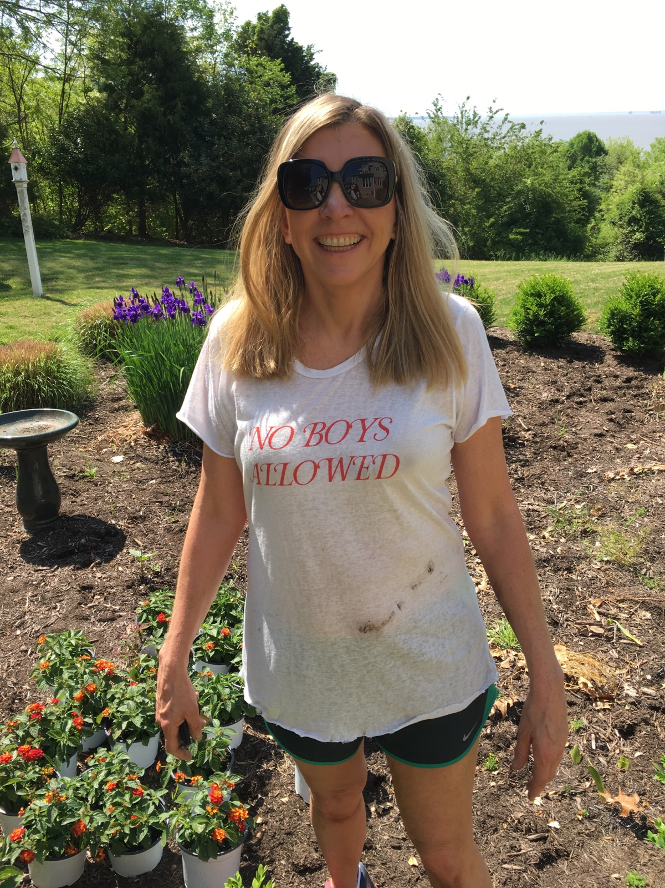

Such great news pats....keep on keeping on the great road. Hugs Verda

Glad to hear that all is going well for you. I will keep praying. Charlie B.

Daphne and I are off for three weeks to Iceland and Greece. Daphne says I never take her anyplace so I thought two extremes of weather and location would make amends. I think I told you we lost Milt Katz after a long, long slog with Parkinson’s. He was a wonderful man. We were so close at Langley. You two are up there in my hall of heroes too. You both continue to age gracefully in ways that shine, really shine. I continue to learn wonderful lessons from you two. Take good care of yourselves. George

Enjoy your trip to Iowa and know your Warrior team is in my daily players. Awesome letter from John. Much love. Levia

Please keep Pat Vaughan in your prayers. She battling the big C. 🙏🏻🙏🏻   
She’s quite the trooper, having strong faith in our Lord. Please don’t hesitate to text me or PM me if you have questions. We all love her dearly, she’s a beautiful soul. And pray for John and the family to keep them strong and understanding as they go through this journey with her. It is treatable, so send all your positive energy to her. Thank you. Dee

Prayers have been lifted for both of you and your family. I pray for complete return to health. I miss you guys but love you just the same as always. Hugs, Nancy Z

Just to let you know you are loved from Kandetsteg! Sue  
  


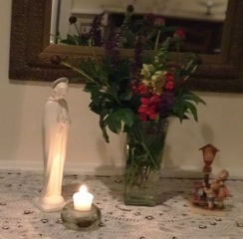  
**My Blessed Mother Mary prayer place. Remember when we used to do this in school & Crowning of Mary?**

Hi Pat, Such a great email!  Hope you are packing for that trip to Iowa!  I was moved by John sharing his heart and what this journey has meant to him! You can always tell the folks who have "walked through the fire"!  You just can't remain the same!  I'm glad John is making a book of your messages. We also have a 4 in. note book of those I received on my cancer journey in 2006.  I also had a blog that I made. It was good therapy for me....but more than anything, I wanted to journal for my kids and grandkids a record of all the times God was so faithful thru lots of major and small events of my story. You have no way of knowing how God is at work in this journey, but I assure you, HE IS! Fear not tomorrow....God is already there! Prayers continue..... Lloyd & Donna

The college UNK contracts me to supervise student teachers in the western part of Nebraska. I enjoy being back in the classrooms, and helping young people become educators for our future students. Prayers for Pat continue! Marge :)

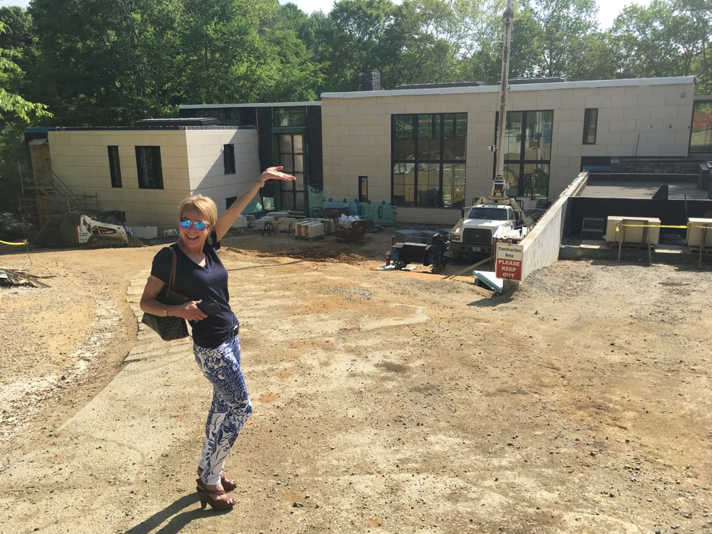

**Susan reminds Pat to keep dreaming.**

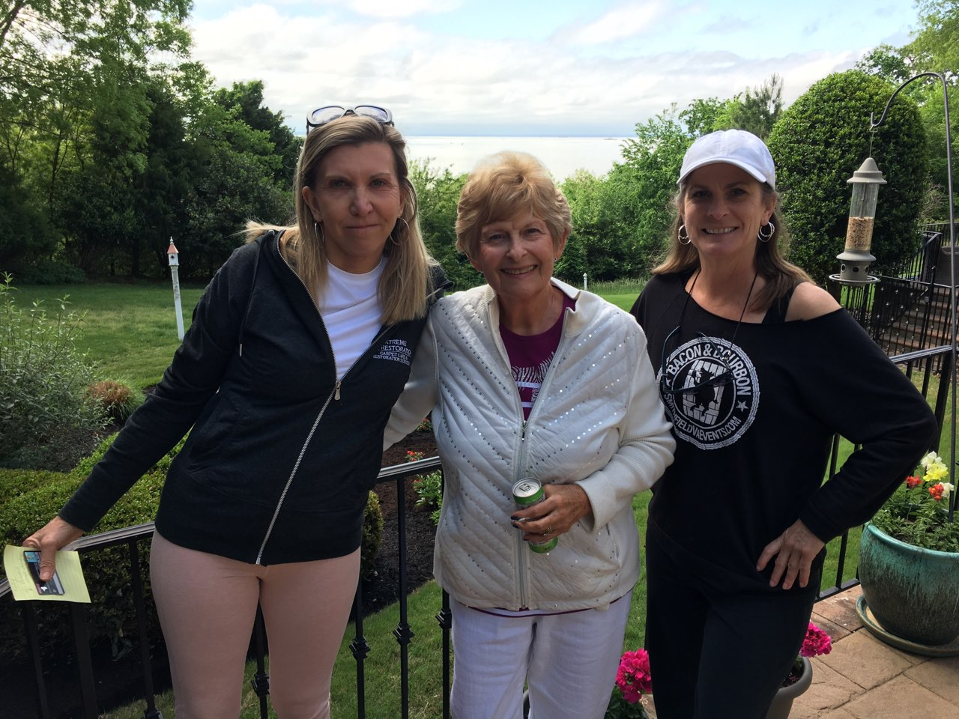

**The Green Crew provides plants for Pat.**

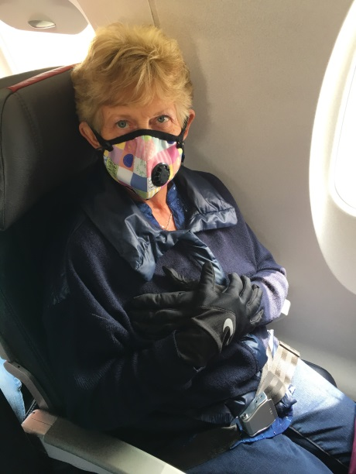

**Mask and gloves on way to Iowa to cheer for Emily!**

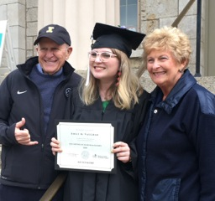

**2 Goals reached.  Emily graduated and we were there to celebrate!  I am doing well.  Thanks for all your prayers, cards, texts, emails. Please continue to pray for my team, Pat Ward, Susie Kerscher, Mary Hawn, Bettie Bennett, and Alice Borelli. Never Give UP!**

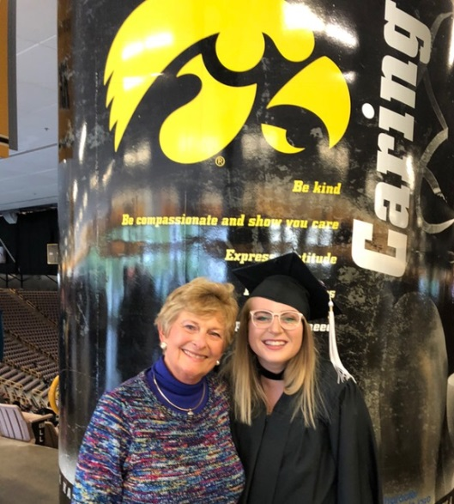

Was so happy to see the photos of you at Emily's graduation!  Definitely tell her to reach out to me again. I want to hear her post-graduation plans -  xo  Jennifer Deaton, WGA

Praise the Lord! You look great! Darlene

Gorgeous photo! I’m so glad you’ll had such a great weekend and WELL DONE, EMILY! Xoxo Susan A

Many congratulations guys!!!! Dick D

So grateful!! Glad you are progressing well. We continue to pray!! Love y’all! Cale & Aura

One of my favorite young ladies….well done Emily!!!!! You must be so proud, P&J. Lynn C

Loved the photo. Which was the graduate???    Carol Palencar

Dear Pat, Thank you so much for reaching out and letting me know of this challenge.  I am so sorry.  No matter how brave, no matter how good the doc and the medicine, it is a scary and difficult journey to go through. I am glad that you are getting good care.

It took me a long time to answer as I was on my culinary trip in Tuscany. It was great fun, but I broke a bone in my foot on the third day.  I got an ace bandage and walked on it for 17 days. As you might imagine, I am in a boot now and may have to have surgery. Smile.

    I also reread Beautiful Mystery. I think it is the saddest book, but, I think, one of the best written.

   Precious Lord,

           I ask that your healing presence would be with Pat and all who love her.  Remove fear and bring hope. Soothe impatience and bring your peace.  Let your LIGHT shatter all darkness. Thank you for bringing Pat into my life.  We lift our lives and our love to you.  Amen Judy Cobb Gamache

**Dear Wine and dine friends, I talked to Pat Ward yesterday by phone. She called me on her way home from the doctor. She and Ron met with her doctor last week and she decided not to continue with any additional chemo treatment. They brought in health professionals to make sure this was her decision. She said she had thought about it for a long time (actually from the beginning) and said no more. She and Ron will now be under hospice care in her home. I don’t know anything about time lines and was afraid to ask. Hospice (plus her other care support team) will keep her comfortable which I interpret is keeping her out of pain. She says she sleeps most of the time now. I asked to see her again. (Not for 2 hours! Just to blow kisses). I will contact Ron. Please pile on the prayers for Pat, Ron, Ryan, Dee, & Laura & the 5 grandchildren. They are all hurting more than we will ever know. She said she would contact Father Mike. I am still praying for a healing miracle! Never give up. 💕 Pat**

This is such great news!! Yes, you have been in all of our prayers! Your presence would make the party a huge hit! Please let me know if we can do anything and know that you are in our prayers! Love, Leslie

**Aqua friends, I was saddened to hear that Alice passed on Monday, June 11, after a 2 1/2 year battle with cancer.  Many of you may not have gotten to know her as she moved here one year ago from Northern Virginia.   She joined the aqua group to strengthen her legs.   I got to know her a bit because she was at “my end of the pool” and wanted to know who did my hair.  Then I found out she was one of my neighbors whose house I walked by on my “shady walk.”  She brought me a beautiful Hydrangea plant when she heard of my diagnosis and “smooth move” tea.  How kind.  I brought her soup and put her on my prayer team list.  She was a lovely woman and is survived by two sons and her husband, Joe.  One son lives at home so Joe is not alone.  It would be most kind of you to send a sympathy card whether you know her or not.  Just add “aqua group” to your name.  She loved the class.  If you want to drop off cookies or soup to Joe and Brandon, that would be nice too.   My only regret is I didn’t get to know her better before she left us.  Count each day as a blessing and make the most of it.  Keep Pat Ward and her family in your prayers.   She is in hospice at home and being well taken care of.   I am doing just fine.  Praise God.   Love and miss you all,   Pat**

Alice Baker Borrelli, 66, of Williamsburg, VA, died peacefully surrounded by family on June 11, 2018 after a two year long battle with cancer.  Alice was born in Roanoke, VA, a daughter of the late Raymond and Lorna Baker, and raised in Cloverdale, VA.  She graduated from the College of William & Mary and completed a Master’s Degree in Public Administration at New York University.  She married Joseph Borrelli of Brooklyn, New York in 1977 and moved to the Washington DC area where they raised two sons, Michael and Brandon.  Alice spent her 20 year career with AT&T in sales/marketing and then as a lobbyist.  After a brief retirement, she joined Intel Corporation and became Director of Global Health Care Policy.

Hi Pat - Joe and Mary here. Bea told us about your health challenge, and we were sorry to hear it - but we're sure you will tackle this with the same determination as all other challenges you've faced. You have a supportive husband (hi John!), and no doubt a great medical team to advise you - and all the good wishes from your many Amway friends and family. We have a glass of wine every night, and in our toast we always ask for good health for us and our friends - we're adding you to the list.

Would have written sooner, but we are busy getting ready for our next trip to England to see family and business friends. This time we're sailing over on the Queen Mary 2! Happy Healing! Love, Mary and Joe

Dear Pat, I noticed your name listed among the sick in the parish bulletin. Be assured of your prayers for God’s healing graces. When the students return in the fall, you will be our first Mass intention of the school year. Respectively, Diane at Veritas Preparatory School.

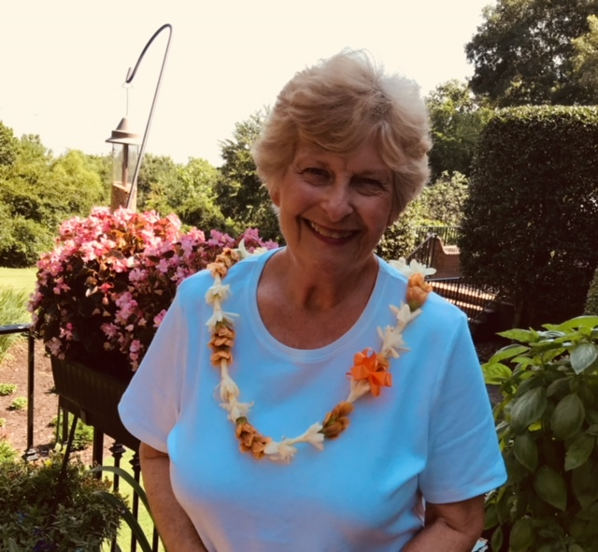

**The lovely fragrant lei is from Ann Horton from Hawaii. Very healing.**

**Ladies on the Edge,   I am sending you this announcement as some of you may have known Pat from golf, or Woman’s Club, or Garden club.   She was very active.  If you didn’t know her, you missed out on a wonderful person.   Love, Pat  
My friend, Pat Ward, passed peacefully, July 2, 2018.   No longer in pain, she was surrounded by her family at her home in Kingsmill.   Pat and I go back to our Poquoson days where we raised our kids together and did projects for the Woman’s Club.   We also kept our eyes on each other’s kids as they grew through the teenage years.  Our two youngest boys were in the same grades as her two girls.  More than once I heard “Are you talking to Pat Ward again!”  Small town living at its best.  It was fun reminiscing with Ron, DeeDee, and Laura last Saturday.  When we decided to leave Poquoson, Pat was our realtor.  She did her best to sell, in her words, “that big, bad-ass house.”   Hurricane Isabel finally sold it.  No one could believe a house in Poquoson was “untouched by Isabel.”  Imagine my surprise one morning when I heard her deep voice in my aqua class at Kingsmill!   Pat!  Is that you?  She and Ron had moved to Kingsmill from Yorktown so we had another chance to “play” with them.  Our only regret is that we didn’t play more and longer.  God bless the Ward family, Ron, Dee Dee, Laura, Ryan and their beautiful grandchildren.  Pat loved them with all her heart.  We will miss her forever.     
  
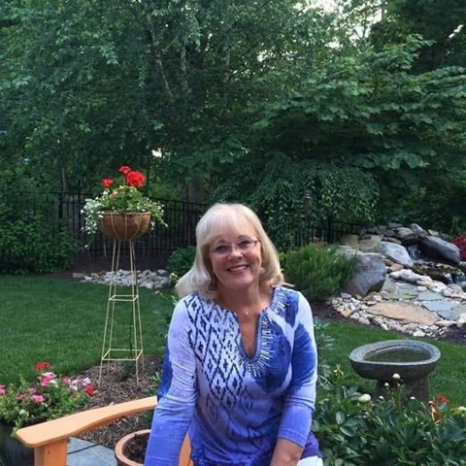  
 When I asked her how she was going to spend the next 6 months, she said enjoying my family while I watch my flowers grow.   She did.**

Pat, What a lovely tribute to Pat. I am so sorry you’ve lost such a good friend. She was a wonderful person, who had a remarkable spirit. It was evident from the moment I met her three years ago. What fun it was last year when I found out she was in our W&D! Having lost a dear friend 12 years ago to pancreatic cancer, I can relate to how difficult it is to watch a loved one endure the ravages of this ugly disease. And, oh, how I miss her still. All we can do now is pray for the Ward family. She’s left an indelible mark and tons of happy memories. Rest well. Love, Sherry

Dear Pat, I am so sorry to hear about the loss of your dear friend. It is never easy to lose such a friend and such a beautiful history together! Carol McKnight (Marcia Lee's daughter)

Dear Pat, I am so very sorry you lost a very very good friend, however she is now in the loving arms of our Lord. You had so many wonderful years together and your memories are overflowing. They will keep you strong. Take care friend. God Bless you. Love, Sheila

Aloha Pat and John, You have been so much on my mind and in our prayers. I am certain the road to recovery for Pat has had its share of ups and down but I hope you have a sense of peace knowing you both are so loved and admired by many, thus the road to recovery is undeniable a journey worth taking. There is an old adage which states, "Gratitude without words is gratitude never heard" and I am so grateful for the gift of you. It has been one of the greatest pleasures of my life simply to spend time with you. It was so kind of you to send the corporation’s publication of Aunt Jan and Uncle Bill, the photo of Uncle Bill, and the video of Aunt Jan's jewelry. When I viewed the video first, prior to reading about it, I thought you were sending me a kind of "dream big" video you had taken displaying table after table of beautiful jewelry. To those who attended her celebration service, what an unexpected gift from Aunt Jan. Reminds me of ho'omanao mau or lasting remembrance. After I read the story on display of Aunt Jan's jewelry, it reminded me while I was wearing my mother’s ring and with tears in my eyes, I told Keith how important it was to me to place her ring on my finger knowing it was once worn against her skin. Then smarty pants jokester trying to lighten the mood said, "I understand honey, that's why I'll be leaving you my underwear!" So bad! I didn’t get to see Aunt Jan as often as I would have like to, given the distance between Hawaii and Florida, but we communicated quite often. She was mightily blessed with what I call the "Williams" wild sense of humor and oh how we could laugh until our cheeks hurt! It was only after dad passed away that we became extremely close. She was in essence my connection to my dad and I was her connection to her brother. The last time we spoke on June 6, she was actually at the hospital waiting to have test performed. Then on June 12, my cousin Cathy phoned on behalf of Aunt Jan to let me know she wasn't up to talking but wanted me to know she loved me with all of her heart. It never dawned on me she was actually saying good-bye. I did not learn of her passing until a couple of days afterwards when my cousin Cathy phoned again. I first told Cathy, Aunt Jan visited me in a dream a couple of days prior to her call. It was very brief but vivid to the point it woke me up. I told Aunt Jan she looked beautiful and I loved her and to be sure and tell my dad hello for me and that I loved him. I thought it was a stupid thing to say because it didn't make any sense as dad was in heaven and she is still with us. After I shared the story of my dream, Cathy then proceeded to share the news of Aunt Jan's passing. Now the dream makes sense. Unfortunately, when I spoke to my cousin, the plans for her service had not yet begun. Unfortunately, I was not made aware of the celebration of life service until I opened an email from the corporation on the same day of the service.  Now you understand why the items you sent are especially meaningful to me and very much appreciated. With love and enormous gratitude, Karen W. Benedick

Thank you once again for sharing. She was Aunt Jan to us.  I will miss her calls and my conversations with her.  She kept us motivated as we have no upline to do so. She was Elsie’s best friend. They were almost like sisters. After Elsie passed she took us under her wing.  We are so so sad.  I wished we could have gone to the funeral.  Thanks again Pat.  We love you and John.  Stay positive and beautiful as always. You fight my lady. Dee Marsh

Pat and John, Where do I start in thanking you? Words will not do justice for all that you guys have done for us over the past six months. The drinks, food, cards and all your visits that my Pat really enjoyed. The picture that Sherry took the two “Pats” will always be cherished. You guys always did something that you thought just may bring a cure to this awful disease. We will return your light to you soon. In the mean time we will always remain good friends! Love you both, Ron

**Ron, John sent me your note.  Thank you for your kind thoughts.  As I received my great news today, I thought of your Pat.   How I wished we could have saved her. I truly believe that she saved my life as my diagnosis was one month after hers.  Without her, I would have gone on with my hurty stomach.  It’s hard to believe that was only 4 months ago for me.   My heart breaks for you and your family.   Let’s not let time pass when we get together again.   I know you need time to heal and reflect.   Let us help you.  We are always up for dinner and glass of wine.   We will leave the timing up to you.  We won’t forget you.  Love,   Pat**

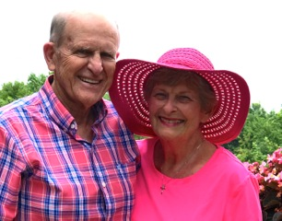

John & Pat at Kingsmill

**GREAT NEWS!  I AM HEALED!  No more Lymphoma anywhere!  PRAISE GOD!   I am overcome with GRATITUDE!**

**Thank you to Dr. Kruger and his wonderful medical team.  John and I trusted him with my life, and he came through 100%!  He is one of the kindest doctors I have ever met.**

**Thank you to our family who called, visited, texted, prayed, and cared for us.  Thank you to our neighbors who encouraged us and brought us food made with love.**

**Thank you to all of you who prayed for us.  Cooked for us.  Sent cards. Called. Gave us guidance.  Your support and love has taught us a lot.**

**Thank you to my husband (AKA “Nurse Bob”).  He kept track of everything and gave me my one pill every night at 7:07.**

**I praise God for this experience.  It has been incredible.  John and I are better for it. We are stronger in our faith and know for sure we are in God’s hands.**

**We learned to live in day-tight compartments and value each day.  Now we are excited about the future.  For the next couple of years I will be checking in monthly with the medical team so they** **can keep an eye on me.  Every other month I will have a medicine that helps keep the lymphoma away.  In the meantime I will be working on getting stronger with exercise, good nutrition, and of course my supplements.**

**I just read a book called One Word that will change your life.   My Word Is Grateful.**

**Pat Vaughan I am Grateful.**

We are so thankful to our great God for your healing. He has answered your prayers and those of so many others. Blessings and Shalom, Bill and Vera

Pat, What did I tell you ! God is Good !  coming out shouting ! Love you guys, Marcus

Such wonderful news!!!!!!!!! Gail T.

Hi Pat, Such great news!!!  Thank you for the kind words about Scott too! I hope you continue to get stronger and get back to your regular exercise routine soon.  Let me know if you would like to walk the neighborhood! Janet K

If you feel as good as you look in that picture you are SUPER! So glad you are all well.  Good job “Nurse Bob”! xoxo Lynn C

Hallelujah!!!  God is good, every day!  Great, wonderful, miraculous (that’s what He’s about!) news!.  Good fight, well won.  We are celebrating! SO!  When will be see you in the pool, Miracle Lady??? Gail S

Praises, praises, praises!  What wonderful news, Pat. Congratulations.  I am so happy to hear. Fondly, Amanda D

Marvelous.  Thank God our Heavenly Father, as well as the wonderful doctors, family and friends. You (and I) are truly blessed.  I am through with the wellness treatments and will keep you up to date. I pray Bettie B

Absolutely fabulous news! I look forward to seeing you at aqua classes sometime in the near future! Martha Barrett

So wonderful to hear all! Mary Kay & Ken Flegel

Pat and John from Pat and Joe, I tell Joe all my emails and he feels be knows you. We pray together every night and you have been in our prayers. We both are very pleased with your latest news. Thank we God. Pat T

Thank you God for Pat’s healing. Dave and Phyllis

An ANSWER to my prayers! OUR prayers. I have been praying for you each nite. We all have. I can't wait to tell Dad. He will be so THRILLED. Tesa says she thanks God for your recovery and sends along her favorite Scripture: Ephesians 3: 20-21. What a blessing and a relief!!! With so much LOVE, Kevin

Congratulations. I’m glad that your challenge is being managed. Highly blessed.  Dr. Chet

So, so wonderful to hear your happy news! Much love, Martha S

Pat, This is more than wonderful news! Congratulations!! I know you must feel like you can exhale now! I can’t wait to tell my mom when I call her tonight. Best wishes~ continue your good health and positive attitude. Sue S

YOU HAVE MADE MY DAY!!!  The best news I have heard in a long, long time. Nurse Bob has done such a great job we might want to rent him out?? Will still keep you both in our prayers as you work on getting stronger. Love, Marian & Tom S

John and Pat: We are thrilled!  Praise the Lord! Keep up the good work! Mike and Linda W

Pat and John, God Bless us one and all!! Let us all follow Pat’s word for the best life...,. GRATITUDE: from am to pm, find gratitude; share gratitude; with friends, family, and neighbors and all! We are so happy for you and your entire family!! HEALED!! Love that word! ❤️Ann and Chuck H

Hello Pat!!!! I am so thrilled to receive this note and your GREAT news!!!!! It is certainly an answer to so many prayers!!!! Please give John my best. Warmest regards, John & Elizabeth Parker

PTL! Neva

Were so happy everything has worked out for you. You are AMAZING person in our life and so lucky to have you right down the street.  Life is precious and we are so grateful you are still alive!  It’s amazing we have what we need right at our figure tips.  Acres of diamonds.  We all love you so much!  Tanya P.S.  Keep listening to the cicadas sing it’s good for the soul!

Hallelujah! Your attitude was very important in healing, I'm sure! Jane L

Wonderful news! Annette & George L

Dear Pat, I’m so happy I could cry!  You are truly blessed.  Congratulations and wishing you increased strength each day.  hugs, Terri and Stan G

Praise the Lord.  Your faith never faltered. Thank God.  I’m so happy for you and your family.  I love you Pat.  Dee M

Praise the Lord! Hallelujah! So happy for you! God is so good! Love you! Darlene A

That's fantastic!  Patty S W

Pat, My heart is so happy for your healing! To God be the glory! Continued prayers for your daily strength, joy, laughter, praise and peace. Abundant blessings to you. Warm Regards, Carol Prewitt

Amen. God is so good and gracious. So glad to hear the good news!! Bob O

Yahoo!!! I am so excited.  Best thing I have had happen today. What a way to finish the day. Just so very happy for you and John!!!  Sharon N

Great News all the best for the future. Rocco P

GREAT NEWS!!! You have been blessed!!! Cindy Z

We can’t tell you how thrilled we are with this news… God is good! Love to you both every day, Bill and Sue G

I just read your email!! I’ve been chomping at the bit all day waiting to hear. I am soooo happy and so full of joy for you! Praise God! We love you!!! Andrea G

Mom you get a 2nd chance!!!! Make it amazing!! J4

The best news ever!!! Herb W

Praise God for your blessing.  He takes care of us if we but ask him.  And then of course thank him.  Thinking of you.  Connie I

Praise the Lord for this great news.  We are SO happy to learn this.  Take good care of yourselves.  I lost my mom yesterday so we are sad here but rejoicing that she is with my dad and all her loved ones in heaven. God is good all the time! Love, Pam and Dave F

Pat, My heart is so happy for your healing! To God be the glory! Continued prayers for your daily strength, joy, laughter, praise and peace. Abundant blessings to you. Warm Regards, Carol Prewitt

That is the best news I have heard in a long time! Wonderful. Joette L

That's the best news ever!  Congratulations! Mike and Babs B

Pat, just read your message praise God I am so thrilled for you miracles do happen love and continued prayers. Janice

Pat, that is wonderful news!! Alana R

That's fantastic!  Patty Wells

Praise God! Dottie H

Congrats to you Pat.   So glad to hear the good news.    You and John are in my prayers.   Blessings,  Annie N

Pat, I am so thankful that you were healed!  I can only imagine.  –Steve Lusk

WONDERFUL NEWS, Pat!! I’m so happy for you (and John 😊). Prayers answered! Diane H

Fantastic!!! Answer to all our prayers 💕💕 Helen S "With God behind us and His arms beneath us, we can face whatever lies before us." Unknown

THANK GOD!!!!!!!!!!!!! Tom D

Yeah God & Yeah Doctors~!!!   Praise the LORD!!   Thanks for the awesome news!! Sherry W

Pat, I am SOOOOOOOO happy for you. I just shared this GOOD news with my church choir. We have had you and "Nurse Bob" on our prayer list since the beginning. I've been preparing a lecture for our church forum on the Feast of the Transfiguration and in my research I discovered that this was and is a mountain top experience for all of us. When we have these experiences we need to remember that we are never alone. Praise God from whom ALL blessings flow! Ken Mc

What awesome news Pat! Thanks and praise to God, Amen!! Stay well; you are such a gift to all!   
Love, Lisa & Tony Bagladi

So excited to hear this news...tears rolling down my cheeks...there is a higher power and prayer is powerful... Grateful for this day of news... Cheryl C

So very HAPPY for you-Praise to Jesus, our Lord and God. Patty D

I'm so happy to hear this!!! I'm sending you good wishes, Marilyn Mc

ABSOLUTELY THRILLED FOR BOTH OF YOU!! God is good! Julie W

Praise God! Dottie H

John and Pat that’s awesome news! We can never be grateful enough!!! Rashad

Praise be to God!!  I am grateful for you too! Brenda Dumler

Great news you two! Great photo! Leigh (Merola) Baesler

Hi Pat! It’s Julianne Lowe. Johnny and Jo’s granddaughter. I just saw this email and wanted to extend my happiness to you and your family! Glad you are doing better and I will continue to pray for your health to remain perfect! Best,

I think of you every day and hope all is going well. Harry Fronista wanted to know about you. Love you and John my aleons (aleon - different definitions - mine is "someone for whom I would take a bullet"). Butch

God bless you Pat and of course your loving nurse. I planned to call church tomorrow to continue your name on the prayer list and I will. In thanksgiving for your healing. When I saw you at the RE cocktail party, your bright blue eyes were sparkling and bright, I thought then you couldn't possibly be sick!! Love, Sheila G

So awesome. Guy

Fantastic news, I’m so very happy for u and ur family . God is Great !!  Jeanette R

This brought me to tears. So so very happy for this report!!!! I hope you know how much you and John mean to us. Aaron and I often "gripe" that,”if those darn Vaughans hadn't come knocking on our door, we would still be in Texas perfectly content with mediocrity". But we are, of course, just kidding. We wouldn't truly be happy.  You have given us a chance to dream and to hope ...and you both mean the world to us. – Shannon

Pat, I am so glad to hear your wonderful news! Shannon and I have both been inspired by your attitude towards overcoming this challenge and rejoice with you and John in your victory. We look forward to many years working with you and John to keep building this wonderful friendship network .All the best, Aaron

Awesome, the best news I’ve heard in a very long time.  Of course everyone knows how tough, prayerful and thankful you are and that can’t be beat. Jack A

Thanks be to God.. it brought tears to my eyes.  We love you. JoAnn L

|  |  |
| --- | --- |
| FABULOUS!!!  Thanks for sharing the truly great news!  Love, John and Mary Elizabeth  Praise god. He is in control. May God Bless! You😃 Bev L |  |

Our I.C. Weatherly Team is so grateful, too!!! Praise the Lord! Nancy Ziegler Peetz

And, beautiful!!  Sorry we missed your debut!  Glory and majesty!  And, the wonders of science. Gail

You look like John's new bride.  So beautiful! Maryellen S

Fantastic!  Glad you beat this. Corrine S

THANKS FOR THE NEWS—AND ALL THE ADVANCEMENTS!!!  MAY YOU-NEVER HAVE TO USE THEM AGAIN—BUT THANK GOD THEY ARE OUT THERE AND IMPROVING CONTINUOUSLY!! Chris Rodgers

OH SO HAPPY TO READ THIS !!!   Alan had Hodgkin’s in 2004 - he’s still in remission.  I don't know how long you were going through this - but I feel bad I didn't know earlier or I would have been praying for you and sending you joyful cards etc. But, the great news is that you are FINE and moving on.   Praise the Lord :) :)  :) I hope that our lives will bring us together again in the near future.  We'd LOVE to see you :) Love & hugs galore! Janie F

You're special Pat and God knows that.  He's not done with you yet and we are all grateful.  Looking forward to the fall.... LLyod S

Dear Pat & John, Giving thanks and rejoicing with you over your good news!.  What a mighty God we serve.  My brother Tim who is a cancer survivor has said often he wouldn't have asked to have cancer but neither would he trade the experience.  I'm sure you can relate.  Much love to you both. Becky  V

What absolutely fabulous news! If I could, I'd do cartwheels across the lawn! Thanks for letting us know. Now be good. Obey doc's orders. This next part is not just a walk in the park, either, you know. 'Tis downright too easy to make exercise excuses or to take "just a taste won't hurt" of what's not your best nutrition bet. After a few weeks, months, it's easy to let yourself get lax. You're still on my nightly prayer list. Love, Chris

Pat, We’re so glad that you've weathered your recent storm and came out seemingly stronger for it. I think that you've inherited the "Unsinkable Madelyn Mareydt" gene, and continue to be aided and abetted by your stalwart "Nurse Bob", er, husband John. Good on you! Ken & Patt Yuhasz

Amen! Amen! Praise God! Praise His Holy Name!  So very happy for you and John.  Love always, Bruce and Jackie

Pat That's great news.. Paul J. Monaghan

Wow Pat, I am so sorry that I have been out of touch. This is outstanding news and you and John look marvelous. I am so glad for you although RN John wouldn't have anything less. Grateful would be the word I use. I often think lightly about faith in our God and just as often think how well I recovered after my stroke. Anyway, Nancy and I are so glad you are better. We'll have to stop by, but the store has been our anchor lately. Blessings to you and John and grateful you are healed. Truly, Dave and Nancy V

We are just thrilled about your news!  Praise God for your healing! 😊 Hugs! Angie & Bob

Hi Pat! What wonderful news!  I had no doubt in my mind that with your and John's positive attitude and faith in God you would conquer the Lymphoma and you DID!!! Thank you for sharing your story.  Your email had quite a profound impact on me especially when you wrote “I praise God for this experience.  It has been incredible.  John and I are better for it. We are stronger in our faith and know for sure we are in God’s hands."  I say that because I had a few complications during our child birth experience that created a lot of anxiety for me and I have been working through it.  However, once we got past the complications the labor and delivery went smooth and we knew that God was there for us every step of the way.  I had certain expectations for the child birth, breastfeeding, etc. and it definitely didn't go the way I planned it; however, I praise God for this experience as it has put things in perspective and helped me to know that God has a plan and that things aren't always going to go as expected and I have to let go, be in for the ride and be GRATEFUL. You and John are very inspirational and your gratitude, faith and pure joy for life is contagious. Thank you!  Hope you can meet little Marco soon! Thinking of you! Nia

Hi Pat, What exciting news!  We are doing cartwheels and jumping around.....well almost! LOL.

Only God!   Yes....you both are richer with having this in your lives! Life is great.....LIVE IT!  MAKE EACH DAY COUNT!! Hugs attached, Lloyd & Donna C

Fabulous news!  God bless both of you. Carol and Bob P

How wonderful! Jane and I are thrilled to hear your news.  What an answer to our prayers. With our love, Jane and David Beougher

Hallelujah!! “Let’s get up early now / dive clear into the day / let’s get out of the car with open arms / not wait to be embraced” Jennifer D

Pat this is incredible news! I'm so happy for you and John. This whole experience had to be terrifying and I'm so relieved to hear you kicked its butt and came out on top =) Ashley and I love you guys and are also very **grateful** to hear you are healed and back in good health! With love, Colby

Beautiful message!  Brings tears… So pleased you are healed.  It was a welcomed surprise when I saw you coming down the steps to the pool this morning. Praise God! ME

That is the happy news of the day and days ahead! Love hearing that news... All well with us at our mountain home...talks in works for the younger family ones to buy our mountain home...going to be very hard to walk away after 40 years but with age we c it necessary ......the younger ones can get lot nice years here while we continue to live and travel in our Motorhomes till????? Hugs on your great news yes prayers are answered....Verda and Don W

WOW!!!!! What great news. We are SO Happy for you two. You deserve it because you believed it and appreciate it. God is pleased with you as you are grateful to Him................. John and Pam W

Hi so happy you can do what you love swimming and water aerobics and I am sure you will appreciate it so much more!  It’s amazing what people take for granted sometimes.  Enjoy the pool.❤️you Tanya

This is GREAT NEWS, PRAISE GOD!  I'm glad to hear you are healed, you and John will continue to be in my prayers. Roddy & Ellen Spriggs

Oh, Pat! This is the most wonderful news! I am overjoyed to hear it! Looking forward to seeing you at water aerobics soon! Your journey has been a lesson and inspiration for all of us.....With love, Mary S

Pat; Thank you so much for your update!  We have been thinking, praying, vibing positive thoughts the whole way through. Loved your picture!!!  You (both) look and sound so great!  You had a great team working on your behalf! Of course, I’ve always said that you could be an author as you write so well.  Who knows?  You have a story to tell! Keep up the good work . . . physically and mentally.  We wouldn’t expect anything less. Our Best to you Both!!!  Thanks, John, for your diligence, patience and good work! We Love you, Betty and Pat K

***Just got home to read this very wonderful message. I'm so happy to hear the good news about your healing. God does answer prayers. Best wishes always for continued good health from Charlene and Carl Zduncyk.***

Amen and so be it! Will forward this great news to Hawaiian Presbyterian prayer team and Hawaiian Holistic Prayer Watch. Marilyn Cabral

Praise God~~So wonderful~~!!!~So happy for you Kathy Jo Smith (Weatherly Team)~~

PAT!!!! THIS IS FABULOUS NEWS!!! CONGRATS AND THANKFUL FOR YOUR LEADERSHIP!!CELEBRATE!!!!! PRAISES TO GOD AND ANSWER TO PRAYERS!!! Cheri B

Myrna and I rejoice greatly with you and John.  Your  'medical message' and those preceding and those to come play across the firmament of life in testimony to the ingredients of personal fulfillment. You are truly the captain of your soul but blessed with many shipmates.  We stand in the rear of the crew but proud to be on board--Captain. Love John and Myrna

I am so happy for you.  I would love to hear that word for Frank.  We will keep you and Frank in our prayers.  Lee K

Hi so happy you can do what you love swimming and water aerobics and I am sure you will appreciate it so much more!  It’s amazing what people take for granted sometimes.  Enjoy the pool.❤️you Tanya

So very happy to hear of your good news.  Many blessings. Sharon Barton

Dear Pat, What a blessing -- such wonderful news -- God has heard the prayers of his people from all over the world!! Love, Betty Looney

Pat and John, So happy for both of you! Thanks for sharing your great news. Love, Lucille Szoke

Praise God!  While I was confident that I would be receiving this email with its victorious subject, I continued to remind those microscopic warrior angels that they were still on duty until further notice.  Armed with angels, attitude and Double-X, you whupped those negative cells. Now, excuse me, please, while I go frighten the dogs with my off-key hymns of praise and gratitude.  We shall go rejoicing! Mary Hawn

Happy to know of your HEALING.  That's wonderful.  Will continue keeping you in our prayers for Optimal Health. God is Good, Good is Great. Praise God for his healing of our dear friend Pat and Nurse Bob :) Peace be with you Mike & Yan

So thankful that you are cancer free. You are a Major example that prayer does indeed, work. And we are all grateful that you articulate your experience & thankfulness so well! John - Thanks to you for being at her side through this journey. We all know you wouldn’t be anywhere else! Love you both! Arla Harvey

So happy for you. Bill Chaney

When the spirit moves--no reports required---YOU ARE A CAPTAIN--not a dancing queen like ....Well..... another 'revealing' time ....perhaps.  Yours in life's tango.  John and Myrna

So glad to hear your awesome news!  Teri Olson

We are so happy for you! Thanks be to God... Murray and Sara Rudisill

Sending up thanks and praise for your healing! God is so good!  We rejoice with you and for you. Our prayers for your continued good health. Peace, blessings and love, Pat Goscienski

Magnificent news! Praise be to God along with your team of gifted healers. Awaiting your return...... With love and gratitude, Karen and Keith

Pat, This is fantastic news. Life is good, so glad to hear this good news!!!! Get this emoji: <https://a.getemoji.me/6DoIA2vBtO> Tom Russo

Thrilled with your wonderful, Glorious news that you have no more cancer!!!!  
Love You & John 💕 Sonny & Susy (Cher) Denn

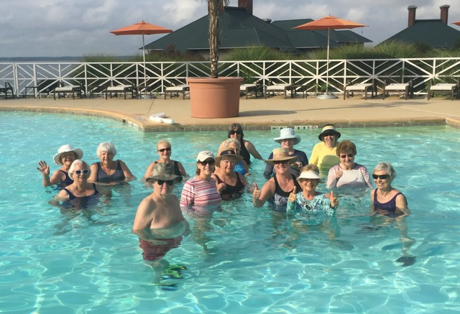  
  
**July 12, 2018  Water Aerobics I’m Back!  Glorious!  Grateful! Pat Vaughan**

**A 4 month story. Thanks for all the Love Notes, they will be remembered forever. John**

**“A bell’s not a bell ‘til you ring it – A song’s not a song ‘til you sing it – Love in your heart wasn’t put there to stay – Love isn’t love ‘til you give it away!” Oscar Hammerstein 11**

**I rang “The Bell” today 2July2020 to celebrate finishing the last 2 years of monthly shots after remission.**

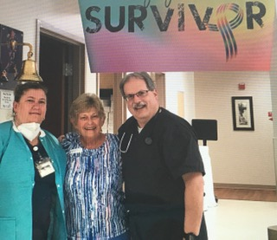

**Dr Kruger and Nurse Melissa in photo with me.**

**Thank you to my awesome medical team led by Dr. Kruger.  Thank you to my family, friends, neighbors, and business associates who supported and encouraged me through the last 2 1/2 years. Thank you to my husband, John, who stayed by my side and wrote everything down!  Thank you to my God for this incredible experience and for always being with me.   "I can do   all things through Christ who strengthens me."  
Philippians   4:13**

Thank God!!!!!!!!!!! Jim S

Thank you sir!  It was great to see Pat "Ring The Bell" !!!!  So happy about that. Mike S

Pat! So happy for you!  Very pleased for you. Chris S

What a wonderful message. We can thank God for your healing as he directed you, John, medical team, drugs, family, friends, Amway, neighbors, and  your strong will to make good on your promise to serve the Lord.

Continue, my dear friend in great health.... Mimi F

Greatest news!! We are well here at mountain home sort of isolated our usual neighbors are not here this summer staying in Florida so no one around but few weekenders

Yesterday we went for grocer Walgreens big R (for deer food) first to town in a month. Resupplied now another month!! Hugs, Verda W     (PS keep on keeping on forever)

 🕺Bill Br

Pat, Wonderful! All good! I am so glad! XO, Candi H

Wonderful news📣❤  Also like that scripture! Dottie and Jon H

What fantastic news!! You are amazing and so brilliantly strong! Celebrate good times 😘 Susan A

Congratulations. I am happy to be able to take you off of my daily healing request list.

You are back on the list.  I’m happy that at least one illness is over, but, our Daddy has a way of keeping us humble. I know He will see you through this too.  We are blessed.

Love you. Bettie B

Awww, Pat, this is such a great photo (movie) and such a thrill to see "SURVIVOR" on your list of accomplishments.  I'm so very, very happy to read this and to see you - looking sooooooo fantastic.  What a beautiful sight !!   Thank you for sharing this wonderful milestone with me (and others) and Praise God, is right - you are a SURVIVOR !!!!!!!!!!!!!!!!!!!!!!!!!!!!!!!! Love to you, always, Your friends here in PA

Janie & Alan F :-)))))

Congratulations Pat.  We are happy for you. We love you! Take care Sally Z

Dearest Pat, As I have been traveling so very much since January 2014 (like 72+% of each year!), I have been missing much news and today ... I saw your FANTASTIC NEWS, THAT YOU ARE A CANCER SURVIVOR!!!!!! I am thrilled to know that God has spared your life and allowed you to continue being a blessing to everyone who knows you! Pat, I love you and will be forever grateful for the role you have played in my life, our lives, as you always believed in us, supported us and loved us. THANK YOU FOR BEING YOU Again, congratulations on this most exciting news! With Love and Gratitude, ~Jan H

Amen and Amen!!!  Bruce L

A victor, a conqueror, my heroine!  Wrapped in love and lifted in prayer by all who love you.  Those microscopic warrior angels with their fiery swords vanquished those little demon cells, just as we believed they would.  I so love good news! Mary H

God bless you! I think of you and your family so often. Sure do hope to see you soon, Love to ALL! Tillie

Pat, that's so great to hear.  You've always been in my prayers PG M

Congratulations!   I didn't realize you were still going through chemo~~! SO VERY BLESSED TO HAVE YOU IN OUR LIVES! PRAISE THE LORD!  Love you both! Sherry W  http://us.i1.yimg.com/us.yimg.com/i/mesg/tsmileys2/01.gif

God answered the prayers of His people!!! Betty L

Fantastic! Lots of prayers answered. Helen S

“Our adversities are God’s universities” Dr. Paige Patterson

SUPER!!!!! Terry N

Praise the Lord!!!! Tom K

﻿

GOD IS GOOD—I AM SO HAPPY FOR YOU PAT—WELL DONE AND CONGRATULATIONS TO EVERYONE WHO WAS THERE FOR YOU. Tom B

Praise God!! We are so happy to hear this Pat!!

Thank you for the update, we love you guys! Cale & Aura!

You look marvelous ringing that bell.  Congratulations!  Continued blessings. Enjoy your weekend. Jane M-R

Pat, Congratulations thank you dear Lord. Blessings, Joanie D

Pat, You made my day!!!! This is fantastic news! I am so happy for you. You had the right attitude and great faith! You truly are a special person I am delighted to hear this news.

Be well Be safe Thomas R

WELL DONE, PAT! Lynn C

Amen! God bless you my friend🥰❤️ Levia D

Awesome!  So happy for you!  You look great! Darlene A

Welcome to the club! I still remember the first conversation about this at a conference. Glad you’re going to be around for a while. Chet Z

﻿ Pat we are so happy for you sending love and continual prayers🙏🥰🇺🇸🇺🇸 Janice G

Wonderful news Pat!! Have a very special 4th in July celebration 😊.!!! Dick D

Beautiful. Just beautiful. Thank you Jesus! I'll spread the word! Kevin P

So happy for you ❤️❤️ Ryan Ward

👍🏼 Cheryl C

We just love this! You look wonderful! We wish you continued good health! Thank you for sending this out to our aqua group, you are an inspiration! Janet K

﻿Well done! You’re so lucky you were able too. You were lucky they caught it early and did the right kind of healing treatments. Glad you are still alive! Love Tanya V

﻿Heartiest congratulations! Job well done! Annette L

That’s awesome Pat congratulations! 😘😘😘😘😘😘😘😘😘😘 Suzanne K

﻿Wow congrats J4

WHAT WONDERFUL NEWS! I’ll share this special video with my mom. CONGRATULATIONS! Sue S

CONGRATULATIONS Pat!!!  God is good!!!  xo Mary B

Congratulations! Jane L

Thank God for you!!! I got to ring the bell too😊 What a wonderful job of medical and God. Stew Z

﻿Pat— Yeah! That is wonderful❤️ Jill Y

﻿That is AWESOME! I am so proud of you! Made me cry watching you ring that bell! I LOVE YOU! Julie V

WONDERFUL NEWS!!!!!  So happy! Lots of love and hugs to you! Mary V

Outstanding! God is Good! Love Jay B

Congratulations!! Ginny C

﻿Wonderful news! Kerry L

﻿Bravo 👏 👏👏👏 Precious Lord, one of your most worthy prayer warriors.

❤️ Karen D

We rejoice with you! May you enjoy many more years of good health and happiness!

Love, Pat G

Hello Pat, Really glad to hear the good news....what a relief! Stay well and healthy and our regards to you and John. Sharookh & Zenobia L

You are one courageous, strong, inspirational and beautiful woman! I’m glad you got that video! I love seeing you ring that bell 😍 Maria V

That is awesome Pat!  Praise God!  You look great. I am blessed because of you. Brenda D

Joyous Day for you! Grateful season for all of us that we got to see you still in our lives! Leading by example, you’ve taught us many things over the years that are extremely valuable. Hope and persistence among them that I’ve “caught”. We celebrate with you. Karen & Rick

We could not be happier for you, dear friend.  God Bless! Pam F

**Pat rang The Bell yesterday. We thought a lot about the last 2 ½ years. I think the most lost I have ever been in my life was that morning at your home when the doctor told us the news about Pat’s diagnosis. I will never forget “the huddle” and Jackie’s completely uplifting prayer. It was like someone was pouring hope into every single cell in my body. You are such a special couple made of two wonderful people. You were in the right place in my life that morning. Thank you. You deserve God’s Blessings your entire lives. That is my prayer. Love, John Dear John, Thank you for letting us know about Pat’s ringing the bell!  Praise the Lord!!!  John, I am humbled by your words about our huddle prayer.  I felt the love of the Holy Spirit and He was able to pray through me for you and Pat.  God has given us such wonderful friends in you and Pat.  He has blessed us in so many ways, who could count them all?  I’m going to have a good happy cry and share with Bruce your message.  And by the way, I’m ringing my cow bells at my front door for you both!  Love,  Jackie**

Congratulations on the great news about your recovery.  I’m not surprised to hear this with your energy and good nutrition.  I’m eager to read the details from John in the future and seeing you down the road for a longer discussion. Much love to you and the family.  Cheers, Sam and Francesca