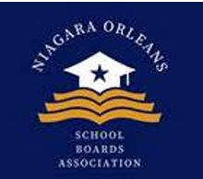
Niagara Orleans School Board Association (NOSBA)
Board Meeting Agenda
March 25, 2026 | 6:00 PM
Join Zoom Meeting: Click for Zoom Link
Meeting ID: 872 7143 8527
Passcode: 804167

1. Call to Order & Welcome

2. Approval of Minutes – Meeting was cancelled due conflicts – low attendance

Click for March Summary Update in Lieu of Meeting

3. Treasurer’s Report

4. Old Business
- May 7th Program: Discussion of last minute details.

5. New Business
- August Mixer: Program
- Additional Event Ideas
- Board of Education (BOE) Presentations
  - Requests and planning for NOSBA presentations Link to NOSBA Presentation
- Dates for Next Year

6. Other Business for the Good of the Organization

7. Adjournment

