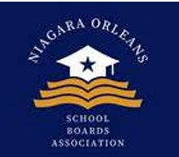
Niagara Orleans School Board Association (NOSBA)
Board Meeting Agenda
March 25, 2026 | 6:00 PM

1. Call to Order & Welcome

2. Approval of Minutes

3. Treasurer’s Report

4. Old Business
- Bank Account Update
- Prospective Board Members Training
  - Discussion: Should this be scheduled at a different time of year?
- May 7th Program
  - Venue
  - Advertisements
  - Program Details
  - Food Arrangements

5. New Business
- August Mixer
- Additional Event Ideas
- Board of Education (BOE) Presentations
  - Requests and planning for NOSBA presentations

6. Other Business for the Good of the Organization

7. Adjournment

