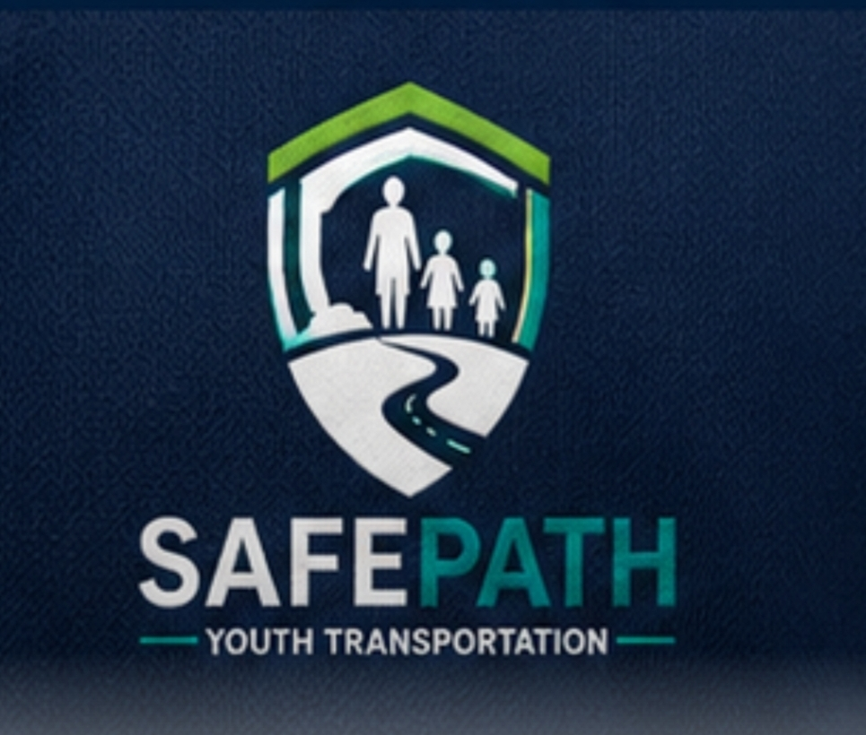

SafePath Youth Transportation Donation List for
Vehicle Comfort & Entertainment

Purpose: To provide a safe, comfortable, trauma-informed, and engaging transportation experience for children and youth.

Comfort & Entertainment
- Children's books (various ages)
- Coloring books and washable crayons
- Travel-size puzzle and activity books
- UNO or other travel card games (older youth)
- Fidget toys and sensory toys
- Disposable or sanitized headphones
- Soft, child-friendly music playlists

Comfort Items
- Tissues
- Hand sanitizer
- Disinfecting wipes
- Bottled water (when approved)
- Individually wrapped snacks (with agency/parent approval and allergy awareness)
- Small blankets
- Travel pillows

Electronics
- Tablet with age-appropriate educational games and movies
- Portable power bank
- Charging cables

Safety & Special Needs
- First aid kit
- Motion sickness bags
- Umbrella
- Booster seats and child safety seats (as required)
- Emergency contacts and trip forms

Trauma-Informed Comfort Kit
- Stress balls
- Fidget cubes
- Pop-it toys
- Small new stuffed animals (when appropriate)
- Positive affirmation cards
A Special Thank You for your Contribution to SafePath Youth Transportation!


