**REPORT PREPARED FOR:**

**RISH GOLD PROJECT#** 24015309

**LAB ID** 54035551

**REPORT DATE** 8/23/2024

**SAMPLE NAME:** THCA Saucy Diamonds - 080824

**DATE RECEIVED:** 8/15/2024

|  |  |  |
| --- | --- | --- |
| **THCA** | **TOTAL CBD** | **TOTAL CANNABINOIDS** |
| **99.02%** | **ND** | **99.02%** |

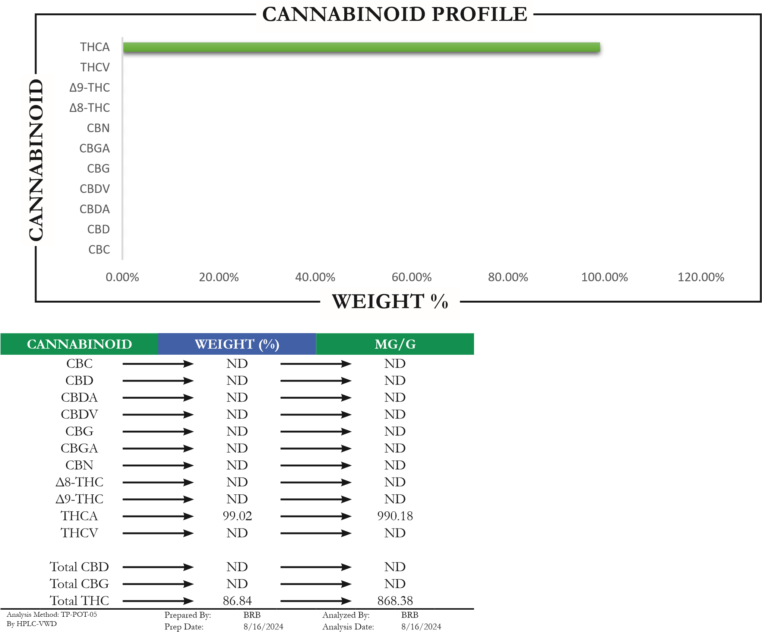

Total THC = (0.877 x THCA) + Δ9-THCTotal CBD = (0.877 x CBDA) + CBD Batch ID: AUG1624A-POT

Total CBG = (0.877 x CBGA) + CBG

ND = Not Detected

APPROVED BY:

# JUSTIN HALL 8/23/2024

LAB DIRECTOR **SIGNATURE SIGNED ON**

Accreditation# 115522 Page 1 of 4

This is a Badger Labs Certificate of Analysis and may not be reproduced without written approval from Badger Labs. Badger Labs maintains strict confidentiality of all client data. Any information regarding an analysis is shared only with the the individuals designated on the Laboratory Chain of Custody (COC) as contacts unless authorization is received. Limits of Quantification (LOQ) are available upon request. This report complies to the requirements of the ISO/IEC 17025:2017 standard. Review the results, expanded uncertainty and specifications to ensure they meet your requirements. Uncertainty values are available upon request.

# PESTICIDES

|  |  |  |  |  |  |  |  |
| --- | --- | --- | --- | --- | --- | --- | --- |
| **PESTICIDE** | **ACTION LEVEL**  **(PPB)** | **SAMPLE LEVEL**  **(PPB)** | **PESTICIDE** | | **ACTION LEVEL**  **(PPB)** | | **SAMPLE LEVEL**  **(PPB)** |
| Acephate | 100 | ND | Imidacloprid | | 5000 |  | ND |
| Acequinocyl | 100 | ND | Kresoxim methyl | | 100 |  | ND |
| Acetamiprid | 100 | ND | Malathion | | 500 |  | ND |
| Aldicarb | LOD | ND | Metalaxyl | | 100 |  | ND |
| Avermectin B1a | 100 | ND | Methiocarb | | LOD |  | ND |
| Avermectin B1b | 100 | ND | Methomyl | | 1000 |  | ND |
| Azoxystrobin | 100 | ND | Methyl-Parathion | | LOD |  | ND |
| Bifenazate | 100 | ND | Mevinphos | | LOD |  | ND |
| Bifenthrin | 3000 | ND | Myclobutanil | | 100 |  | ND |
| Boscalid | 100 | ND | Oxamyl | | 500 |  | ND |
| Captan | 100 | ND | Paclobutrazol | | LOD |  | ND |
| Carbaryl | 500 | ND | Pentachloronitrobenzene | | LOD |  | ND |
| Carbofuran | LOD | ND | Permethrin I | | 500 |  | ND |
| Chlorantraniliprole | 10000 | ND | Phosmet | | 100 |  | ND |
| Chlorfenapyr | LOD | ND | Piperonyl butoxide | | 3000 |  | ND |
| Chlorpyrifos | LOD | ND | Prallethrin | | 100 |  | ND |
| Clofentezine | 100 | ND | Propicanozole | | 100 |  | ND |
| Coumaphos | LOD | ND | Propoxur | | LOD |  | ND |
| Cyfluthrin | 2000 | ND | Pyrethrin I | | 500 |  | ND |
| Cypermethrin | 1000 | ND | Pyrethrin II | | 500 |  | ND |
| Daminozide | LOD | ND | Pyridaben | | 100 |  | ND |
| Diazinon | 100 | ND | Spinetoram J | | 100 |  | ND |
| Dibrom (Naled) | 100 | ND | Spinetoram L | | 100 |  | ND |
| Dichlorvos | LOD | ND | Spinosyn A | | 100 |  | ND |
| Dimethoate | LOD | ND | Spinosyn D | | 100 |  | ND |
| Dimethomorph I | 2000 | ND | Spiromesifen | | 100 |  | ND |
| Dimethomorph II | 2000 | ND | Spirotetramat | | 100 |  | ND |
| Ethoprophos | LOD | ND | Spiroxamine | | LOD |  | ND |
| Etofenprox | LOD | ND | Tebuconazole | | 100 |  | ND |
| Etoxazole | 100 | ND | Thiacloprid | | LOD |  | ND |
| Fenhexamid | 100 | ND | Thiamethoxam | | 5000 |  | ND |
| Fenoxycarb  Fenpyroximate | LOD  100 | ND  ND | Trifloxystrobin | | 100 |  | ND |
| Prepared By: BRB | Analyzed By: | | BRB |  |
| Fipronil  Flonicamid  Fludixonil | LOD  100  100 | ND  ND  ND | Prepared Date: 8/21/2024 Analyzed Date: 8/21/2024  Analysis Batch: AUG2124A-PES  Analyzed by method TP-PES-01 on HPLC/MS/MS or GC/MS  ND = Analyte not detected  PPB = Parts per billion | | | |  |
| Hexythiazox | 100 | ND |  | | | |  |
| Imazalil | LOD | ND |  | | | |  |

# RESIDUAL SOLVENTS

|  |  |  |  |  |  |  |  |
| --- | --- | --- | --- | --- | --- | --- | --- |
| **CATEGORY I** | **PPM** | **CATEGORY II** | | | | **PPM** | |
| Ethylene Oxide ND  Methylene Chloride ND  Benzene ND  1,2-Dichloroethane ND  Chloroform ND  Trichloroethylene ND  Prepared By: JPH  Date Prepared: 8/23/2024  Analyzed By: JPH  Analysis Date: 8/23/2024  Analysis Batch: AUG2324A-SOL  Analysis method: TP-SOL-01 by HS-GC/MS  No Category I solvent may be present to pass  ND = Not detected  PPM = Parts per million | | | | Propane  Butane/Isobutane  Pentane  Acetone  Acetonitrile  Hexane  Ethyl Acetate  Heptane  Methanol  Diethyl Ether  Ethanol  Isopropanol Toluene m+p Xylene o-Xylene | | | | ND  ND  ND  ND  ND  ND  ND  ND  ND  ND  ND  ND  ND  ND  ND | |
| **METALS** | | | |  | | | | **PASS** | |
| **METALS**  **FDA - CATEGORY I** | **ACTION LEVEL**  **(PPM)** | | | **SAMPLE LEVEL**  **(PPM)** |
| Arsenic (As) | 1.5 | | | ND |
| Cadmium (Cd) | 0.5 | | | ND |
| Lead (Pb) | 0.5 | | | ND |
| Mercury (Hg) | 3.0 | | | ND |

Prepared By: HS

Date Prepared: 8/21/2024

Analyzed By: HS

Analysis Date 8/22/2024

Analyzed by EPA method 6020A via ICP-OES or ICP-MS

ND = Not detected

PPM = Parts per million

# MYCOTOXINS

|  |  |  |  |  |  |
| --- | --- | --- | --- | --- | --- |
| **MYCOTOXIN** | | | **ACTION LEVEL**  **(PPB)** | | **SAMPLE LEVEL**  **(PPB)** |
| Aflatoxin B1  Aflatoxin B2  Aflatoxin G1 | | | Sum of all alflatoxins not to exceed 20 PPB | | ND  ND  ND |
| Aflatoxin G2 | | |  | | ND |
| Ochratoxin | | | 20 | | ND |
| Prepared By: | BRB | |
| Date Prepared: | 8/21/2024 | |
| Analyzed By: | BRB | |
| Analysis Date | 8/21/2024 | |
| Analysis Batch: | AUG2124A-MYC | |

Analyzed by TP-MYC-01 on HPLC/MS/MS

ND = Not detected

PPB = Parts per billion

**MICROBIALS PASS**

|  |  |  |
| --- | --- | --- |
| Total Coliform | **ACTION LEVEL**  **(CFU/G)** | **SAMPLE LEVEL**  **(CFU/G)** |
|  | ND |
| E. Coli | Presence | ND |
| Yeast & Mold |  | ND |
| Enterobacteriaceae |  | ND |
| Salmonella | Presence | ND |
| Total Count |  | ND |

Prepared By: PS

Date Prepared: 8/21/2023

Analyzed By: PS

Analysis Date 8/23/2024

Analyzed by COMPACTDRY method.

ND = Not detected

CFU/G = Colony forming uniits per gram