**Manifest:** 2501140002 **Test Performed:** Potency

**Sample ID:** 1A-GHEMP-2501140002-0002 **Report No:** P-2501140002-V2

**Name:** THCAISO-010925.1 - MFR=010925 - **Receive Date:** 2025-01-14

EXP=010927 **Test Date:** 2025-01-20 **Type:** Concentrate **Report Date:** 2025-01-22

**Client ID:** CID-00303 **Sample Condition:** Good

**Gobi Hemp - CDPHE Certified Certificate of Analysis**



**Client:** RISH GOLD

**Scope:** The content of 21 cannabinoids was determined by an in-house developed method certified by CDPHE for solvent extraction followed by High Performance Liquid Chromatography with Diode Array Detection.

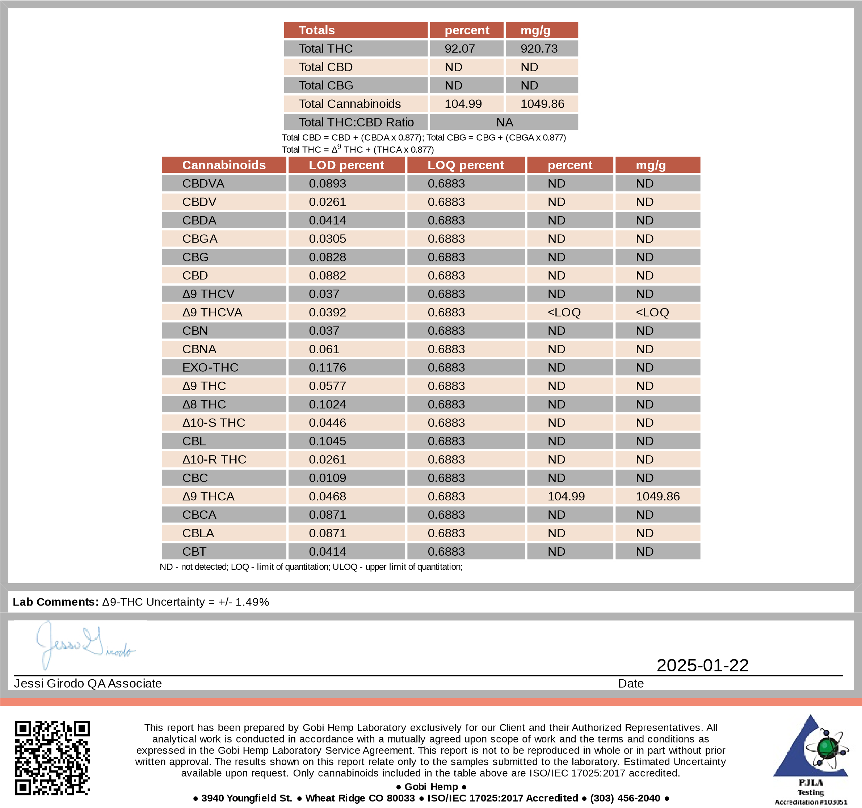

# Analytical Report - Certificate of Analysis

**Manifest:** 2501140002

**Sample ID:** 1A-GHEMP-2501140002-0002

**Sample Name:** THCAISO-010925.1 - MFR=010925 - EXP=010927

**Sample Type:** Concentrate

**Client ID:** CID-00303

**Client: RISH GOLD**

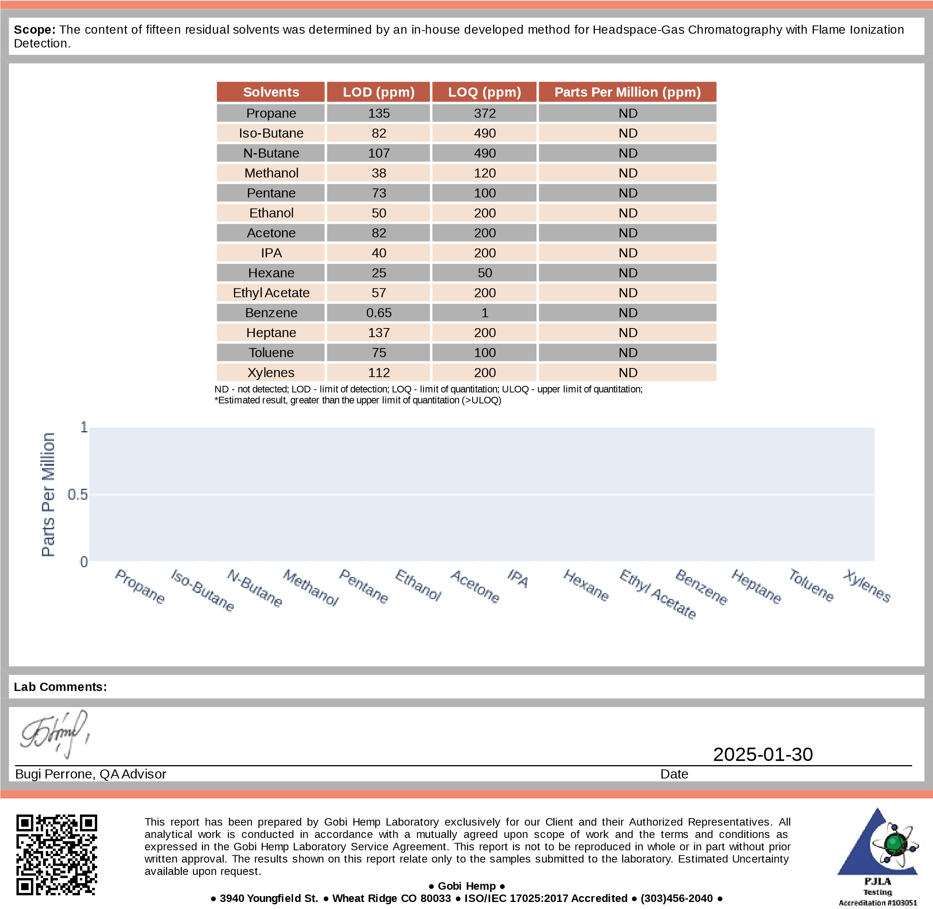

|  |  |
| --- | --- |
| **Test Performed:** | Hemp Lab |
| **Report No:** | R-2501140002-V1 |
| **Receive Date:** | 2025-01-14 |
| **Test Date:** | 2025-01-29 |
| **Report Date:** | 2025-01-30 |

**Sample Condition:** Good

**Method Reference:** GH-OP-08

# Analytical Report - Certificate of Analysis

**Manifest:** 2501140002

**Sample ID:** 1A-GHEMP-2501140002-0002

**Sample Name:** THCAISO-010925.1 - MFR=010925 - EXP=010927

**Sample Type:** Concentrate

|  |  |
| --- | --- |
|  |  |
| **Client:** | RISH GOLD |
|  |  |

|  |  |
| --- | --- |
| **Test Performed:** | Hemp Lab |
| **Intended Use:** | Inhaled or Audited Product |
| **Report No:** | MT-2501140002-V1 |
| **Receive Date:** | 2025-01-14 |
| **Test Date:** | 2025-01-28 |
| **Report Date:** | 2025-01-31 |

**Sample Condition:** Good

**Method Reference:** GH-OP-17

**Scope:**

Arsenic, Cadmium, Lead and Mercury were determined by an Inductively Coupled Plasma Mass Spectrometer (ICP-MS) using an in-house developed

method.

**Elemental Impurities**

**LOD (ppm)**

**LOQ (ppm)**

**Parts Per Million (ppm)**

Arsenic

0.007

ND

0.025

Cadmium

0.003

0.01

ND

Lead

0.003

0.01

ND

Mercury

0.003

0.0009

ND

ND - not detected; ULOQ - upper limit of quantitation; LOD - limit of detection; LOQ - limit of quantitation

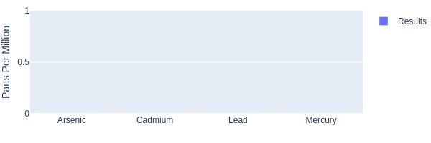

**Lab Comments:**

|  |
| --- |
| 2025-01-31  None Date |

This report has been prepared by Gobi Hemp Laboratory exclusively for our Client and their Authorized Representatives. All analytical work is conducted in accordance with a mutually agreed upon scope of work and the terms and conditions as expressed in the Gobi Hemp Laboratory Service Agreement. This report is not to be reproduced in whole or in part without prior written approval. The results shown on this report relate only to the samples submitted to the laboratory. Estimated Uncertainty available upon request. Sample(s) tested at Gobi Analytical.

* **Gobi Hemp ●**
* **3940 Youngfield St. ● Wheat Ridge CO 80033 ● ISO/IEC 17025:2017 Accredited ● (303)456-2040 ●**

# Pesticide Residues Report - Certificate of Analysis

**Manifest:** 2501140002

**Sample ID:** 1A-GHEMP-2501140002-0002

**Sample Name:** THCAISO-010925.1 - MFR=010925 - EXP=010927

**Sample Type:** Concentrate

**Client:** RISH GOLD



This report has been prepared by Gobi Hemp Laboratory exclusively for our Client and their Authorized Representatives. All

analytical work is conducted in accordance with a mutually agreed upon scope of work and the terms and conditions as

expressed in the Gobi Hemp Laboratory Service Agreement. This report is not to be reproduced in whole or in part without prior

written approval. The results shown on this report relate only to the samples submitted to the laboratory. Estimated Uncertainty

available upon request.

**●**

**Gobi Hemp**

**●**

**●**

**3940 Youngfield St.**

**●**

**Wheat Ridge CO 80033**

**●**

**ISO/IEC 17025:2017 Accredited**

**●**

**(303)456-2040**

**●**



2025-02-05

Bugi Perrone, QA Advisor

Date

**Test Performed:** Pesticide

**Report No:** PE-2501140002-V4

**Receive Date:** 2025-01-14 **Test Date:** 2025-02-05 **Report Date:** 2025-02-05

**Sample Condition:** Good

**Method Reference:** GA-OP-11

**Executive Summary:**

Sample 1A-GHEMP-2501140002-0002 has

passed

pesticide testing.

The following pesticides were detected in the sample:

Cypermethrin

**Scope:**

The content of the reported pesticide residues were quantified using LC-MS-MS and GC-TQMS. Identification was based on the retention

time of each compound and the product mass spectra generated using Single Reaction Monitoring (SRM) or Dramatic Multiple Reaction

Monitoring, and quantitation was determined using external standard calibration.

**Lab Comments:**

•

# Pesticide Residues Report

|  |  |  |  |  |  |  |  |  |  |  |  |  |  |  |  |  |
| --- | --- | --- | --- | --- | --- | --- | --- | --- | --- | --- | --- | --- | --- | --- | --- | --- |
| **Pesticide** | **Limits (ppm)** | | **Result (ppm)** |  |  | **Pesticide** | **Limits (ppm)** | | **Result (ppm)** |  |  | **Pesticide** | **Limits (ppm)** | | **Result (ppm)** |  |
|  | **Regulatory** | **Reporting\*** |  |  |  | **Regulatory** | **Reporting\*** |  |  |  | **Regulatory** | **Reporting\*** |  |  |
| Abamectin |  | 0.10000 | ND | LCMS | Dodemorph |  | 0.10000 | ND | LCMS | Oxamyl |  | 1.50000 | ND | LCMS |
| Acephate |  | 0.10000 | ND | LCMS | Endosulfan sulfate |  | 0.10000 | ND | GCMS | Paclobutrazol |  | 0.10000 | ND | LCMS |
| Acequinocyl |  | 0.10000 | ND | LCMS | Endosulfan-alpha |  | 0.20000 | ND | GCMS | Parathion-methyl |  | 0.10000 | ND | GCMS |
| Acetamiprid |  | 0.10000 | ND | LCMS | Endosulfan-beta |  | 0.10000 | ND | GCMS | Permethrins |  | 0.50000 | ND | LCMS |
| Aldicarb |  | 0.10000 | ND | LCMS | Ethoprophos |  | 0.10000 | ND | LCMS | Phenothrin |  | 0.10000 | ND | LCMS |
| Allethrin |  | 0.10000 | ND | LCMS | Etofenprox |  | 0.10000 | ND | LCMS | Phosmet |  | 0.10000 | ND | LCMS |
| Atrazine |  | 0.10000 | ND | LCMS | Etoxazole |  | 0.10000 | ND | LCMS | Piperonyl butoxide |  | 1.00000 | ND | LCMS |
| Azadirachtin |  | 0.50000 | ND | LCMS | Etridiazole |  | 0.10000 | ND | GCMS | Pirimicarb |  | 0.10000 | ND | LCMS |
| Azoxystrobin |  | 0.10000 | ND | LCMS | Fenhexamid |  | 0.12500 | ND | LCMS | Prallethrin |  | 0.10000 | ND | LCMS |
| Benzovindiflupyr |  | 0.10000 | ND | LCMS | Fenoxycarb |  | 0.10000 | ND | LCMS | Propiconazole |  | 0.10000 | ND | LCMS |
| Bifenazate |  | 0.10000 | ND | LCMS | Fenpyroximate |  | 0.10000 | ND | LCMS | Propoxur |  | 0.10000 | ND | LCMS |
| Bifenthrin |  | 1.00000 | ND | LCMS | Fensulfothion |  | 0.10000 | ND | LCMS | Pyraclostrobin |  | 0.10000 | ND | LCMS |
| Boscalid |  | 0.10000 | ND | LCMS | Fenthion |  | 0.10000 | ND | GCMS | Pyrethrins |  | 0.10000 | ND | LCMS |
| Buprofezin |  | 0.10000 | ND | LCMS | Fenvalerate |  | 0.10000 | ND | GCMS | Pyridaben |  | 0.10000 | ND | LCMS |
| Carbaryl |  | 0.10000 | ND | LCMS | Fipronil |  | 0.10000 | ND | LCMS | Pyriproxyfen |  | 0.10000 | ND | LCMS |
| Carbofuran |  | 0.10000 | ND | LCMS | Flonicamid |  | 0.10000 | ND | LCMS | Quintozene |  | 0.10000 | ND | GCMS |
| Chlorantraniliprole |  | 0.10000 | ND | LCMS | Fludioxonil |  | 0.10000 | ND | LCMS | Resmethrin |  | 0.10000 | ND | LCMS |
| Chlorphenapyr |  | 0.10000 | ND | GCMS | Fluopyram |  | 0.10000 | ND | LCMS | Spinetoram |  | 0.10000 | ND | LCMS |
| Chlorpyrifos |  | 0.10000 | ND | LCMS | Hexythiazox |  | 0.10000 | ND | LCMS | Spinosad |  | 0.10000 | ND | LCMS |
| Clofentezine |  | 0.10000 | ND | LCMS | Imazalil |  | 0.10000 | ND | LCMS | Spirodiclofen |  | 0.25000 | ND | LCMS |
| Clothianidin |  | 0.10000 | ND | LCMS | Imidacloprid |  | 0.10000 | ND | LCMS | Spiromesifen |  | 3.00000 | ND | LCMS |
| Coumaphos |  | 0.10000 | ND | LCMS | Iprodione |  | 0.50000 | ND | LCMS | Spirotetramat |  | 0.10000 | ND | LCMS |
| Cyantraniliprole |  | 0.10000 | ND | LCMS | Kinoprene |  | 0.10000 | ND | GCMS | Spiroxamine |  | 0.10000 | ND | LCMS |
| Cyfluthrin |  | 0.20000 | ND | GCMS | Kresoxim-methyl |  | 0.10000 | ND | LCMS | Tebuconazole |  | 0.10000 | ND | LCMS |
| Cypermethrin |  | 0.25000 | 0.972 | GCMS | MGK-264 |  | 0.10000 | ND | GCMS | Tebufenozide |  | 0.10000 | ND | LCMS |
| Cyprodinil |  | 0.10000 | ND | LCMS | Malathion |  | 0.10000 | ND | LCMS | Teflubenzuron |  | 0.10000 | ND | LCMS |
| Daminozide |  | 0.10000 | ND | LCMS | Metalaxyl |  | 0.10000 | ND | LCMS | Tetrachlorvinphos |  | 0.10000 | ND | LCMS |
| Deltamethrin |  | 0.50000 | ND | LCMS | Methiocarb |  | 0.10000 | ND | LCMS | Tetramethrin |  | 0.10000 | ND | LCMS |
| Diazinon |  | 0.10000 | ND | LCMS | Methomyl |  | 0.10000 | ND | LCMS | Thiabendazole |  | 0.10000 | ND | LCMS |
| Dichlorvos |  | 0.10000 | ND | GCMS | Methoprene |  | 2.00000 | ND | LCMS | Thiacloprid |  | 0.10000 | ND | LCMS |
| Dimethoate |  | 0.10000 | ND | LCMS | Mevinphos |  | 0.10000 | ND | LCMS | Thiamethoxam |  | 0.10000 | ND | LCMS |
| Dimethomorph |  | 0.10000 | ND | LCMS | Myclobutanil |  | 0.10000 | ND | LCMS | Thiophanate-methyl |  | 0.10000 | ND | LCMS |
| Dinotefuran |  | 0.10000 | ND | LCMS | Naled |  | 0.10000 | ND | LCMS | Trifloxystrobin |  | 0.10000 | ND | LCMS |
| Diuron |  | 0.10000 | ND | LCMS | Novaluron |  | 0.10000 | ND | LCMS | lambda-Cyhalothrin |  | 0.20000 | ND | GCMS |

*or Lower Limit of Quantitation (LLOQ).

ND (Not Detected) = sample result is below MDL.

>HLOQ = sample result is above Higher LOQ.

**



This report has been prepared by Gobi Hemp Laboratory exclusively for our Client and their Authorized Representatives. All

analytical work is conducted in accordance with a mutually agreed upon scope of work and the terms and conditions as

expressed in the Gobi Hemp Laboratory Service Agreement. This report is not to be reproduced in whole or in part without prior

written approval. The results shown on this report relate only to the samples submitted to the laboratory. Estimated Uncertainty

available upon request.

**●**

**Gobi Hemp**

**●**

**●**

**3940 Youngfield St.**

**●**

**Wheat Ridge CO 80033**

**●**

**ISO/IEC 17025:2017 Accredited**

**●**

**(303)456-2040**

**●**



2025-02-05

Bugi Perrone, QA Advisor

Date