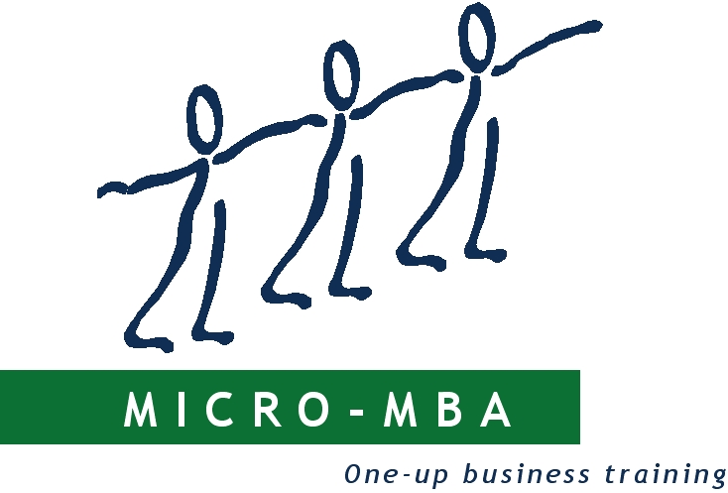

Friday, July 31, 2026

Thank you for expressing interest in Micro-MBA. We are the undoubted experts at what does NOT work because we have made so many mistakes as we have tried to alleviate poverty. We would like to help others to avoid the same pitfalls!

The Micro-MBA Course is a highly effective modular competency-based course that has been used by more than 230 development organisations throughout Africa. The course was developed specifically in relation to the needs and abilities of people in the micro-business sector of the South African economy, but has been found to be of value throughout sub-Saharan Africa, as well as in Latin America. About 190 000 emerging entrepreneurs in the micro and small-business sectors have been educated in this way over the past 28 years. The course requires the equivalent of grade 6 literacy, but illiterate people are encouraged to bring a literate friend or family-member with them to the course. In this way “2 are trained for the price of one!” There is no doubt that focusing on individuals is more effective than trying to work with production projects, but the Micro-MBA course has been effective in both paradigms.

The programme begins with a 5-day, learner-driven course, based on a series of simple workbooks covering the basics of business management comprising the following modules:

 Investigating the Market
 Using a Calculator
 Buying
 Costing and Pricing
 Selling
 Writing a Business Plan
 Money Management
 Stock Control

After the basic classroom experience, each learner is expected to meet with the facilitator at least once a month for three months. At that stage, those who demonstrate that they are applying what they have learned are awarded a Micro-MBA Diploma. The course, which is updated and improved at irregular intervals, is offered in three versions, i.e. Blue books for Traders, Green books for Producers and Red books for Service Providers. The books are available in English, French, Portuguese, Spanish and Afrikaans.

A pack of training materials (which comprises 8 workbooks and bookkeeping materials that should last for 6 months) costs $70. There is also a charge for sending the goods via courier. This varies according to distance from main centres. It makes more sense to enter into a Royalty agreement with us, which involves the licensing of our intellectual property, plus a fee per set of training books printed locally. Please let us know if you are interested in this option.

Courses for people who wish to become Trainers and Mentors in their community are run regularly in Cape Town. The cost per person for this intensive 4-day course is US$500 payable “up-front.” Participants are required to complete all the exercises in all 14 workbooks prior to the first day of the course, therefore arrangements must be made two to three weeks prior to the course to allow time for the training materials to be sent via courier. The pack of training materials for Trainer-Mentors comprises 5 generic workbooks plus three each for Traders, Producers and Service-Providers – a total of 14 workbooks. It also includes a copy of the Trident “Bizzy” game, used to enhance calculator skills.

The course typically starts on a Tuesday morning and finishes on Friday afternoon. It takes longer when translation is required.

Unfortunately we don’t have a programme for Trainer/Mentor courses for the year. These courses are arranged by appointment in Cape Town, or as a quorum emerges in other areas.

We are prepared to run courses for Trainer/Mentors anywhere, provided that the following conditions are met. We need:
- A pre-paid “quorum” of at least 10 Trainer/Mentors at $500 per person.
- A suitable (air-conditioned) venue with facilities for teas must be provided by the hosting organisation. The venue should include either a data-projector or a pc-compatible HD screen, plus a flip-chart and pens.
- Travel and accommodation costs for the course facilitator from two days prior to the course until one day after the course plus a cash per diem of US$100 for each day spent away from Cape Town (to cover dinners and incidentals).
- Wi-Fi access must be available throughout the course.

On the Trainer/Mentors’ course, we deal with the TASK and the PROCESS of empowering people to start or improve their small businesses. The TASK is fairly simple, but very important. It involves learning how to assist emerging entrepreneurs as they work through the 8 workbooks that comprise Micro-MBA.

The PROCESS is as important as the task and here we deal with the principles that we have found to be important in bringing people from a place of dependence, through independence, to interdependence. Apart from concentrating on skills needed to implement the Micro-MBA course, we also deal with the basics of Competency-based Training; Transactional Analysis; Managing Change; the Trainer as Leader vs the Trainer as Manager and the importance of Effectiveness vs Efficiency. We also place a strong emphasis on Emotional Intelligence and Social Intelligence. We have come to recognise the enormous power that a prevailing world-view has on the culture within which it reigns. Throughout the course, we attempt to help delegates realise that development does not occur in a vacuum.

We believe that facilitators are the natural mentors of the small businesses, therefore they should be contactable by their clients after the basic course and follow-up period.

It would be a privilege to work with you for the empowering of the emerging entrepreneurs in your area.

I look forward to hearing from you.

Yours in Development

CEDRIC BUFFLER
Managing Director



https://www.facebook.com/micromba.TridentInstitute/

https://www.instagram.com/micro_mba_international/

