
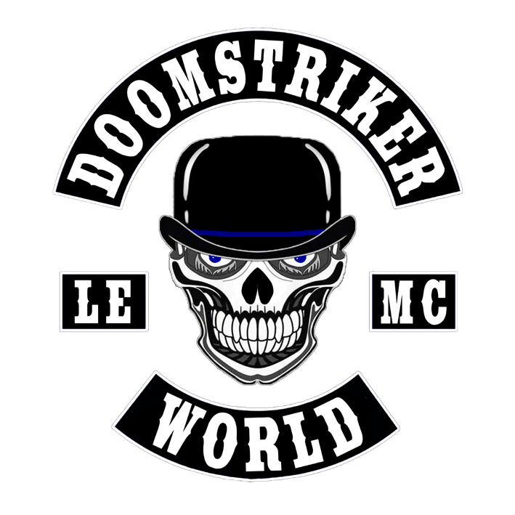
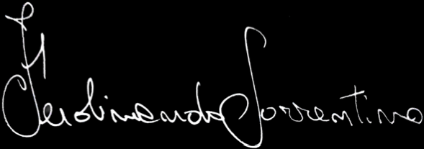
DOOMSTRIKER® LE MC STATUTE
Ferdinando Sorrentino -
Founding President
DOOMSTRIKER® LE MC STATUTE
CHAPTER PAGE
- ENTRY REQUIREMENTS 4
- INTERNATIONAL STATUTE 5
- MOTHER COUNCIL 6
- COMPOSITION OF COUNCILS 7
- DUTIES OF OFFICE 10
- COUNCIL MEETINGS 17
- STATUS WITHIN CLUB 20
- ELECTIONS OR NO-CONFIDENCE VOTES 24
OF THE NATIONAL PRESIDENT
- COLOURS AND MERCHANDISING 25
- THE EMBLEM AND VEST 28
- DISCIPLINARY SANCTIONS 30
- NATIONAL REGULATIONS 32
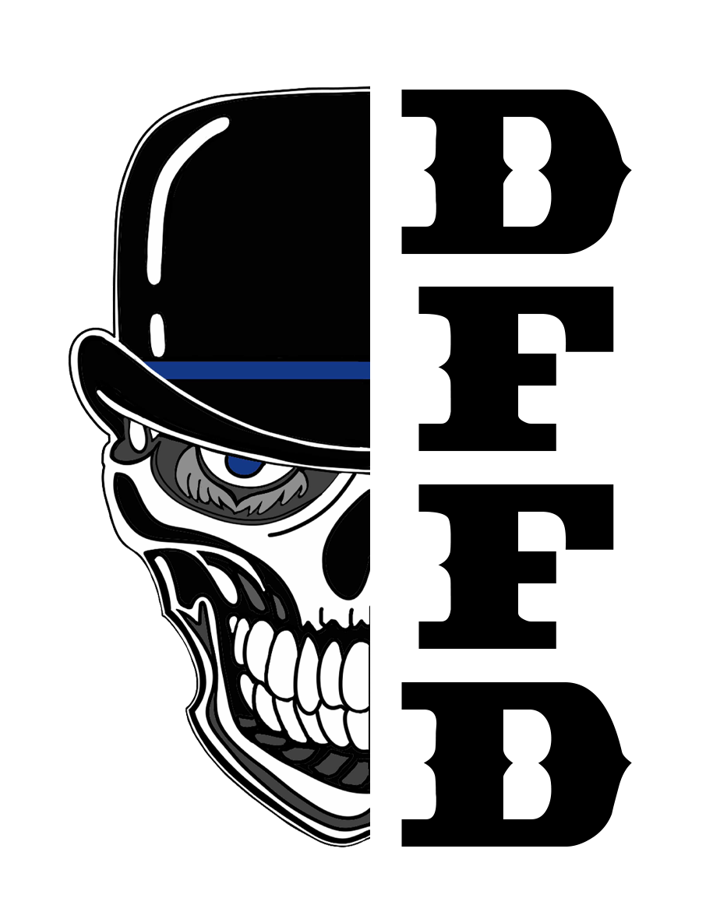

ENTRY REQUIREMENTS
- Members of the police force, either on active duty or retired (no dishonourable discharge)

- Members of the Armed Forces, on active duty or retired (no dishonourable discharge)

- Members of the Fire Brigade, on active duty or retired (no dishonourable discharge)

- Members of civil or paramilitary security administrations who have been sworn-in to legally recognised institutions of their country, that are not subject to criminal proceedings or pending charges, have no criminal convictions.

- Civilian supporters not subject to criminal proceedings or pending charges, who have not been convicted of criminal offences and are not subject to ongoing investigations

- Former members of other Law Enforcement Clubs. The admission procedures and steps to achieve Full Colour status will be decided by the relevant National Council.

- Own a motorcycle with a manual transmission and an engine capacity of at least 500 cc.

INTERNATIONAL STATUTE
The International Statute binds all club members worldwide to strict compliance.
Its rules, conduct and philosophy cannot be replaced by any other internal document within the country, and every club member must have a thorough knowledge of the International Statute.
Nevertheless, each nation may adopt further internal regulations in a National Statute, that must never conflict with the International Statute but must support it, respecting the international statute official document.

Further regulations (National Statute) may therefore be adopted that are important for better managing the club in relation to the culture and territory concerned.
Further regulations must be drawn up by the National Council and forwarded to the International Council for approval.
The Founder and co-founders, after hearing the non-binding opinion of the International President and the 'Mother Council', are the only ones authorised to make concrete changes to the International Statute, either independently or at the request of the National council of each country, subject to a special meeting convened by the International President.
This Statute may be amended in its entirety except for its Law Enforcement nature, which may never be called into question.

After receiving requests for amendments to the Statute, the International President shall notify the Founder and the "Mother Council” he is responsible in deciding if it is necessary to convene a special meeting and shall indicate the date and place for the relevant discussion. The meeting may be held in person or via video call. To ratify any amendments, the decision of the Founder, the Mother Council and the International President representing the National councils shall suffice.
In the event of a tie in the vote, the Founder's vote counts double.

THE MOTHER COUNCIL COMPOSITION
CURRENT INTERNATIONAL PRESIDENT IN OFFICE
FERDINANDO SORRENTINO (FOUNDER/FIRST MEMBERS)
SERGIO FARGNOLI (CO-FOUNDER/FIRST MEMBERS)
ANDREA TZENU (CO-FOUNDER/FIRST MEMBERS)
GREGORIO LO RUSSO (FIRST MEMBERS)
RAFFAELE PIZZOLLA (FIRST MEMBERS)
CURRENT NATIONAL PRESIDENT OF ITALY
CURRENT ITALIAN CHAPTER PRESIDENTS

The meeting of the "Mother Council" is valid even if only the International President, the Founder, the co-founders and the National President of Italy are present.

COMPOSITION OF COUNCILS
INTERNATIONAL COUNCIL
This is the body that oversees the club's activities worldwide. It consists of:
International President;
International Vice President;
International Sergeant-at-Arms;
International Secretary.

NATIONAL COUNCIL
For important decisions of a national nature and of interest to the Club, it promptly informs the International Council.
It intervenes on behalf of its own country if Chapter Presidents request its presence to collaborate and resolve club issues within the various chapters.
It liaises with Chapter Presidents, promptly sharing with them decisions taken at national level and received from the Mother Council.

If it is necessary to hold a vote, the vote of the National President counts double in the event of a tie. It consists of:
National President;
National Vice-President;
National Sergeant-at-Arms;
National Secretary;
National Treasurer;
National Head Road Captain;
In countries where there are not at least two chapters, the President of the only chapter represents that country. If there is only one or two members in the entire country, they are identified as Nomads and liaise with the International Council as they do not have a National President as a point of reference.

UNITED STATES OF AMERICA NATIONAL COUNCIL
The US National Council employs Enforcers without voting rights.
It interfaces outside the United States with the International President.
It intervenes on behalf of its own country if Chapter Presidents request its presence to collaborate and resolve club issues within the various chapters.
It liaises with Chapter Presidents, with whom it promptly shares decisions taken at national level and received from the Mother Council.

If it is necessary to hold a vote, the National President's vote counts double in the event of a tie. It consists of:
National President;
National Vice-President;
National Sergeant-at-Arms;
National Secretary;
National Treasurer;
National Head Road Captain;

CHAPTER COUNCIL
The body responsible for the internal organisation of the chapter, ensuring compliance with the International Statute and the implementation of the regulations set by the National Council. It consists of:
President;
Vice President;
Sergeant-at-Arms;
Secretary;
Treasurer;
Road Captain;

It consists of at least three members residing in the same area, where they elect their chapter and take its name.
The positions of President, Vice-President or Sergeant-at-Arms may only be held by members who have served for at least 36 months as: members of the police force; armed forces; or. If the Chapter consists of only 3 members, the positions shall be assigned as follows:
President(mandatory Law Enforcement), Sergeant-at-Arms (mandatory Law Enforcement), Secretary
If there are three or more members belonging to three different areas but within the same historical-geographical territory, it will be possible to open a new territorially named Chapter that can represent the different areas.
If there are hangarounds, Prospects or Probates scattered in geographical areas that do not fall within the same historical-geographical territory where there is no Doomstriker LEMC chapter and fewer than three members, they will be part of the nearest Doomstriker LEMC Chapter until they achieve full colour status.
DUTIES OF OFFICE

FOUNDER:
Collaborates with the International President to help him manage the various dynamics of the club worldwide more easily.
Spreads the club's philosophy throughout the world by attending all meetings where the International President requests his presence.
INTERNATIONAL PRESIDENT:
Appointed by the Founder, he is responsible for the club worldwide and ensures that the philosophy and rules laid down in the international statute are always respected.
He maintains relations with the National Presidents of the Club, providing them with support in the event of internal problems and when his intervention is requested.
As part of his role, he works directly with the International Enforcer for the USA and the International Ambassador for Europe. These two positions do not have voting rights.
They cooperate at US and European level in promoting the philosophy and rules of the club, acting on request as collaborators of the National Council and assisting the International President in assessing various situations in relation to the culture and territory of the nation or state concerned.
The International President can only be dismissed by the Founder.

INTERNATIONAL VICE PRESIDENT:
Assists and replaces the President and, in his absence or when appropriate, assumes his powers and duties.

INTERNATIONAL SGT AT ARMS:
The International Sergeant-at-Arms constantly ensures the safety of the Founder, the International President and the members of the International Board He coordinates the club Sgt At Arms with the collaboration of the National Sgt At Arms.He maintains constant contact with the International President on any global issues relating to security and discipline.
He intervenes independently, if necessary, to settle internal disputes.
He takes instructions exclusively from his President.
If the latter is absent, from the Vice President.
INTERNATIONAL SECRETARY:
Manages the Single International Secretariat, which is responsible for the tasks indicated therein.
Participates in all meetings of the International Council and takes minutes of the meetings in both Italian and English.
He maintains constant contact with all European and US National Secretaries.
He works directly with the Founder and the International President.
The International “Keeper” is responsible for official merchandising orders for the entire club.

NATIONAL PRESIDENT:
Elected by the International President.
Within the National Council, he is the representative of the club.
He chairs meetings and ensures, through the Secretary, that they are conducted democratically and in full compliance with the club's philosophy.
He acts on his own initiative if conditions are such that the members' meeting cannot be convened in time.
If necessary, he can remove the officers who make up his board through the Sergeant-at-Arms.
The national presidency lasts four years.
At the end of the term of office, at the first national meeting, a vote will be held to elect a new National President, where each Chapter President (as representative of the full colours voting members of their chapter) may confirm the incumbent National President or propose a candidate from their chapter or another chapter for the presidency.
A vote of no confidence in the National President may be taken by unanimous or 51% majority vote of the Full Colours members, obviously only in extremely serious and documented cases, such as:
conduct that does not comply with the rules and philosophy of the club; total inactivity in the club, i.e. not only absence from important events and meetings but also continuous and repeated absence, even by telephone, to respond to various requests from chapters without valid justification; criminally prosecutable offences.
The National Secretary shall convene a meeting to appoint a new National President, at which each Chapter President (representing the voting Full Colors members of their Chapter) may propose a candidate from their chapter or another chapter for the presidency.
In the event of voluntary resignation, the new National President will be appointed by vote of the Chapter Presidents (representing the voting Full Colours of their chapter), where each President may propose a candidate from their chapter or another chapter for the presidency.
The new National President independently appoints the members of his National council .
NATIONAL VICE PRESIDENT:
Assists and replaces the President and, in his absence or when appropriate, assumes his powers and duties.
NATIONAL SGT AT ARMS:
Ensures the constant safety of the members of the National Council, Coordinates the chapter Sgt At Arms with their collaboration.
Maintains constant contact with the National President on any national issues regarding security and discipline.
Intervenes independently, if necessary, to resolve internal disputes.
Takes directives exclusively from his President.
If the latter is absent, from the Vice President.
ENFORCER:
Assists the SGT At Arms in his duties, with whom he collaborates directly, and has no voting rights.

NATIONAL SECRETARY:
Responsible for the Chapters secretaries in his country. Organises events and National Meetings and collaborates with his National council.
Maintains friendly relations with the other Doomstriker Secretaries of other countries.
Organises meetings and takes note of the various discussion points to be presented at the beginning of the assembly.
He collects the forms relating to requests for official merchandise and submits them to the International Keeper by the set date.
He is responsible for drafting and keeping the minutes, which he must make available for inspection by every full member of the Club.
Minutes the meetings and keeps the records.
NATIONAL TREASURER:
He is required to provide detailed accounting information to all chapter treasurers.
Manages finances and administers them in such a way as to ensure economic stability in all situations, including emergencies.
He/she records income and expenditure and presents them in detail using the system considered most transparent and useful for the Nation.
At each meeting, he provides the President with the accounting situation, which is recorded in the relevant minutes of the meeting, which remain available to any full-colour member who requests them.

HEAD ROAD CAPTAIN:
The Head Road Captain is responsible for road safety in the case of national club formations or for trips involving several chapters outside provincial, regional and national contexts, with the collaboration of the chapter Road Captains.
He is responsible for deciding the itineraries during Club trips and movements at national level.

CHAPTER PRESIDENT:
The National President appoints the Chapter President. The new President appoints his own council.
Within the council, he is the representative of the club.
He chairs meetings and ensures, through the Secretary, that they are conducted democratically and in full compliance with the club's philosophy.
He acts on his own initiative if conditions are such that the members' meeting cannot be convened in time.
If necessary, he removes the members of his council through the Sergeant-at-Arms.
The Chapter President may be removed from office by direct intervention of the National President or by a unanimous or 51% majority vote of the chapter members, obviously only in extremely serious and documented cases such as:
conduct that does not comply with the rules and philosophy of the club; total inactivity in the club, i.e. not only absence from important events and meetings but also continuous and repeated absence, even by telephone, without valid justification; criminally prosecutable offences.
The chapter secretary will call a meeting to appoint a new president, at which each member will vote for a candidate from their own chapter.
The majority of votes will determine the appointment of the new President.
In the event of a tie, the National President shall cast the deciding vote, which shall close the ballot.
The appointment of the new President will be ratified by the National Secretary.
The Chapter President shall appoint or confirm their own council
In the event of voluntary resignation, the new President will be appointed by vote of the chapter members.
CHAPTER VICE-PRESIDENT:
Assists and replaces the President and, in his absence or when appropriate, assumes his powers and duties.
CHAPTER SGT AT ARMS:
He is responsible for the behaviour and training of Hangarounds, Prospects, Probates and Full Colours.
He constantly monitors their participation in club activities and maintains constant contact with the National Sgt At Arms on any internal issues within the chapter regarding security and discipline.
He intervenes independently, if necessary, to settle internal disputes.
He ensures that all members do not contravene the rules established in these Statutes.
If the latter is absent, the Vice President takes over.
CHAPTER SECRETARY:
Responsible for organising Chapter events and meetings.
Collaborates with his/her board and with the National Secretary, to whom he:
- independently reports any news/activities concerning the activities of their chapter;
- sends the forms relating to official merchandising orders by the set date (for Italy to the Keeper);
- sends the Roster in real time in case of changes.
He is responsible for the materials entrusted to him, organises meetings and takes note of the various discussion points to be presented at the beginning of the meeting.
He is responsible for drafting and keeping the minutes, which he must make available for inspection by every full member of the chapter.
At the end, send the relevant minutes to the National Secretary, if requested.
CHAPTER TREASURER:
He is required to provide detailed information on the financial situation to all members of the chapter.
He manages the finances and administers them in such a way as to ensure economic stability in all situations, including emergencies.
He/she records income and expenditure.
At each ordinary meeting, he provides the President with the accounting situation, which is recorded in the relevant meeting minutes, which remain available to any full-colour member who requests them.
ROAD CAPTAIN:
Responsible for road safety training within the chapter.
Decides on itineraries during chapter trips and travel.
Informs the National Road Captain and the Road Captains of other chapters in the event of trips outside the territory of their own chapter.
He quantifies stops for fuel and refreshments, coordinates departure and arrival times and is responsible for the cruising speed of the group, taking into account the presence of less powerful motorcycles.
He instructs members on the need for motorcycles to be technically sound and in perfect working order and checks that they have the correct registration documents so as not to create danger or hinder travel.
Assists the National Head Road Captain during club training.

MEMBER:
Members actively participate in all club events.
Wears the colours responsibly, interacts and actively collaborates in club initiatives and is required to respect and enforce the club's statutes, officers and elders in the same way as everyone else.

COUNCIL MEETINGS
INTERNATIONAL COUNCIL MEETING:
The International council meetings are decided on a case-by-case basis.
The International President has the power to request special meetings or gatherings at a global level and organises them through the International Secretary.
NATIONAL MEETING:
The National meeting is held twice a year, at the beginning and end of the motorcycling season, preferably in the town where the first Doomstriker Chapter in the country was founded, or in a different location if the logistical conditions are better.
All Club members are required to attend the National meeting, except in cases of unavoidable family or work commitments, a Hangarounds may not take part in the congress phase of the meeting.
Full Members have voting rights and may submit proposals, while Prospects and Probates may submit proposals but do not have voting rights.
Hangarounds may not attend the congress phase of the meeting, unless otherwise decided by the speaker.

The participation of Hangarounds and Prospects in the planning and organisation of the event is necessary as it constitutes a significant training course for integration into club life.
The National Secretary presents the agenda and then gives the floor to the National President.
He then takes the minutes of the important points of the meeting, with the aid of recording devices if necessary, and coordinates the congress phases so that everything takes place in a democratic and peaceful atmosphere.

CHAPTER MEETING:
This is convened at least once a month by the Chapter Secretary.
Any full member of the chapter (Full Colours) may request a special meeting if necessary.
All Full Colors, Probates and Prospects must attend the chapter meeting.
Prospects may submit proposals with or without voting rights at the discretion of the President.
The participation of Hangarounds in the meeting is at the discretion of the President, but topics relating to Club business must be excluded.
The presence of Hangarounds is mandatory for their training, even if their presence is unrelated to the issue of the meeting.
The Secretary presents the agenda and then gives the floor to the President. He then takes minutes of the important points of the meeting, with the aid of recording devices if necessary, and coordinates the proceedings so that everything takes place in a democratic and peaceful atmosphere.
STATUS WITHIN THE CLUB

CANDIDATES:
This is someone who asks to join the club.
They participate in the recreational activities of the chapter and the Club wearing the official support patch on their vest.
If deemed suitable by the Sergeant At Arms and all Full Colours of the relevant chapter, they are presented to the National Council, which, together with the chapter's Sergeant At Arms, determines the timing of their entry into the club.
Only then can they begin their journey as a Hangaround. If introduced to the Club by a Full Colour member, the latter becomes their 'Godfather', taking responsibility for their behaviour until they achieve Full Colour status.

HANGAROUND:
This is the first status and its path, which is of fundamental importance, is necessary to learn about the MC reality, values and respect for traditions.
They wear the patch with the name Doomstriker on the front of their vest, along with the patch of the Chapter to which they belong to and the Hangaround status patch, as described in the official brochure.

Their point of reference is the Sgt At Arms, from whom they receive the necessary instructions and teachings to reach the next step.
They participate in all club activities except for the congress phase of the National Meetings.
They do not talk about the Club for any reason with anyone who is not a member.

Always wears the vest when riding a motorbike.
The period for advancing to the next step is a minimum of three months, during which time the guidelines of the National Council must be followed in order to advance.

PROSPECT:
After approval by the SGT At Arms and all full members of the chapter, and after consulting with the members godfather, if applicable, the Hangaround will achieve Prospect status.
The decision must be shared with the National Council so that it can exercise any right of veto.
The Hangaround patch on the front of the vest will be replaced with the Prospect patch and the patch indicating their country will be added.
On the back of the vest, they shall apply the bottom rocker of their country, the Prospect top rocker and the LE - MC badges in accordance with the official brochure.
This period serves as training for the Prospect to understand the dynamics of the Club, its rules and, above all, how to behave in the presence of LEMC or other entities.
He must always wear the vest when riding his motorbike.
Receive instruction from his Sgt At Arms to achieve the next status.
The period for moving on to the next step is a minimum of 9 months, regulated by the Sgt At Arms, with reference to the relevant guidelines of the National Council.
Participate in all club activities.
Attend national meetings and do not discuss the Club for any reason with anyone who is not a member.

PROBATE:
Probate is the status acquired by applicants who come from other LEMC clubs.
Their admission is governed exclusively by the National Council.
On the front of the vest, they will wear the Probate Patch and on the back of the vest, they will replace the Prospect top rocker with the Club name, in accordance with the guidelines set out in the official vest brochure.
This period places the Probate as a full member on probation, during which time their knowledge of becoming a future Full Colour member and their attachment to the other members and the Club itself will be assessed.
The ease with which he rides with the Club colours and his practical and cognitive familiarity in the various contexts in which he may find himself.
They always wear the vest when riding a motorbike.
Their point of reference is the Sgt At Arms.
Participates in all Club activities, including National meetings, where he has no voting rights but may intervene by expressing his opinions, giving his views, and making proposals.
The period for transition to Full Colour is a minimum of 9 months and requires the authorisation of the National Council.

FULL COLOUR:
After the period specified in these statutes, the Prospect or Probate will be evaluated by the Sergeant-at-Arms, who will propose the transition to Full Colour member to the President and all Full members of the Chapter.
The transition to full membership status will be granted following a unanimous vote by the Full Colour members of the Chapter.
The Chapter President, upon unanimous approval, will present this decision to the National President.
After approval by the National Council, the President will add the round DFFD patch, the SPQR patch and, if applicable, the flag of their country and authorised side rockers to the front of the vest.
The family skull is placed on the back of the vest.
Always wear the vest with pride when riding a motorcycle.
The transition to Full Colour must always be considered a celebration to be shared with all brothers, therefore it must take place during National Events, with at least one representative of the National council or the International council present.

ELECTIONS OR NO-CONFIDENCE VOTES FOR THE NATIONAL PRESIDENT
NATIONAL PRESIDENT ELECTIONS:
Elections for the National President take place every four years in the event that Full Colours LE candidates submit their candidacy.

The elections are organised by the International President with the assistance of the International Sergeant at Arms and the International Secretary.
Voting is conducted by open ballot, not a secret ballot, with candidates forwarded to the International Webmaster.

The procedures will be described as necessary.
NO CONFIDENCE IN THE NATIONAL PRESIDENT:
In the event of serious misconduct, the National President may be dismissed by the Founder, the International Council or the Chapter Presidents (representing all voting Full Colours of their Chapter) of their country.
In the event of a vote of no confidence by the Chapter Presidents (representing the voting Full Colour memebers), it is necessary to collect a statement of no confidence containing clear, unequivocal reasons proving the National President's responsibility.

This statement must be signed by both the Presidents and the members who are withdrawing their confidence and forwarded to the relevant National Council and the International Council for evaluation.

COLOURS AND MERCHANDISING
CLUB COLOURS:
Each full member may have a maximum of two sets of Colours supplied by the only authorised workshop in Italy. The patches are the property of the Doomstriker® LE MC Cultural Association for Italy and, in the event of abandonment or removal from the Club, must be delivered intact to the relevant Sergeant At Arms and subsequently sent to the International Keeper (for Italy) within a maximum of ten days of notification of departure from the club.

Lady Strikers patches, like those for Misses and Juniors, must also be returned to the club in the event of a full member leaving.
Failure to comply will result in the consequences described in the chapter on DISCIPLINARY SANCTIONS (Bad Standing).
Patches returned by members who have left the club will be made available to the club again.
The supply of patches and official merchandise is distributed by a single workshop.
The International Keeper is responsible for checking and sending patches to members worldwide.
Commemorative plaques used at events may be produced by chapters in accordance with the Club's official colours and logo, which must be requested from the International Webmaster.
However, each chapter may contact its own supplier to produce SYLD merchandise bearing a logo chosen by the chapter members and the chapter name.

SYLD merchandise must be approved by the National Council.
countries outside Italy may apply to the International Secretary to purchase merchandise made in Italian workshops.
MERCHANDISE Full members (Full Colour) may wear pins bearing the official club logo in a discreet manner and in reasonable numbers, at their discretion.
All merchandise bearing the club's emblem or name should remain with the club in the event of a member leaving.
Each Chapter may propose gadgets for 'Supporters' to its national executive committee and, once authorisation has been obtained, may arrange for their production itself.
such merchandise, including patches, must never mention the name and symbol of the club, but only acronyms that indirectly refer to the Doomstriker Club (the acronym DFFD - Doomstriker Forever Forever Doomstriker - may only be used by full members).

PARTICIPATION IN MOTORCYCLE EVENTS
Doomstriker® Law Enforcement Motorcycle Club members undertake to attend all official LEMC events authorised by the National Executive Committee.
If, for any reason, only one member representing their country can attend an event, that member will be financially supported for travel expenses at a previously agreed percentage, subject to authorisation by their National Executive Committee.
The member will pay the expenses in advance and, upon their return, will submit receipts or invoices to the National Treasurer, who will communicate the amount spent for distribution among all members of their country, from Hangaround to Full Colour status.

Doomstriker® LEMC requires attendance at the following events:
- Doomstriker International Motorcycle Rally;
- National LEMC events;
- Doomstriker events in countries other than their own

THE EMBLEM
It is represented by a skull wearing an American-style bowler hat. The colours used to represent the emblem are black, white, grey and blue.
THE VEST It can only be made of leather or black denim.
It must always be worn when riding a motorbike, even alone, at official Club events and meetings, even if online.
POSITIONING AND MEANING OF THE PATCHES FRONT OF THE VEST:
On the left, from top to bottom:
- Pin with Doomstriker World logo
- Flag of your country
- Club name
- Country of origin
On the right, from top to bottom:
- Road name (optional) only from Full Colours• Position held (if applicable)
- Chapter name.
On the left at heart height:
- DFFD World round patch.
- Below, SPQR MMXIII patch On the right side (optional):
- large curved patch indicating the Administration where the Chapter is located.
On the left side (optional):
- large curved patch with the initials W.B.W. (World in Black and White) or DFFD.
If you choose to wear the DFFD Side Rocker, you must not wear the Vertical DFFD flash.
BACK OF THE VEST:
The symbols will be applied to the back of the vest, divided into five patches, in the following order:
Top Rocker with the name of the club;
Centrally, the club logo with the MC badge on the right and the LE badge on the left;
Bottom Rocker with the indication of the position or where the Chapter is located.
FOUNDER:
Back Bottom Rocker FOUNDER Front Flash Founder The rest is optional.
FOR CO-FOUNDERS:
Left side flash Founder. Right side patch W.B.W. (World in Black and White) or DFFD The rest is optional.
FOR THE INTERNATIONAL BOARD:
They do not wear the national flag as they represent the Doomstriker world.
On the left side, instead of the nation, they wear International.
They do not wear the nation's Side Rocker.
Right side WBW or DFFD Side Rocker (optional).
OPTIONAL SYMBOLS AUTHORISED FOR FULL MEMBERS
Pins with military or paramilitary awards relating to a single officially recognised qualification may be worn on the front of the vest (top left).
TATTOOS Full members may tattoo the club's symbols after at least 3 years of membership, bearing in mind that if for any reason they leave the club, the date of departure must be added to the tattoo.

DISCIPLINARY SANCTIONS
For Chapter members: The sanction is requested by the SGT at ARMS or the President.
The person to be examined is summoned by their Secretary.
If the person to be examined is a Full Colour or a Probate/Prospect, the decision-making body is the National Executive Committee plus the President and the SGT at Arms of the Chapter concerned and, if necessary, the Full Colours who highlighted and reported the disciplinary offence.

However, if the person under investigation is a Hangaround, the decision will be made by their own Chapter.
If the person does not appear before the disciplinary committee, they will be removed from the Club.
During the meeting, the parties will be heard, then the judgement will be made and a vote will be taken on the consequences of the case.
If the request for sanctions is voted unanimously, it will be applied immediately and made effective.
The sanctions that will be adopted in the event of non-compliance or failure to comply will be decided at the sole discretion of the examining committee and are as follows, in order of severity:
a. Loss of office
b. Downgrading of status
c. Loss of colours. Serious misconduct is defined as:
- posing a risk to the safety of the Club or a member of the Club;
- disrespecting the symbols of the club and its officers;
- showing blatant disaffection of Club life;
- breaking the law;
- breaking the rules of this statute

BAD STANDING:
This is applicable in the event of:
a) failure to return the equipment as described in Chapter 8 of these Articles of Association, followed by civil proceedings for breach of contract and/or criminal proceedings in the event of misappropriation b) wilful damage to Club property as described in the relevant chapter;
- committing offences under the Criminal Code;
- serious offences against members;
- relationships, courtship or harassment of a woman who is the wife, girlfriend or partner of another Club member; f) disclosure of confidential information
concerning the Club to other Clubs;
g) does not disclose information or facts, including external ones, that could damage the Club.

If disciplinary action is to be taken against a member of an Executive Committee not belonging to the Parent Company, it shall be taken by the Executive Committee to which the member concerned belongs.
In the event of a vote of no confidence in a First Member, the only members with jurisdiction are the Founder and co-founders, upon the recommendation of the International President and National President of Italy.
When members at any level, through their arbitrary decisions or repeated behaviour that is not in line with the Doomstriker philosophy, jeopardise the serenity and balance of the club, the Founder, through the International President, may take final decisions independently, even in derogation of these International Statutes.

REGULATIONS
With separate documentation, each Nation may adopt REGULATIONS to direct Sergeants At Arms, Secretaries, Treasurers, Road Captains and Enforcers to standardise certain procedures of interest to the Club, in full compliance with these Statutes.

The minimum time frames necessary to achieve the relevant statuses must be strictly adhered to. These are indicative and at the discretion and sole responsibility of the Sergeant At Arms, who has no limits on application if the member does not meet the requirements necessary to represent the next status.
It is the responsibility of the Chapter Secretary to strictly enforce the minimum timeframes of the roster.
The GUIDELINES of each country must in any case be sent to the Single Secretariat for approval by the International Board.
Under no circumstances may these Statutes be amended except by the Founder, after consulting the non-binding opinion of the International President and the Mother House.
These Statutes must be kept by every Secretary at every level, known to all members and brought to all meetings so that they can be consulted.
IT IS EVERYONE'S DUTY TO CULTIVATE AND NURTURE A PHILOSOPHY BASED ON BROTHERHOOD, HONOUR AND RESPECT, WHICH UNITES THE BROTHERS IN THE PRIDE OF WEARING THE SYMBOLS OF OUR CLUB.
DOOMSTRIKER® MC STATUTES

