
2025

ANNUAL SECURITY REPORT
832 North Broad St.| Philadelphia, PA 19130

TABLE OF CONTENTS

INTRODUCTION
 Accreditation & Memberships
 Licensing & Certification

ANNUAL SECURITY REPORTING
 Jeanne Clery Act
 VAWA (Violence Against Women Act)
 Preparation
 Statement of Availability
 Disclosure
 Notification
 Clery Geography & Crimes
 Emergency Contacts & Resources

SAFETY & SECURITY
 Campus Security Authorities
 Reporting a Crime
 Timely Warning
 Contact Information
 Safety & Access
 Security Cameras
 Visitor Policy
 Parking Policy
 Maintenance Policy
 Campus Search Policy
 Registered Sex Offenders
 Safety Awareness & Prevention Programs  Student Code of Conduct
 Prohibited Conduct

EMERGENCY POLICIES & PROCEDURES
 Descriptions of Emergency Response &
Evacuation Procedures
 Emergency Response, Evacuation
Notifications, & Timely Warnings

TITLE IX: SEX-BASED DISCRIMINATION POLICY
 Nondiscrimination Statement and Notice
 Title IX Coordinator
 Definitions
 Prohibited Conduct
 Grievance Procedures

SUBSTANCE ABUSE & PREVENTION
 Enforcement & Disciplinary Actions
 Health Risks & Legal Consequences
 Testing & Inspections
 Resources & Prevention
 Local State & Federal Laws
 Treatment Facilities
CAMPUS & PUBLIC CRIME DATA
 Crime Statistics: 2024 – 2025

INTRODUCTION
Final Touch Barber Academy is a 20,000-square-foot private post-secondary institution and maintains a single campus located at 832 N Broad St Philadelphia PA 19130. Notably, the campus does not include residential accommodations, satellite sites, or public properties that directly adjoin or are accessible from our primary campus area.

Final Touch Barber Academy acknowledges that upholding crime prevention is a shared duty involving the institution as well as every individual affiliated with its operations, whether as employees, students, or visitors. The most effective approach to crime prevention revolves around vigilant monitoring of the premises and prompt reporting of any unusual or questionable activities.

Accreditations & Memberships
Final Touch Barber Academy is a proud member of the American Association of Cosmetology Schools (AACS), a Pivot Point International Member School, a member of the Greater Phoenix Chamber of
Commerce and accredited by the Commission of the Council on Occupational Education (COE)

Licensing & Certification
The Pennsylvania State Board of Barber Examiners has licensed Final Touch Barber Academy as a school to provide Barber License, Barber Teacher and Barber Crossover Program.

ANNUAL SECURITY REPORTING

Jeanne Clery Disclosure of Campus Security Policy and Campus Crime Statistics Act
The Clery Act requires all colleges and universities that participate in federal financial aid programs to report campus crime data, support victims of violence, and publicly outline the policies and procedures they have implemented to improve campus safety. The United States Department of Education monitors compliance.

The Clery Act mandates that colleges and universities receiving federal funding disseminate a public Annual Security Report (ASR) to employees and students every October 1st. This ASR must include campus crime statistics for the preceding three calendar years and details about efforts to enhance campus safety. ASRs must also contain policy statements on crime reporting, campus facility security and access, law enforcement authority, the incidence of alcohol and drug use, and the prevention of and response to sexual assault, domestic or dating violence, and stalking.

VAWA (Violence Against Women Act)
VAWA is a U.S. law designed to help prevent and address domestic violence, sexual assault, and stalking. Passed in 1994, it provides funding for victim services, trains law enforcement, and establishes programs to support survivors. The law aims to improve the response to these crimes and enhance protection for victims.

The Violence Against Women Act was reauthorized, and significant amendments were made to the Clery Act through the Campus Sexual Violence Elimination Act (Campus Save Act). This amendment enhances the Clery Act by requiring higher education institutions to disclose campus crime statistics and security information.

Preparation
Final Touch Barber Academy collaborates across multiple departments, including Operations, Student Services, Guest Services, and Education, to prepare the Annual Safety Report. Each department contributes relevant information.

Statement of Availability
Final Touch Barber Academy is committed to assisting all members of the Philadelphia community in providing for their own safety and security.

If you would like to receive the Annual Security Report that contains this information, you can stop by the Final Touch Barber Academy at 832 N Broad St. Philadelphia PA 19130, or you can request that a copy be mailed to you by calling 215-433-6557.

The Annual Security Report contains information regarding campus security and personal safety, including crime prevention, law enforcement authority, crime reporting policies, disciplinary procedures, and other matters of importance related to security and safety on campus. They also contain information about crime statistics for the three previous calendar years concerning reported crimes that occurred on campus, in certain off-campus buildings or property owned or controlled by Final Touch Barber Academy, and on public property within or immediately adjacent to and accessible from the campus.

Disclosure
The ASR is accessible at finaltouchbarberacademy.com. The ASR is available within the Final Touch Barber Academy app.

Notification
Current and prospective students are notified by email which includes a link to the Final Touch Barber Academy websites about the updated report's availability. These notifications include a link to the report's website.

Employee Notification and Acknowledgement: Employees are notified about the updated ASR via email, which includes a link to the website where the report is published.

Clery Geography
For collecting crime statistics for the U.S. Department of Education and Final Touch Barber Academy’s annual security report, Clery geography includes:
- Buildings and property on the institution's campus
- Public property within or immediately adjacent to and accessible from the campus

For maintaining Final Touch Barber Academy’s crime log, Clery geography also includes these locations.
Final Touch Barber Academy crime statistics within the Clery geography are reported to the U.S. Department of Education via the online data collection portal at surveys.ope.ed.gov/campus safety.

Final Touch Barber Academy reports and discloses crime statistics for the three most recent calendar years concerning the number of specific crimes that occurred on or within its Clery geography and were reported to local police agencies or campus security authorities. The crimes include:

- Criminal homicide, including murder, non-negligent manslaughter, and negligent manslaughter.
- Sex offenses, including rape, fondling, incest, and statutory rape.

- Robbery
- Aggravated assault
- Burglary
- Motor vehicle theft
- Arson

Final Touch Barber Academy reports arrests and referrals for disciplinary actions related to liquor law violations, drug law violations, and illegal weapons possession. This includes both arrests and cases referred to as a campus disciplinary action. Hate crimes are also reported, including the number of each type of primary crime determined to be a hate crime, as well as specific hate crimes such as larceny-theft, violence, domestic violence, and stalking must be included.simple assault, intimidation, and
EMERGENCY CONTACTS AND RESOURCES
The following is a list of emergency, crisis, and student resource information:
EMERGENCY | 9-1-1
Non-Emergency | 311 | Philadelphia Police
Campus Security Authorities | 267-446-1267 | FTBA Compliance
Title IX Coordinator | 267-446-1267 | FTBA Compliance
Silent Witness | 215-686-8477 | Philadelphia Police Dept
Suicide and Crisis Help Line | 988 | Crisis Support Philadelphia
Alcohol Anonymous | 888-471-1067 | Alcohol Anonymous
Drug Anonymous | 988 | https://988lifeline.org/
Child Abuse Hotline | 215-683-6100 | City of Philadelphia
Domestic Violence | 800-799-7233 | National Domestic Violence Hotline

SAFETY & SECURITY

Local Law Enforcement
Local law enforcement has the arresting authority on Final Touch Barber Academy’s Campus.
FTBA complies with all local, state, and federal laws. When a student conducts or behaves adversely, it impacts FTBA’s community, the educational programs are jeopardized, and all are at risk. Behavior that is in violation of local, state, or federal law will not be tolerated. FTBA does not protect from prosecution by law enforcement agencies in these cases.

Campus Security Authorities (CSAs)

Responsibilities of CSAs:
FTBA’s Campus Security Authorities (CSAs) are responsible for promptly reporting any incidents of crime that come to their attention. This reporting is crucial for compiling FTBA Academy's Annual Safety Report and, if necessary, issuing Timely Warning Notices.

CSAs are entrusted with the authority and obligation to take proactive measures and respond to safety and security matters on behalf of FTBA Academy. They play a pivotal role in maintaining a secure campus environment.

❖ It is important to note that FTBA’s CSAs do not have arresting authority.

Reporting Procedures: Confirmed and documented incidents of crime, as identified by the CSAs, are communicated to the President of FTBA. This communication is to ensure and maintain transparency and inform decision-making regarding campus safety.

Obligations of Designated Campus Security Authorities:
- Maintain an Accurate and Up-to-Date Campus Crime Log: Ensure all incidents are recorded accurately and timely.
- Report Campus Crimes and Violations of the Clery Act, VAWA, and Title IX: Ensure compliance with federal mandates by reporting all relevant incidents.
- Encourage Reporting: Encourage individuals who have experienced or witnessed crimes to come forward and report these incidents.
- Provide Information on Resources: Offer information about available resources for assistance and support to affected individuals.
- Confidentiality in Reporting: Assure reporting individuals that the incident will be included as a statistical record without revealing their identity.
- Timely Reporting: Complete the CSA Clery crime reporting form within 24 hours of receiving pertinent information.
- Uphold Reporting Obligations: Report incidents regardless of whether the alleged victim pursues formal legal actions or engages law enforcement.

Reporting a Crime: If you or someone you know needs to report a crime, contact any of the Campus Security Authorities listed below:

- Ronald Curtis, Director of Student Services ronc479@gmail.com
- Christopher Edge, Director of Education Haircuts24seven@gmail.com
- Howard Myers, Education Manager, hrmyerssr@gmail.com

FTBA has designated these individuals to play a pivotal role in upholding the safety and security of the campus community.

Timely Warning Notification Policy
The Academy is committed to ensuring the safety of its faculty, staff, and students by providing timely warnings about potential threats. In compliance with the relevant regulations, the Academy will issue timely warnings to alert the campus community when:

Pattern of Criminal Activity:
- A pattern of criminal activity that poses a threat to the safety of the campus community becomes apparent.

Confidentiality of Victims:
- Timely warnings will not include the names or other identifying information of victims to ensure their confidentiality.

Protection of Law Enforcement Efforts:
- Specific information may be withheld from timely warnings if disclosing it could compromise law enforcement efforts to investigate or solve the crime.

By adhering to this policy, the Academy aims to effectively inform and protect its campus community while supporting ongoing law enforcement activities.

Crime Log
FTBA maintains a crime log to ensure transparency and campus safety in compliance with federal regulations. While no crimes have been reported to campus security to date, this log is prepared to record any future incidents within Clery geography, detailing the nature of the crime, report date, time and location, and disposition of the complaint. Entries will be made within two business days unless confidentiality or legal concerns arise.

Information may be withheld if its release jeopardizes investigations, safety, or evidence but will be disclosed once the risk is no longer present. Crime logs from the past 60 days are available for public inspection during business hours, and older logs are provided within two business days upon request. By adhering to this policy, FTBA Academy ensures compliance with federal regulations and maintains a safe and transparent environment for all.

Criminal Activity
If the incident may involve a crime, report it to the Student Services Office and a CSA.

Emergencies
If you believe the situation is an emergency:
- Step 1: Call 911 immediately.
- Step 2: Notify a CSA as soon as possible

After Contacting the CSA
- Remain available to assist with documentation
- Follow directions from emergency responders or CSAs • Secure the area if safe to do so

Submission Guidelines
- Submit the completed form to Student Services
- When possible, complete it within 24 hours
- If unsure whether to report, consult Student Services

Contact Information
Students, faculty, and staff are responsible for having current and accurate information on file with the Academy to ensure they receive timely warning notifications.
FTBA does not assume responsibility for incorrect contact information on file.

Safety & Access
FTBA welcomes students, staff, faculty, approved contractors, and guests during standard business hours. Outside of these hours, entry is restricted to authorized employees and janitorial, maintenance, or facility upgrade contractors through the use of keys and security codes.

Security Cameras
FTBA has installed security cameras in common areas. These cameras are used to identify and monitor theft, mischief, vandalism, and potential safety risks.

Visitor Policy
During school hours, students, staff, and faculty are generally not permitted to have visitors unless given approval by the President or Department Head based on specific circumstances. This policy applies to all campus areas, including the student breakroom, employee breakroom, student patio, and parking areas.

Parking Policy
FTBA does not have designated student parking lot. Parking is permitted on all streets surrounding the building.

Maintenance Policy
The Operations department at FTBA coordinates and supervises campus maintenance, repairs, and upgrades to the facility and equipment. Furthermore, this department conducts assessments of landscaping, locks, alarms, and lighting to pinpoint and address areas that require attention. FTBA is dedicated to ensuring the security of its premises and surroundings. The Property Manager assumes responsibility for overseeing the roof, exterior lighting, parking lot, landscaping, and sidewalks.

Campus Search Policy
To protect the safety and well-being of our students, campus searches may occur at any time and without notice. These searches could encompass student lockers, book bags, or personal possessions if required for investigative purposes. Individuals suspected of engaging in criminal behavior will be handed over to the appropriate legal authorities for further action.

Registered Sex Offenders
Pennsylvania State Police requires offenders to register based on their Pennsylvania Risk Assessment score. Information can be found on the state website at Meganslaw.psp.pa.gov. Various free-of-charge search results can be obtained using information such as the violator's last name, the zip code for the area of interest, and a specific address with results for the surrounding three square miles. In addition, a downloadable listing of sex offender information can be obtained for a fee. Pennsylvania has no law against offenders seeking or obtaining employment or living near educational institutions.

Safety Awareness & Prevention Programs
All students, faculty, and staff should have a preconceived plan of action in the event of criminal activity they should become involved in or witness.

Following the general rules listed below can help mitigate the risk of becoming a victim of crime.
- Be alert for suspicious persons and activity on campus. For example, if you see an unfamiliar face in the vicinity, proceed to your work/class area and then report the matter immediately.
- Walk in well-lit areas. If possible, do not walk alone.
- In case of a personal attack, scream as loudly as possible and run toward a more lighted or highly trafficked area.
- Do not voluntarily enter an assailant’s vehicle or go to a more remote location with an assailant.
- Be aware of your surroundings. If you think you are being followed, go to a crowded area.
- Be alert and observant of the people around you.
- Trust your instincts. If you sense trouble, get away as soon as possible.
- Do not carry large amounts of money.
- Park your vehicle in populated and well-lit areas, if possible.
- Lock all vehicle doors and check them before leaving your parked car.
- Carry keys in your hand. Allowing you to reenter your vehicle rapidly should you see a suspicious person in the area.

Employee Awareness & Prevention Programs
FTBA implements awareness and prevention programs for all new employees as part of their initial onboarding and periodic sessions.

Student Awareness & Prevention Programs
For students, FTBA offers thorough awareness and prevention programs integrated into the student orientation and periodic sessions. These programs ensure students are well-versed in the policies and procedures to maintain campus safety.
These programs are designed to ensure employees and students are well-informed and prepared to maintain a safe and supportive campus environment. The key components include:
- Annual Security Report (ASR) and Safety Policies: New students and employees are oriented on the importance of the ASR and various safety and security policies. This covers emergency response, evacuation procedures, incident reporting, and maintaining a secure environment.
- Title IX Training: Focused on understanding and preventing gender-based discrimination, sexual harassment, and related issues. This training helps employees recognize and address any instances of sex-based discrimination effectively.
- Clery Act Training: New hires are educated on the significance of the Clery Act, including crime reporting requirements and the impact of accurate reporting on the campus community.
- Bystander Intervention: Focused on how to safely and effectively intervene in potentially harmful situations. Participants learn to recognize when intervention is needed, understand factors contributing to violence, overcome barriers, and implement safe intervention strategies. During orientation and periodic training sessions, participants learn to: o Recognize situations where intervention is needed. o Understand cultural and institutional factors that contribute to violence. o Overcome common barriers to intervention.
o Identify and implement safe and effective intervention strategies. Training methods include interactive workshops, role-playing scenarios, and group discussions, which help build a proactive community ready to act against violence.
- Risk Reduction Strategies Risk reduction strategies are integrated into training programs for both students and employees to decrease perpetration and bystander inaction while empowering victims. Training sessions provide practical information on recognizing and avoiding potentially dangerous situations, enhancing personal safety, and supporting victims. Tools and resources, such as safety apps and self-defense classes, are introduced and made available. Additionally, participants learn to understand and address the conditions that facilitate violence, ensuring they are better equipped to promote overall safety and well-being within the campus community.

By incorporating these programs and strategies into student and employee training, FTBA Academy ensures a well-informed, supportive, and proactive campus environment dedicated to preventing violence and promoting safety.

Student Code of Conduct
This code of conduct guides students in personal behavior that reflects FTBA’s mission and culture. It supports and maintains a professional, safe, and healthy learning environment that promotes students' academic, social, and professional growth.
While attending school during regular hours or participating in school-sponsored activities, students are expected to:
- Practice Professionalism: Commit to education and engage respectfully and honestly with the FTBA community.
- Be Accountable: Take responsibility for personal success and handle critical feedback constructively.
- Stay Engaged: Prioritize learning, minimize distractions, and be prepared and punctual for classes and clinical sessions.
- Maintain Respect: Use school-appropriate language and behavior, follow educator instructions, and respect classroom rules and expectations.
- Support Others: Encourage fellow students and avoid becoming a distraction.
- Value Attendance: Regular attendance is crucial for success and to maximize educational benefits.

Prohibited Conduct
Sex-Based Harassment is a form of sex discrimination and means sexual harassment and other harassment on the basis of sex, including on the basis of sex stereotypes, sex characteristics, pregnancy or related conditions, sexual orientation, and gender identity, that is:
- Unwelcome Conduct determined by a reasonable person to be so severe, pervasive and objectively offensive that it effectively denies a person equal access to FTBA’s Education Program or Activity. Such conduct may include, but is not limited to, unwelcome sexual advances, requests for sexual favors, verbal or physical conduct of a sexual nature, sexual exploitation sexual coercion, sexual touching, and fondling, the touching of an unwilling person’s intimate parts, and forcing an unwilling person to touch another’s intimate parts.
- Quid Pro Quo Harassment. An employee, agent, or other person authorized by the recipient to provide an aid, benefit, or service under the recipient’s education program or activity explicitly or impliedly conditioning the provision of such an aid, benefit, or service on a person’s participation in unwelcome sexual conduct;
- VAWA Offenses. Domestic violence, dating violence, sexual assault, and stalking. (as defined in VAWA -34 U.S.C. § 12291) Specific offenses.
  - Sexual Assault meaning an offense classified as a forcible or nonforcible sex offense under the uniform crime reporting system of the Federal Bureau of Investigation;
  - Dating Violence means violence committed by a person:
    - Who is or has been in a social relationship of a romantic or intimate nature with the victim; and
    - Where the existence of such a relationship shall be determined based on a consideration of the following factors:
      - The length of the relationship;
      - The type of relationship; and
      - The frequency of interaction between the persons involved in the relationship; iii. Domestic Violence meaning felony or misdemeanor crimes committed by a person who:
    - Is a current or former spouse or intimate partner of the victim under the family or domestic violence laws of the jurisdiction of the recipient, or a person similarly situated to a spouse of the victim;
    - Is cohabitating, or has cohabitated, with the victim as a spouse or intimate partner;
    - Shares a child in common with the victim; or
    - Commits acts against a youth or adult victim who is protected from those acts under the family or domestic violence laws of the jurisdiction; or
iv. Stalking means engaging in a course of conduct directed at a specific person that would cause a reasonable person to:
    - Fear for the person’s safety or the safety of others; or
    - Suffer substantial emotional distress.
- Hostile Environment Harassment. Unwelcome sex-based conduct that, based on the totality of the circumstances, is subjectively and objectively offensive and is so severe or pervasive that it limits or denies a person’s ability to participate in or benefit from the recipient’s education program or activity (i.e., creates a hostile environment). Whether a hostile environment has been created is a fact-specific inquiry that includes consideration of the following:
  - The degree to which the conduct affected the complainant’s ability to access the recipient’s
education program or activity;
  - The type, frequency, and duration of the conduct;
  - The parties’ ages, roles within the recipient’s education program or activity, previous interactions, and other factors about each party that may be relevant to evaluating the effects of the conduct;
  - The location of the conduct and the context in which the conduct occurred; an
  - Other sex-based harassment in the recipient’s education program or activity.
- Sexual Misconduct Offenses:
Actions that constitute sexual misconduct include, but are not limited to, inappropriate comments, jokes, gestures, and the posting of images. This conduct is defined as any unwanted and distressful behavior that is sexual in nature, including harassment, bullying, or victimization.
- Discrimination:
Prohibited based on race, color, national origin (Title VI of the Civil Rights Act of 1964), sex (Title IX of the Education Amendments of 1972), disability (Section 504 of the Rehabilitation Act of 1973), and age.
- Retaliation Offenses:
Intimidation, threats, coercion, or discrimination against individuals who participate in grievance procedures or report violations is strictly prohibited.
- False Statements:
      - Knowingly making false statements or submitting false information during the grievance process is prohibited.
      - Making false statements or providing false information to FTBA Academy personnel is prohibited.
- Weapons and Violence:
The possession of weapons on campus, including vehicles, is strictly prohibited. The use of firearms imposes severe disciplinary sanctions, including legal action. Engaging in acts of violence, including physical harm, bodily harm, or threatening the safety of another student or FTBA Academy employee, is prohibited.
- Audio/Video Recording:
Videotaping and audio recordings are not allowed at any time unless approved by the President. Photography of another student and/or guests may occur only with the permission of students and/or guests.
- Bullying:
Bullying, defined as any harmful or intimidating behavior communicated via verbal, physical, or by electronic means.
- Drugs and Alcohol:
Manufacturing, distribution, dispensing, possession, or use of drugs (including medical marijuana), alcohol, or related paraphernalia on campus, including any property owned or leased by FTBA Academy, as well as during any academy activities. Prescription and over-the-counter medications are permitted, provided they do not impair safe participation in academy activities.
- Disruptive Behavior:
Any actions or behaviors that significantly interfere with the normal operations of the environment, obstruct the learning or work of others, or create an atmosphere of intimidation, hostility, or undue stress are prohibited. This includes but is not limited to, loud or repeated interruptions, physical or verbal aggression, obstructive or inappropriate use of technology, and refusal to follow established guidelines or directives.
- Academic Dishonesty:
Cheating or plagiarizing is prohibited. This includes, but is not limited to, giving and receiving answers; unauthorized use of external assistance, resources, or materials that are not explicitly permitted; copying the work of others; falsifying data or records; collaborating in an unauthorized manner; and using technology in prohibited ways during assessments or assignments.
- Other Prohibited Conduct:
    - Using profane, obscene, or ethnically offensive language.
    - Possessing pornographic material.
    - Theft (from another student or FTBA Academy).
    - Gambling on campus.

Statement of Non-Hazing
FTBA strictly prohibits any form of hazing by students, employees, or affiliated groups. Hazing is defined as any conduct that endangers the mental or physical health or safety of an individual for the purpose of initiation, admission into, affiliation with, or continued membership in any group or organization—regardless of the individual’s willingness to participate.

Hazing is not tolerated under any circumstances. This includes but is not limited to behaviors involving physical harm, intimidation, humiliation, forced consumption, or coercion. When hazing is sex-based or occurs in the context of a sex-based power dynamic, it may also constitute a violation of Title IX and will be addressed accordingly.

Any individual who engages in hazing, witnesses hazing, or becomes aware of hazing is strongly encouraged to report the incident to the Title IX Coordinator or other designated campus official.
Retaliation for reporting hazing is strictly prohibited.
Violations of this policy may result in disciplinary action, up to and including termination of enrollment or employment.

Disciplinary Sanctions
Students who commit these serious offenses will face strong disciplinary sanctions. Some of these offenses violate state and federal laws, and many of them directly threaten the well-being and safety of the students or the FTBA community.

Upon determination that violations of prohibited conduct have occurred, the following disciplinary sanctions may be imposed:
- Informal warning
- Formal warning
- Early dismissal
- Suspension
- Termination
- Legal action

EMERGENCY POLICIES & PROCEDURES
Specific emergencies, crimes, and suspicious activities that don't involve serious personal injury, property injury, or property loss can be reported to your local law enforcement officers at their nonemergency number. Some examples may include reports of a burglary where the suspect has left the vicinity, hit-and-run accidents with no injuries, graffiti or other vandalism, or persons disturbing the peace.

What Constitutes an Emergency
An emergency is any situation that poses an immediate threat to a person’s health, safety, or property. This includes (but is not limited to):
- Serious injuries or medical conditions (e.g., loss of consciousness, difficulty breathing, seizures) • Fires, smoke, or strong gas smells
- Real, threatened, or impending danger including active threats or violence on or near campus
- Severe weather or natural disaster affecting campus operations
- Missing persons, or suspected drug or alcohol overdose
- Any situation requiring 911 or first responder involvement

Timely Warning & Emergency Response
Timely warnings are triggered when the Academy determines a crime for which we must report statistics, such as a criminal homicide, sex offenses, robbery, aggravated assault, burglaries, hate crimes, persons with weapons with intent to use, and the threat of violence to students and employees. If a situation arises, either on or off campus, that, in the judgment of the President, constitutes an ongoing or continuing threat to the Academy's community. In that case, a campuswide Timely Warning will be issued. The warning will be issued through the FTBA app, email, or phone, depending on the situation. A notice will be published in all cases that could immediately threaten individuals and the community.

Timely Warning Notification
The Academy will alert faculty, staff, and students if a pattern of criminal activity becomes apparent. Timely Warnings do not include the names of victims. In addition, when issuing a Timely Warning, some specific information may be withheld if there is a risk of compromising law enforcement efforts to investigate or solve the crime.

Emergency Notifications
FTBA notifies its community of an emergency using the emergency message system in the FTBA app. However, due to the fast-moving nature of an emergency, it may not be possible to notify building occupants in a timely manner. Emergency evacuations may be prompted by the notification from the FTBA leadership team, faculty, staff, or other building occupants aware of immediate danger.

Emergency Evacuation Drills
The Academy conducts emergency evacuation drills with students, staff, and faculty each year.

Emergency Evacuation Policy & Procedure
Evacuation means exiting a facility as directly and safely as possible. Evacuation is appropriate when conditions inside a structure threaten the health and safety of building occupants, and leaving the facility is safer than remaining inside it. Evacuation should occur through the closest exit, but depending on the circumstances, an alternate or secondary evacuation route may need to be used. The goal of evacuation is to leave the premises as quickly and safely as possible.

Strategies for an Effective Evacuation
- Exit the premises through the nearest exit.
- Exit immediately; do not return personal items.
- If possible, inform others of the evacuation.
- If possible, help others evacuate.
- Evacuate regardless of whether others agree to follow.
- Use the safest evacuation route possible.
- Avoid contact with the hazard (fire, suspicious package, violent intruder, etc).
- Prevent individuals from entering an area where the risk may be.

Notification
The Academy notifies its community of an emergency using the emergency message system in the Final Touch Barber Academy app. However, due to the fast-moving nature of the event, it may not be possible to notify building occupants promptly. Emergency evacuations may be prompted by notification from the FTBA leadership team, faculty, staff, or other building occupants who are aware of immediate danger.

If you feel your safety is at risk and evacuation is an appropriate strategy, you do not have to wait for official notification.

Preparedness
Knowing the nearest exits and evacuation routes is essential before an emergency. Refer to the FTBA emergency evacuation plan and exit maps posted in each classroom, the student clinics, the break room, and the office on evacuation routes before an event occurs to be equipped to act fast and ensure your safety.

If you feel your safety is jeopardized and evacuating is an appropriate strategy given your circumstances, you do not have to wait for an official notification to evacuate.

Shelter In Place Policy and Procedures
Shelter in place is a precaution aimed at keeping the Academy's community members safe by requiring people to remain in their current location until the danger has passed.
Find a secure place indoors and stay there until you are given an "all clear" or told to evacuate.

Strategies for effective Sheltering-In-Place
To effectively shelter in place, you must first consider the hazard and choose a place to shelter in a safe building. For example, for a severe thunderstorm, the safest location is inside a large, enclosed structure. Stand or sit away from doors and windows that lead outside. Stand out from concrete walls and avoid lying on concrete floors. Close doors and windows to the outside to prevent wind damage and injuries inside the building.
General recommendations that may increase the effectiveness of sheltering-in-place:
- Shelter in an area that will shield you from the hazard.
- A better shelter area will vary based on the hazard but in general, choose a place away from windows and glass, with no vents, and away from room corners where debris can accumulate.
- Large storage closets, utility rooms, pantries, break rooms, and conference rooms without exterior windows may work well as shelter areas.
- When sheltering in place, crouch down along the wall and protect your head with your hands, if necessary.
- Stay away from lobbies, walkways, and other large glassed-in areas. Additionally, stay away from large, open spaces with an extended roof span.
- Take a cell phone and flashlight, if possible.
- If outside, seek shelter in the nearest building.
- Time permitting, close and lock external facing doors and windows and close curtains, blinds, or shades.
- If instructed, use duct tape, plastic sheeting, or heavy-duty plastic garbage bags to seal all cracks around the doors, windows, or vents.
- Facility managers should turn off HVAC or systems that exchange inside air with outside air.
- Consider that a shelter-in-place event can last minutes to hours. Be cognizant of seating areas and access to restrooms.
- Remain in a sheltered area until given the 'all clear’ by the City of Philadelphia Emergency responders. The Academy's faculty and staff will signal that an all-clear has been given.
- When given the 'all clear,’ open windows and doors, turn on HVAC and ventilation systems, and go outside until the building's air has been exchanged with the now clean outdoor air.

Notification
The Academy notifies its community of an emergency using the emergency message system in the FTBA app. However, due to the fast-moving nature of the event, it may not be possible to notify building occupants in a timely manner. Shelter-in-place may be prompted by the notification from the FTBA leadership team, faculty, staff, student, coworker, or other building occupant's coworkers or students aware of immediate danger.

If you feel your safety is at risk and sheltering in place is an appropriate strategy, you do not have to wait for official notification.

Preparedness
Identify areas suitable for shelter-in-place before an incident, allowing you to think clearly during an emergency and increase your safety odds. Also, communicate everyday actions or procedures during emergencies to family members and loved ones. Finally, review FTBA's emergency procedures and be aware and cautious of threats in your locality.

Lockdown Policy & Procedures
Lockdown Is a procedure used when there is an immediate threat to the building occupants. This temporary sheltering technique limits building occupants' exposure to imminent hazards or dangers. When "locking down," building occupants will shelter inside a room and prevent access from the outside.

Strategies for Effective Lockdown
No room can be made 100 percent inaccessible from an outside entrance, but below are a few strategies that can make a room more feasible for lockdown.
- Choose a room with a sturdy door and a strong lock. if possible.
- Avoid locking down in a room with glass windows or panes as they are easily penetrable. If possible.
- Be aware of which way the door opens
- In addition to locking, fortify entranceways with heavy items.
- If possible, avoid limiting escape routes
- Stay low and hide behind large items that may provide full or partial cover
- Avoid detection.
- Be out of the view of the hazard (stay away from glass windows or doors).
- Turn cell phones on silent (not vibrate; a vibrating phone is still audible).
- Turn off room lights.
- Turn off other items that may cause noise, such as TVs, radios, or web browsers.

Notification
The Academy notifies its community of an emergency using the emergency message system in the FTBA app. However, due to the fast-moving nature of a threat associated with lockdown, it may not be possible to notify building occupants in a timely manner. Lockdown notification may come from the FTBA leadership team, faculty, staff, students, coworkers, or other building occupant's coworkers or students.

It is important to note that if you feel your safety is at risk and lockdown is an appropriate strategy given your situation, you do not have to wait for an official notification of lockdown.

Preparedness
Knowing what characteristics make a room more conducive to lockdown may help avoid danger during an incident. Considering an appropriate lockdown room in a facility before an incident is critical.

Notifying Law Enforcement
If an event warrants locking down, notify law enforcement as soon as possible, but only if it is safe to dial 9-1-1 on any Academy landline phone or mobile device.

Interaction with Law Enforcement
When law enforcement arrives on the scene, their primary goal will be to neutralize the threat, not to assist injured victims.

Emergency medical personnel will treat the victims. Law enforcement will have limited information about the location of the threat.

Interacting With Law Enforcement:
- Remain calm and follow officers' directions
- Put down any items in your hands (cell phone, tools, etc).
- Immediately raise your hands and spread your fingers.
- Always keep your hands visible.
- Avoid making quick movements toward officers, such as holding on to them for safety.
- Avoid shouting, pointing, or screaming.
- Do not stop to ask officers for help or directions when evacuating; proceed in the order from which officers are entering the building.

Lockout Policy & Procedures
A lockout, which is different from a lockdown and ensures all access to the facility is inaccessible, is used to constrain access to the facility. A lockout intends to prevent an outside threat from entering a secure facility. When lockout procedures are activated, internal doors are not necessary to be locked and fortified, only for external entranceways.

Violent Intruder Policy & Procedure
Knowing what to do is crucial if you are in a potentially threatening situation. Putting time and distance between you and the threat is the best way to increase your safety.

The Department of Homeland Security provides the following guidance:

RUN – Escape the situation if you know you can safely evacuate without coming in contact with the threat.

HIDE – If escaping is not an option, barricade access to your space, hide, silence your devices, and stay as quiet as possible.

FIGHT – As a last resort, and only if the above two strategies fail, act aggressively toward the person or persons creating the threatening situation using whatever weapons are available to you at that time.

The above strategies are not sequential. Instead, use whichever option increases your safety, given your circumstances.

TITLE IX: SEX-BASED DISCRIMINATION POLICY NONDISCRIMINATION STATEMENT
FTBA does not discriminate on the basis of sex and prohibits sex discrimination in any education program or activity that it operates. Individuals may report concerns or questions to the Title IX Coordinator. The notice of nondiscrimination is located at FTBA.edu.

NOTICE OF NONDISCRIMINATION
FTBA complies with Title IX of the Education Amendments of 1972 and its implementing regulations, which prohibit discrimination based on sex, gender identity, and sexual orientation in any education program or activity receiving federal financial assistance. This includes admissions and employment.

Inquiries about Title IX may be referred to FTBA’s Title IX Coordinator, the U.S. Department of Education’s Office for Civil Rights, or both.

TITLE IX COORDINATOR AND CONTACT INFORMATION
Title IX Coordinator: Ronald Curtis
Location: 832 N Broad St Philadelphia PA 19130
Email: ftouchbarber@gmail.com
Phone: 267-446-1267

PURPOSE
This policy outlines FTBA’s procedures to prevent and respond to sex-based discrimination, including sexual harassment, sexual violence, dating and domestic violence, and stalking, in compliance with Title IX regulations.

SCOPE
This policy applies to all members of the FTBA community—students, faculty, staff, vendors, and visitors—within the United States, in connection with any Academy program or activity.

DEFINITIONS
- Complainant: An individual who is alleged to be the victim of conduct that could constitute sex discrimination.
- Respondent: An individual who is reported to be the perpetrator of conduct that could constitute sex discrimination.
- Formal Complaint: A document filed by a complainant or signed by the Title IX Coordinator alleging sex discrimination and requesting an investigation.
- Supportive Measures: Non-disciplinary, non-punitive services offered to the complainant or respondent to ensure equal access to education.
- Consent: A knowing, voluntary, and mutual agreement to engage in sexual activity. Consent must be clear, ongoing, and cannot be obtained by force, coercion, or incapacitation.

PROHIBITED CONDUCT
- Quid Pro Quo Harassment: When an employee conditions the provision of an educational benefit or service on an individual’s participation in unwelcome sexual conduct.
- Hostile Environment: Unwelcome conduct that is so severe, pervasive, and objectively offensive that it denies a person equal access to an education program or activity.
- Sexual Assault, Dating Violence, Domestic Violence, and Stalking** as defined in the Violence Against Women Act (VAWA).
- Sexual Misconduct: Includes inappropriate or unwanted sexual behavior, including nonconsensual sexual contact or intercourse.
- Retaliation: Intimidation, threats, coercion, or discrimination against any person for the purpose of interfering with any right or privilege under Title IX.
- Hazing: Conduct that endangers the health or safety of a student for initiation or membership in a group. When sex-based, this may constitute discrimination under Title IX.

FALSE REPORTS
Knowingly making a false report or providing false information in a Title IX matter is a violation of FTBA policy and may lead to disciplinary action.

CONFIDENTIAL RESOURCES
Confidential resources are available and are not required to report disclosures to the Title IX Coordinator. These may include counselors, health service providers, and certain designated staff. See FTBA.edu for contacts.

SUPPORTIVE MEASURES
Supportive measures may include academic adjustments, schedule changes, counseling referrals, and mutual no-contact orders. These are available to either party and provided regardless of whether a formal complaint is filed, to preserve equal access without unreasonably burdening the other party.

EMERGENCY REMOVAL
A respondent may be removed on an emergency basis after an individualized safety and risk analysis determines an immediate threat to health or safety. The respondent will be notified and given an opportunity to challenge the removal immediately afterward.

MANDATORY & DISCRETIONARY DISMISSAL Mandatory dismissal:
- The alleged conduct, even if proven, does not constitute sexual harassment.
- The conduct did not occur in the Academy’s program or activity.
- The conduct occurred outside the United States.
Discretionary dismissal:
- The complainant withdraws the complaint in writing.
- The respondent is no longer enrolled or employed.
- Circumstances prevent sufficient evidence collection.
Dismissals will be communicated to all parties, who will be given the opportunity to appeal.

GRIEVANCE PROCEDURES
- Written notice of allegations to both parties.
- Presumption of non-responsibility.
- Opportunity to present evidence and identify witnesses.
- Equal access to evidence and findings.
- Impartial decisionmaker, separate from investigator or Coordinator.
- Rape shield protections limiting irrelevant sexual history evidence.
- Protection of privileged records unless written consent is provided.
- Written outcome determination and rationale.
- Right to appeal based on procedural error, new evidence, or bias.

HEARING PROCEDURES AND REQUIREMENTS
- Hearing Format
  - A live hearing is held after the investigation.
  - May occur in person or via video.
  - Overseen by a neutral decision maker.
- Notice of Hearing
  - Parties will receive date, time, location, and participant info.
  - May object to conflict of interest.
- Advisors
  - Each party may bring an advisor (including attorney).
  - If no advisor, one will be provided for cross-examination.
- Cross-Examination
  - Conducted only by advisors.
  - Irrelevant questions excluded by decisionmaker with rationale.
  - Refusal to answer will not imply guilt.
- Evidence and Records
  - Only relevant, permissible evidence considered.
  - Hearing recordings or transcripts maintained.

STANDARD OF EVIDENCE
FTBA uses the **clear and convincing evidence** standard for all Title IX complaints and applies this standard consistently across all comparable proceedings.

APPEALS
Appeals may be submitted based on:
- Procedural irregularity
- New evidence
- Conflict of interest or bias

INFORMAL RESOLUTION
Informal resolution may be offered if both parties voluntarily agree in writing. Not available where the respondent is an employee and the complainant is a student.

DISCIPLINARY SANCTIONS AND REMEDIES Sanctions may include:
- Warning
- Schedule modifications
- Suspension or expulsion
- Termination of enrollment or employment
Remedies for complainants may include:
- Academic or housing adjustments
- Counseling or medical services
- No-contact orders or schedule changes

RECORDKEEPING
Records related to complaints, investigations, outcomes, supportive measures, and training are kept for a minimum of seven years.

TRAINING
All Title IX personnel receive training on:
- Sexual harassment definitions
- Grievance procedures, including investigations, hearings, and appeals • Impartiality, avoiding bias or conflicts of interest

Training materials are publicly posted at FTBA.edu or available upon request.

HEARING RULES OF DECORUM
- Advisors may not speak outside of cross-examination.
- All participants must act professionally.
- The decisionmaker may remove or mute disruptive participants.

These standards apply equally to all participants, including parents or guardians.

RETALIATION
Retaliation against individuals who report concerns or participate in Title IX processes is strictly prohibited and may result in disciplinary action.

SUBSTANCE ABUSE & PREVENTION
Commitment to a Drug-Free Campus:
FTBA is dedicated to maintaining a campus free from substance abuse. Employees and students are prohibited from consuming, possessing, selling, purchasing, or being under the influence of alcohol or illegal drugs, as defined by federal law, on any property owned or leased by FTBA, including vehicles and while conducting company business. Legally prescribed and over-the-counter drugs are permitted if used as prescribed and do not impair safe performance of duties or training.

Reporting and Accommodation:
Employees should inform their department heads if prescribed medications may impair job performance or safety. Students should report similar concerns to Student Services. Reasonable accommodations will be considered to support safety and compliance.

Enforcement & Disciplinary Actions:
FTBA has a zero-tolerance policy towards substance abuse. Employees and students found to be impaired by drugs or alcohol while at work or school are subject to disciplinary actions, up to and including termination of employment or enrollment. Reports of substance abuse should be made to the department head, the President, or Student Services. Immediate reporting is required if substance use poses an imminent safety threat, with failure to report also resulting in disciplinary action.

Health Risks & Legal Consequences:
Substance abuse can lead to serious health issues, including respiratory failure, heart attack, and overdose, and increases the risk of transmittable diseases. Legally obtained drugs can also impair judgment and coordination. FTBA prohibits any use that affects safety and compliance, both on and off campus, and will enforce this policy up to legal prosecution under Arizona law.

Testing and Inspections:
To enforce this policy, FTBA reserves the right to conduct drug and alcohol testing and to inspect property on school premises where there is reasonable suspicion of policy violation. This may include the use of drug-detection dogs.

Resources and Prevention:
FTBA provides resources on substance abuse prevention through the Student Services office and digitally via the FTBA app. The policy includes detailed information on the penalties for drug possession tailored to the nature and intent of possession.

General Provisions:
This policy does not alter the at-will employment relationship between FTBA and its employees. Violations may lead to criminal prosecution consistent with local, state, and federal laws.
- Controlled Substance – governed by the Controlled Substance Drug, Device and Cosmetic Act of 1972 and Tiele 18 Section 7508, possessing or using dangerous drugs is a Class 4 felony. In Pennsylvania, a "dangerous drug" is generally defined as any narcotic that is not marijuana. Including the possession of cocaine, methamphetamine, amphetamines, anabolic steroids, hallucinogenic drugs, and certain prescription medications. First offense is for possession of these drugs is a misdemeanor and $5000 fine. Sale or distribution of a controlled substance is a felony and punishable by 15 year imprisonment and $25,000. Each drug has it own category and fines based on the category they are in. See the Control Substance Drug, Device and Cosmetic Act of PA.
- Marijuana – 35 PA. Cons. Stat § 780-113 Possession of 30g or less of marijuana without compensation is a misdemeanor punishable by up to 30 days in jail and a fine of up to $500. Possession of more than 30g is a misdemeanor and up to 1 year incarceration and $5000 fine. Sale of 30 grams or less is a misdemeanor punishable by 30 days incarceration. More than 30g is a felony and punishable by 2.5 to 5 years in jail and a $15,000 fine.
-  Sale within 1000 ft of a school or within 250 ft of recreational playground punishable by 2-4 years in prison.
 Sale to a minor, or after a previous drug conviction, brings doubled penalties.
 Possession for the personal use of fewer than 2 pounds of marijuana is a Class 6 felony, punishable by a minimum sentence of 6 months, a maximum sentence of 1.5 years, and a minimum fine of $1000 or a fine to exhaust the proceeds of the drug offense. In addition, if probation is granted after conviction for this offense, the offender will face a mandatory sentence of 24 hours of community service.
- DUI –In Pennsylvania, Driving Under the Influence of drugs or alcohol is illegal for adults and minors. Pennsylvania has strong penalties for DUI.
 First offense: Fined, probation and mandatory alcohol safety program for alcohol breathe of .08 to .099% Increased finds and potential 12 month license suspension for alcohol level of .10 to .159%. Any level of 16% or higher will include higher fines and possible jail time.
 Second and subsequent offenses: The judge will apply higher fines and longer license suspension with a potential of felony
If you or someone you know is struggling with drug or alcohol abuse, please call 1-888-616-4010 for a referral or one of the treatment centers provided in the table below.

Please note: FTBA does not have a professional relationship with or endorse any treatment centers.

Any student who violates this policy is subject to expulsion from the program. In addition, any staff or faculty member who violates this policy is subject to sanctions leading up to or including termination.

Drug & Alcohol Treatment Facilities

- U.S. Substance Abuse & Mental Health Services Administration|800-487-4889| samhsa.gov

- 988 Pennsylvania|9-8-8 | https://988lifeline.org/

- Addictions|717-287-9154| https://www.addictions.com/rehabs/pennsylvania/

Campus Safety and Security Survey
Completion Certificate
The Campus Safety and Security data for

FTBA Academy
(460914)
were completed and locked on August 29, 2025.
Thank you for your participation in the 2025 data collection.
This certificate was prepared on August 29, 2025

Printable Read-Only Institution Forms

Registration
First Name
Nancy
Last Name
Meduna
Title
Arizona
President
Address 1
13402
North Scottsdale Road
Address 2 (Optional)
Suite B-160
City
Scottsdale
State
ZIP Code
852544065
Phone
4029800428
Extension (Optional)

Fax (Optional)

E-mail Address
invoices@FTBA.edu
Comment
* Please use this box if you would like to provide additional contact information such as a cell phone number or the best time to reach you if there are questions about your survey. Also, if the person listed above is not the person who enters the data, please provide the name and contact information for the person who enters the data. This information is for the survey help desk staff only. It will not be seen by the public.

Institution Information
General Information
Institution Name : FTBA Academy
Address 1
13402
North Scottsdale Road Suite B
160
City State ZIP Code
Scottsdale
Arizona
852544065
Web Address (Optional)
FTBA.edu/
Chief Administrative Officer infomation
Name Title
Nancy Meduna
President
E-mail Address Phone Extension (Optional)
nancy@FTBA.edu
(402) 980-0428

Campus Information
Campus Name
Main Campus
Location
State or Outlying Area Other Country
Address
13402
North Scottsdale Road Suite B
160
City State or Outlying Area ZIP Code County (Optional)
Scottsdale
Arizona
85254-4065
Description
(
Optional
)

Campus Safety Officer
General Information
Name Title
Andria Young
Director of Student Services
E-mail Address Phone Extension (Optional)
andria@FTBA.edu
(480) 222-9540
208

Address
Location
State or Outlying Area Other Country
Address
13402
North Scottsdale Road Suite B
160
City State or Outlying Area ZIP Code
Scottsdale
Arizona
85254-4065

Campus Fire Safety Officer
General Information
Name Title
Cheri Parcells
Director of Operations
E-mail Address Phone Extension (Optional)
cheri@FTBA.edu
(480) 222-9540
208

Address
Location
State or Outlying Area Other Country
Address
13402
North Scottsdale Road Suite B
160
City State or Outlying Area ZIP Code
Scottsdale
Arizona
85254-4065

Lead Title IX Coordinator
General Information
Name Title
Andria Young
Director of Student Services
E-mail Address Phone Extension (Optional)
andria@FTBA.edu
(480) 222-9540
204

Address
Location
State or Outlying Area Other Country
Address
13402
North Scottsdale Road Suite B
160
City State or Outlying Area ZIP Code
Scottsdale
Arizona
85254-4065
Does your Institution have other designees who share these responsibilities?
Yes No

Update Status
Date Completed:
8/29/2025
Updated

2025 Campus Safety and Security Survey
Institution: (460914001) User ID: C4609141

Screening Questions
Please answer these questions carefully. The answers you provide will determine which screens you will be asked to complete for this data collection.
- Does your institution provide On-campus Student Housing Facilities?
No.
Yes. (If Yes is selected, you must enter the number of student housing facilities below and enter Fire Statistics for each facility.)
Number of On-campus Student Housing Facilities:
0

- Does your institution have any noncampus buildings or properties?
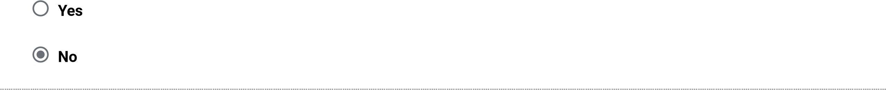
- Have you combined statistics that you received from the local or state police with your institution statisticsfor this report? If you answer No to this question, you will be asked to provide the data you received from the local and state police separately.
Yes. Local and/or state law enforcement agencies provided us with statistics that we are combining with statistics collected by our campus security authorities.
No. We are not combining the statistics because we cannot determine whether the statistics we obtained from local and/or state law enforcement agencies are for on-campus incidents or public property incidents.
Not available. We cannot determine if the statistics we obtained from local and/or state law enforcement agencies are for our Clery geography.
Not available. We made a good-faith effort to obtain statistics from local and/or state law enforcement agencies, but the agencies did not comply with our request.

Criminal Offenses - On campus
For each of the following criminal offenses, enter the number reported to have occurred On Campus.
Criminal offense Total occurrences On campus
2022 2023 2024 a. Murder/Non-negligent manslaughter
0
0
0
0
0
0
0
0
0
0
0
0
0
0
0
- Manslaughter by Negligence
- Rape
- Fondling
- Incest
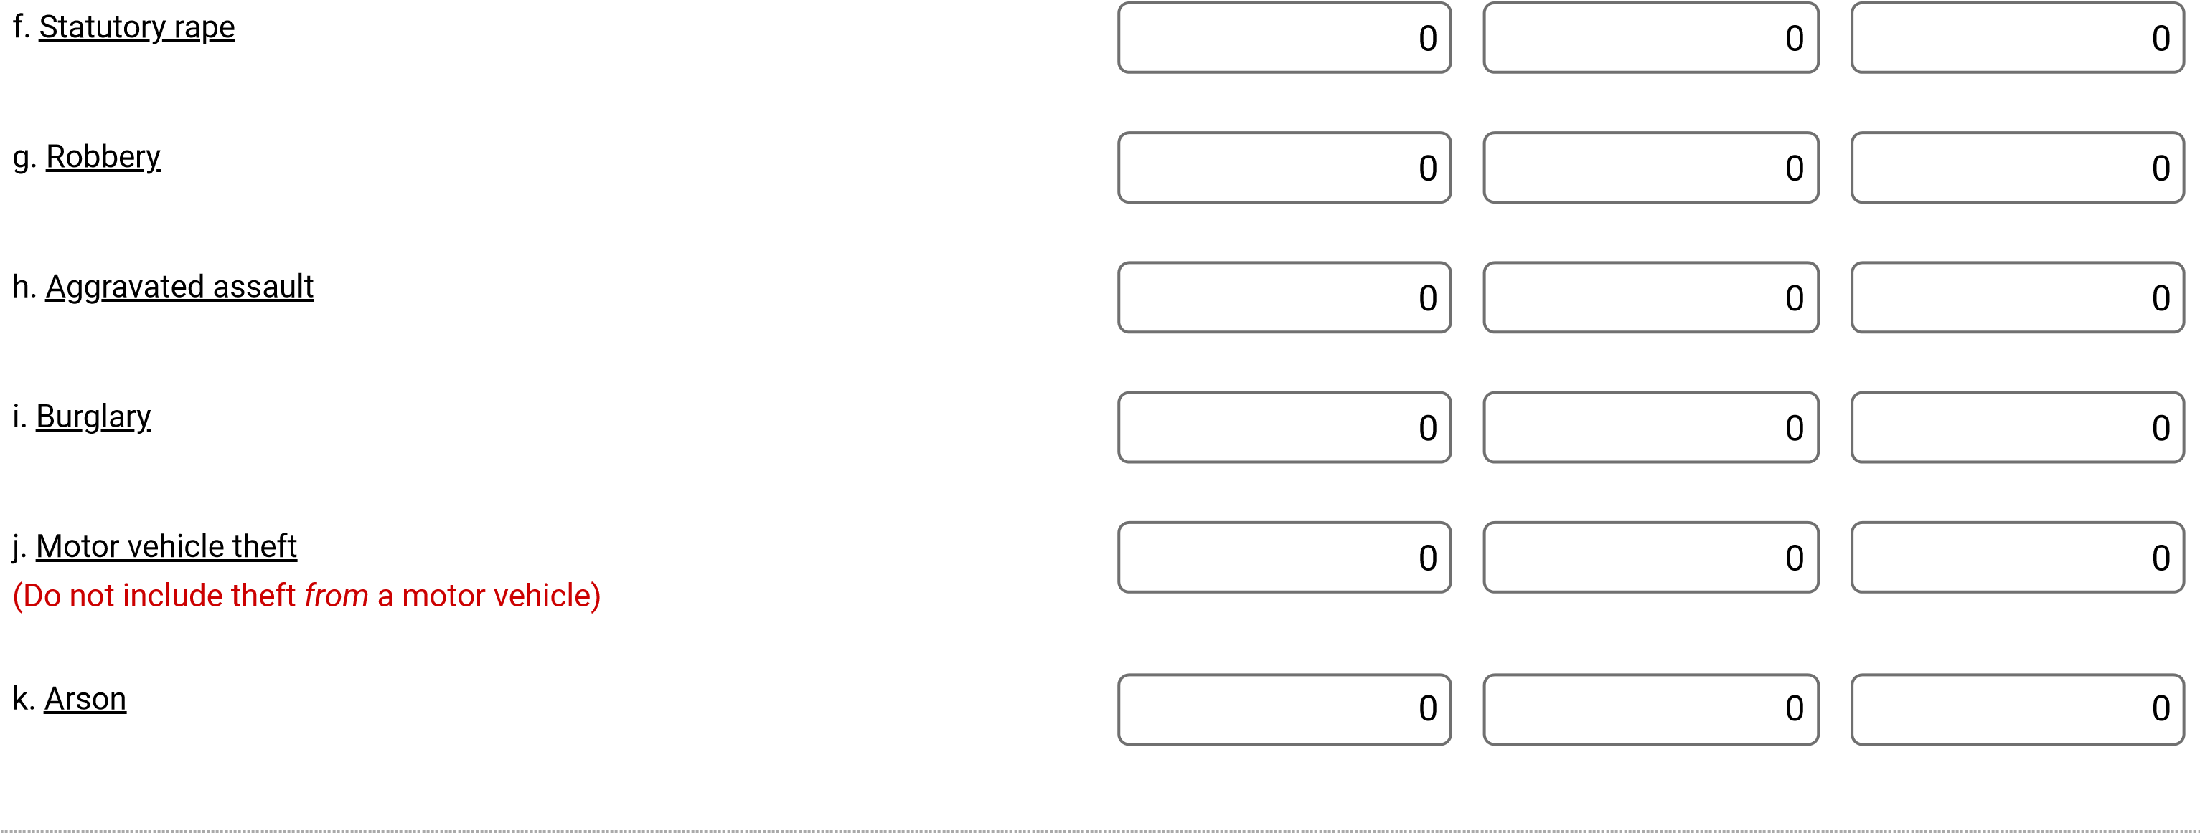
Caveat:
If you have changed prior years’ data, you must add a caveat explaining the change. Use the following format: “For (YEAR), Line (X) was changed from (A) to
(B) because (REASON).”

Criminal Offenses - Public Property
For each of the following criminal offenses, enter the number reported to have occurred on Public Property.
Criminal offense Total occurrences on Public Property
2022 2023 2024 a. Murder/Non-negligent manslaughter
0
0
0
0
0
0
0
0
0
0
0
0
0
0
0
0
0
0
0
0
0
0
0
0
0
0
0
0
0
0
- Manslaughter by Negligence
- Rape
- Fondling
- Incest
- Statutory rape
- Robbery
- Aggravated assault
- Burglary
- Motor vehicle theft
(Do not include theft from a motor vehicle)
Caveat:
If you have changed prior years’ data, you must add a caveat explaining the change. Use the following format: “For (YEAR), Line (X) was changed from (A) to
(B) because (REASON).”

Hate Crimes - On campus
For the criminal offenses listed below, first enter the total number of Hate Crimes that were reported to have occurred On campus. Then break down each total by category of bias (e.g., race, religion).
YEAR 2024
Criminal offense Total Occurrences of Hate crimes (Category of Bias for crimes)
Race Religion Sexual Gender Gender Disability Ethnicity National
orientation
Identity
Origin
a.
g
hter
g
ent manslau
li
g
Murder/ Non-ne
0
0
0
0
0
0
0
0
0
c.
Ra
pe
0
0
0
0
0
0
0
0
0

d. Fondling
e.
Incest
0
0
0
0
0
0
0
0
0
f.
pe
ra
y
Statutor
0
0
0
0
0
0
0
0
0
g.
Robbery
0
0
0
0
0
0
0
0
0
h.
A
gg
ravated assault
0
0
0
0
0
0
0
0
0
i.
Bur
g
lary
0
0
0
0
0
0
0
0
0
j.
(
Do not include theft
from
a motor
Motor vehicle theft
0
0
0
0
0
0
0
0
0
vehicle) k. Arson
0
0
0
0
0
0
0
0
0
0
0
0
0
0
0
0
0
0
0
0
0
0
0
0
0
0
0
0
0
0
0
0
0
0
0
0
- Simple assault
- Larceny-theft
- Intimidation
o.
Destruction/damage/ vandalism of property
YEAR 2023
Criminal offense Total Occurrences of Hate crimes (Category of Bias for crimes)
Race Religion Sexual Gender Gender Disability Ethnicity National
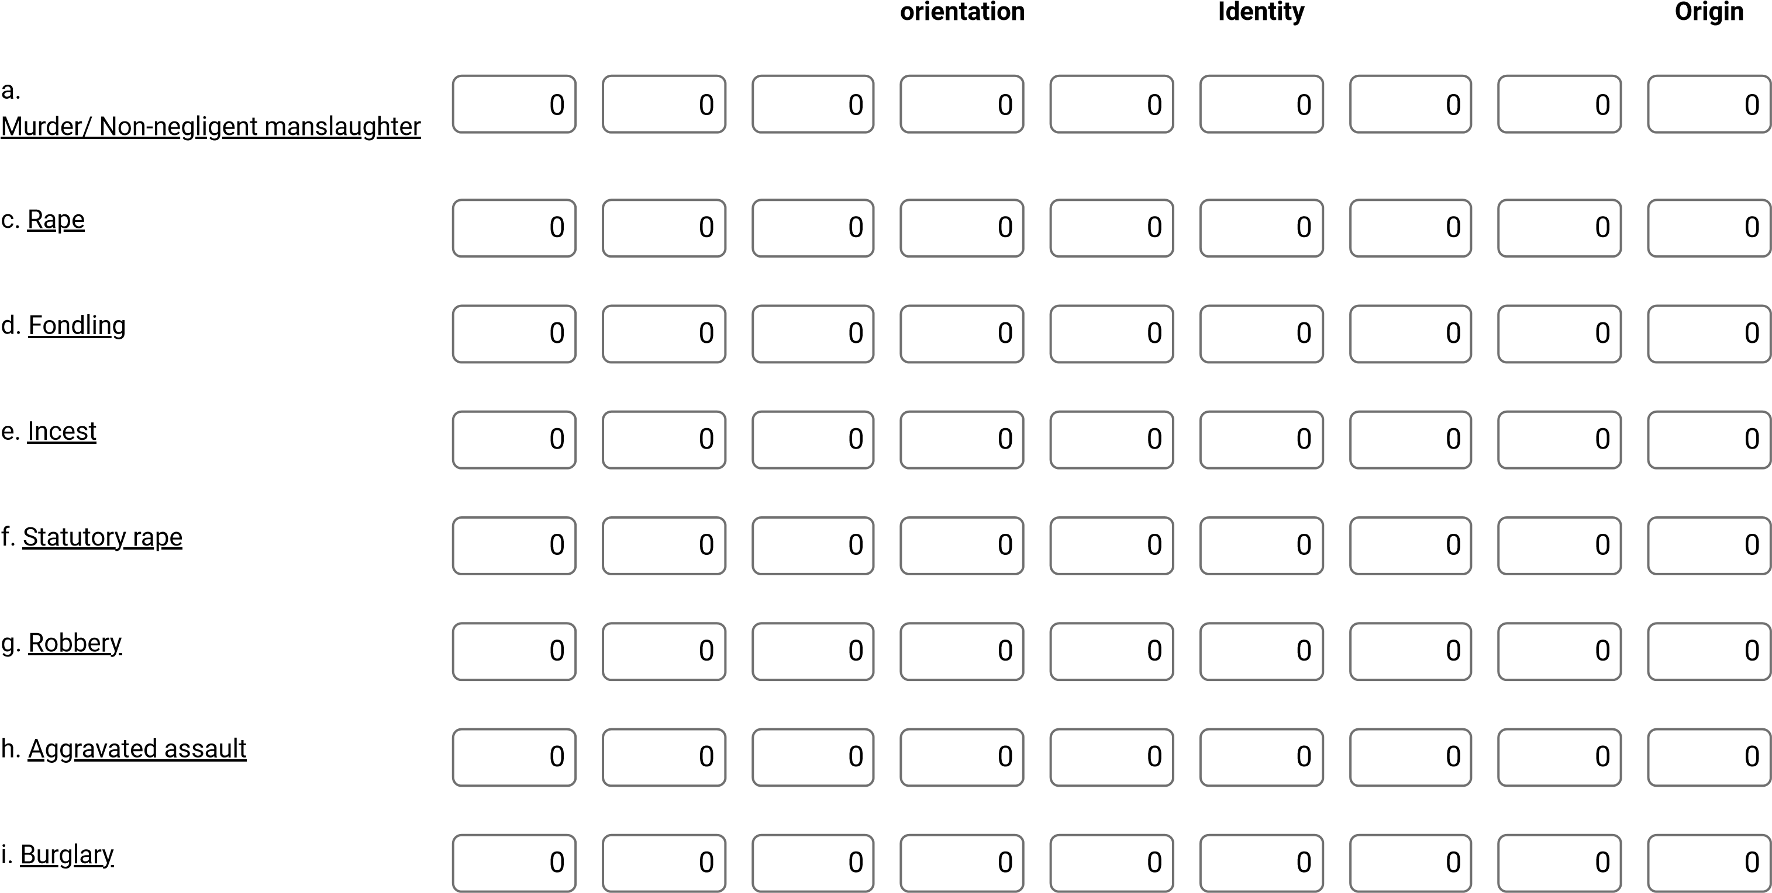
j. Motor vehicle theft
(Do not include theft from a motor vehicle)
k.
Arson
0
0
0
0
0
0
0
0
0
l.
ple assault
Sim
0
0
0
0
0
0
0
0
0
m.
y
-theft
Larcen
0
0
0
0
0
0
0
0
0
n.
Intimidation
0
0
0
0
0
0
0
0
0
o.
Destruction/dama
g
e/
0
0
0
0
0
0
0
0
0
vandalism of property
YEAR 2022
Criminal offense Total Occurrences of Hate crimes (Category of Bias for crimes)
Race Religion Sexual Gender Gender Disability Ethnicity National
orientation
Identity
Origin
a.
g
hter
g
ent manslau
li
g
Murder/ Non-ne
0
0
0
0
0
0
0
0
0
c.
Ra
pe
0
0
0
0
0
0
0
0
0
d.Fondling

- Incest
- Statutory rape
- Robbery
- Aggravated assault
- Burglary
- Motor vehicle theft
- Arson
- Simple assault
- Larceny-theft
- Intimidation
o.
Destruction/damage/ vandalism of property

Caveat:
If you have changed prior years’ data, you must add a caveat explaining the change. Use the following format: “For (YEAR), Line (X) was changed from (A) to
(B) because (REASON).”

Hate Crimes - Public Property
For the criminal offenses listed below, first enter the total number of Hate Crimes that were reported to have occurred on Public Property. Then break down each total by category of bias (e.g., race, religion).
YEAR 2024
Criminal offense Total Occurrences of Hate crimes (Category of Bias for crimes)
Race Religion Sexual Gender Gender Disability Ethnicity National
orientation
Identity
Origin
a.
ent manslau
hter
g
g
li
g
Murder/ Non-ne
0
0
0
0
0
0
0
0
0
c.
Ra
pe
0
0
0
0
0
0
0
0
0
d.
g
Fondlin
0
0
0
0
0
0
0
0
0
e.
Incest
0
0
0
0
0
0
0
0
0
f.
pe
ra
y
Statutor
0
0
0
0
0
0
0
0
0
g.
Robbery
0
0
0
0
0
0
0
0
0
h.
A
gg
ravated assault
0
0
0
0
0
0
0
0
0
i.
Bur
g
lary
0
0
0
0
0
0
0
0
0
j.
(
Do not include theft
from
a motor
Motor vehicle theft
0
0
0
0
0
0
0
0
0
vehicle)
k.
Arson
0
0
0
0
0
0
0
0
0
l.
ple assault
Sim
0
0
0
0
0
0
0
0
0
m.
y
-theft
Larcen
0
0
0
0
0
0
0
0
0
n.
Intimidation
0
0
0
0
0
0
0
0
0
o.
Destruction/dama
g
e/
0
0
0
0
0
0
0
0
0
vandalism of property YEAR 2023
Criminal offense Total Occurrences of Hate crimes (Category of Bias for crimes)
Race Religion Sexual Gender Gender Disability Ethnicity National
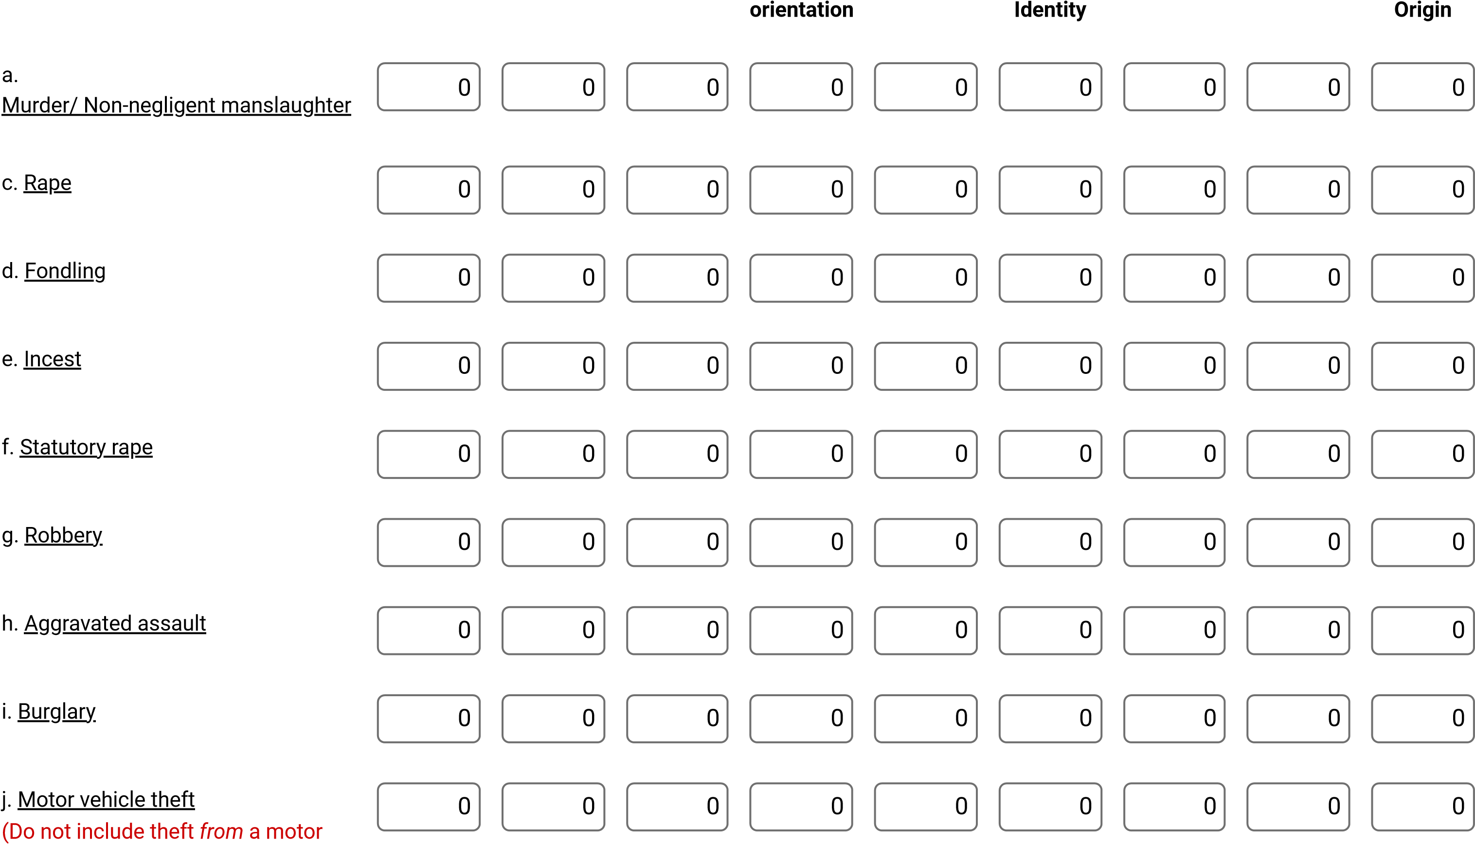
vehicle)
- Arson
0
0
0
0
0
0
0
0
0
0
0
0
0
0
0
0
0
0
0
0
0
0
0
0
0
0
0
0
0
0
0
0
0
0
0
0
0
0
0
0
0
0
0
0
0
- Simple assault
- Larceny-theft
- Intimidation
o.
Destruction/damage/ vandalism of property
YEAR 2022
Criminal offense Total Occurrences of Hate crimes (Category of Bias for crimes)
Race Religion Sexual Gender Gender Disability Ethnicity National
orientation
Identity
Origin
a.
ent manslau
hter
g
g
li
g
Murder/ Non-ne
0
0
0
0
0
0
0
0
0
c.
Ra
pe
0
0
0
0
0
0
0
0
0
d.
g
Fondlin
0
0
0
0
0
0
0
0
0

- Incest
- Statutory rape
- Robbery
- Aggravated assault
- Burglary
- Motor vehicle theft
- Arson
- Simple assault
- Larceny-theft
- Intimidation
o.
Destruction/damage/ vandalism of property Caveat:
If you have changed prior years’ data, you must add a caveat explaining the change. Use the following format: “For (YEAR), Line (X) was changed from (A) to
(B) because (REASON).”

VAWA Offenses - On Campus
For each of the following crimes, enter the number reported to have occurred On Campus.
Crime Total occurences On Campus
2022 2023 2024
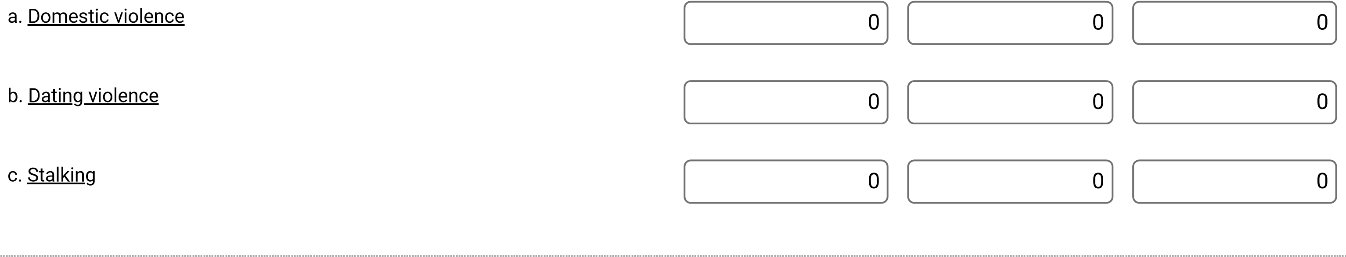
Caveat:
If you have changed prior years’ data, you must add a caveat explaining the change. Use the following format: “For (YEAR), Line (X) was changed from (A) to (B) because (REASON).”

VAWA Offenses - Public Property
For each of the following crimes, enter the number reported to have occurred on Public Property.
Crime Total occurences on Public Property
2022 2023 2024
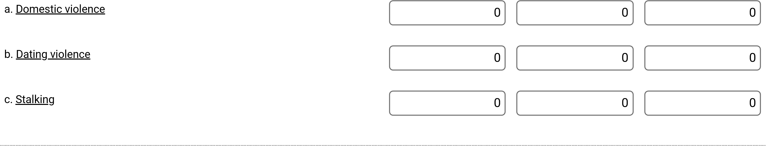
Caveat:
If you have changed prior years’ data, you must add a caveat explaining the change. Use the following format: “For (YEAR), Line (X) was changed from (A) to (B) because (REASON).”

Arrests - On campus
Enter the number of Arrests for each of the following crimes that occurred On Campus.
Crime Number of Arrests
2022 2023 2024
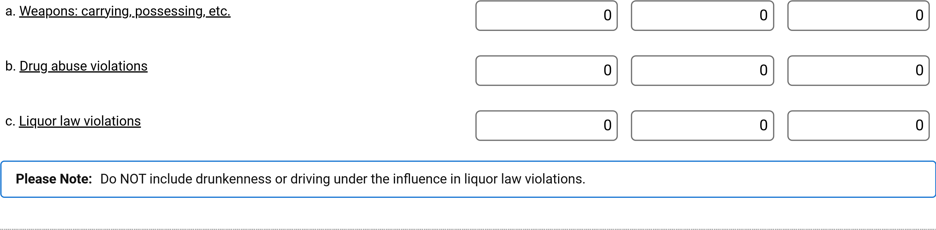
Caveat:
If you have changed prior years’ data, you must add a caveat explaining the change. Use the following format: “For (YEAR), Line (X) was changed from (A) to (B) because (REASON).”

Arrests - Public Property
Enter the number of Arrests for each of the following crimes that occurred on Public Property.
Crime Number of Arrests
2022 2023 2024
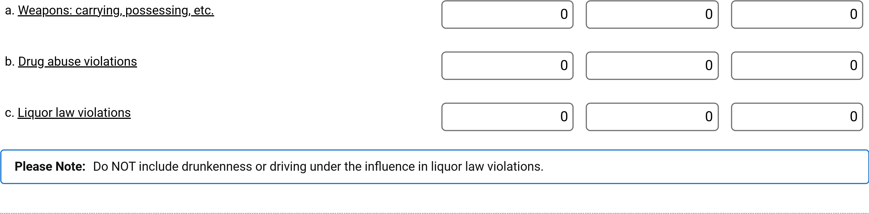
Caveat:
If you have changed prior years’ data, you must add a caveat explaining the change. Use the following format: “For (YEAR), Line (X) was changed from (A) to (B) because (REASON).”

Disciplinary Actions - On Campus
Enter the number of persons referred for disciplinary action for crimes that occurred On Campus for each of the following categories.
Do not include disciplinary actions that were strictly for school policy violations.
If the disciplinary action is the result of an arrest, please do not count it here; count the violation as 1 arrest.
Crime Number of persons referred for
Disciplinary Action
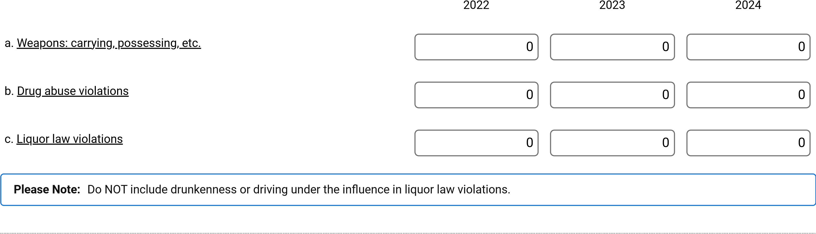
Caveat:
If you have changed prior years’ data, you must add a caveat explaining the change. Use the following format: “For (YEAR), Line (X) was changed from (A) to
(B) because (REASON).”

Disciplinary Actions - Public Property
Enter the number of persons referred for disciplinary action for crimes that occurred on Public Property for each of the following categories.
Do not include disciplinary actions that were strictly for school policy violations.
If the disciplinary action is the result of an arrest, please do not count it here; count the violation as 1 arrest.
Crime Number of persons referred for
Disciplinary Action
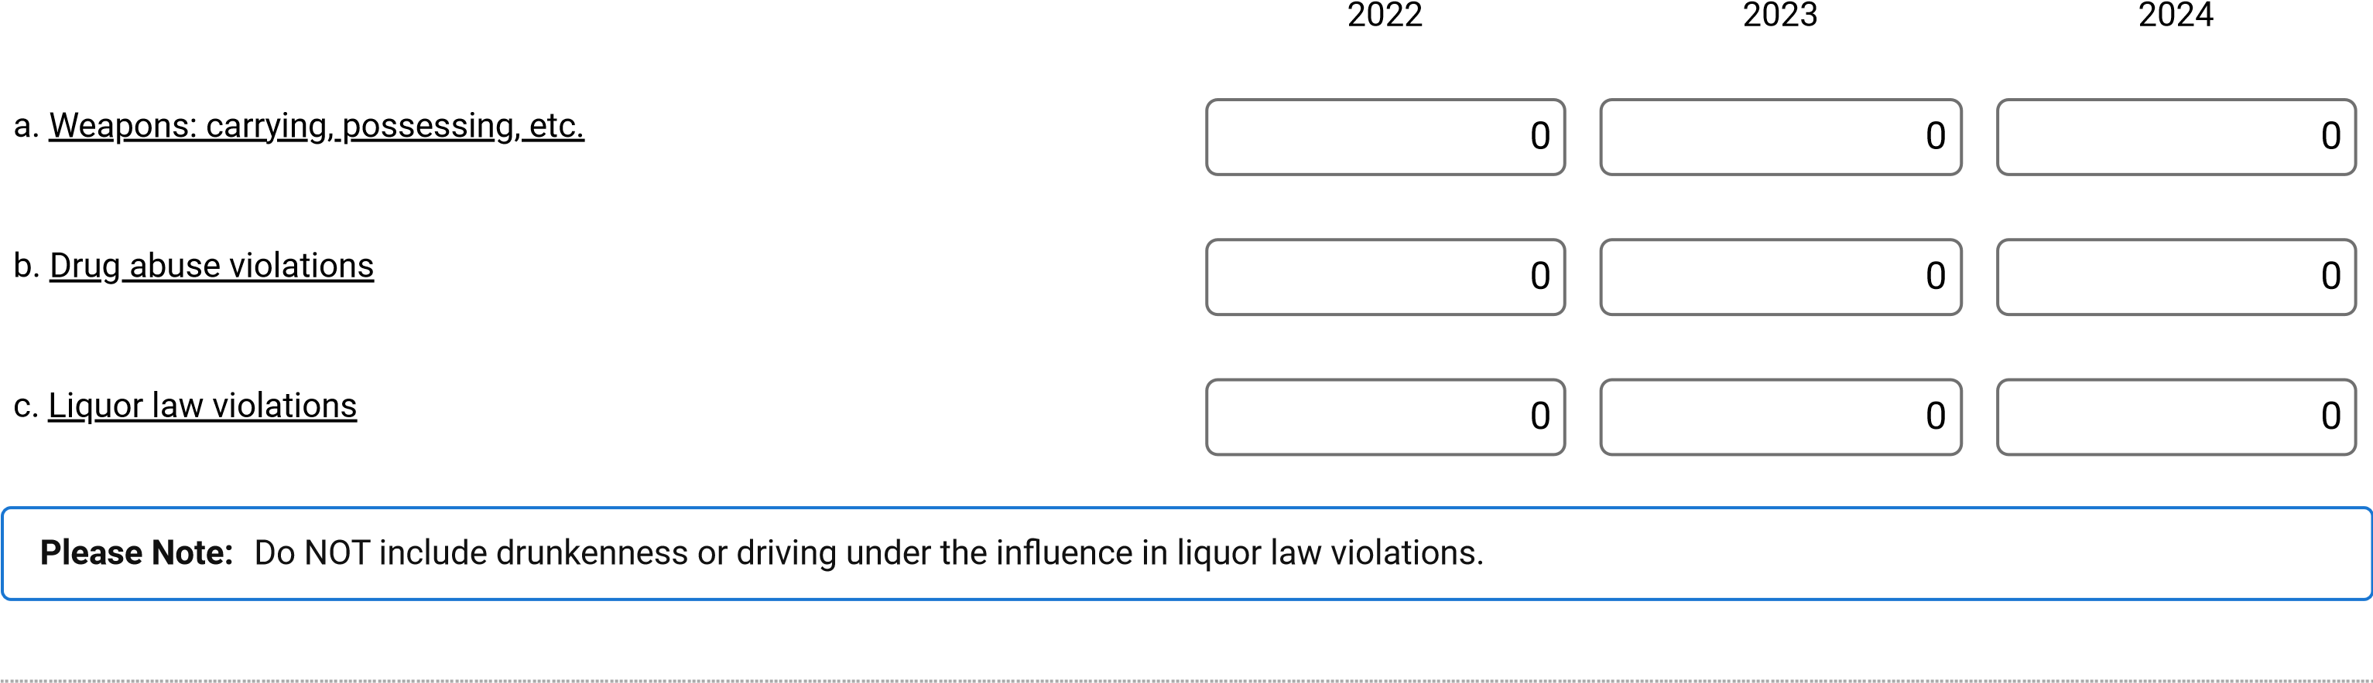
Caveat:
If you have changed prior years’ data, you must add a caveat explaining the change. Use the following format: “For (YEAR), Line (X) was changed from (A) to (B) because (REASON).”

Unfounded Crimes
Of those crimes that occurred On Campus, in On-campus Student Housing Facilities, on or in Noncampus property or buildings, and on Public Property, enter the number of crimes that were unfounded.
The total number of unfounded crimes should include all criminal offenses, hate crimes, domestic violence, dating violence, or stalking incidents that have been unfounded. Arrests and disciplinary actions cannot be unfounded.
Number
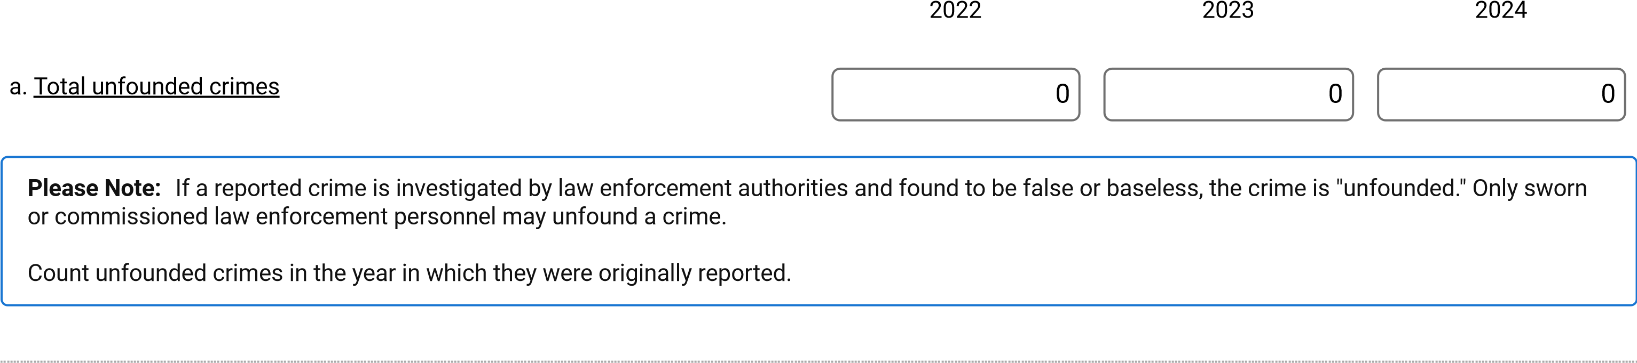
Caveat:
If you have changed prior years’ data, you must add a caveat explaining the change. Use the following format: “For (YEAR), Line (X) was changed from (A) to
(B) because (REASON).”

9/2/25, 3:38 PM 2025 Campus Safety and Security Survey
Institution: (460914001)  Fires - Summary |  |  |  |  |  |  |  | User ID: C4609141
 |  | 2022 |  |  | 2023 |  |  | 2024
S/N Name of Facility | Fires | Injuries | Deaths | Fires | Injuries | Deaths | Fires | Injuries Deaths
Total
https://surveys.ope.ed.gov/campussafety/#/read-only-survey/460914001/fire-summary?authToken=eyJhbGciOiJIUzI1NiIsInR5cCI6IkpXVCJ9.eyJ1bmlxdWVfbmFtZSI6IkM0NjA5MTQxIiwiaHR0cDovL3Nj… 1/1

FTBA Academy ■ Annual Security Report 2025


Thank you for your Clery Act request. There were no reported calls for service at the provided address during the time-period requested.
Please note that incidents are recorded to the closest address, so any of the Clery reporting indicators occurring on the public property within or immediately adjacent to the address will be included in the counts at the address. Addresses with no incidents will result in a blank page for each categorical grouping.

Apartment numbers, unit numbers or suite numbers are not always entered in the data; therefore, this report reflects counts based on address information without specifying apartment, unit, or suite numbers.

To obtain an Incident Report: If you received a report the corresponding incident number that is on the report can be used to identify and purchase the Incident Report of interest. If you are interested in requesting Incident Reports, you will need to submit a request to the Phoenix Police Public Records Detail utilizing the Public Records Portal (see below).

How to submit your request(s) to the Phoenix Police Public Records Portal: This can be found online at https://phxpublicsafety.dynamics365portals.us/. There may be a minimal fee that can be paid for online. If you have questions regarding the fee or need assistance with the online service, please contact the Phoenix Police Public Records Detail. The Public Records and Services Unit is providing customer service through the online Public Records Portal, phone requests, and in person requests are by appointment only. For over-the-phone customer service you can call 602-534-1127. If you would like to schedule a virtual appointment send an email to policerecords.appts@phoenix.gov. The public window hours of operation are as follows: Monday-Friday: 8:00am - 4:00pm, Saturday – Sunday: Closed

If you have questions regarding this report, you can send an email to CARU@phoenix.gov. If you have an additional request for information you must submit the additional inquiry as a new request to the Phoenix Police Public Records Detail utilizing the Public Records



Updated 4/14/2022 Clery Act Cover Page No Incidents Found (NIF)

CITY OF PHOENIX POLICE DEPARTMENT
Reported Incidents for Select Offenses^
Address: 13402 N SCOTTSDALE  Date Range: 1/1/2024 - 12/31/2024  CRIME TYPE DATE TIME INCIDENT # | ^Offenses Required by Clery Act: Homicide, Rape, Robbery,  Aggravated Assault, Burglary, and  Motor Vehicle Theft  PREMISE
According to Uniform Crime Reporting (UCR) Criteria

Total

Any Part l UCR crimes that do not appear in this report had a count of 0 for the time period indicated.
This report is based on Uniform Crime Reporting (UCR) criteria which are not equivalent to Pennsylvania Revised Statutes (ARS) statistics and therefore this data cannot be directly compared to ARS reports. Under the hierarchy rule of UCR, only the most severe offense of an incident is counted. Part One Property Crimes include motor vehicle theft, burglary, arson, and theft/larceny. Part One Violent Crimes include criminal homicide, rape, robbery, and aggravated assault. Homicides, rapes, and aggravated assaults are counted per victim. Numbers may differ from other published reports due to case updates/reclassifications and/or to differences associated with unfounded incidents. UCR data excludes unfounded cases if the incident and the unfound occurred in the same month. However, if the incident and the unfound occurred in different months, then the removal of the unfounded cases will not be reflected in the data. Any reports with missing or incorrect information would not be properly depicted in this report. Any listed crimes that do not appear in this report had a count of 0 for the time period indicated. Any incident reports with the occurrence date missing will be based on the date of when the crime was reported. Beginning in January 2014, the UCR Rape category includes incidents that meet the updated FBI rape definition. Beginning in January 2016, the UCR Aggravated Assaults category includes incidents that meet the updated FBI aggravated assault definition in regards to the use of BB/pellet guns. Therefore, caution should be used when comparing across years.
CITY OF PHOENIX POLICE DEPARTMENT
Adult Arrests for Select Charge Codes^
Arrest Location: 13402 N SCOTTSDALE
Date: 1/1/2024 - 12/31/2024

DATE TIME ARREST # CHARGE TYPE CHARGE COUNT

TOTAL : 0
^Only adult arrests for liquor law violations, drug law violations, weapon possession violations, and stalkings are included in this report. Liquor law violations are queried as Pennsylvania Revised Statutes (ARS) Code like 4-%. Drug law violations are queried as ARS Code like 13-34%. Illegal weapons possession is queried as ARS Code like 13-3102%. Stalking is queried as ARS Code like 13-2923%. Any of these statute codes that do not appear in this report had a count of 0 for the time period indicated.
Arrests still pending entry into the RMS system will not be included. Arrests may have multiple charges. Counts are the number of charges, not number of arrests. Any arrests with missing or incomplete information are not included. Arrest counts are based on Pennsylvania Revised Statutes (ARS) which are not equivalent to Uniform Crime Reporting (UCR) statistics and therefore this data cannot be directly compared to data from other states. Charges included are those that were recorded on adult bookings, and Citations in Lieu of Detention (CLD) documents. Implementation of a new Records Management System (RMS) occurred October 10, 2015; use caution when comparing totals across years.
CITY OF PHOENIX POLICE DEPARTMENT
Juvenile Arrests for Select Charge Codes^
Arrest Location: 13402 N SCOTTSDALE
Date: 1/1/2024 - 12/31/2024

DATE TIME CONTACT # CHARGE TYPE CHARGE COUNT

TOTAL : 0
^Only juvenile arrests for liquor law violations, drug law violations, weapon possession violations, and stalkings are included in this report. Liquor law violations are queried as Pennsylvania Revised Statutes (ARS) Code like 4-%. Drug law violations are queried as ARS Code like 13-34%. Illegal weapons possession is queried as ARS Code like 13-3102%. Stalking is queried as ARS Code like 13-2923%. Any of these statute codes that do not appear in this report had a count of 0 for the time period indicated.
Juvenile arrests still pending entry into the RMS system will not be included. Information may change as data is entered and/or updated. Juvenile arrests may have multiple charges. Counts are the number of charges, not number of arrests. Any juvenile arrests with missing or incomplete information may not be properly depicted in this report. Juvenile arrests counts are based on Pennsylvania Revised Statutes (ARS) which are not equivalent to Uniform Crime Reporting (UCR) statistics and therefore this data cannot be directly compared to data from other states. Charges included are those that were recorded on juvenile detentions/referrals, and Citations in Lieu of Detention (CLD) documents. Implementation of a new Records Management System (RMS) occurred October 10, 2015; use caution when comparing totals across years.

CITY OF PHOENIX POLICE DEPARTMENT  Incident Reports for Domestic Violence Related Offenses  According to Pennsylvania Revised Statutes (ARS) Criteria  Address: 13402 N SCOTTSDALE  Date Range: 1/1/2024 - 12/31/2024 | CLERY ACT REPORT 2024

DATE TIME INCIDENT #
TOTAL :
0
Domestic Violence refers to incidents in which the domestic violence flag was marked "Y" and includes all reported crime types. This report is based on Pennsylvania Revised Statutes (ARS) which are not equivalent to Uniform Crime Reporting (UCR) statistics and therefore this data cannot be directly compared to data from other states or UCR reports. Incident reports still pending entry into the RMS system will not be included. Counts may change as additional reports are approved and/or reclassified. Any incident reports with missing or incomplete information may not be properly depicted in this report. Any incident reports with the occurrence date missing will be based on the date of when the crime was reported. Apartment numbers, unit numbers, or suite numbers are not always entered in the data. Therefore, this report reflects counts based on address information without specifying apartment/unit/suite numbers. This means that any incident at the same street address would be included in the count regardless of the apartment/unit/suite number. Implementation of a new Records Management System (RMS) occurred October 10, 2015; use caution when comparing totals across years.
CITY OF PHOENIX POLICE DEPARTMENT  Uniform Crime Reporting (UCR) Hate Crimes  Address: 13402 N SCOTTSDALE  Date Range: 1/1/2024 - 12/31/2024 | CLERY ACT REPORT 2024

DATE TIME INCIDENT #
TOTAL :
0
This report is based solely on Hate Crime Incident Reports received from the Bias Crime Unit and verified according to federal reporting guidelines. Because of the difficulty of ascertaining the offender's subjective motivation, bias is to be reported only if the investigation reveals sufficient information to lead a reasonable and prudent person to conclude that the offender's actions were motivated, in whole or in part, by bias. The mere fact that the offender is biased against the victim's race, religion, disability, sexual orientation, and/or ethnicity/national origin does not mean that a hate crime was involved. Rather, the offender's criminal act must have been motivated, in whole or in part, by his/her bias. Not all Bias Crime incidents are reported to the Bias Crimes Detail. Counts may change as additional reports are finalized and/or reclassified. Any incident reports with missing or incomplete information may not be properly depicted in this report. Any incident reports with the occurrence date missing will be based on the date of when the crime was reported. Apartment numbers, unit numbers, or suite numbers are not always entered in the data. Therefore, this report reflects counts based on address information without specifying apartment/unit/suite numbers. This means that any incident at the same street address would be included in the count regardless of the apartment/unit/suite number. Implementation of a new Records Management System (RMS) occurred October 10, 2015; use caution when comparing totals across years.

