

ORDER FORM

YOUR DETAILS

|  |  |
| --- | --- |
| Name |  |
| Address |  |
| Email |  |
| Phone |  |

Please email your order form to [t1dandme.shop@gmail.com](mailto:t1dandme.shop@gmail.com)

You will be contacted with a confirmation of your order.

Please double check carefully that everything is correct. When you are satisfied please use the PayPal link or Bank Transfer information that will be sent to you to make your payment.

When payment is received your order will be made.

As each order is made to your custom requirements, please allow up to 4 weeks to receive your order. We will endeavor to make your order as quickly as we can.

Flat rate postage of $4.00 within Australia.

Please ensure that container size, colour, picture and font are selected. Please see choices available on pages 5 & 6 below to double check the size measurements.

|  |  |  |  |  |  |  |  |  |  |  |
| --- | --- | --- | --- | --- | --- | --- | --- | --- | --- | --- |
| Container | Select one | | | | | | | | | |
| Mini | Orange | Blue | Red | | Yellow | Green | |  |  | |
| Small | Pink | | Green | | | Blue | | |  | |
| Medium | Clear | |  | | |  | | |  | |
| Large | Clear | |  | | |  | | |  | |
| Sandwich | Pink | | Green | | | Tan | | | Blue | |
|  | | | | | | | | | | |
| Picture | Butterfly | Heart | Flower Y | Flower B | | Car R | Car B | | Trex | Steg |
| Font | No Insulin | | G | | |  | | |  | |
|  |  | |  | | | Quantity | | |  | |

|  |  |  |  |  |  |  |  |  |  |  |
| --- | --- | --- | --- | --- | --- | --- | --- | --- | --- | --- |
| Container | Select one | | | | | | | | | |
| Mini | Orange | Blue | Red | | Yellow | Green | |  |  | |
| Small | Pink | | Green | | | Blue | | |  | |
| Medium | Clear | |  | | |  | | |  | |
| Large | Clear | |  | | |  | | |  | |
| Sandwich | Pink | | Green | | | Tan | | | Blue | |
|  | | | | | | | | | | |
| Picture | Butterfly | Heart | Flower Y | Flower B | | Car R | Car B | | Trex | Steg |
| Font | No Insulin | | G | | |  | | |  | |
|  |  | |  | | | Quantity | | |  | |

|  |  |  |  |  |  |  |  |  |  |  |
| --- | --- | --- | --- | --- | --- | --- | --- | --- | --- | --- |
| Container | Select one | | | | | | | | | |
| Mini | Orange | Blue | Red | | Yellow | Green | |  |  | |
| Small | Pink | | Green | | | Blue | | |  | |
| Medium | Clear | |  | | |  | | |  | |
| Large | Clear | |  | | |  | | |  | |
| Sandwich | Pink | | Green | | | Tan | | | Blue | |
|  | | | | | | | | | | |
| Picture | Butterfly | Heart | Flower Y | Flower B | | Car R | Car B | | Trex | Steg |
| Font | No Insulin | | G | | |  | | |  | |
|  |  | |  | | | Quantity | | |  | |

|  |  |  |  |  |  |  |  |  |  |  |
| --- | --- | --- | --- | --- | --- | --- | --- | --- | --- | --- |
| Container | Select one | | | | | | | | | |
| Mini | Orange | Blue | Red | | Yellow | Green | |  |  | |
| Small | Pink | | Green | | | Blue | | |  | |
| Medium | Clear | |  | | |  | | |  | |
| Large | Clear | |  | | |  | | |  | |
| Sandwich | Pink | | Green | | | Tan | | | Blue | |
|  | | | | | | | | | | |
| Picture | Butterfly | Heart | Flower Y | Flower B | | Car R | Car B | | Trex | Steg |
| Font | No Insulin | | G | | |  | | |  | |
|  |  | |  | | | Quantity | | |  | |

|  |  |  |  |  |  |  |  |  |  |  |
| --- | --- | --- | --- | --- | --- | --- | --- | --- | --- | --- |
| Container | Select one | | | | | | | | | |
| Mini | Orange | Blue | Red | | Yellow | Green | |  |  | |
| Small | Pink | | Green | | | Blue | | |  | |
| Medium | Clear | |  | | |  | | |  | |
| Large | Clear | |  | | |  | | |  | |
| Sandwich | Pink | | Green | | | Tan | | | Blue | |
|  | | | | | | | | | | |
| Picture | Butterfly | Heart | Flower Y | Flower B | | Car R | Car B | | Trex | Steg |
| Font | No Insulin | | G | | |  | | |  | |
|  |  | |  | | | Quantity | | |  | |

|  |  |  |  |  |  |  |  |  |  |  |
| --- | --- | --- | --- | --- | --- | --- | --- | --- | --- | --- |
| Container | Select one | | | | | | | | | |
| Mini | Orange | Blue | Red | | Yellow | Green | |  |  | |
| Small | Pink | | Green | | | Blue | | |  | |
| Medium | Clear | |  | | |  | | |  | |
| Large | Clear | |  | | |  | | |  | |
| Sandwich | Pink | | Green | | | Tan | | | Blue | |
|  | | | | | | | | | | |
| Picture | Butterfly | Heart | Flower Y | Flower B | | Car R | Car B | | Trex | Steg |
| Font | No Insulin | | G | | |  | | |  | |
|  |  | |  | | | Quantity | | |  | |

|  |  |  |  |  |  |  |  |  |  |  |
| --- | --- | --- | --- | --- | --- | --- | --- | --- | --- | --- |
| Container | Select one | | | | | | | | | |
| Mini | Orange | Blue | Red | | Yellow | Green | |  |  | |
| Small | Pink | | Green | | | Blue | | |  | |
| Medium | Clear | |  | | |  | | |  | |
| Large | Clear | |  | | |  | | |  | |
| Sandwich | Pink | | Green | | | Tan | | | Blue | |
|  | | | | | | | | | | |
| Picture | Butterfly | Heart | Flower Y | Flower B | | Car R | Car B | | Trex | Steg |
| Font | No Insulin | | G | | |  | | |  | |
|  |  | |  | | | Quantity | | |  | |

|  |  |  |  |  |  |  |  |  |  |  |
| --- | --- | --- | --- | --- | --- | --- | --- | --- | --- | --- |
| Container | Select one | | | | | | | | | |
| Mini | Orange | Blue | Red | | Yellow | Green | |  |  | |
| Small | Pink | | Green | | | Blue | | |  | |
| Medium | Clear | |  | | |  | | |  | |
| Large | Clear | |  | | |  | | |  | |
| Sandwich | Pink | | Green | | | Tan | | | Blue | |
|  | | | | | | | | | | |
| Picture | Butterfly | Heart | Flower Y | Flower B | | Car R | Car B | | Trex | Steg |
| Font | No Insulin | | G | | |  | | |  | |
|  |  | |  | | | Quantity | | |  | |

SELECTION

Container

Mini Snack Box Orange Blue Red Yellow Green

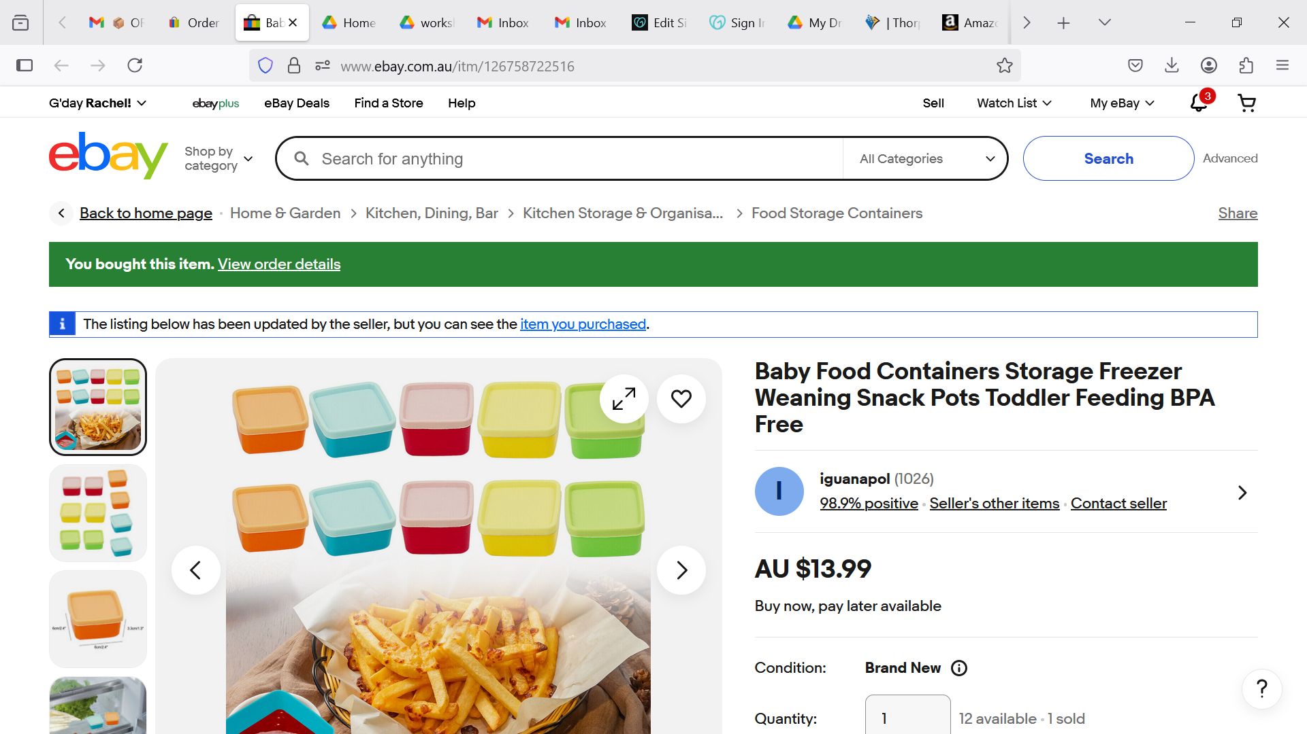

Small Snack Box pink green blue

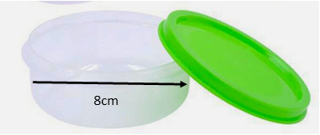 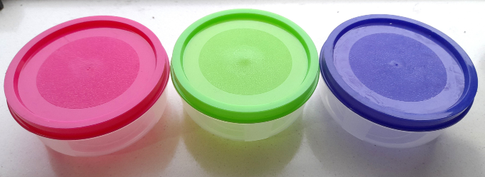

Medium Snack Box- only available in clear Large Snack Box- only available in clear

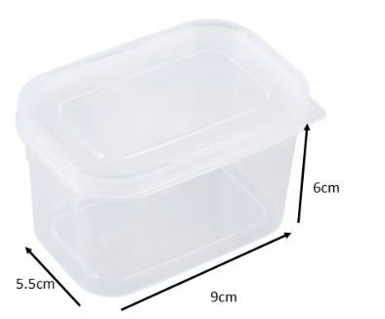

Sandwich Box tan pink blue green

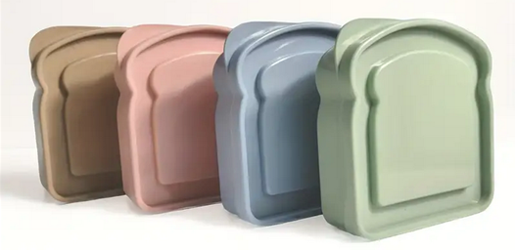

Pictures

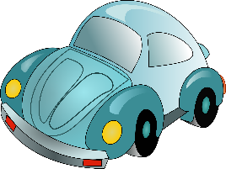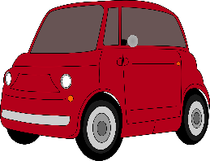

Flower Y Flower B Heart Car R Car B

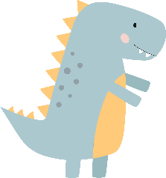

Trex Butterfly Steg

Font

g

NO INSULIN