
ORDER FORM

YOUR DETAILS

Name
Address
Email
Phone

Please email your order form to t1dandme.shop@gmail.com

You will be contacted with a confirmation of your order.
Please double check carefully that everything is correct. When you are satisfied please use the PayPal link or Bank Transfer information that will be sent to you to make your payment.
When payment is received your order will be made.
As each order is made to your custom requirements, please allow up to 4 weeks to receive your order. We will endeavor to make your order as quickly as we can.
Flat rate postage of $4.00 within Australia.

Please ensure that container size, colour, picture and font are selected. Please see choices available on pages 5 & 6 below to double check the size measurements.

Container | Select one
Mini | Orange ☐ | Blue ☐ | Red ☐ |  | Yellow ☐ | Green ☐
Small | Pink ☐ |  | Green ☐ |  |  | Blue ☐
Medium | Clear ☐
Large | Clear ☐
Sandwich | Pink ☐ |  | Green ☐ |  |  | Tan ☐ |  |  | Blue ☐
Insulated | Pink ☐ |  | Green ☐ |  |  | Blue ☐
Choose your picture & Font
Picture | Butterfly ☐ | Heart ☐ | Flower Y ☐ | Flower B ☐ |  | Car R ☐ | Car B ☐ |  | Trex ☐ | Steg ☐
Font | No Insulin ☐ |  | G ☐
 |  |  |  |  |  | Quantity

Container | Select one
Mini | Orange ☐ | Blue ☐ | Red ☐ |  | Yellow ☐ | Green ☐
Small | Pink ☐ |  | Green ☐ |  |  | Blue ☐
Medium | Clear ☐
Large | Clear ☐
Sandwich | Pink ☐ |  | Green ☐ |  |  | Tan ☐ |  |  | Blue ☐
Insulated | Pink ☐ |  | Green ☐ |  |  | Blue ☐
Choose your picture & Font
Picture | Butterfly ☐ | Heart ☐ | Flower Y ☐ | Flower B ☐ |  | Car R ☐ | Car B ☐ |  | Trex ☐ | Steg ☐
Font | No Insulin ☐ |  | G ☐
 |  |  |  |  |  | Quantity

Container | Select one
Mini | Orange ☐ | Blue ☐ | Red ☐ |  | Yellow ☐ | Green ☐
Small | Pink ☐ |  | Green ☐ |  |  | Blue ☐
Medium | Clear ☐
Large | Clear ☐
Sandwich | Pink ☐ |  | Green ☐ |  |  | Tan ☐ |  |  | Blue ☐
Insulated | Pink ☐ |  | Green ☐ |  |  | Blue ☐
Choose your picture & Font
Picture | Butterfly ☐ | Heart ☐ | Flower Y ☐ | Flower B ☐ |  | Car R ☐ | Car B ☐ |  | Trex ☐ | Steg ☐
Font | No Insulin ☐ |  | G ☐
 |  |  |  |  |  | Quantity

Container | Select one
Mini | Orange ☐ | Blue ☐ | Red ☐ |  | Yellow ☐ | Green ☐
Small | Pink ☐ |  | Green ☐ |  |  | Blue ☐
Medium | Clear ☐
Large | Clear ☐
Sandwich | Pink ☐ |  | Green ☐ |  |  | Tan ☐ |  |  | Blue ☐
Insulated | Pink ☐ |  | Green ☐ |  |  | Blue ☐
Choose your picture & Font
Picture | Butterfly ☐ | Heart ☐ | Flower Y ☐ | Flower B ☐ |  | Car R ☐ | Car B ☐ |  | Trex ☐ | Steg ☐
Font | No Insulin ☐ |  | G ☐
 |  |  |  |  |  | Quantity

Container | Select one
Mini | Orange ☐ | Blue ☐ | Red ☐ |  | Yellow ☐ | Green ☐
Small | Pink ☐ |  | Green ☐ |  |  | Blue ☐
Medium | Clear ☐
Large | Clear ☐
Sandwich | Pink ☐ |  | Green ☐ |  |  | Tan ☐ |  |  | Blue ☐
Insulated | Pink ☐ |  | Green ☐ |  |  | Blue ☐
Choose your picture & Font
Picture | Butterfly ☐ | Heart ☐ | Flower Y ☐ | Flower B ☐ |  | Car R ☐ | Car B ☐ |  | Trex ☐ | Steg ☐
Font | No Insulin ☐ |  | G ☐
 |  |  |  |  |  | Quantity

Container | Select one
Mini | Orange ☐ | Blue ☐ | Red ☐ |  | Yellow ☐ | Green ☐
Small | Pink ☐ |  | Green ☐ |  |  | Blue ☐
Medium | Clear ☐
Large | Clear ☐
Sandwich | Pink ☐ |  | Green ☐ |  |  | Tan ☐ |  |  | Blue ☐
Insulated | Pink ☐ |  | Green ☐ |  |  | Blue ☐
Choose your picture & Font
Picture | Butterfly ☐ | Heart ☐ | Flower Y ☐ | Flower B ☐ |  | Car R ☐ | Car B ☐ |  | Trex ☐ | Steg ☐
Font | No Insulin ☐ |  | G ☐
 |  |  |  |  |  | Quantity

Container | Select one
Mini | Orange ☐ | Blue ☐ | Red ☐ |  | Yellow ☐ | Green ☐
Small | Pink ☐ |  | Green ☐ |  |  | Blue ☐
Medium | Clear ☐
Large | Clear ☐
Sandwich | Pink ☐ |  | Green ☐ |  |  | Tan ☐ |  |  | Blue ☐
Insulated | Pink ☐ |  | Green ☐ |  |  | Blue ☐
Choose your picture & Font
Picture | Butterfly ☐ | Heart ☐ | Flower Y ☐ | Flower B ☐ |  | Car R ☐ | Car B ☐ |  | Trex ☐ | Steg ☐
Font | No Insulin ☐ |  | G ☐
 |  |  |  |  |  | Quantity

Container | Select one
Mini | Orange ☐ | Blue ☐ | Red ☐ |  | Yellow ☐ | Green ☐
Small | Pink ☐ |  | Green ☐ |  |  | Blue ☐
Medium | Clear ☐
Large | Clear ☐
Sandwich | Pink ☐ |  | Green ☐ |  |  | Tan ☐ |  |  | Blue ☐
Insulated | Pink ☐ |  | Green ☐ |  |  | Blue ☐
Choose your picture & Font
Picture | Butterfly ☐ | Heart ☐ | Flower Y ☐ | Flower B ☐ |  | Car R ☐ | Car B ☐ |  | Trex ☐ | Steg ☐
Font | No Insulin ☐ |  | G ☐
 |  |  |  |  |  | Quantity

Library Bags | Select one
Style 1 | All I need is love, happiness & insulin ☐
Style 2 | Strong & Brave T1D Warrior ☐
 |  |  | Quantity

Library Bags | Select one
Style 1 | All I need is love, happiness & insulin ☐
Style 2 | Strong & Brave T1D Warrior ☐
 |  |  | Quantity

SELECTIONS
Container
Mini Snack Box Orange Blue Red Yellow Green
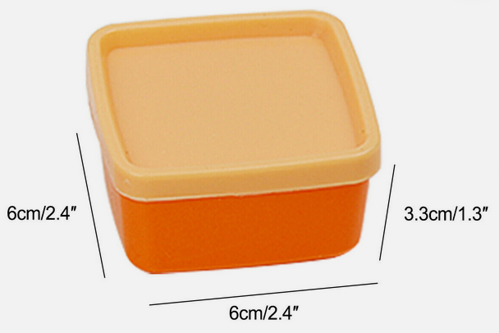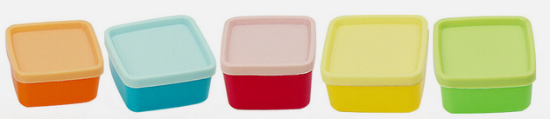

Small Snack Box pink green blue
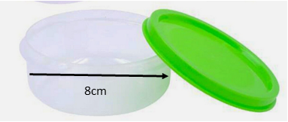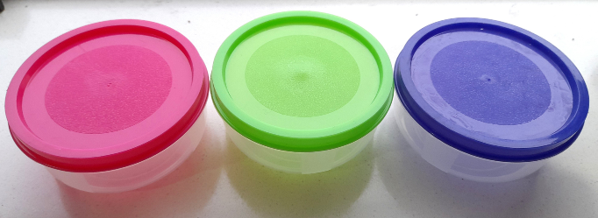

Medium Snack Box- only available in clear Large Snack Box- only available in clear
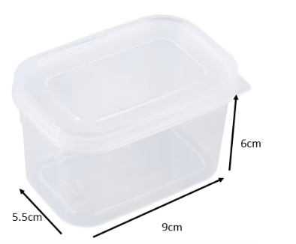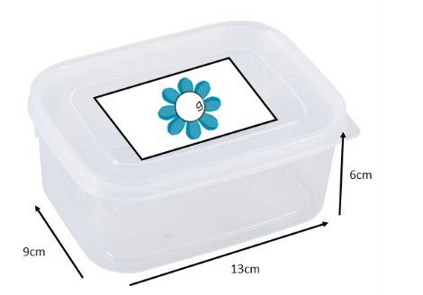

Sandwich Box tan pink blue green
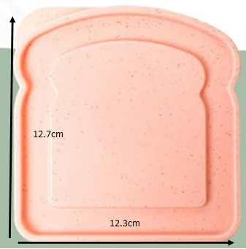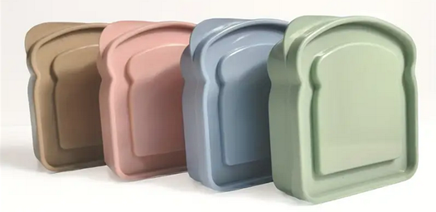

Library Bags
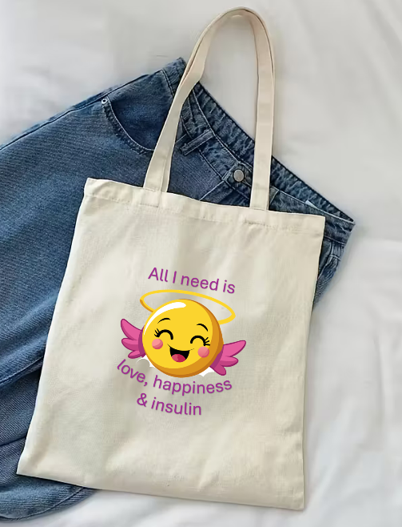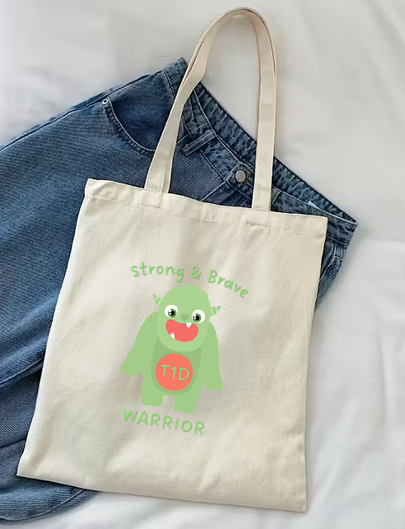

Pictures
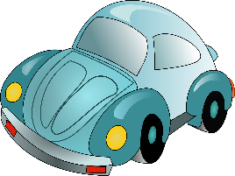
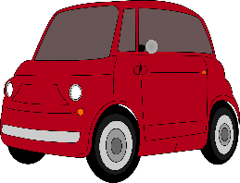




Flower Y Flower B Heart Car R Car B
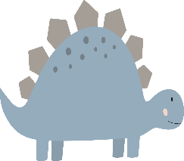

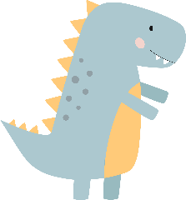

Trex Butterfly Steg

Font
g
NO INSULIN

