ORDER FORM

Please ensure that container size, colour, picture and font are selected.

|  |  |  |  |  |  |  |  |  |  |  |
| --- | --- | --- | --- | --- | --- | --- | --- | --- | --- | --- |
| Container | Select one | | | | | | | | | |
| Mini | Orange | Blue | Red | | Yellow | Green | |  |  | |
| Medium | Pink | | Green | | | Purple/Blue | | |  | |
| Large | Clear | |  | | |  | | |  | |
| Sandwich | Peach | | Green | | | Tan | | | Grey | |
|  | | | | | | | | | | |
| Picture | Butterfly | Heart | Flower Y | Flower B | | Car R | Car B | | Trex | Steg |
| Font | No Insulin | | G | | |  | | |  | |
|  |  | |  | | | Quantity | | |  | |

|  |  |  |  |  |  |  |  |  |  |  |
| --- | --- | --- | --- | --- | --- | --- | --- | --- | --- | --- |
| Container | Select one | | | | | | | | | |
| Mini | Orange | Blue | Red | | Yellow | Green | |  |  | |
| Medium | Pink | | Green | | | Purple/Blue | | |  | |
| Large | Clear | |  | | |  | | |  | |
| Sandwich | Peach | | Green | | | Tan | | | Grey | |
|  | | | | | | | | | | |
| Picture | Butterfly | Heart | Flower Y | Flower B | | Car R | Car B | | Trex | Steg |
| Font | No Insulin | | G | | |  | | |  | |
|  |  | |  | | | Quantity | | |  | |

|  |  |  |  |  |  |  |  |  |  |  |
| --- | --- | --- | --- | --- | --- | --- | --- | --- | --- | --- |
| Container | Select one | | | | | | | | | |
| Mini | Orange | Blue | Red | | Yellow | Green | |  |  | |
| Medium | Pink | | Green | | | Purple/Blue | | |  | |
| Large | Clear | |  | | |  | | |  | |
| Sandwich | Peach | | Green | | | Tan | | | Grey | |
|  | | | | | | | | | | |
| Picture | Butterfly | Heart | Flower Y | Flower B | | Car R | Car B | | Trex | Steg |
| Font | No Insulin | | G | | |  | | |  | |
|  |  | |  | | | Quantity | | |  | |

|  |  |  |  |  |  |  |  |  |  |  |
| --- | --- | --- | --- | --- | --- | --- | --- | --- | --- | --- |
| Container | Select one | | | | | | | | | |
| Mini | Orange | Blue | Red | | Yellow | Green | |  |  | |
| Medium | Pink | | Green | | | Purple/Blue | | |  | |
| Large | Clear | |  | | |  | | |  | |
| Sandwich | Peach | | Green | | | Tan | | | Grey | |
|  | | | | | | | | | | |
| Picture | Butterfly | Heart | Flower Y | Flower B | | Car R | Car B | | Trex | Steg |
| Font | No Insulin | | G | | |  | | |  | |
|  |  | |  | | | Quantity | | |  | |

YOUR DETAILS

|  |  |
| --- | --- |
| Name |  |
| Address |  |
| Email |  |
| Phone |  |

You will be contacted with a confirmation of your order.

Please double check carefully that everything is correct. When you are satisfied please use the PayPal link that will be sent to you to make your payment.

When payment is received your order will be made.

As each order is made to your custom requirements, please allow up to 4 weeks to receive your order. We will endeavor to make your order as quickly as we can.

Flat rate postage of $3.00

SELECTION

Container

Mini Snack Box Orange Blue Red Yellow Green

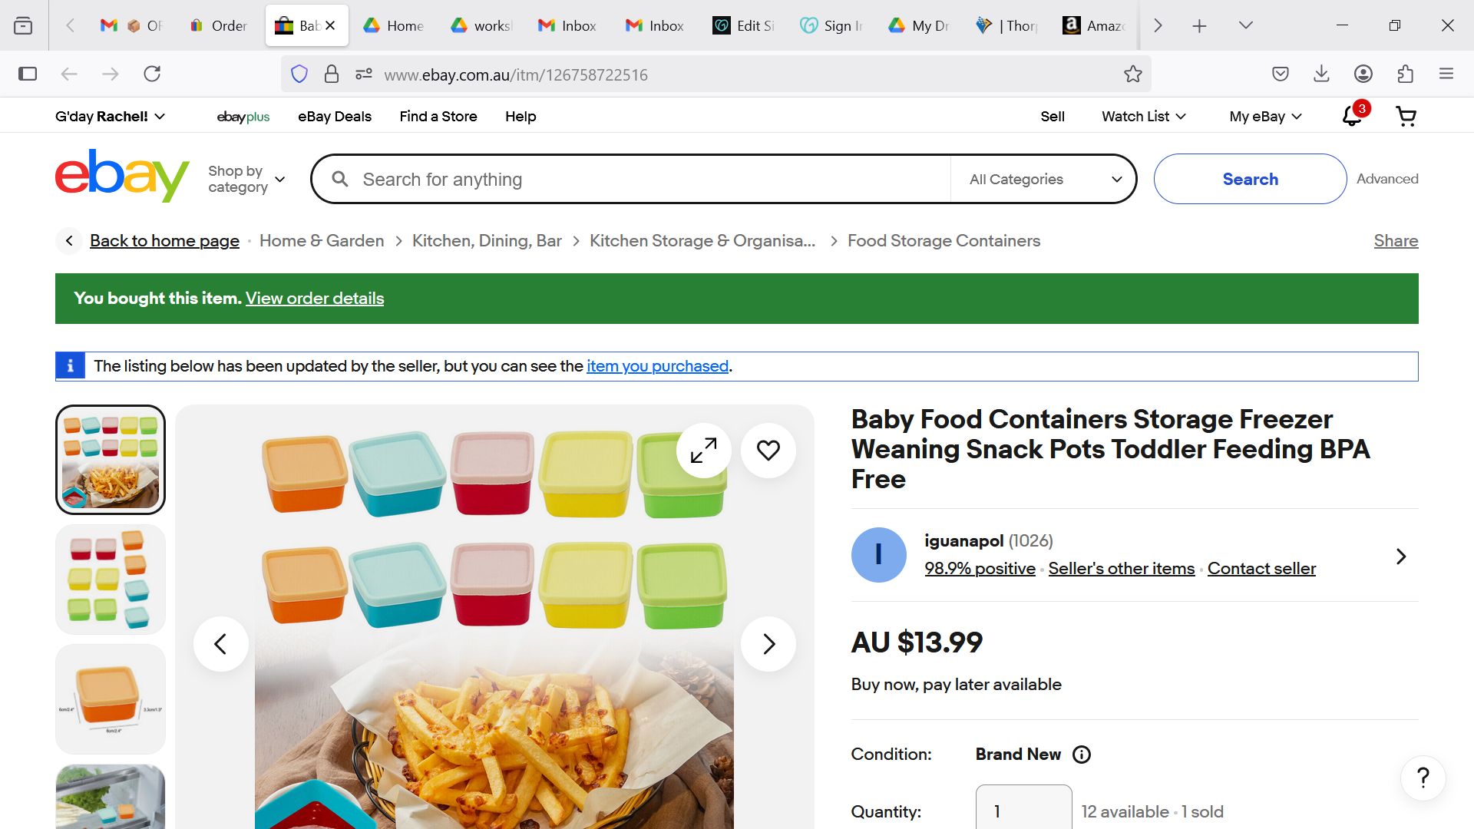

Medium Snack Box pink green purple/blue

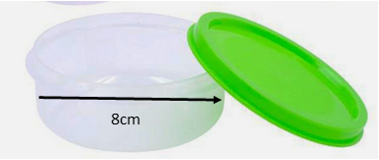 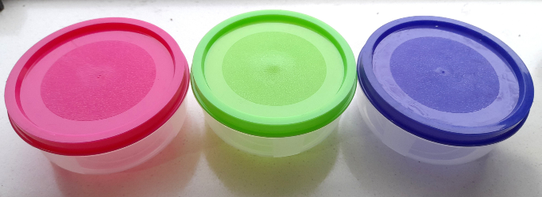

Large Snack Box- only available in clear

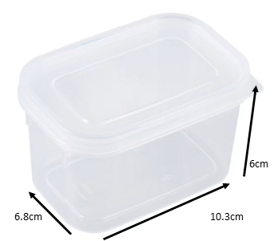

Sandwich Box peach green tan grey

Pictures

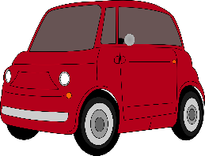

Flower Y Flower B Heart Car R Car B



Trex Butterfly Steg

Font

g

NO INSULIN