|  |
| --- |
| Annual 2024 Report |
| Annual Meeting Notice  April 8, 2025  7:00 PM  700 N. Main Benton, Kansas 67017 |
| Butler Rural Water No. 5 |

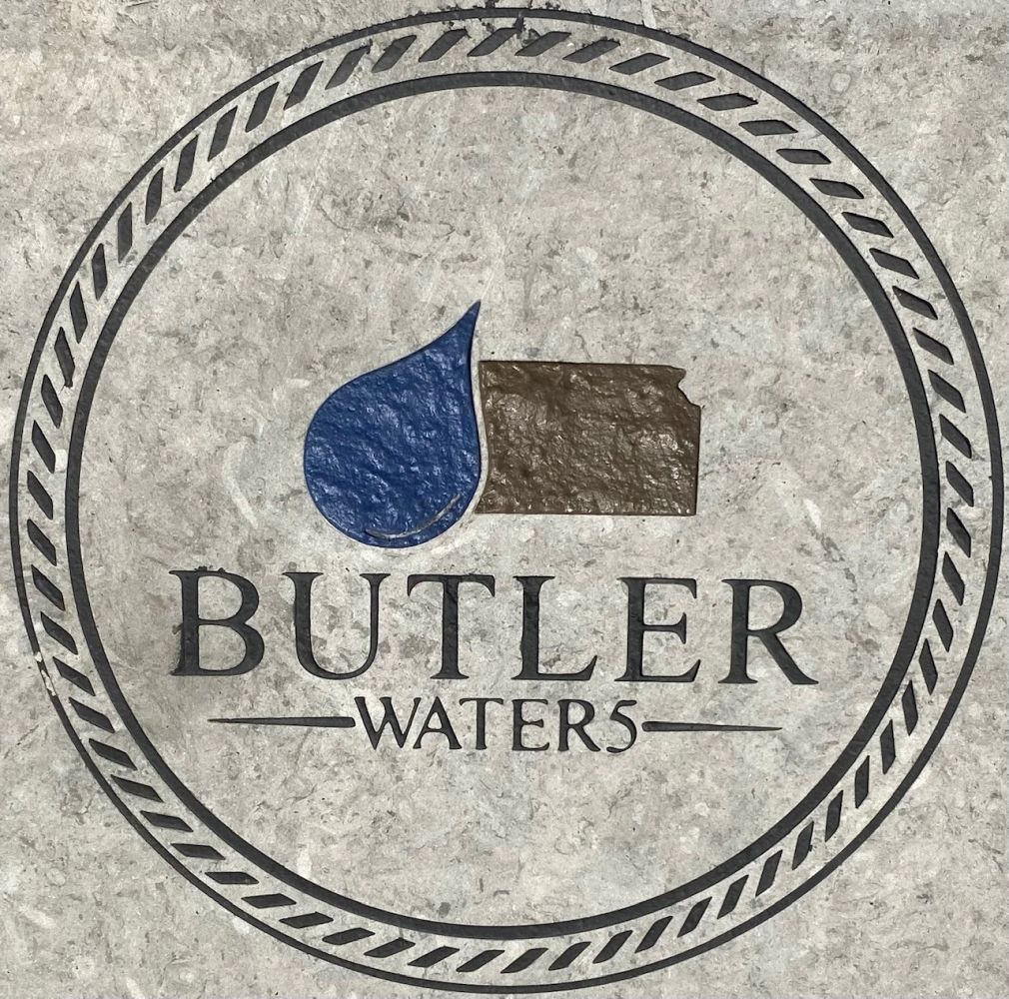

sss

|  |
| --- |
| **The year in review** Butler Rural Water District #5 (RWD #5) has been providing water service to customers for the past 47 years. The project included in 2024 was the installation of (7) tower placed over the district so that we can now read water meter in real time. This system allowed us to reduce mileage on trucks running the district to retrieve the reading every month along with reducing tire wear and fuel consumption and allowing our technician to work on more pressing issues.  **District 5**  The project that has kept staff busy in 2024 was the new Lead & Copper rule. The EPA has requested all water municipalities to identify any lead in the distribution system and provide a plan for removal. Butler Rural Water #5 started construction in 1977, so the system has NO lead in its distribution. EPA also requires a catalog of pipe material in our customers’ homes. This information will be placed in a database for customer information and to help with how the district treats the water. If you have not sent your survey in, please send it back soon. These surveys are required. The District did meet the EPA required date of October 17th, 2024, for the upload of all customers Lead & Copper information short of 200 customers that failed to return the required information. These customers will receive a pamphlet every June asking for this information. If you happen to be one of these customers, please fill out the information and return ASAP due to the district will have to send this pamphlet every year until all accounts have a Lead & Copper survey on file. |

Meet the staff.

We are very proud of our employees. Years of Service

Terry Brown District Manager/Operator 19

Jon Shaffer Operator/Operations 12

Clara Jewell Office 9

Cale Stephens Operator/Maintenance 9

Alex Cook Maintenance 3

Devin Hise Maintenance 1

Breanna McCutcheon 3 Mos

Water purchased in 2024.

During 2023, the District purchased 133,410418 gallons of water from the City of El Dorado and 75,846,075 gallons from the City of Wichita for a combined total purchase of 209,256,493 gallons. Water sold to both North-5 and South-5 customers totaled 187,979,651 gallons. The year ended with 2,304 customers which is an increase of 49 customers District-wide. The District also sells bulk water to the City of Towanda that accounts for 36.8% of the gallons sold in 2024.

Cost of doing business

As rates continue to increase from our sources, RWD #5 can no longer be subsidized and will increase customer rates accordingly. The District has worked on a 10-year plan to help control rates as recommended by the water rate study.

Retirement Announcement for Ron Engelbrecht

As the manager of the District, I want to take a moment to express our heartfelt gratitude for Ron Engelbrecht, who has dedicated 20 incredible years of service to our board. Since joining in 2006, Ron has taken several different positions, showcasing his unwavering commitment and passion for ensuring our water district operates at its best.

Ron has played a crucial role in navigating many significant projects over the years, including the development of multiple water sources, the implementation of radio reading technology, advanced software solutions, and some of the best automated controls that many other water districts can only aspire to have.

We have been fortunate to have such a dedicated board member who invested countless hours of his time to improve our services. As Ron embarks on his well-deserved retirement, we want to thank him for all that he has done for us and our community. His legacy will certainly continue to inspire us all.

Congratulations, Ron! Enjoy this new chapter in your life.

Best wishes,

Manager, Terry Brown

Reminder about meter damage

Water meter lids are equipped with a flat disc radio-read transmitter allowing collection of customer usage readings. The customer is responsible for protecting the water meter lid, radio, and ring assembly from damage. Please keep the assembly visible by trimming grass around your meter. Do not hit, drive over, or mow over the assembly. If the transmitter is damaged and must be replaced, a minimum of $265 replacement cost will be assessed to the customer.

Reminder about payment due date

Water bill payments are due on or before the 20th of each month regardless of what day of the week it falls. If the envelope post-mark date shows on or before the 20th, late charges will not apply. For your convenience, the office has a drop slot located in the office door inside the porch and a drive-up payment box located between the two drives for after-hours and weekend payments. Other payment options are online payment at bucorwd5.com (small fee applies) or ACH monthly debit which is free and requires a signed authorization form. Not receiving a bill through the USPS does not dismiss late fees.

Shut-off notices are mailed by the 10th of the month if payment has not been received for the previous month. Non-receipt of the notice through the USPS does not dismiss the shut-off policy. This is basically a 10-day notice to have your bill paid in full by the 20th of the month or be subject to having your water meter locked and a $100 service fee added. If the meter is locked, the amount due must be paid in full with CASH, MONEY ORDER, or DEBIT/CREDIT CARD. NO CHECKS WILL BE ALLOWED.

The Consumer Confidence Reports

The Consumer Confidence Report (CCR), which is the water quality report for 2023, will be available in April on our website at bucorwd5.com. The Environmental Protection Agency (EPA) is now allowing water systems to deliver this report online through a direct link. Your monthly billing card will contain information about when the report is available.

Cross Connection

As spring approaches and lawn irrigation systems that use rural water are put into use, this is a reminder that the District’s Cross-Connection Program requires that all backflow prevention device(s) be tested and inspected annually by a certified tester to ensure that the device is functioning properly. The annual test report must be provided to RWD #5 ONLINE ONLY at BUCORWD5.com and will be retained on file for the Kansas Department of Health and Environment routine inspection. Failure to certify device(s) will result in meters being locked AND A $100 NON-COMPLance FEE will be added to your account UNTIL CERTIFIED.

Members are reminded that physical connection between any private water system (well) and the District water system is prohibited. Violation of the provision shall be grounds for disconnection of service. Representatives of the District have the right at all reasonable hours to enter upon the customers’ premises to test control valves, inspect piping, and do their duties for the proper maintenance and operation of service, or to remove its service equipment and shut off after discontinuing of service to customers.

High Water Usage

Customers may experience higher water usage, which is typical at dryer times and in the summer. You may wonder if you have a leak. There are steps you can take to check for a leak: 1) check for dripping faucets/showers and running toilets, 2) sump pumps running more than usual may indicate a leak exists from your meter to the home, 3) check yard frost-proof spigots or lawn irrigation systems if connected to rural water, 4) did you fill a swimming pool or have an automatic pool filler, 5) did you have company or extra family members for an extended period of time, 6) walk the line from the home to the meter checking for soft/muddy areas, 7) have you installed any new appliances/water softener system. Please remember, the service line from the meter to the home or business is the responsibility of the customer.

2024 Annual Audit

The onsite 2024 annual audit was performed by the firm Regier Carr Monroe, LLP, CPA’s.

Contact the Office

Office staff is available to address customer needs during office hours, which are 8:00-12:00 & 1:00-4:30 Monday through Thursday and 8:00-1200 on Friday. You may reach the office at 316-778-1631. The emergency numbers are 316-461-9427 or 316-737-1376.

Justin Kneisel Chairman

Bill Resse Secretary

Aaron May, Treasurer

Butler County Rural Water District #5

Unaudited Report