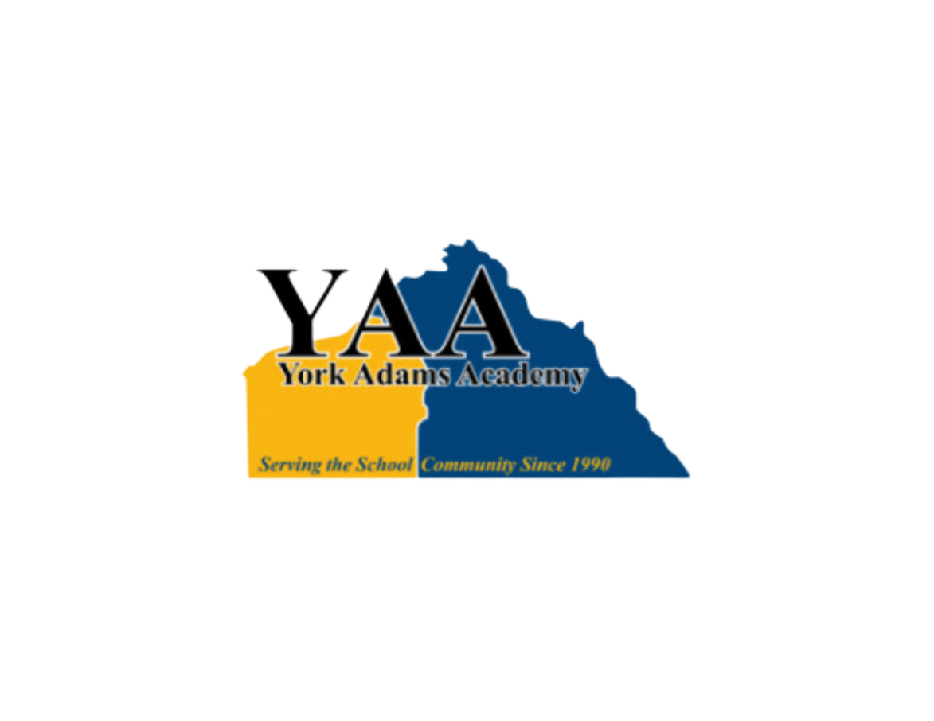

**Joint Board of Directors’ Meeting**

**York Learning Center**

**300 E. 7th Avenue, Suite 500**

**York, PA 17404**

**Tuesday, August 27, 2024 *@ 6:30 PM***

Meeting Convened at 6:32 PM.

Ms. Karen Baum called the meeting to order.

1. **Attendance**

**Board Members Present:**

Mr. Corey Thurman Central York School District

Mr. Scott Wingard Dallastown Area School District

Mr. Bryan Fink Eastern School District

Ms. Tiffany Manning Northeastern School District

Mr. Marc Greenly Red Lion Area School District

Ms. Karen Baum, Vice President Spring Grove Area School District

**Board Members Not Present:**

Mr. Terry Emig, Treasurer Dover Area School District

Ms. Heidi Thomas West Shore School District

Mr. Brian Siatkowski West York Area School District

Ms. Ellen Freireich, President York Suburban School District

**Also in Attendance:**

Ms. Ruth Ackerman, Director

Dr. Joseph Mancuso, Superintendent of Record

Mr. Brian Geller, Business Manager

1. **APPROVAL OF MINUTES – Ms. Baum**
   1. Approval of Minutes from the March 26, 2024 meeting. Ms. Baum asked if any members had any comments or changes to the minutes. No changes or comments were made. The minutes stand as presented.
2. **DISCUSSION ITEMS**
   1. Mr. Wingard suggested that YAA ask its member districts for curriculum guides and accompanying textbooks to improve continuity and reduce costs.
   2. The L.I.U. has offered a choice of lease agreements.
   3. Sign a two-year agreement for years 2025-26 and 2026-27 at $45K/yr.
   4. Sign a three-year agreement for years 2025-26, 2026-27, and 2027-28 at $45k/yr. regardless of location.
   5. After discussing the pros and cons of each choice, the agreement was to ask for a three-year agreement for approval at the September board meeting.
3. **ACTION ITEMS**
   1. Approval of Treasurer’s Report: May, June, and July 2024

Mr. Geller presented and highlighted sections of these reports. There was a motion by Mr. Thurman and a second by Mr. Greenly. The motion was approved 6 Yes – 0 No.

* 1. Accounts Payable Bills: May, June, and July 2024

There was a motion by Mr. Greenly and a second by Mr. Thurman. The motion was approved 6 Yes – 0 No.

* 1. Approval of Lauren Williams, Adams/Hanover site Administrative Assistant effective August 12, 2024.

There was a motion by Mr. Greenly and a second by Mr. Thurman. The motion was approved 6 Yes – 0 No.

* 1. Accept resignation of Lauren Williams, Administrative Assistant effective August 24, 2024.

There was a motion by Mr. Greenly and a second by Mr. Thurman. The motion was approved 6 Yes – 0 No.

* 1. Approval of the 2023-2024 auditor engagement letter from Withum for $10k.

Mr. Geller provided background on Withum and the terms of the agreement. There was a motion by Mr. Thurman and a second by Ms. Manning. After discussion the motion was approved 6 Yes – 0 No.

1. **DIRECTOR OF STUDENT SERVICES’ REPORT – Ms. Stafford**
   1. This week she will be testing 55 new students for admission.
2. **DIRECTOR’S REPORT – Ms. Ackerman**
   1. The 2024-2025 school year began on August 19, and to date, four students already completed their coursework for graduation.
   2. Met with the high school administration at Southern York SD to offer them to join the YAA.
   3. Contacted the four member districts that have not paid their first installment payment.
3. **PRESIDENT’S REPORT**

No report

1. **SUPERINTENDENT OF RECORD’S REPORT – Dr. Mancuso**

No report

1. **ADJOURNMENT**

Motion to adjourn the meeting at 7:08 p.m. was made by Mr. Greenly and seconded by Mr. Thurman. The motion was approved.