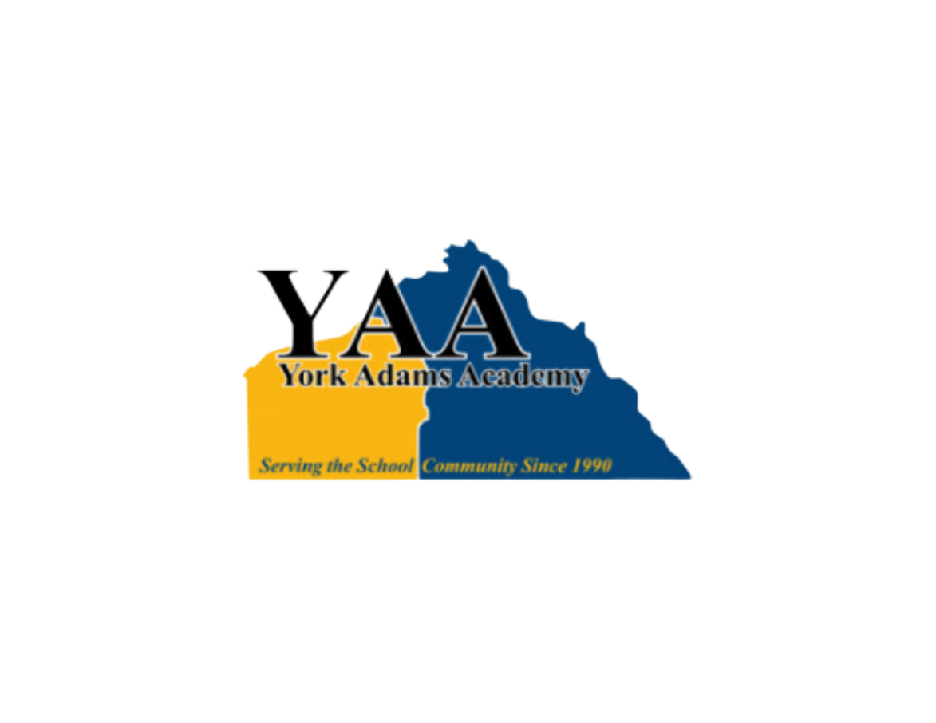

**Joint Board of Directors’ Meeting**

**York Learning Center**

**300 E. 7th Avenue, Suite 500**

**York, PA 17404**

**Tuesday, September 24, 2024 *@ 6:30 PM***

Meeting Convened at 6:31 PM.

Ms. Ellen Freireich called the meeting to order.

1. **Attendance**

**Board Members Present**

Mr. Scott Wingard Dallastown Area School District

Mr. Terry Emig, Treasurer Dover Area School District

Mr. Bryan Fink Eastern School District

Ms. Tiffany Manning Northeastern School District

Mr. Marc Greenly Red Lion Area School District

Ms. Karen Baum, Vice President Spring Grove Area School District

Ms. Heidi Thomas West Shore School District

Ms. Ellen Freireich, President York Suburban School District

**Board Members Not Present**

Mr. Corey Thurman Central York School District

Mr. Wes Myers West York Area School District

**Also in Attendance**

Ms. Ruth Ackerman, Director

Dr. Joseph Mancuso, Superintendent of Record

Mr. Brian Geller, Business Manager

1. **APPROVAL OF MINUTES**
   1. Approval of minutes from the August 27, 2024 meeting. Ms. Freireich asked if any members had any comments or changes to the minutes. One correction is to replace Brian Siatkowski’s name with Wes Myers in the attendance section. Minutes approved with this correction noted.
2. **DISCUSSION ITEMS**
   1. Approval of the bid for the server backup. The L.I.U. manages the YAA computer system. Their recommendation is to add a backup server in case the main server ever crashes. The existing main server should be okay for another 5 years. Through discussion, it was noted that the YAA has added cyber liability insurance as an added measure of security. Since the backup server was not a budgeted expenditure and has a useful life exceeding 1 year, the capital reserve account is where these funds are to be drawn.

*There was a motion by Mr. Greenly and a second by Terry Emig to purchase a backup server from the L.I.U. for $4,221.91, and use the capital reserve fund as the funding source. The motion was approved 8 Yes – 0 No.*

* 1. Refundable enrollment fee concept explained. Mrs. Ackerman noted the ongoing concern that some students enroll, withdrawal prior to graduation, and do not return the issued textbook(s). This costs the YAA money. Her recommendation is to enact a $25 student fee be paid at time of enrollment. If the student graduates, the $25 will be used towards the student’s graduation expense. If the student withdraws prior to graduation and does not return the textbook(s) issued, then this $25 is not refunded to the student.

*There was a motion by Mr. Greenly and a second by Ms. Baum to create a $25 refundable enrollment fee that will be used towards a student’s graduation expenses or returned to a withdrawing student if textbook(s) returned. Upon enrollment a student is to sign this agreement and pay the $25 fee. It will be at the Director’s discretion to waive this student fee in cases of student financial hardship. The motion was approve 8 Yes – 0 No.*

* 1. Mrs. Ackerman presented a new logo to the board for comment. Julie Haynes created this logo in-house. Her artwork was well received. One consideration is to find out whether this logo can be embroidered or patched on to clothing.

1. **ACTION ITEMS**
2. Approval of Treasurer’s Reports:
3. August 2024
   1. Mr. Geller presented these reports. *There was a motion by Mr. Emig and a second by Mr. Greenly. Ms. Manning had left the meeting. The motion was approved 7 Yes – 0 No.*
4. Approval of Bills:
5. August 2024
   1. *There was a motion by Mr. Emig and a second by Mr. Greenly. The motion was approved 7 Yes – 0 No.*
6. Approval of the 3 year lease agreement between York Adams Academy and Lincoln Intermediate Unit #12 from July 1, 2025 through June 30, 2028 with a fixed annual amount of $45,000 per year (paid quarterly) as attached.
   * 1. *There was a motion by Mr. Greenly and a second by Ms. Thomas. The motion was approved 6 Yes – 0 No – 1 Abstain. Ms. Freireich abstained since she serves on both boards.*
7. The approval of Caitlin Hoffman, part-time Adams Administrative Assistant position, for 20 hours a week with an hourly starting rate of $17.62/hr., retroactive to September 3, 2024.
   * 1. *There was a motion by Mr. Greenly and a second by Mr. Fink. The motion was approved 7 Yes – 0 No.*
8. **DIRECTOR OF STUDENT SERVICES’ REPORT** 
   1. Ms. Ackerman gave an update on Ms. Stafford’s activities year to date. Ms. Stafford is testing on average 10-12 student per week, conducting student orientation every day. 22 students have already graduated this year from YAA.
9. **DIRECTOR’S REPORT – Ms. Ackerman**
   1. Southern York SD will purchase 1 YAA student seat this year pending approval from Southern School District’s school board.
10. **PRESIDENT’S REPORT**
    1. Ms. Freireirch thanked both her fellow board members and Dr. Mancuso for their dedicated support of the York Adams Academy.
    2. The next YAA board meeting will be October 29 starting at 6:30 p.m.
11. **SUPERINTENDENT OF RECORD’S REPORT**
    1. No report.
12. **ADJOURNMENT**

Mrs. Freireich adjourned the meeting at 7:15 p.m.